**Final Project Report**

Link to firebase: https://webproject-16d3b.web.app

**Initial Design Proposal**

**Idea Behind Website**

In this project I aim to create a website which primarily focuses on the sales of used cars. The user will be able to search car listings, filter them and ideally post an advert.

**Potential Users**

Potential users include anyone looking to buy or sell a vehicle, meaning the website will have to accommodate for both a youthful and elderly user. Accessibility will be taken into account in terms of a neat, easily navigable site with clear call-to-action buttons.

**Main Features of Website**

Features central to this project include; a search to filter listings, numerous other filters to narrow a search down (price, mileage, etc.), a ‘favourite’ icon to bookmark adverts you’re interested in and finally the ability post an advert.

**Wireframes**

**Homepage**

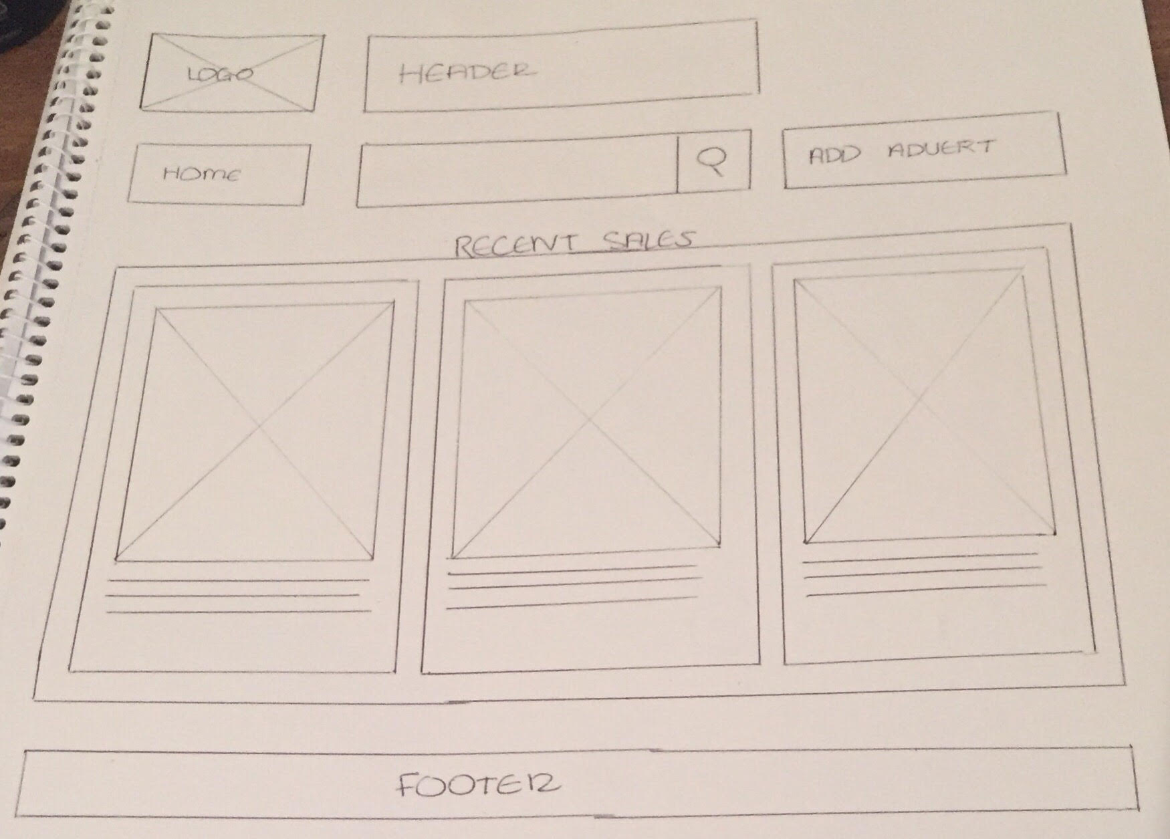

**Search Result Page**

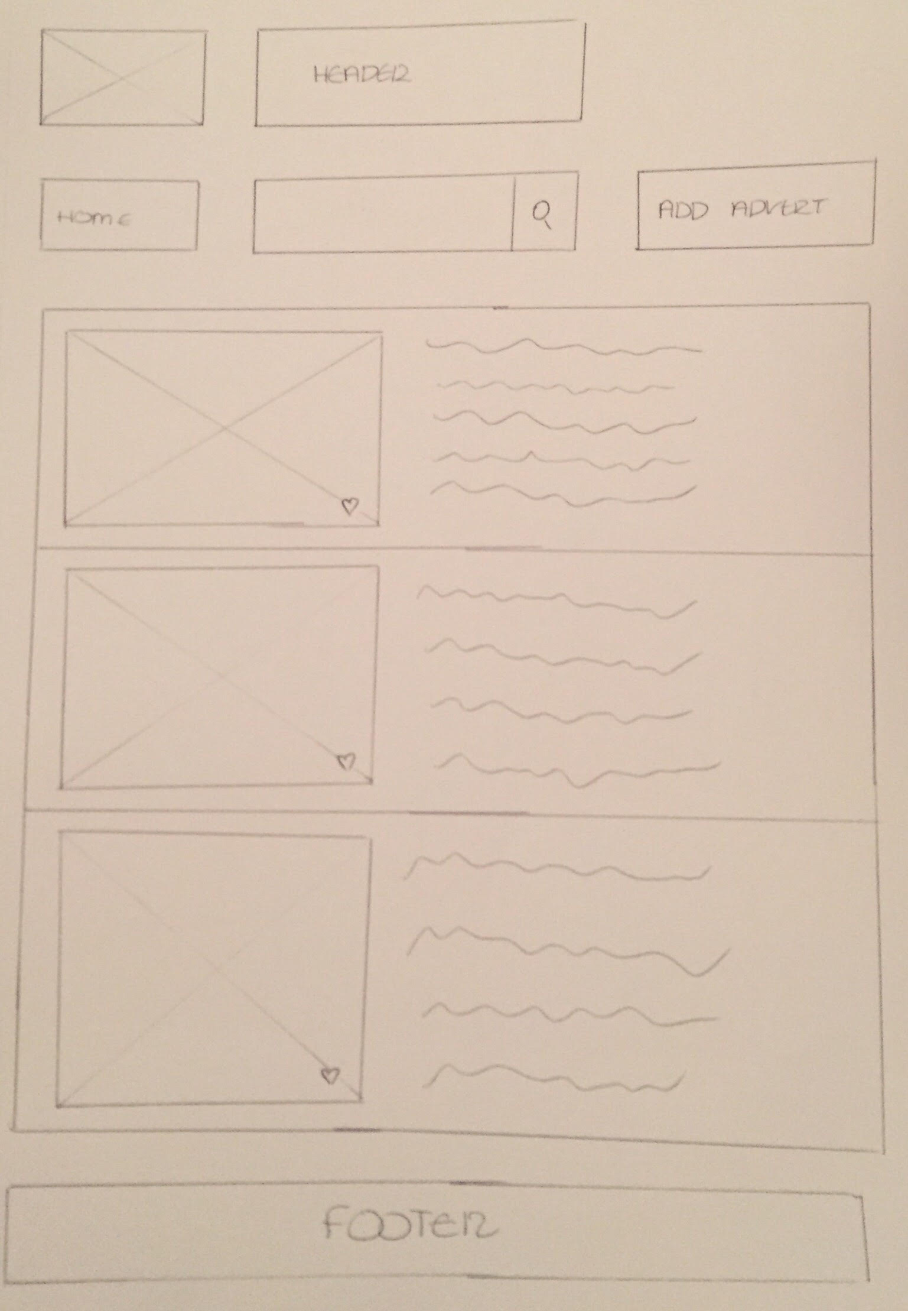

**Component Tree Diagram**

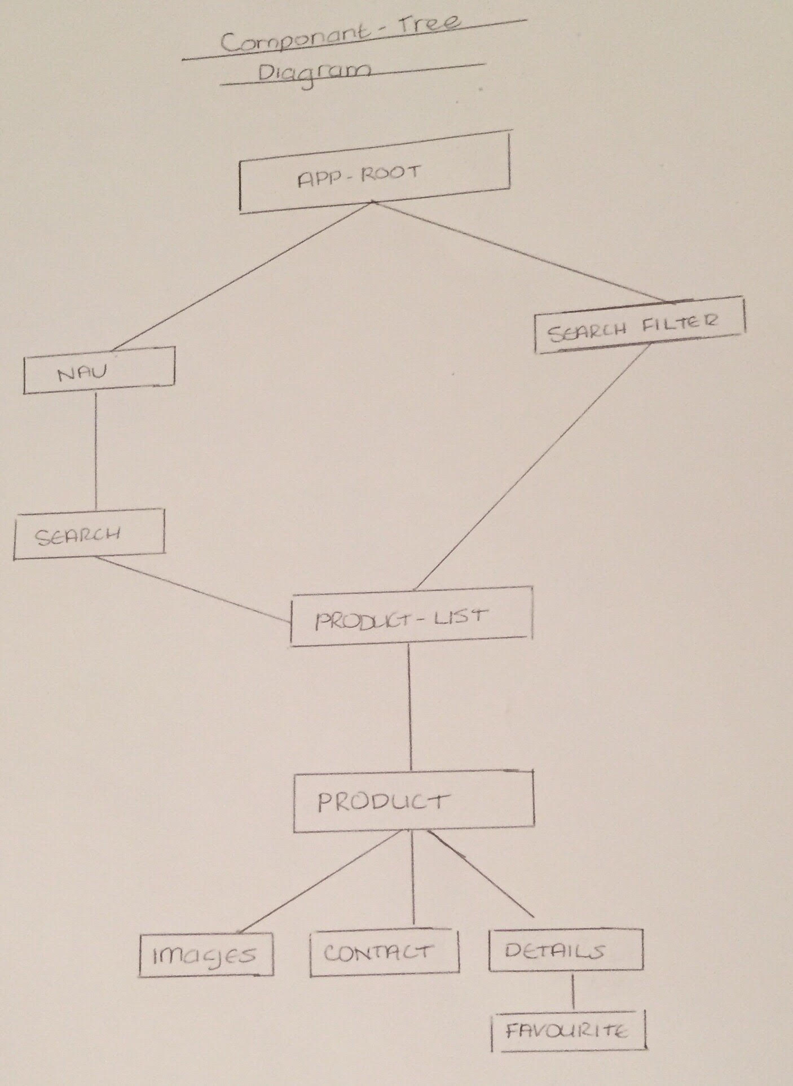

**Architecture Diagram**

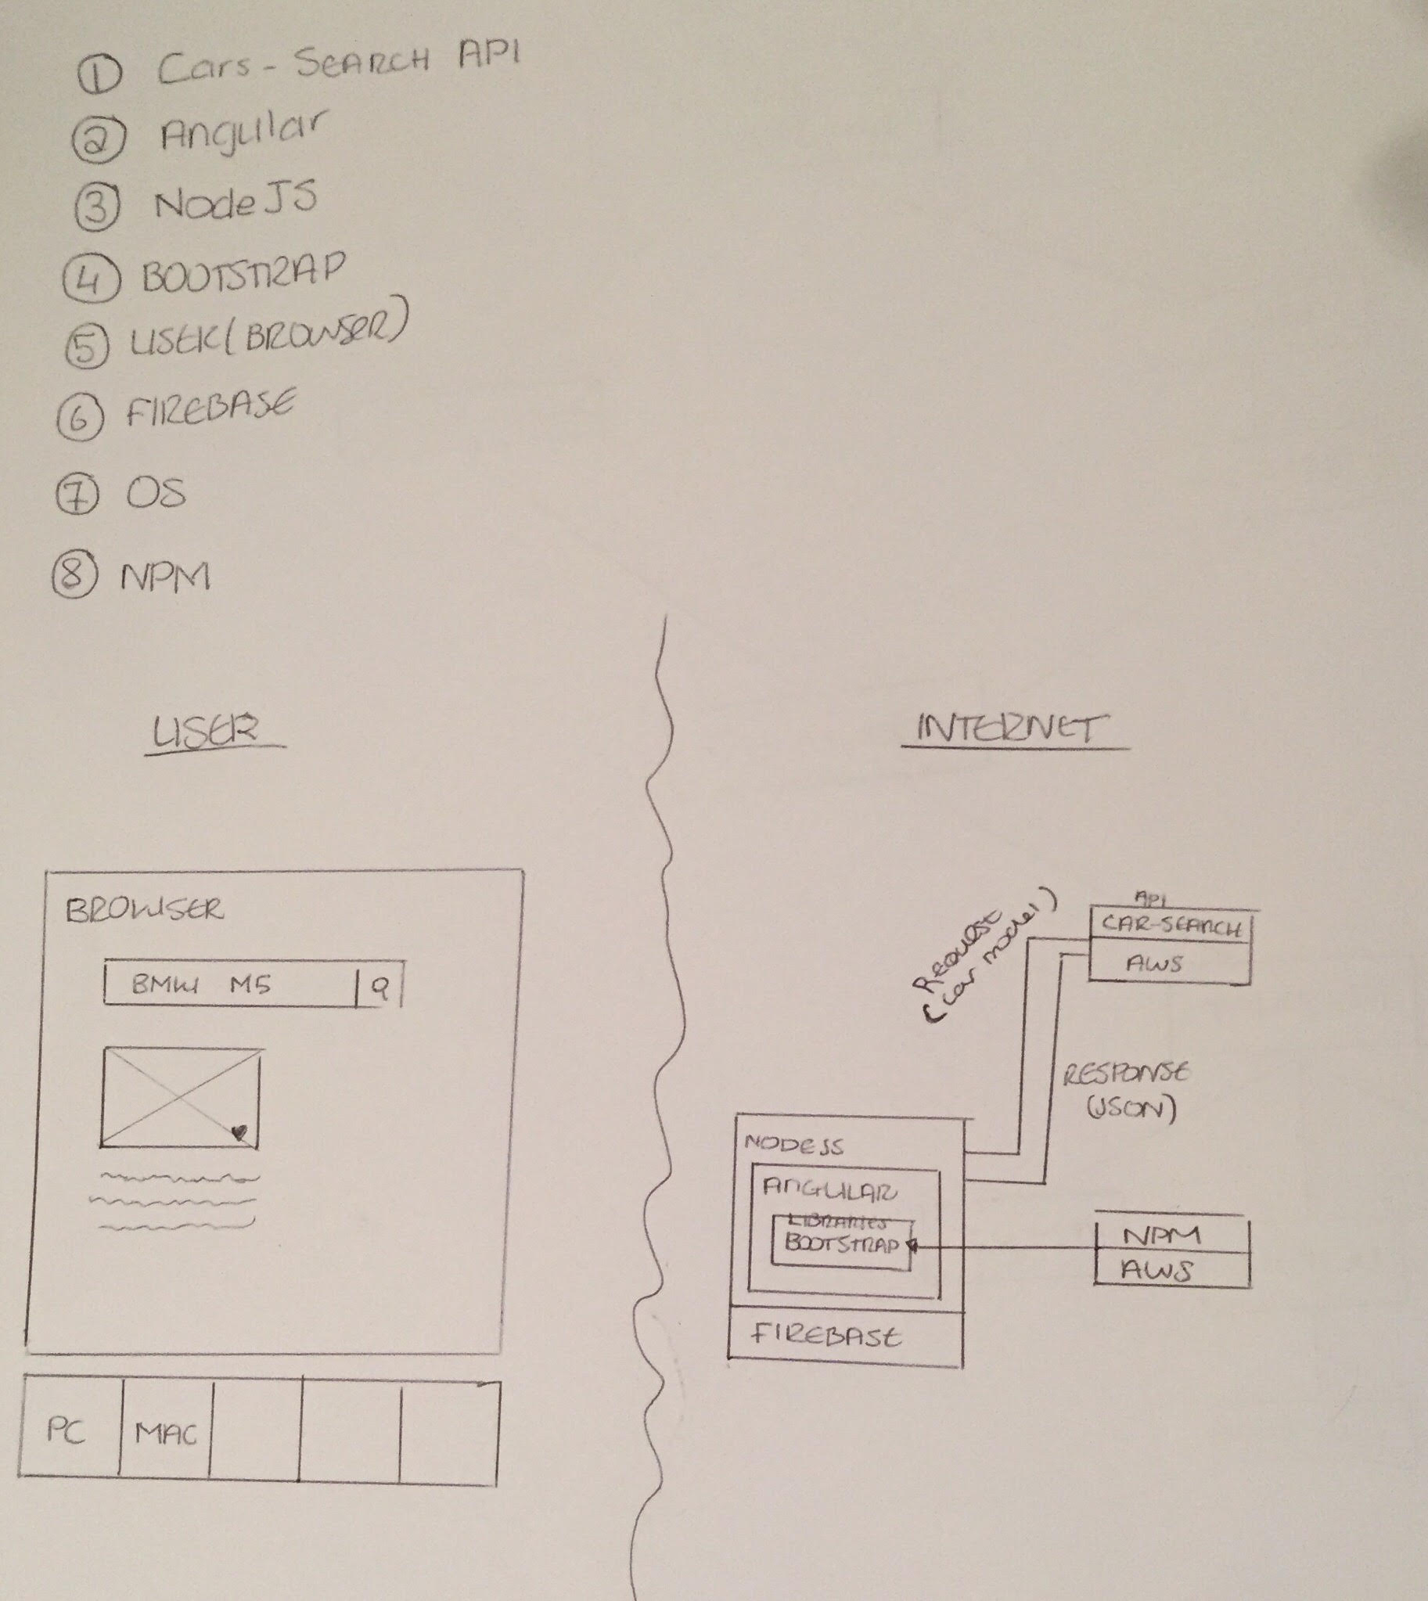

**Components**

**AppComponent – Main component (Search function and Create Advert navigation), utilizes API data.**

**CreateAdvert – Creates advert form, submits advert info to database.**

**Car – Structures for each car in the advert component.**

**Proposal Changes**

No recent sales: Placed more for of an emphasis on the search and place advert function. Homepage benefitted from a more refined aesthetic.

Footer: Not necessary for this website.

Model Filter: This was added to replace the other minor filters mentioned such as mileage as it was more appropriate.

Favourite Icon: Place advert function replaced this feature as showcase of a NoSQL database.

Overall the final application benefits from minor changes with regard to styling to allow the user to navigate the site simply and efficiently.

**Main Elements – API (Marketcheck)**

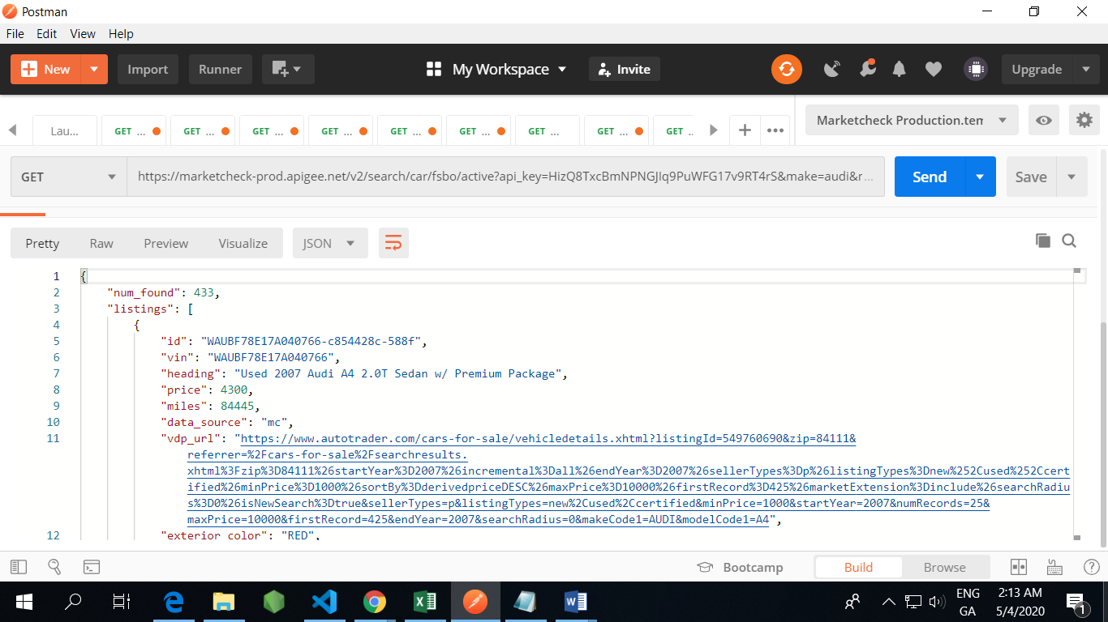

**Firebase - Database**

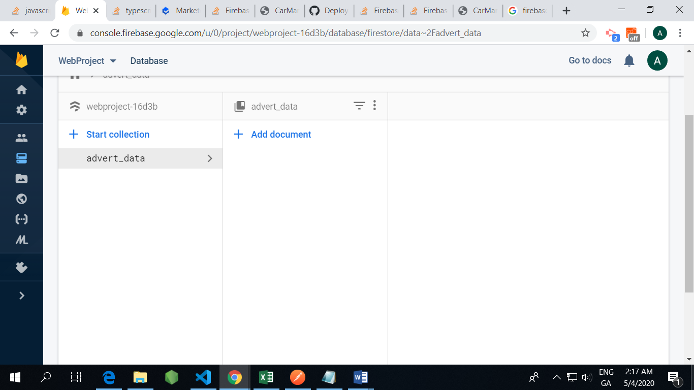

**Firebase – Hosting**

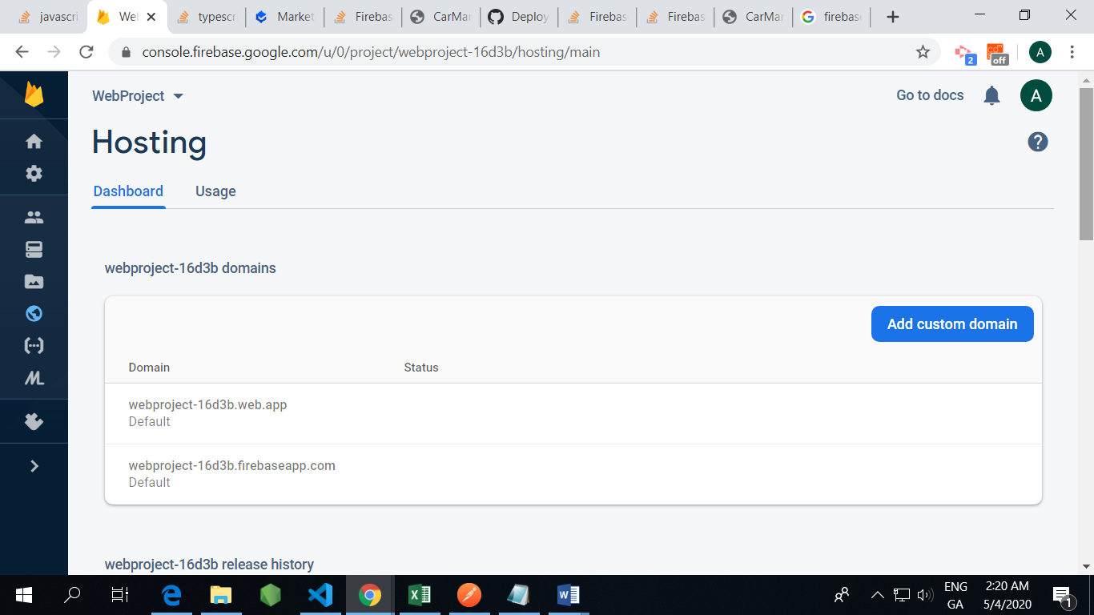

**Angular – TypeScript Framework**

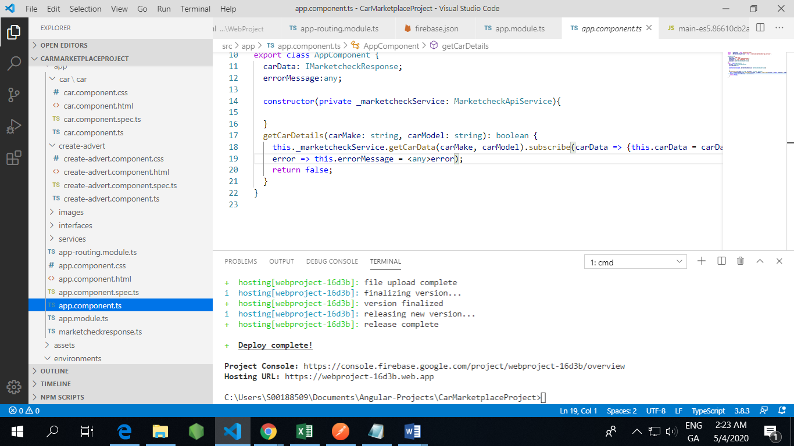

**Bootstrap- Front End/CSS Framework**

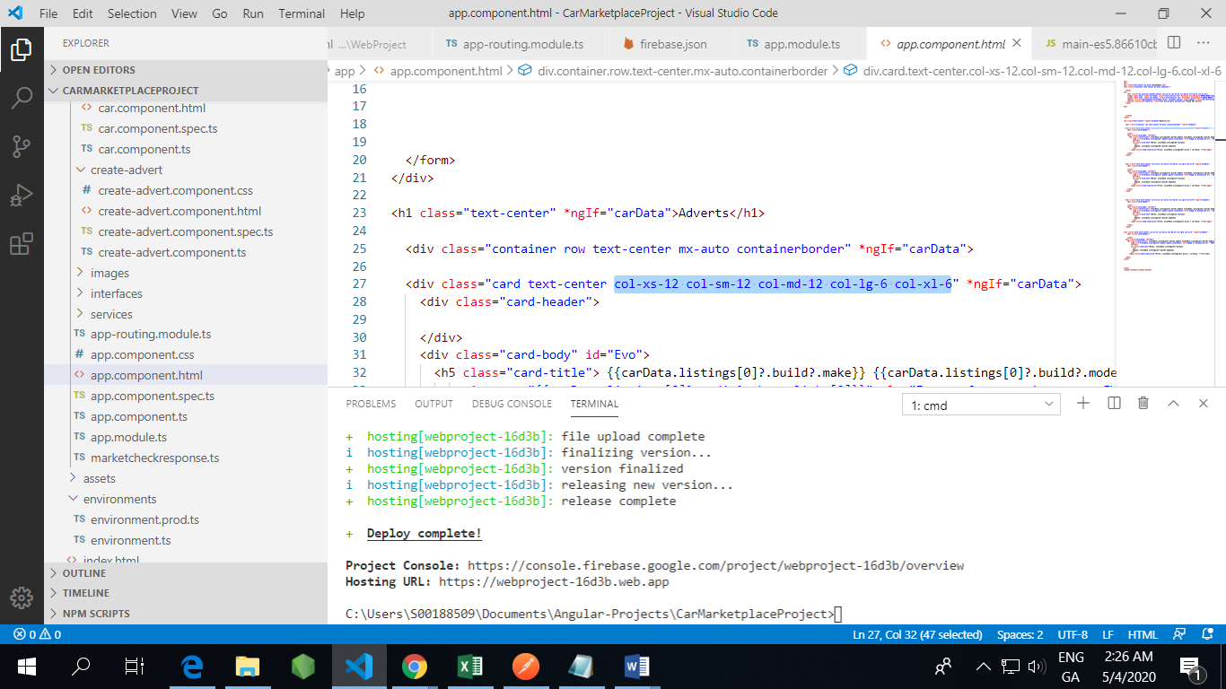

**Node - JavaScript** **runtime environment**

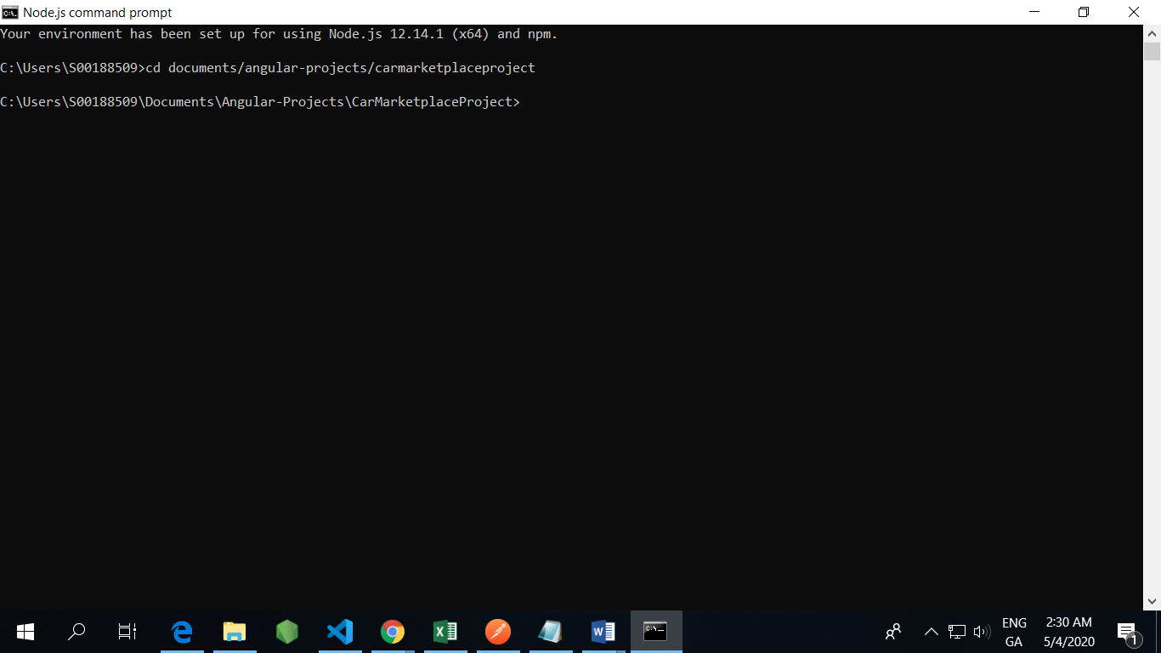

**Main CSS Classes**

col-xs-12 col-sm-12 col-md-12 col-lg-6 col-xl-6 – Used to cater to smaller screens (mainly images in search and advert functions.)

container – Used to keep things neatly contained in the search and advert functions.

mx-auto, text-center, justify-content – Center buttons, divs, containers etc. throughout the application.

@media screen – Apply responsive sizing to buttons etc. for different screen sizes.

card/card-body – For homepage search, to keep content uniform to each object.

**Application Screenshots**

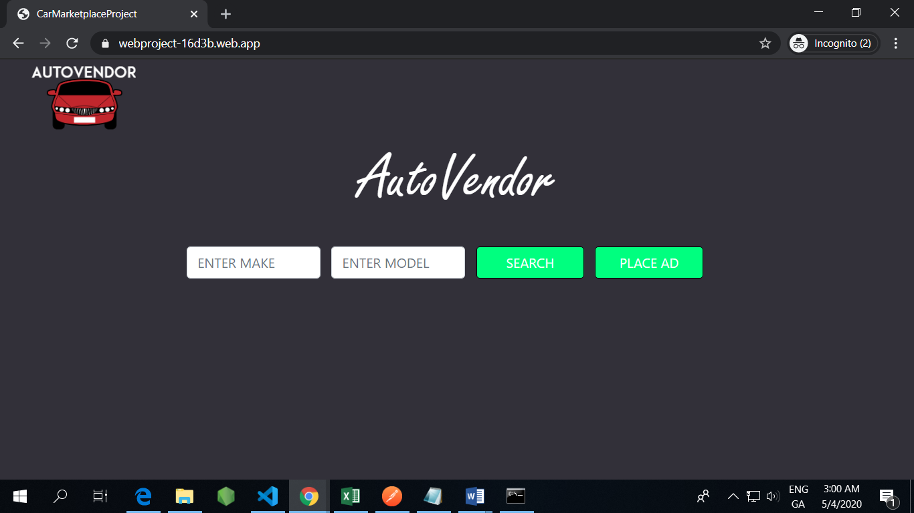

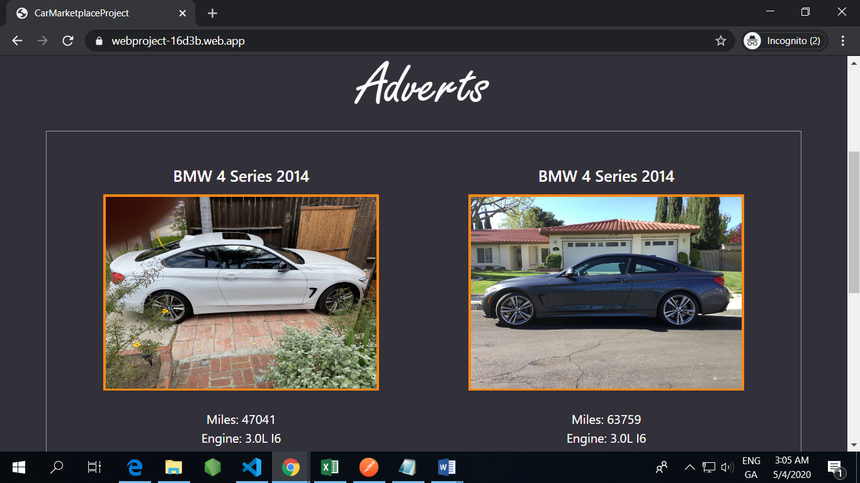

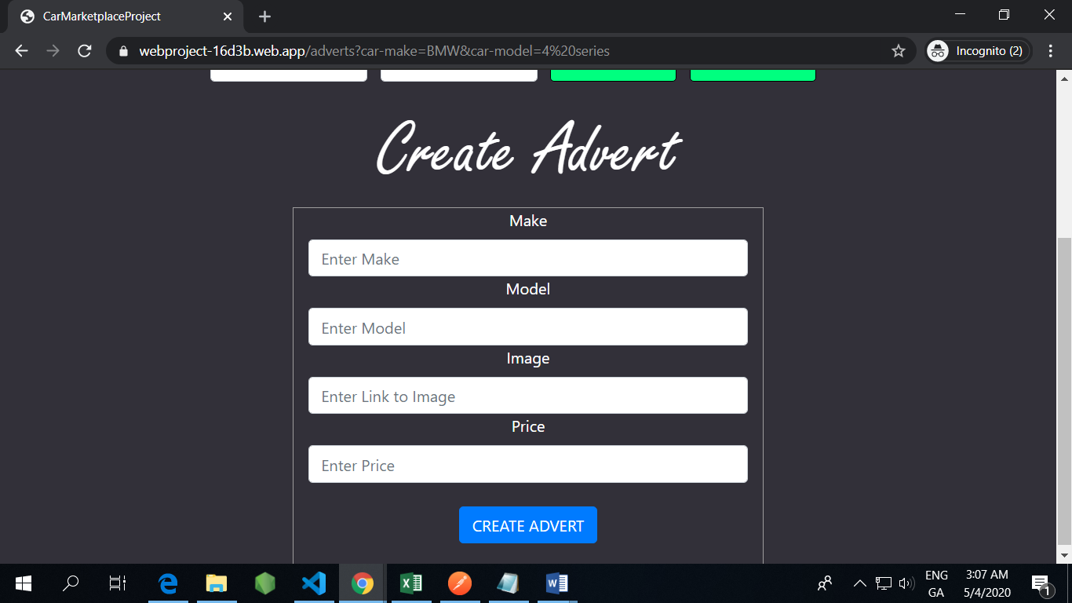

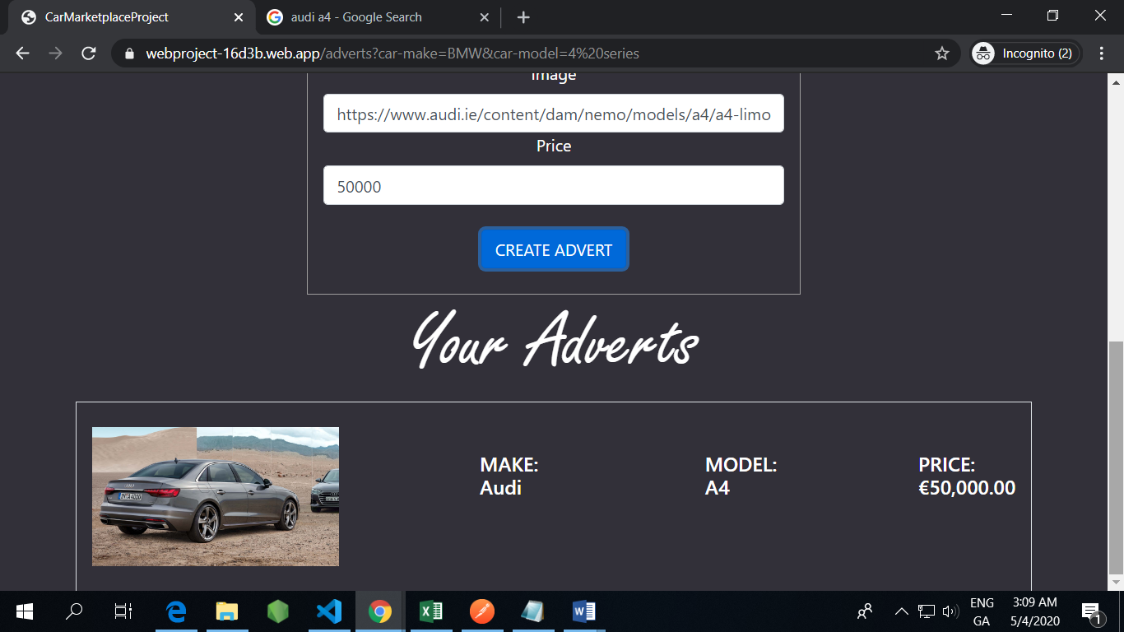

**Reflection**

Initially I found this project to be a struggle, Angular was proving difficult to grasp at first. However, I quickly found that the work we had completed in class served as great examples to get me started and from there I could eventually figure out all of the various issues I encountered while completing each aspect of the project.

Reflecting on the project I am grateful for encountering the issues. With every mistake I made I learned something new. These issues varied from the basics of angular (Component trees and their inner workings) to dealing with API data (Objects and Arrays) and deploying on firebase using dist rather than dist/ProjectName which caused more trouble than I’d like to admit, I also had issues had some minor issues with routing in firebase hosting but eventually found a solution from researching.

Overall I am significantly more confident regarding Angular, API’s, NoSQL databases and firebase.

**Self-Evaluation**

