Alan Rosenthal
alan_rosenthal@student.uml.edu
Assignment 2
10/18/2012

Degree of Success
I believe I fully completed the problem 100%. The test I ran produced expected results.

Discussion of Approach
My approach was very close to what Prof. Moloney described in his sample code. I created pthreads in the main loop for both consumers and producers. I also had a signal handler thread and a deadlock detection thread. If the deadlock detection thread observed that there was a deadlock, it would end the process. The main loop would output a 1 for a success, and a 0 for a deadlock.
I created a bash script to generate a header file, recompile the code, and then rerun it with new conditions. The bash script ran all tests in a single run. This took approximately two hours to finish.

Description of Problems Not Able to Resolve
I was able to resolve all problems. However at one point I did have an issue where I was segmentation faulting. I was able to fix this after extensive debugging.

Charts
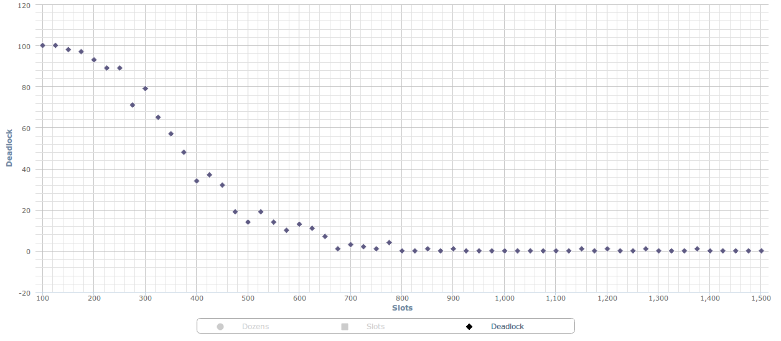
100 Dozen

150 Dozen
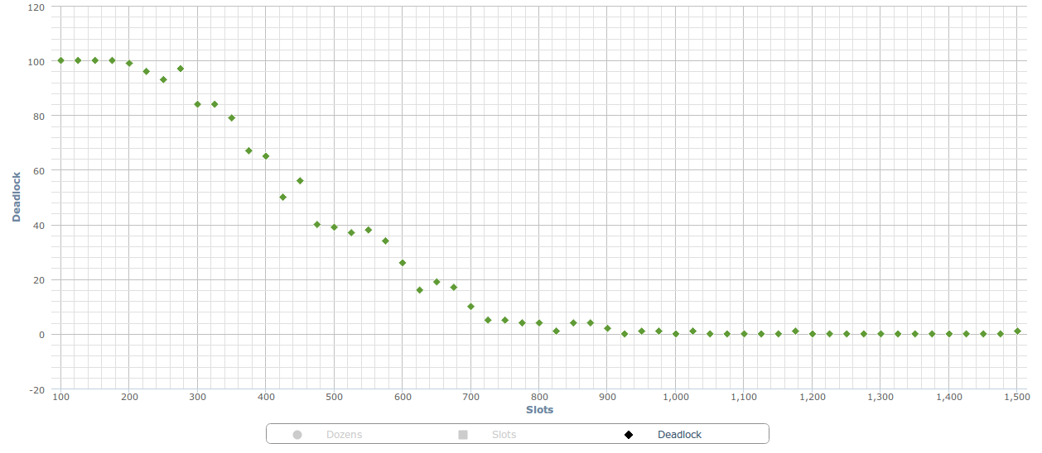

200 Dozen
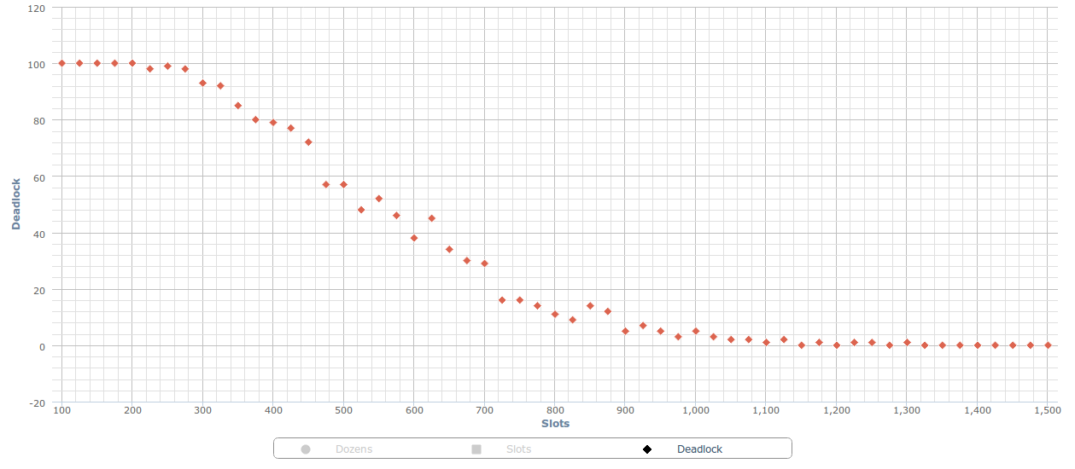

250 Dozen
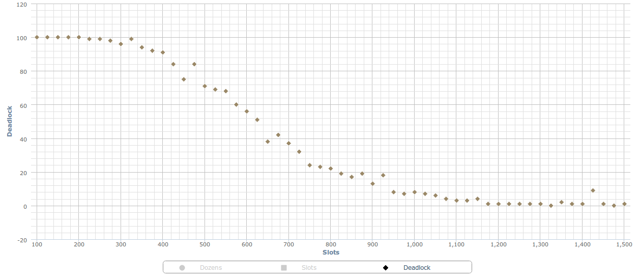

300 Dozen
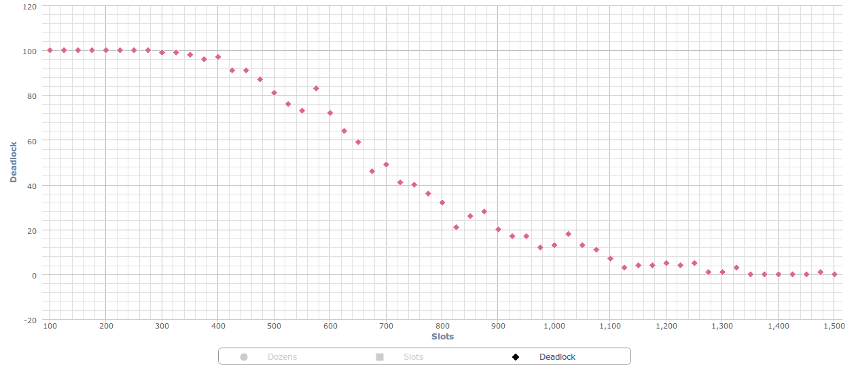

100, 150, 200, 250, 300 Dozen
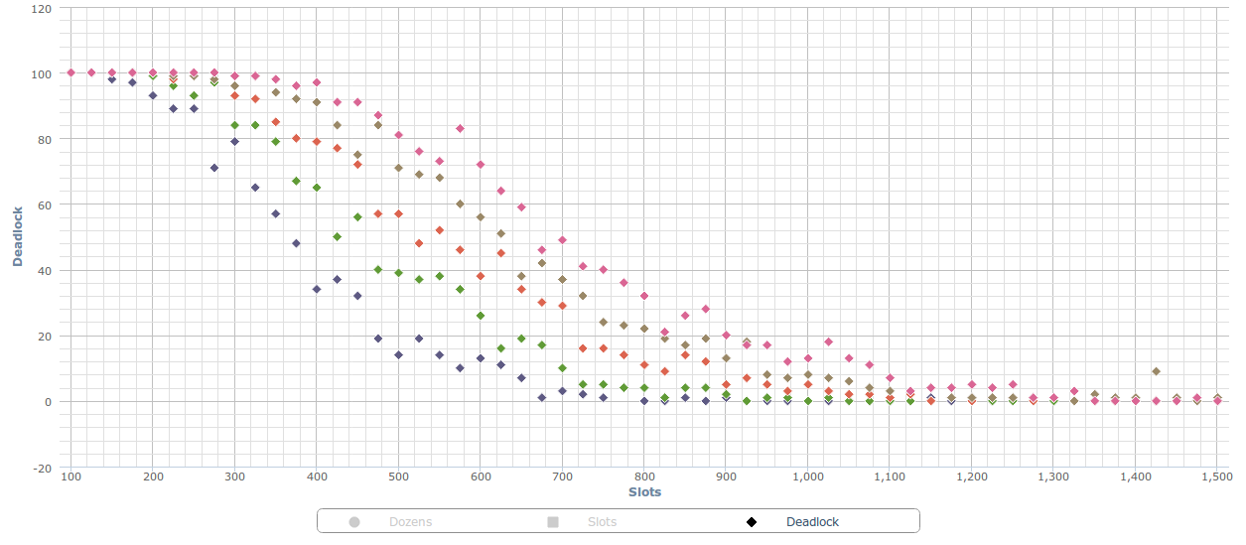

Discussion of Charts
All the tests were run with 4 types of donuts, 30 producers, and 50 consumers. The number of dozens varied as well as the slot size. The charts show deadlock percentage vs. the number of slots for five different cases of number of dozens (100, 150, 200, 250, 300). Each graph was compiled after running 100 instances of the process with 25 step intervals from 100 to 1500 for the slot size.

Each of the five chart vary slightly, but an obvious pattern emerged. There are three sections to each graph. When the slot size is small, the deadlock rate is close to 100%. Then there is a linear region, until the slot size gets sufficiently large and the deadlock rate is close to 0%.

For the 200 dozens of donut cause, the process is deadlocked until the slot size reaches 275. Then there is a linear descent, hitting 50% deadlock at a slot size of 525, and descending to 0% deadlock at 900 slots. After 900 slots, the deadlock percentage stays at 0%.

The final chart shows all the datasets together. It clearly shows a correlation between the number of dozens and the deadlock percentage. The fewer dozens, the less likely-hood of deadlock. By adding more dozens for the consumers to consume, the linear region shifts to the right.

If deadlocking were a critical issue for this application, I would suggest using a large slot size.

