**Get ready guide!**

Things you must do before the challenge, should not take you long, don’t worry we have you covered! Please read the whole document.

**Prerequisites**

Make sure you know a little about Python depending on your experience. We will be using the Flask framework, don’t worry we have you covered!

Here are some great resources so you get familiar with the framework:

<https://www.tutorialspoint.com/flask/flask_sqlalchemy.htm>

Also, we would advise you to use <https://dev.mysql.com/downloads/workbench/> which works for windows and mac. This allows you to test your queries before inserting into the code.

You need to understand about HTML and CSS a little bit.

Understand a little about SQL, if you don’t already

Things to install before the challenge:

Visual Studio Code (if you have another editor installed that is fine (do not use notepad++)

<https://code.visualstudio.com/>

Once you have downloaded this program, you need to setup your GitHub account to the program. There should be option to setup GitHub on Visual Studio Code to sign in:

<https://code.visualstudio.com/docs/editor/github>

Git (step by step guide below)

<https://git-scm.com/download/win>

<https://git-scm.com/download/mac>

Docker (step by step guide below)

<https://www.docker.com/products/docker-desktop>

Make sure you have Zoom installed and Slack account on our dedicated workspace set up!

**On the day of the event you will be given a template, which you will be given a link to the public repository from one of engineers on the Slack.**

**Don’t worry if this overwhelming for you, we will have you covered throughout the Coding Challenge.**

**Remember to join the kick-off on the 15th of October at 4pm!**

**Git installation and how to use it?**

Installing Git is pretty straight forward by following this guide:

Windows: <https://www.youtube.com/watch?v=Jge57UHvYto> (this is good tutorial, just be careful with headphones)

Mac: <https://www.youtube.com/watch?v=KLoSedTd9B0>

Or just follow this guide or find guides online:

<https://git-scm.com/book/en/v2/Getting-Started-Installing-Git/>

Remember to check your version of git with: git –version

How to use Git and clone a project from GitHub: <https://www.youtube.com/watch?v=5HLst694D_Y>

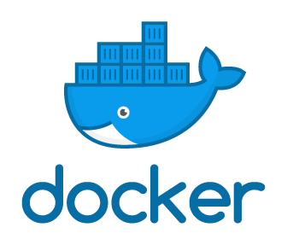**How to install Docker Desktop on Windows and on Mac**

Windows

First step – If you have Windows Home installed on your machine, please make sure you have Windows 10 version 2004 installed! Otherwise you don’t have to worry about the version with either Professional or Enterprise edition of Windows 10. Go to updates on your Windows 10 operating system and there should be a section, install latest build version 2004.

Second step – Once you have version 2004 installed (if using Windows Home), please follow this short video guide on how to set it up: <https://www.youtube.com/watch?v=B9Qi3yY2yW4> and <https://docs.docker.com/docker-for-windows/install-windows-home/> (if you try installing on Windows 10 Home without version 2004 (latest build of windows) Docker will not install)

Mac (a lot easier to install)

Just install the Docker on your Mac using this useful video: <https://www.youtube.com/watch?v=K90yOMr8wXo> and <https://docs.docker.com/docker-for-mac/install/>