

**UC2F2006IT(BIS)**

**HAND OUT DATE: 2 2020**

**HAND IN DATE: 4 2021**

**WEIGHTAGE:**

**INSTRUCTIONS TO CANDIDATES:**

**1 Submit your assignment at the administrative counter.**

**2 Students are advised to underpin their answers with the use of references (cited using the Harvard Name System of Referencing).**

**3 Late submission will be awarded zero (0) unless Extenuating Circumstances (EC) are upheld.**

**4 Cases of plagiarism will be penalized.**

**5 The assignment should be bound in an appropriate style (comb bound or stapled).**

**6 Where the assignment should be submitted in both hardcopy and softcopy, the softcopy of the written assignment and source code (where appropriate) should be on a CD in an envelope / CD cover and attached to the hardcopy.**

1. **You must obtain 50% overall to pass this module.**

Research Methodology in Computing and Technology (RMCT)

Assignment: Project Proposal

**Summary of Assignment:**

|  |  |
| --- | --- |
| **Module Code:** | CT098-3-2-RMCT |
| **Module Title:** | Research Methodology in Computing and Technology (RMCT) |
| **Module Lecturer:** | Intan Farahana Kamsin |
| **Weighting:** | Coursework weighted at 80% (report) + 20% (presentation) |
| **Assessment Title:** | Research Paper |
| **Assessment Type:** | Individual work |
| **Hand out date:** | 2nd November 2020 |
| **Submission date:** | 5th February 2021 |

Table of Contents

**1.0 Introduction** 5

**2.0 Literature Review** 6

2.1 Research Domain 6

2.1.1 Self-checkout System 6

2.1.2 RFID technology 7

2.1.3 Supermarket 7

2.1.4 Self- Checkout Service with RFID technology in Supermarket 8

2.2 Similar System 9

2.2.1 NCR SelfServ Checkout in Tesco Malaysia 9

2.2.2 Snabble 10

2.2.3 Regi-Robo™ from Panasonic using in retail shop. 10

**3.0 Problem Statement** 11

**4.0 Aim and Objectives** 12

4.1 Aim 12

4.2 Objectives 12

**5.0 Research Questions** 12

**6.0 Significance of Research** 12

**7.0 Research Methodology** 13

**8.0 Overview of the system** 14

**9.0 Conclusion** 14

**10.0 Reference** 15

List of Tables

Table 1 Comparison between NCR SelfSery, Snabble and Regi-Robo™ 10

List of Figures

Figure 1 NCR SelfServ Checkout (Samantha Khor,2015) 9

Figure 2 Snabble Application 10

Figure 3 Regi-Robo™ (Panasonic, 2017) 10

Figure 4 Use Case Diagram of the System 14

**Self- Checkout Service with RFID technology in Supermarket**

**NG XIN JIE**

Asia Pacific University of Technology & Innovation

TP055463@mail.apu.edu.my

**Abstract**

The self-checkout service system has appeared and has gradually become popular all over the world nowadays. The main purpose of the self-checkout service system is to save staff costs and speed up the customer's shopping process. However, according to a number of studies, the self-checkout service system is causing an increase in thefts, and this causes huge losses for businesses. Therefore, the purpose of this research is to apply the latest Radio Frequency Identification (RFID) technology to self-checkout services in supermarket to solve the problem of theft. For this study, it was decided to use systematic sampling and submit a survey to every fifth customer who left the supermarket until the survey results of 100 customers were collected. Using this latest RFID technology in the self-checkout system can make the supermarket without suffering additional losses. This RFID technology is implemented with the help of RFID tags and RFID readers, which are similar to the functions of general bar codes and bar code scanners on the market, but they are safer to avoid theft. In addition, this article also studies how to use RFID to help reduce the waiting time for checkout, which can scan the entire area of goods in a few seconds, which is suitable for inventory, checkout and simplifying the process. For future, RFID technology automatically identify vehicles entering and exiting without stopping the car or RFID employee attendance system, that can automatically sense attendance without touching the machine.

***Index Terms*:** Self-checkout system, Supermarket, RFID, anti-theft

# **1.0 Introduction**

With the advancement of science and technology, people's lives have become more and more hurried, and there is no time to waste, especially shopping. People definitely do not want to waste time waiting in line for checkout. Therefore, self-checkout service systems have emerged and are gradually becoming popular worldwide. The system allows consumers to complete the purchase process without the help of retailer personnel. (Elliot Brenhouse, 2010) In addition to being invented to speed up the checkout process, the self-invented checkout system can also reduce business costs. This is because customers can perform the checkout by themselves, so the cashier can take care of several counters, thereby reducing labor costs. However, recent studies have found that because merchants use a self-checkout system, the cost has not decreased but increased. In addition to intentional theft by thieves, sometimes customers usually cannot scan the products themselves, so they just take things without paying. (Kai-Thomas Krause, Ulrike Vanessa Muller, 2016)

This paper proposes an improved self-checkout system, which implements the latest RFID technology on the original system. RFID is a tracking technology. By using RFID tags to replace the original barcodes on products, in addition to allowing RFID readers to automatically scan all products in a short period of time, merchants can also track the status of products (Ravi Panja et.al, 2009), thereby minimizing loss and theft. This study describes a study of self-checkout systems in supermarkets. This article will be divided into several parts. The first is the literature review, which will conduct a wide range of reading and understanding of the literature in the research field, and conduct a comprehensive analysis and review. The research on related issues is also discussed, including a further description of the purpose and objectives of this research and the research problem. This article also discusses how to conduct the research and what improvements can be brought to the industry as a result of the research. Finally, this article also summarizes the proposed system.

# **2.0 Literature Review**

## 2.1 Research Domain

### 2.1.1 Self-checkout System

Nowadays, many retail stores and shopping malls in the world have introduced the self-checkout system. It is the system in a hardware so that customers can perform the checkout service by themselves (James Morrison & John C. Addy, 2003), this system is more efficiency than the traditional checkout stations that need to operate by workers. It includes many components that similar to traditional checkout counters, which including components for scanning, packing, and bidding customer orders. (Michael B. Persk, 2006) This invention is to reduce the time required for customers to process the purchased items and also reduce labor costs. (Michael Persky, 2004) Normally, customers can handle all the items they want to purchase by themselves. They perform barcode scanning through a scanner and screen, and then make payments. (Peter Terry Catoe, 2014) Generally, there are two payment methods for self-checkout system, either the shoppers print out the receipt at the scanning location, and takes it to the checkout clerk then completes the payment, or they can pay directly at the self-checkout station, and the customers can choose to pay in cash or pay with credit. (Michael Persky, 2004)

### 2.1.2 RFID technology

Radio Frequency Identification technology (RFID) is a new technology that uses radio waves to read and capture the information stored on the RFID tag carried by the object to identify and track the object. (Fatah Chetouane, 2015) The RFID system consists of 3 parts: (1) RFID tag, a microchip that can be embedded in physical products for storing and processing information, which contains a specific serial number (2) reader and its antenna , can receive and send signals to read the information on the RFID tag, such as serial number, location, color, date of purchase and so on. (3) Data processing system, to gather and filter all RFID tag data, then communicate with other supply chain information systems. (Springer,2010) The entire data collection process is based on the electromagnetic wave exchange between these components. RFID tags are superior to barcodes because when using a barcode system, the operator must scan items one by one, and RFID readers can automatically receive information from multiple tags at the same time (Springer,2010) , Besides, when used it for identification of objects, it also has faster response time and processing time, which has absolute advantages in many area. In many industries around the world, more and more organizations have been considering the introduction of RFID systems to Improve its business and operational processes. (SL Ting et.al, 2013) RFID can be mainly used for three purpose: asset management and tracking access control and automatic payments. (Azra Bayraktar et.al, 2010) It has obvious benefits, such as reducing costs, time, human resources and preventing theft. (Sima Ajami and Ahmad Rajabzadeh, 2013)

### 2.1.3 Supermarket

Since the 1990s, the importance of supermarkets in the world food economy has increased a lot. Now, they are not only the main buyers and sellers of food in developed countries, but also in developing countries. The term "supermarket" is used to denote a large self-service store that provides a variety of groceries, food and daily commodities classified by department. (Dr. J. Ramya, 2015) Compared with traditional grocery stores, it has a larger size and a wider range of choices. It also sells goods that are usually found in convenience stores, but compared with large supermarkets, its size Smaller, fewer types of goods to choose from (Srivastava, 2008) Supermarkets are generally run by a variety of commercial organizations, from wealthy locals to well-known multinational companies, so their global procurement network, strict quality requirements and Strong financial resources enable them to provide consumers with relatively cheap but high-quality products.( Olivia Martinez et.al, 2018)

### 2.1.4 Self- Checkout Service with RFID technology in Supermarket

The product information stored in the RFID tag can be retrieved through the RFID reader provided in the self-checkout channel without having to access the lookup table to find product information. (Michael Persky, et.al, 2004) RFID technology can identify thousands of items in a few seconds, RFID reader can capture all the relevant data of the items with RFID tags, and transmit the item information to the host system (Azra Bayraktar, et.al, 2010), this is the biggest advantage of using it in the sales industry, because if barcodes are used, all products purchased by customers must be scanned one by one. (Springer,2010) With RFID, customers no longer need to remove groceries from the shopping cart and place them on a conveyor belt to be tracked for payment. (María-Victoria Bueno-Delgado, et.al, 2011) Generally, the self-checkout system also adds a payment function to enable shoppers to pay bills using various payment methods. This is because improving security is the biggest benefit of using RFID in a self-checkout system, as it provides real-time information about product movement and sounds an alarm to the security system when an unpaid product movement is detected. In addition, some self-checkouts. (Mithu Bhattacharya, 2012) The system also uses RFID tag products to obtain and manage information about inventory levels in order to respond to customer needs in a timely manner. Because RFID technology has the ability to provide the latest information about items, it can provide accurate information about inventory levels. (Azra Bayraktar, et.al, 2010) In this way, merchants can also keep inventory levels to a minimum, which may result in lower inventory costs. (Mithu Bhattacharya, 2012) But in Malaysia, few merchants adopt self-service technology. The implementation of the self-checkout system in Malaysia is still in its infancy, now there is only two Malaysia's supermarkets that have implemented self-checkout system, one of them is Tesco IOI City, Putrajaya and another is Tesco KSL City, Johor Bahru and since the implementation of the system in Malaysia has not yet been exposed to RFID technology, the acceptance of the technology is still uncertain. (Soo-Fen Fam, et.al, 2018)

## 2.2 Similar System

### 2.2.1 NCR SelfServ Checkout in Tesco Malaysia

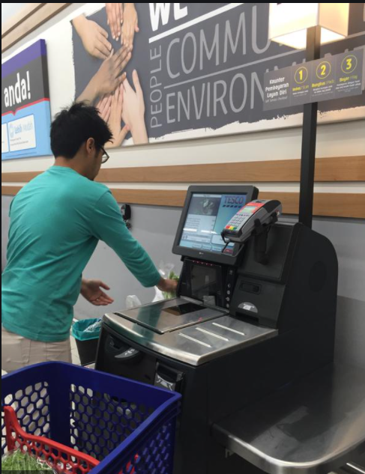

Figure 1 NCR SelfServ Checkout (Samantha Khor,2015)

NCR SelfServ Checkout is a self-service checkout system that launched by Tesco Malaysia and this technology is the first of its kind in Malaysia, which can guide customers to purchase goods by themselves by providing a touch screen throughout the process, thereby reducing queue time. (Samantha Khor, 2015) The system requires customers to scan barcodes one by one themselves, after that the system will enter the types of items such as fruits and vegetables and weigh and then customer can put all the items that already scanned by them into the "bagging area". The machine's "bagging area" sensor will confirm the weight of the previously stored information to ensure that the correct item is bagged. Only when the observed weight matches the expected weight, the customer is allowed to continue paying. If customers do not have a credit or debit card, they can still pay in cash through the banknote scanner and coin slot at the self-checkout station. NCR is currently the leading provider of self-checkouts and according to NCR’s research shows that after consuming the system, the waiting time for customers can be reduced by up to 40%. (Muhammad Raqib Aiman Bin Rosnizam et.al, 2019)

### 2.2.2 Snabble

Figure 2 Snabble Application

Snabble is a well-known Scan&Go application on the market, which is a self-checkout system based on a mobile phone application. Users only need to download the app, and no need to log in or register to use it. After customers have the app, in any participating store, they only need to open the app before putting the item in the shopping cart, click the scanner, scan the barcode of the item in front of the phone camera, and then add the item To the digital shopping cart. Then, if the retailer has supported it, customers can pay directly in the app via direct debit, credit card or PayPal. Otherwise, they can also pay directly at regular checkpoints and self-checkout terminals. (Snabble, 2020) Currently, the application has announced cooperation with an IKEA that located in Germany in 2019. (Patrick Queisler,2019)

### 2.2.3 Regi-Robo™ from Panasonic using in retail shop.

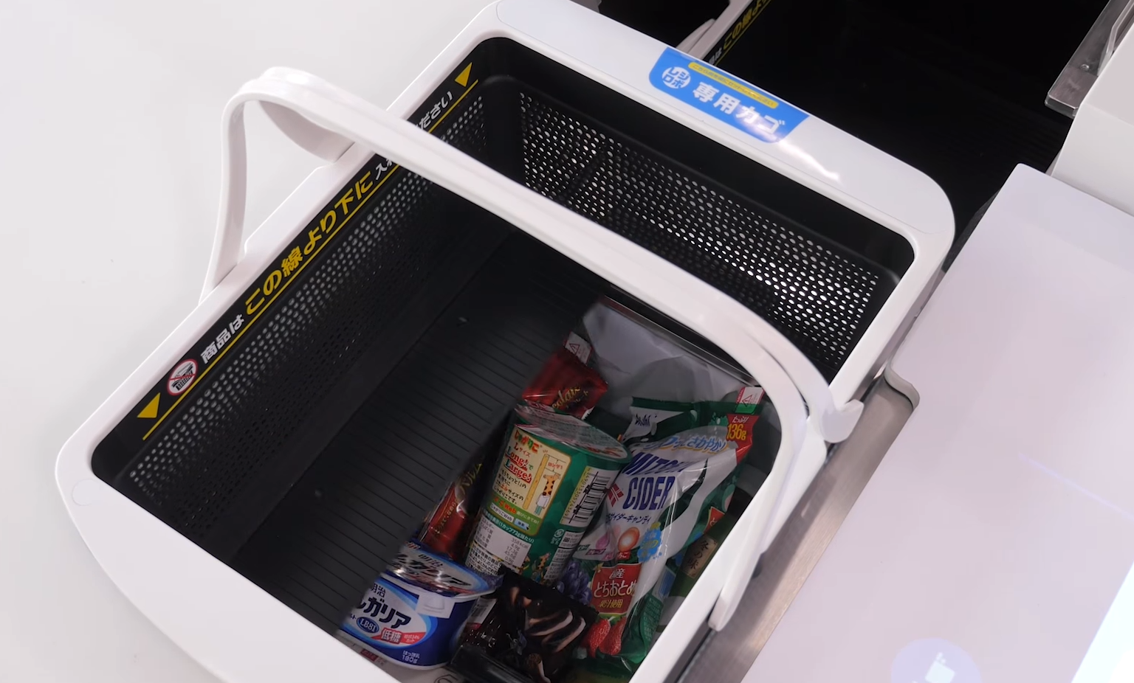

Figure 3 Regi-Robo™ (Panasonic, 2017)

Regi-Robo™ is a fully automatic checkout system that uses a special basket and RFID tags, so that customers do not need to scan the purchased items one by one before payment, achieving faster checkout. When using the Regi-Robo™ system, customers can directly pick-up items that already implement with RFID tags and put them into a shopping basket, and then walk with the shopping basket through a special checkout channel for automatic checkout. The system will automatically scan all products which having RFID tags, and then display the price and total of all items on the screen for customers to pay, thereby significantly shortening the checkout time. This also greatly reduces staff operations and saves store labor. In February 2017, Lawson and Panasonic collaborated on the first experimental demonstration of Regi-Robo(R) in Japan. (Panasonic, 2018)

Table Comparison between NCR SelfSery, Snabble and Regi-Robo™

|  |  |  |  |
| --- | --- | --- | --- |
| **Features** | **NCR SelfServ** | **Snabble** | **Regi-Robo™** |
| **Tag** | Barcode | Barcode | RFID |
| **Efficiency** | Low | Normal | High |
| **Line of sight** | Required | Required | Not Required |
| **Security Level** | Low | Low | High |
| **Mobile App** | No | Yes | No |
| **Payment Method** | Credit/ Debit card & Cash | Credit /Debit card &PayPal through Apps | Credit / Debit card & Cash & Electronic Money |
| **Suitable place** | Retails shop/ Supermarket | Retails shop / Supermarket | Retails shop |

The above table shows the key differences between 3 similar systems. The tags used by NCR SelfServ and Snabble to identify information are barcodes, while the tags used by Regi-Robo™ are RFID tags. By using RFID tag, the efficiency will be better than using Barcode. This is because the barcode scanner needs to directly aim at the barcode just can read the information of the barcode. The most troublesome thing is that customers need to scan all barcodes individually, which is time consuming. On the contrary, the RFID tag does not need to be aligned with the RFID reader and the reading speed of the RFID tag is very fast. It can read about 40 RFID tags at the same time. In addition, the use of RFID has higher security than barcodes, because if the barcode is torn or damaged, the product cannot be scanned, and its data is easy to be copied and counterfeited. However, RFID tags are covered by plastic, which is very rugged and durable, and its data can be encrypted. Among these 3 systems, only Snabble has a mobile application, which is why it is more efficient than NCR SelfServ, because although it also requires customers to scan items one by one, but this process is done when customers are shopping and it allow customer to pay directly through the program. However, if customers use NCR SelfServ, they need to scan the items one by one at the self-checkout station to make payment. At present, NCR SelfServ and Snabble have been used in retail stores and supermarkets. Instead, Regi-Robo™ needs a special shopping basket and is still under development, so it is only used by retailers. Therefore, based on this situation, shows that there is a need to develop a self-checkout system that implemented with RFID for Malaysia supermarket.

# **3.0 Problem Statement**

Merchants introduced the self-service checkout system is to reduce labor costs and speed up the customer checkout process. However, they gradually discovered that after entering the system, the annual income does not increase but decreases. (Adrian Beck, 2003) According to a study conducted by The New York Times on self-checkout kiosks in the United States, the United Kingdom, the Netherlands, and Belgium, self-checkout technology increases the possibility of shoplifting. （Business Insider Intelligence，2016）

After investigation and statistics, in addition to external theft and internal theft, daily customers (customers who usually do not steal in any other way) often embezzle during self-checkout are also the biggest reason. （Gary Mortimer & Paula Dootson，2017） This is because the self-checkout system reduces the monitoring of checkout products, which increases the possibility of theft, which in turn causes the company to pay higher fees. (Christopher Mele, 2016). Besides that, many research reports show that more and more people have been thief in the self-checkout center store consciously or unconsciously. (Katie French,2017) For example, there is a survey by VoucherCodesPro.co.uk for 2634 adults shows that 20% of people admitted that they had stolen during self-checkout, and more than half of them said that they did so because they could not scan items, so they just take things without paying. (Kai-Thomas Krause, Ulrike Vanessa Mueller, 2016)

# **4.0 Aim and Objectives**

## 4.1 Aim

This research aims to implement radio frequency identification (RFID) technology to self-checkout service systems to solve the problem of increased thefts caused by the implementation of self-checkout services in supermarket by focusing on the following specific goals.

## 4.2 Objectives

* To implement self-checkout service systems using radio frequency identification (RFID) technology in supermarket such as Walmart to improve frequent thefts.
* To identify all products by implementing RFID tags on all of the goods
* To implement RFID Reader to read the data of any items collected within its range and it will sound a warning when unpaid goods are identified

# **5.0 Research Questions**

* How can radio frequency identification (RFID) technology improve the phenomenon of frequent theft after the supermarket use the self-checkout service system?
* What are the benefits of implementing RFID tags to identify all goods?
* How the RFID reader works to collect data of the item and identify unpaid goods?

# **6.0 Significance of Research**

After the supermarket uses the self-checkout system, the problem of increased thefts has caused many unnecessary expenditures in the supermarket, which greatly harmed their interests. By using RFID technology to improve the self-checkout system, the system can scan goods faster and more accurately through RFID tags. When a customer passes through the RFID reader door, if there is something unpaid, the reader will make a sound, which will not give the thief any chance. This can significantly improve anti-theft capabilities and make payment faster than ever. Therefore, the research is valuable in term of minimizing the problem.

# **7.0 Research Methodology**

This research will use quantitative and qualitative research methods to conduct an in-depth study of the problems that caused decrease in income of merchants who use the self-checkout system. 100 customers who shop in Malaysia's supermarkets which equipped with self-checkout systems will be selected as the target of this research. The main reason for choosing this research population is that they are direct users of the system. The selection of the customer was based on the systematic sampling method that belongs to probability sampling, because this method does not need to have a list of all customers in advance (Lauren Thomas, 2020), and the exit order of customers is essentially random (Raghunath Arnab, 2017), so if continue to implement this method, can collect different type of customers' survey in different days and time periods, by this shows that it can provide a representative sample of customers.

This research will use a face-to-face survey method to collect data, because this method has a higher response rate and helps visitors get answers more accurately (James K. Doyle,2021), like screening questions, such as gender or race When the interviewee was unable to provide false information. The survey will consist of 7 questions with 5-point Likert scales and 3 open questions, it will distribute to every fifth customer who leaves a supermarket equipped with a self-checkout system. The data collection will be conducted until there are 100 customers' survey results.

After the survey results are collected, the researchers will eliminate missing data and outliers to identify any data points that may affect the accuracy of the results. Then, analyze the remaining quantitative data, generate charts, and summarize them into different descriptive statistics such as average, median, frequency, etc. (Manu Bhatia, 2018) For the qualitative data collected in the open question, we will look for basic observations or patterns, find specific words or ideas that continue to appear in the survey, and then integrate and list the response categories. In the process, we need to ensure that the data analysis and results reliability and validity, and finally look for possible and reasonable explanations of the results, and sort them out. (Nancy Gibson, 2003)

# **8.0 Overview of the system**

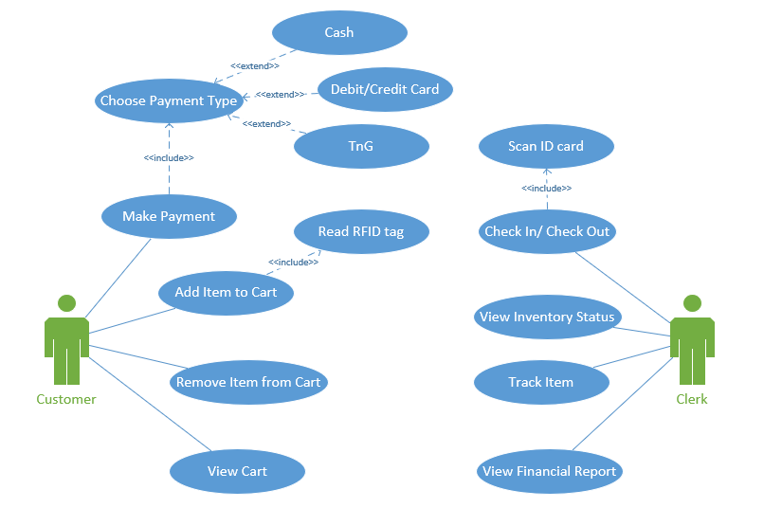

Figure 4 Use Case Diagram of the System

Figure 4 shows that the proposed system with RFID technology. According to the use case diagram, there is enough basic functions of self-service shopping in this proposed system for customer, such as viewing item lists, making payments and so on. Customers can directly take the product and put it directly into their shopping cart. At the end of their shopping, they just need to place the shopping cart in a specific area of ​​the RFID reader, the system will directly read the information on all RFID tags inside and display it on a screen. Then the customer needs to make the payment in this specific area before they can walk out from the supermarket, otherwise if the RFID reader detects an unpaid item, an alarm will sound. For merchants, when the alarm sounds, the RFID tag on the unpaid item will immediately locate them to know the specific location of that item. Merchants can also use the system to check inventory information at any time through the RFID tag on the item to help prevent internal theft. In addition, they can use the system view daily financial reports and to check in or check out by using their employee ID cards.

# **9.0 Conclusion**

This paper proposes the combination of self-checkout system and RFID technology so that it can be used in supermarkets to solve the problem of increased theft rate of supermarket after using the self-checkout system. Through RFID, it can not only scan all items quickly and accurately, but also support merchants to track the location of inventory and items. Once a theft occurs, it is also easy to track the real-time location of the object. With the further popularization of RFID, it can also be used in supermarket parking systems and attendance systems. For example, RFID technology can be used to automatically identify incoming and outgoing vehicles without stopping the car or RFID employee attendance system, which can automatically sense attendance without touching the machine. By this, can improve the efficiency and use of the mall

# **10.0 Reference**

Adrian Beck (2003) *Self-Checkout In Retail: Measuring the Lo*ss [Online] Available at: <https://www.researchgate.net/publication/330214157_SELF-CHECKOUT_IN_RETAIL_MEASURING_THE_LOSS> [Accessed 18 January 2021].

Azra Bayraktar, Erdal Yılmaz and Şakir Erdem (2011) *Using RFID Technology for Simplification of Retail Processes* [Online] Available at: <https://www.intechopen.com/books/designing-and-deploying-rfid-applications/using-rfid-technology-for-simplification-of-retail-processes> [Accessed 17 January 2021].

Business Insider Intelligence (2016) *Theft is erasing some of self-checkout's benefits* [online] Available at: <https://www.businessinsider.com/theft-is-erasing-some-of-self-checkouts-benefits-2016-8> [Accessed 22 December 2020].

Christopher Mele (2016) *Self-Service Checkouts Can Turn Customers Into Shoplifters, Study Says* [Online] Available at: <https://www.nytimes.com/2016/08/11/business/self-service-checkouts-can-turn-customers-into-shoplifters-study-says.html?searchResultPosition=3> [Accessed 23 December 2020].

Dr. J. Ramya (2015) *Customer experience in supermarkets and hypermarkets – A comparative study* [Online] Volume 17, PP 116-123. Available at: <http://www.iosrjournals.org/iosr-jbm/papers/Vol17-issue12/Version-2/P017122116123.pdf> [Accessed 9 January 2021].

Elliot Brenhouse. (2010) *Self-checkout system with anti-theft deactivation device* [online] Available at: <https://patentimages.storage.googleapis.com/b2/4a/ff/87b0be46c47e91/US7672871.pdf> [Accessed 22 December 2020].

Fatah Chetouane,(2015) *An Overview on RFID Technology Instruction and Application* [Online] pp.382–387 Available at: <file:///C:/Users/user/Downloads/1-s2.0-S240589631500350X-main.pdf> [Accessed 30 December 2020].

Gary Mortimer & Paula Dootson (2017) *The economics of self-service checkouts* [online] Available at: <https://theconversation.com/the-economics-of-self-service-checkouts-78593> [Accessed 22 December 2020].

James K. Doyle (2021) *Face-to-Face Surveys* [Online] Available at: <https://web.wpi.edu/Images/CMS/SSPS/Doyle_-_Face-to-Face_Surveys.pdf> [Accessed 15 January 2021].

James Morrison, John C. Addy (2003) *Self-service checkout terminal having a biometric sensing device for verifying identity of a user and associated method* [Online] vol. 35, 1A, pp. 315–318. Available at: <https://patentimages.storage.googleapis.com/65/4e/5d/1f000cde9cb13d/US6522772.pdf> [Accessed 1 January 2020].

Jia Wen Siah, Soo-Fen Fam (2017) *Reuse Intention of Self-checkout Service Quality in Malaysia Hypermarket* [online] pp. 485-495. Available at: <https://theconversation.com/the-economics-of-self-service-checkouts-78593> [Accessed 22 December 2020].

J.W.Siah, S.F.Fam, D.D.Prastyo, H.Yanto, K.S. Fam (2018) *Service Quality of Self-Checkout Technology in Malaysian Hypermarket: A Case Study in Johor* [Online] Vol. 10 No. 2-8. Available at: <https://www.academia.edu/37208828/Service_Quality_of_Self_Checkout_Technology_in_Malaysian_Hypermarket_A_Case_Study_in_Johor?email_work_card=view-paper> [Accessed 23 December 2020].

Kai-Thomas Krause, Ulrike Vanessa Mueller (2016) *System and Method for Mobile Device Self-Checkout for Retail Transactions with Loss Protection* [Online] Available at: <https://patentimages.storage.googleapis.com/63/7a/06/7185b231077690/US20170046707A1.pdf> [Accessed 15 January 2021].

Katie French (2017) *Shoppers steal £3.2billion from self-service tills every year with nearly a quarter of Britons admitting to taking at least one item without paying for it* [Online] Available at: <https://www.dailymail.co.uk/news/article-5215073/Shoppers-steal-3-2bn-self-service-tills-year.html> [Accessed 24 December 2020].

Lauren Thomas (2020) *How to perform systematic sampling* [Online] Available at: <https://www.scribbr.com/methodology/systematic-sampling/> [Accessed 15 January 2021].

María-Victoria Bueno‐Delgado, Francesc Burrull and Pablo Pavón‐ Mariño (2011) *Case Study: Installing RFID Systems in Supermarkets* [Online] Available at: <https://www.intechopen.com/books/radio-frequency-identification/case-study-installing-rfid-systems-in-supermarkets> [Accessed 17 January 2021].

Manu Bhatia (2018) *Your Guide to Qualitative and Quantitative Data Analysis Methods* [Online] Available at: <https://humansofdata.atlan.com/2018/09/qualitative-quantitative-data-analysis-methods/> [Accessed 15 January 2021].

Mithu Bhattacharya (2012) *Impact of RFID on the Retail Value Chain: An Exploratory Study Using a Mixed Method Approach* [Online] pp. 36-49. Available at: <https://www.researchgate.net/publication/262664252_Impact_of_RFID_on_the_Retail_Value_Chain_An_Exploratory_Study_Using_a_Mixed_Method_Approach> [Accessed 18 January 2021].

Michael Persky (2006) *Self-checkout system* [Online] Available at: <https://patentimages.storage.googleapis.com/23/43/ad/77feec6d40368f/US7229015.pdf> [Accessed 2 January 2020].

Michael B.Persky (2004) *Multiple Self-checkout system having integrated payment device* [Online] Available at: <https://patentimages.storage.googleapis.com/0a/0d/c0/e4610a2da9f5ea/US7048184.pdf> [Accessed 28 December 2020].

Muhammad Raqib Aiman Bin Rosnizam, Daisy Mui Hung Kee, Muhammad Ekmal Haikal Bin Mohammad Akhir, Misha Shahqira, Muhammad Amril Hanif, Bin Mohd Yusoff, Roland Satrya Budiman, Aisha Mohammad Alajmi (2019) *Market Opportunities and Challenges: A Case Study of*

*Tesco* [Online] Available at: <http://ejournal.aibpm.org/index.php/JCDA/article/viewFile/807/772> [Accessed 9 January 2021].

Nancy Gibson (2003) *A Step-By-Step Guide To Qualitative Data Analysis* [Online] Available at: <https://www.researchgate.net/publication/292432218_A_Step-By-Step_Guide_To_Qualitative_Data_Analysis> [Accessed 15 January 2021].

Olivia Martinez, Noemi Rodriguez, Allison Mercurio, Marie Bragg & Brian Elbel (2018) *Supermarket retailers’ perspectives on healthy food retail strategies: in-depth interviews* [Online] Available at: <https://bmcpublichealth.biomedcentral.com/articles/10.1186/s12889-018-5917-4#citeas> [Accessed 8 January 2021].

Panasonic (2018) *RFID Based Walk-through Checkout Solution for Future Retail* [Online] Available at: <https://news.panasonic.com/global/topics/2018/55288.html> [Accessed 13 January 2021].

Patrick Queisler (2019) *IKEA To Offer Mobile Self-Scanning And Self-Checkout With Snabble* [Online] Available at: <https://snabble.io/blog/press-releases/ikea-mobile-self-scanning-smartphone-snabble> [Accessed 14 January 2021].

Peter Terry Catoe (2014) *Automated self-checkout system* [Online] Available at: <https://www.researchgate.net/publication/302773613_Automated_self-checkout_system> [Accessed 28 December 2020].

Samantha Khor (2015) *Tesco Introduced Self-Checkout Machines In One Of Its Stores & We Can't Wait To Try It Out* [Online] Available at: <https://says.com/my/news/unexpected-item-in-the-bagging-area> [Accessed 9 January 2021].

Sima Ajami and Ahmad Rajabzadeh (2013) *Radio Frequency Identification (RFID) technology and patient safety* [Online] pp. 809–813. Available at: <https://www.ncbi.nlm.nih.gov/pmc/articles/PMC3872592/> [Accessed 30 December 2020].

S. L. Ting, Albert H. C. Tsang, Y. K. Tse (2013) *A Framework for the Implementation of RFID Systems* [Online] Available at: <https://journals.sagepub.com/doi/10.5772/56511> [Accessed 2 January 2021].

Snabble (2020) *Scan, Pay, Done –* *With Snabble* [Online] Available at: <https://snabble.io/> [Accessed 14 January 2021].

Springer (2010) *Radio-frequency Identification (RFID): Technology and Applications*. [Online] pp 163-194. Available at: <https://link.springer.com/chapter/10.1007/978-1-84996-017-5_5#citeas> [Accessed 7 January 2021].

Raghunath Arnab (2017) *Systematic Sampling* [Online] Available at: <https://www.sciencedirect.com/topics/mathematics/systematic-sampling> [Accessed 15 January 2021].

Ravi Panja, Ashish Chona, Ye Zhou, Leif Chastaine (2009) *Dynamic product tracking system using RFID* [Online] Available at: <https://patentimages.storage.googleapis.com/c0/ed/33/b28baa01c70d1b/US7518511.pdf> [Accessed 13 January 2021].

R.K. Srivastava (2008) *Changing retail scene in India, International Journal of Retail & Distribution Management* [online] Vol. 36 No. 9, 2008 pp. 714-721. Available at: <https://www.researchgate.net/publication/241699675_Changing_retail_scene_in_India> [Accessed 12 January 2020].