SOCIAL MEDIA USAGE ANALYSIS SYSTEM
Mini Project Report
Student Name: ______________________________
Roll Number: ________________________________
Course / Semester: __________________________
Institution: _________________________________
Submission Date: ____________________________

1. Abstract
The Social Media Usage Analysis System is a Python-based mini project designed to summarize and visualize social-media usage patterns in a structured dataset. It uses Pandas to load and validate CSV data, calculate descriptive statistics, compare platform-level usage, and examine correlations between daily usage, sleep hours, and study hours. Matplotlib generates charts for easier interpretation. The included dataset contains 30 synthetic records created for demonstration and is not real survey evidence. The project illustrates a reproducible data analysis workflow and avoids making causal claims from correlations.

2. Project Design/Implementation

2.1 Problem Statement
Social-media usage datasets can contain several variables that are difficult to compare manually. This project provides a simple workflow to validate records, calculate summaries, compare platforms, and visualize patterns.

2.2 Objectives
- Load social-media usage records from a CSV file.
- Validate required columns and remove duplicate, incomplete, or invalid records.
- Calculate average daily usage, sleep duration, and study time.
- Compare average usage across platforms.
- Calculate descriptive correlations between usage, sleep, and study hours.
- Generate visualizations and usage-category counts.

2.3 Tools and Technologies
Python, Pandas, Matplotlib, CSV, and a command-line interface.

2.4 System Workflow
CSV dataset → data validation and cleaning → descriptive analysis → correlation analysis → charts and console output.

2.5 Dataset
The demonstration dataset contains 30 synthetic records with fields for age, platform, daily usage hours, sessions per day, notifications per day, sleep hours, study hours, and primary purpose. The data is synthetic and must not be described as a real survey.

2.6 Implementation
The program checks for required columns, removes duplicates and rows with missing required fields, applies basic range checks to numeric values, calculates grouped summaries and Pearson correlations, and saves three chart images in the outputs folder.

2.7 Sample Findings
- Records analyzed: 30
- Average daily usage: 3.37 hours
- Average sleep: 7.01 hours
- Average study time: 5.17 hours
- Most frequently recorded platform: Instagram
- Platform with highest average daily usage: Snapchat (4.93 hours)
- Correlation of usage with sleep: -0.96
- Correlation of usage with study time: -0.96
These values are computed from the included synthetic sample only. Correlation does not prove causation, and the sample is too small and artificial to support claims about a wider population.

3. Python Code
The complete executable code is provided in main.py in the accompanying project folder/repository. The code below is the main program.
"""
Social Media Usage Analysis System
Academic demonstration using a synthetic sample dataset.
Run: python main.py
Dependencies: pandas, matplotlib
"""
from pathlib import Path
import pandas as pd
import matplotlib.pyplot as plt

BASE_DIR = Path(__file__).resolve().parent
DATA_PATH = BASE_DIR / "data" / "social_media_usage_sample.csv"
OUTPUT_DIR = BASE_DIR / "outputs"
OUTPUT_DIR.mkdir(exist_ok=True)

REQUIRED_COLUMNS = [
"user_id", "age", "platform", "daily_usage_hours", "sessions_per_day",
"notifications_per_day", "sleep_hours", "study_hours", "primary_purpose"
]

def load_and_validate_data(path):
"""Load CSV, check required columns, remove duplicates, and handle missing rows."""
data = pd.read_csv(path)
missing_columns = [column for column in REQUIRED_COLUMNS if column not in data.columns]
if missing_columns:
raise ValueError(f"Dataset is missing required columns: {missing_columns}")

initial_rows = len(data)
data = data.drop_duplicates()
data = data.dropna(subset=REQUIRED_COLUMNS)
data = data[
data["age"].between(10, 100)
& data["daily_usage_hours"].between(0, 24)
& data["sleep_hours"].between(0, 24)
& data["study_hours"].between(0, 24)
& data["sessions_per_day"].ge(0)
& data["notifications_per_day"].ge(0)
].copy()
print(f"Rows loaded: {initial_rows}")
print(f"Rows after validation: {len(data)}")
print(f"Rows removed during validation: {initial_rows - len(data)}")
return data

def analyze_data(data):
"""Print summary statistics, platform comparisons, and correlations."""
print("\n=== SOCIAL MEDIA USAGE ANALYSIS ===")
print(f"Number of records: {len(data)}")
print(f"Average daily usage: {data['daily_usage_hours'].mean():.2f} hours")
print(f"Average sleep: {data['sleep_hours'].mean():.2f} hours")
print(f"Average study time: {data['study_hours'].mean():.2f} hours")
print(f"Most frequently recorded platform: {data['platform'].mode().iat[0]}")
platform_means = data.groupby("platform")["daily_usage_hours"].mean().sort_values(ascending=False)
print("\nAverage daily usage by platform:")
print(platform_means.round(2).to_string())
print("\nCorrelation with daily usage (descriptive only):")
print(f"Usage vs sleep: {data['daily_usage_hours'].corr(data['sleep_hours']):.3f}")
print(f"Usage vs study: {data['daily_usage_hours'].corr(data['study_hours']):.3f}")

bins = [-0.01, 2, 4, 6, 24]
labels = ["Light (≤2h)", "Moderate (>2–4h)", "High (>4–6h)", "Very high (>6h)"]
data["usage_category"] = pd.cut(data["daily_usage_hours"], bins=bins, labels=labels)
print("\nRecords by usage category:")
print(data["usage_category"].value_counts().reindex(labels, fill_value=0).to_string())
return platform_means

def create_visualizations(data):
"""Create chart images for the report and case study."""
platform_means = data.groupby("platform")["daily_usage_hours"].mean().sort_values(ascending=False)

ax = platform_means.plot(kind="bar", figsize=(8, 5), title="Average Daily Social Media Usage by Platform")
ax.set_xlabel("Platform")
ax.set_ylabel("Average daily usage (hours)")
plt.tight_layout()
plt.savefig(OUTPUT_DIR / "average_usage_by_platform.png", dpi=160)
plt.close()

plt.figure(figsize=(8, 5))
plt.scatter(data["daily_usage_hours"], data["sleep_hours"])
plt.title("Daily Social Media Usage vs Sleep Hours")
plt.xlabel("Daily usage (hours)")
plt.ylabel("Sleep (hours)")
plt.tight_layout()
plt.savefig(OUTPUT_DIR / "usage_vs_sleep.png", dpi=160)
plt.close()

ax = data["platform"].value_counts().plot(kind="bar", figsize=(8, 5), title="Number of Records by Platform")
ax.set_xlabel("Platform")
ax.set_ylabel("Number of records")
plt.tight_layout()
plt.savefig(OUTPUT_DIR / "platform_counts.png", dpi=160)
plt.close()
print(f"\nCharts saved in: {OUTPUT_DIR}")

def main():
data = load_and_validate_data(DATA_PATH)
analyze_data(data)
create_visualizations(data)
print("\nAnalysis completed successfully.")

if __name__ == "__main__":
main()

4. Output/Screenshots
Sample console output from the included dataset:
Rows loaded: 30
Rows after validation: 30
Rows removed during validation: 0

=== SOCIAL MEDIA USAGE ANALYSIS ===
Number of records: 30
Average daily usage: 3.37 hours
Average sleep: 7.01 hours
Average study time: 5.17 hours
Most frequently recorded platform: Instagram

Average daily usage by platform:
Snapchat 4.93
Instagram 4.76
YouTube 3.24
WhatsApp 2.32
Facebook 2.20
LinkedIn 1.37

Correlation with daily usage (descriptive only):
Usage vs sleep: -0.964
Usage vs study: -0.960

Analysis completed successfully.
Figure 1. Average daily social-media usage by platform.
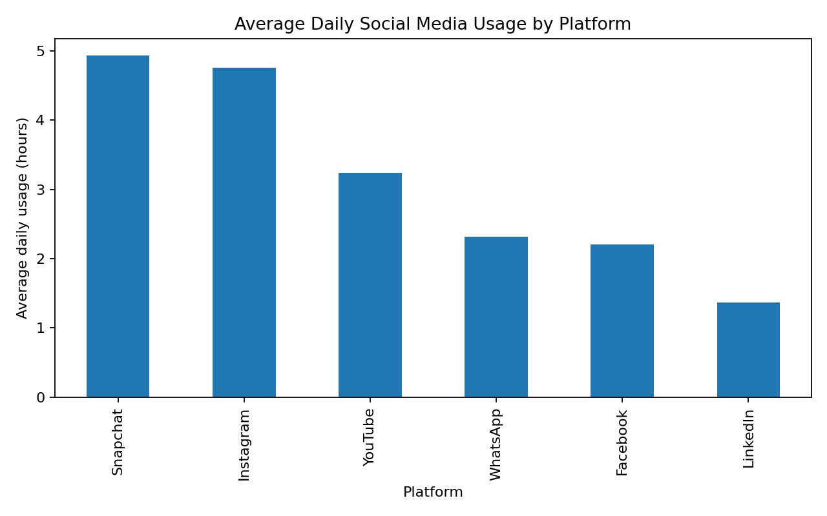
Figure 2. Daily usage compared with sleep hours.
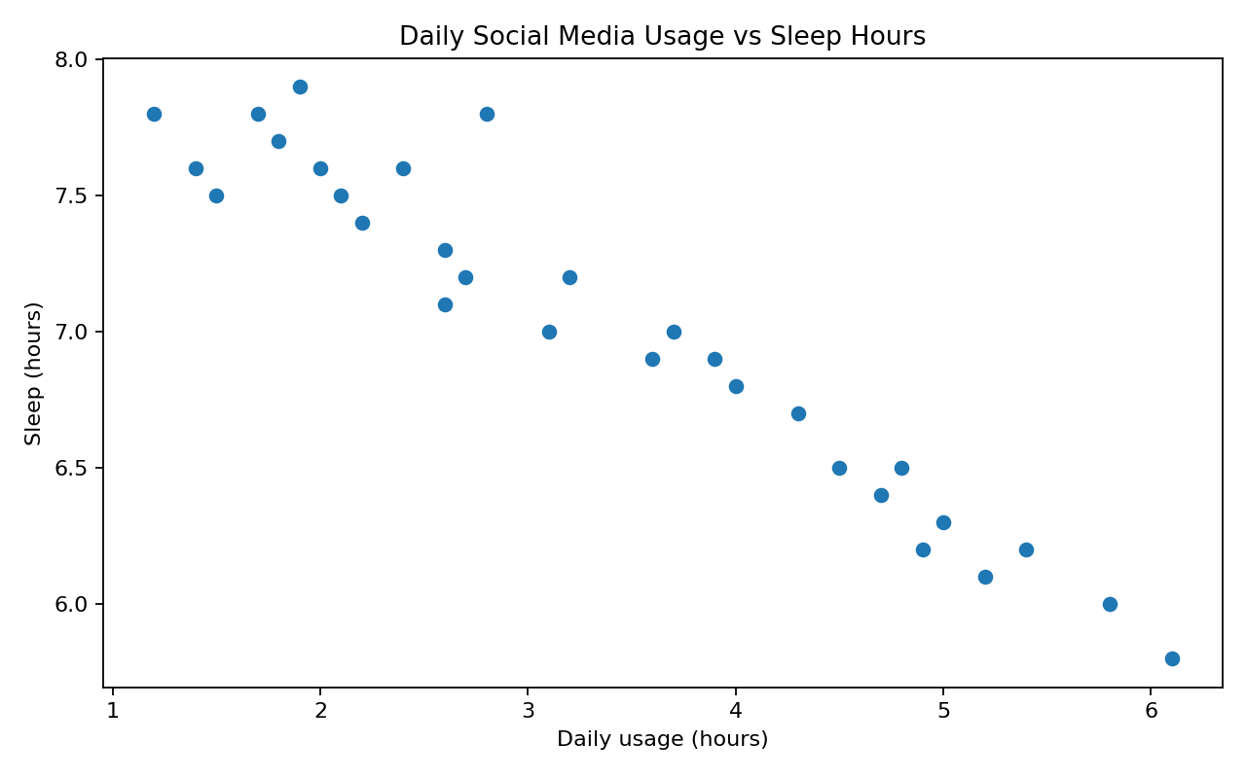
Figure 3. Number of sample records by platform.
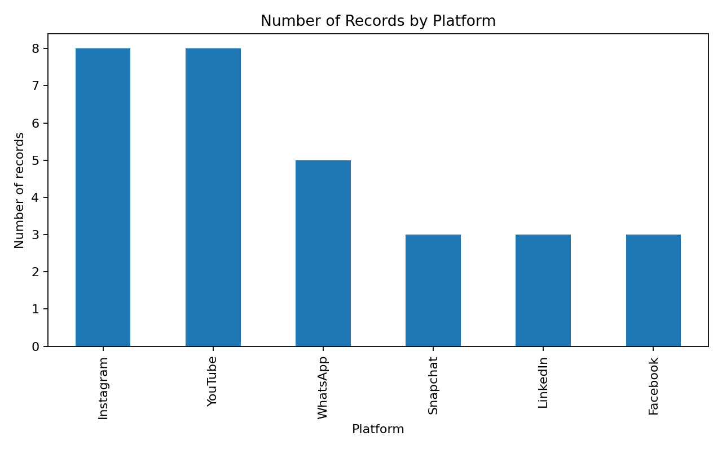

5. GitHub Repository Link
Paste the final repository URL here after uploading the project to GitHub:
https://github.com/YOUR-USERNAME/social-media-usage-analysis-system
Before submission, replace the placeholder URL with the real repository link and verify that the repository is accessible.

