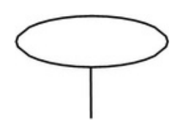

|  |  |  |  |  |
| --- | --- | --- | --- | --- |
| SCSR2043 OPERATING SYSTEMS  (June 2024)  [ Marks] | | |  | | --- | | Marks | | |
| Name  Student ID Section | Aland Fryad  qiu23-0457  OS |
| Instruction : Please answer all of the following questions. Whenever the | | 🖑 | symbol |

appears, please raise your hand to call your instructor, he/she will verify your results by putting his / her initial next to the symbol.

|  |  |  |
| --- | --- | --- |
| 1. | Type the following commands using a text editor and save it as a | yourname .sh |

(Example: ahmad.sh).

|  |  |  |  |
| --- | --- | --- | --- |
| |  | | --- | | echo “Hello world” > helloworld.jar  mkdir cars; mkdir dates; mkdir fruits drinks  cd cars; echo “Honda Accord” > accord.c  cp accord.c civic.c; echo proton > proton.c; cd ../dates; date > dateoftheday  cat dateoftheday > appointment  cd ../fruits; echo apple > apple.txt; cat apple.txt > orange.txt  cd drinks; cp ../cars/*.* .; cp ../fruits/*.* .;  cp ../*.jar . | | |  | | --- | | 🖑 | |

a) Execute the script and draw a tree structure that contains created directories and files. The parent node of the directory begin with $HOME directory.

[4 marks]

|  |
| --- |
| $HOME |

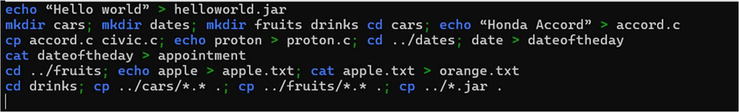

|  |  |  |
| --- | --- | --- |
|  | |  | | --- | | 🖑 | |

b) Write an interactive bash script that will read a type of file extension, display all those files, and count the number of files. To validate your script, display c program files, and enter “c” as the input to the bash script. [4 marks] 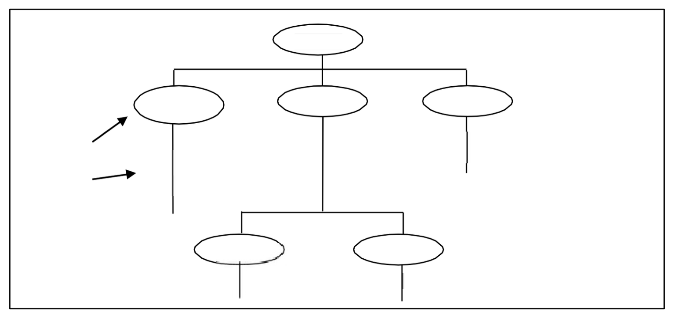

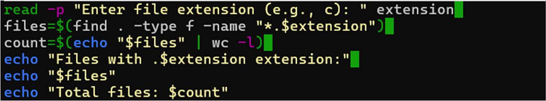

|  |  |  |
| --- | --- | --- |
| 2. The following Figure 1 illustrates a tree structure of some directories and files. | |  | | --- | | 🖑 | |
|  | |

|  |  |  |  |  |  |
| --- | --- | --- | --- | --- | --- |
| Directory | $HOME | | FBE | |  | | --- | | books | |
| subjects | faculties |
| -operating_systems -software_engineering-data_communication | | -Linux_operating_systems |
| -Best_of_software_engineering |
| Text Files |
| FCS | | - Project_Manager |
| -dean | |
| -deputy_dean | |

Figure 1 

a) Write a bash script (called myname2a.sh) that will produce directories and

files as in Figure 1. Each text files contain its filename without the underscore

|  |  |  |
| --- | --- | --- |
| character. For example: text file Project_Manager contains | Project |  |
| Manager). | [4 marks] |
| |  | | --- | |  | | |
| |  | | --- | | 🖑 | |

b) Complete the following table by writing the access control of directories or

files that were produced. Given is the access control for directory called

|  |  |  |  |
| --- | --- | --- | --- |
| book. |  | [2 marks] |  |
| Directory/File | drwxr-xr-x | Access Control | |  | | --- | | 🖑 | |
| books | drwxrwxr-x |
| subjects |
| Best_of_software_engineering | -rw-r--r-- |
| FCS | drwxr-xr-x |
| project_manager | -rw-r--r-- |

c) Write another bash script (called myname2c.sh) that will change the access

control of the directories and files based on the following information:

[4 marks]

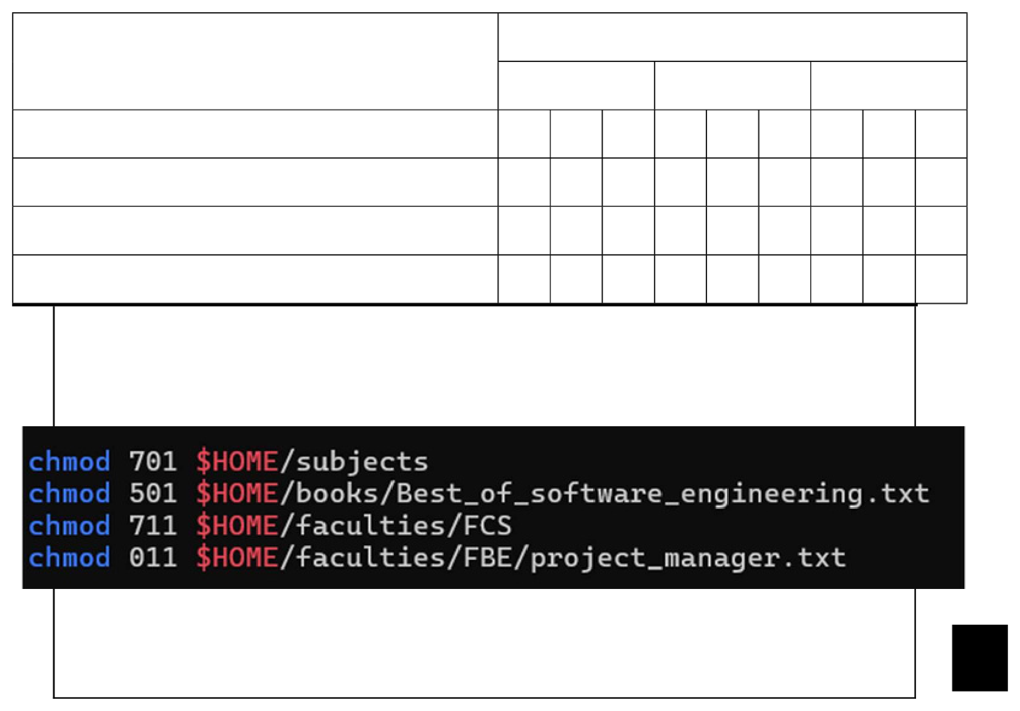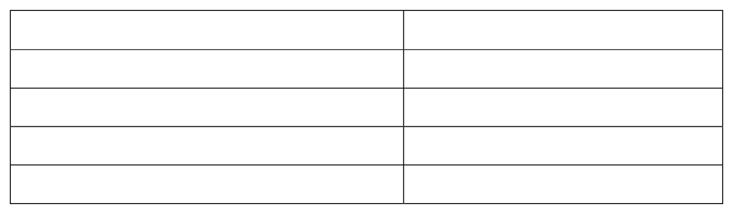

|  |  |  |  |  |  |  |  |  |  |
| --- | --- | --- | --- | --- | --- | --- | --- | --- | --- |
| Directory/File | ✓ | Owner | ✓ | ✓ | Users | x | ✓ | Public | x |
| Group |
| subjects | ✓ | x | x |
| ✓ | x | ✓ | x | ✓ | x | x | x | x |
| Best_of_software_engineering |
| ✓ | ✓ | x | x | x | x | ✓ | ✓ | ✓ |
| FCS |
| x | x | x | x | ✓ | ✓ | x | x | ✓ |
| project_manager |

|  |
| --- |
| 🖑 |

d) Complete the following table by writing the access control for each directory

|  |  |  |
| --- | --- | --- |
| or file after executing the bash script in question 2(c)). | | [2 marks] |
| |  | | --- | | Directory/File | | Access Control | |
| subjects | drwx-----x | |
| Best_of_software_engineering | -r-x-----x | |
| FCS | drwx--x--x | |
| project_manager | ------x--x | |

End of Lab 3

*** All the Best for Final Exam ***