**JavaScript**

**Introduce**

Utilize in sites and servers

Utilize in make mobile apps, program robots and create a VR game.

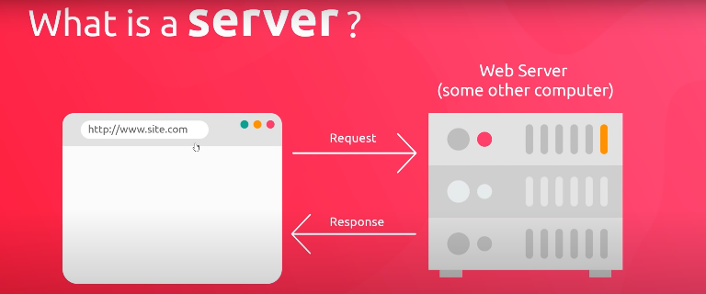What is server?

**Syntax Basics & Types**

alert ('to generate an alert');

Right way link to an external page in JavaScript!

<script src="sandbox.js" ></script> to link an external file

In js ; limited line of code

console.log (); stores information in the browser console

**Variables**:

data stored in the computer's memory.

create variables let or var example: let age = 27;

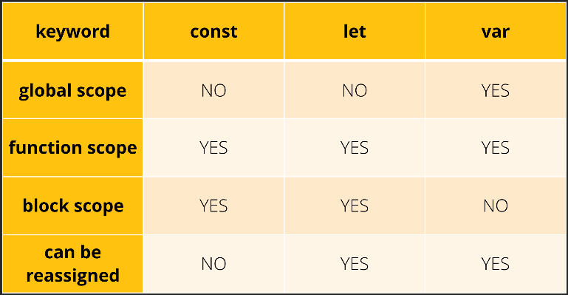const creates a variable whose value is fixed, that is, a read-only constant. This does not mean that the value is immutable, only that the constant variable cannot be changed or returned.

When we want to use two words in a variable, we use CamelCase example let myAge = 25;

To insert comments in JS, use // comment

For comments on multiple lines, use / * at the beginning and * /

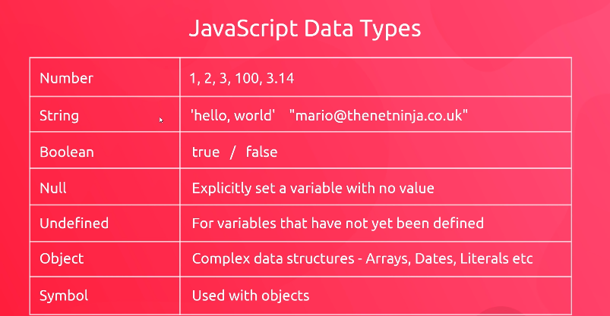**Data Types**

Concatenation junction of two words

**// getting individual characters**

console.log(fullName[3]);

**// string length**

console.log(fullName.length);

.toUpperCase to capitalize

.toLowerCase to tiny

(); indicates a method

**// Find the argument**

let index = email.indexOf('@');

console.log('index of the @ sign:', index);

lastIndexOf () **finds the last character**

**Slice()** method cuts a fraction of the string

**substr** works similar to the slice with the differences between: If start> stop, then substring will change these 2 arguments, If NaN any of the arguments is negative or is, it will be treated as if it were 0.

The function of the **replace('', '')** method is to replace one character with another