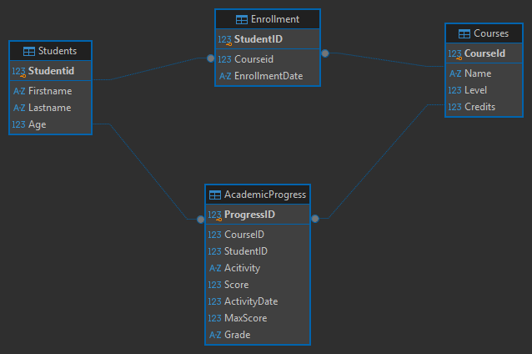
ENTITIES:
Students-contains the students
Courses-contains the courses offered
Enrollment-contains student enroll in courses
AcademicProgress-contains student progress in enrolled courses

