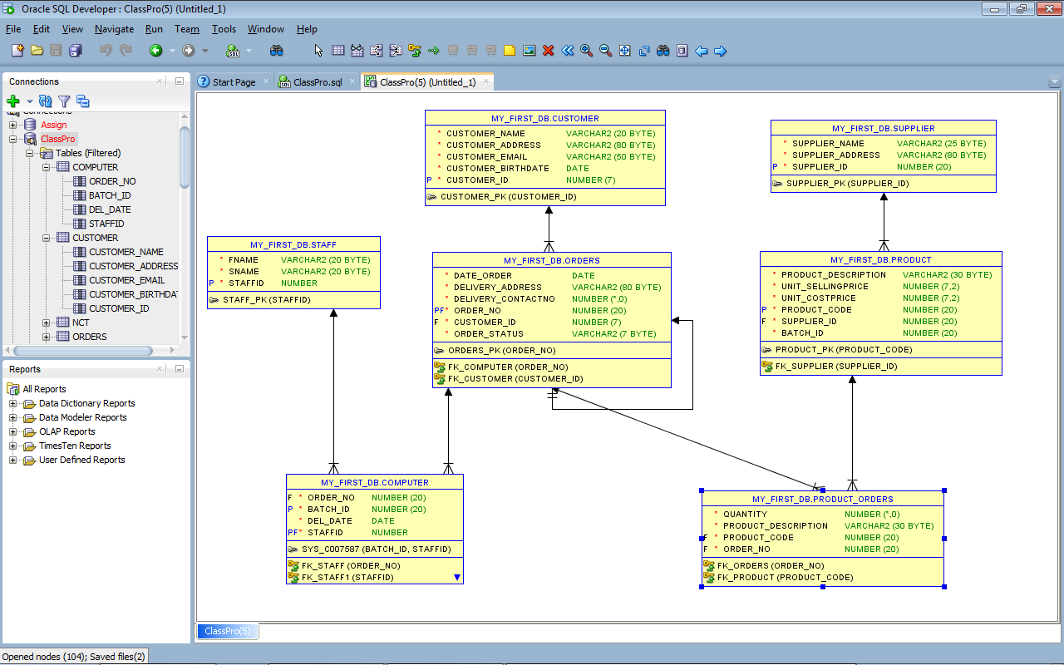CREATE TABLE CUSTOMER

(

Customer_Name VARCHAR2(20) NOT NULL ,

Customer_Address VARCHAR2(80) NOT NULL ,

Customer_Email VARCHAR2(50) NOT NULL ,

Customer_BirthDate DATE NOT NULL ,

Customer_ID NUMBER(7) NOT NULL PRIMARY KEY

);

CREATE TABLE ORDERS

(

Date_Order DATE NOT NULL ,

Delivery_Address VARCHAR2(80) NOT NULL ,

Delivery_ContactNo INTEGER NOT NULL ,

Order_No NUMBER(20) NOT NULL PRIMARY KEY,

Customer_ID NUMBER(7) NOT NULL,

order_status VARCHAR2(7) NOT NULL

);

ALTER TABLE ORDERS

ADD CONSTRAINT fk_customer

FOREIGN KEY(Customer_ID)

REFERENCES CUSTOMER(Customer_ID);

CREATE TABLE PRODUCT

(

Product_Description VARCHAR2(30) NOT NULL ,

Unit_SellingPrice NUMBER(7,2) NOT NULL ,

Unit_CostPrice NUMBER(7,2) NOT NULL ,

Product_Code NUMBER(20) NOT NULL PRIMARY KEY,

Supplier_ID NUMBER(20) NOT NULL,

Batch_ID NUMBER(20) NOT NULL

);

ALTER TABLE Product

ADD CONSTRAINT fk_SUPPLIER

FOREIGN KEY (Supplier_ID)

REFERENCES SUPPLIER(Supplier_ID);

CREATE TABLE PRODUCT_ORDERS

(

Quantity INTEGER NOT NULL ,

Product_Description VARCHAR2(30) NOT NULL ,

Product_Code NUMBER(20) NOT NULL,

Order_No NUMBER(20) NOT NULL

);

ALTER TABLE PRODUCT_ORDERS

ADD CONSTRAINT fk_product

FOREIGN KEY(Product_Code)

REFERENCES Product(Product_Code);

CREATE TABLE SUPPLIER

(

Supplier_Name VARCHAR2(25) NOT NULL ,

Supplier_Address VARCHAR2(80) NOT NULL ,

Supplier_ID NUMBER(20) NOT NULL PRIMARY KEY

);

CREATE TABLE Computer

(

order_no NUMBER(20) NOT NULL,

batch_id NUMBER(20) NOT NULL PRIMARY KEY,

del_date date not null

);

ALTER TABLE computer

ADD CONSTRAINT fk_staff1

FOREIGN KEY (staffID)

REFERENCES staff(StaffID);

CREATE TABLE Staff

(

FName VARCHAR2(20) NOT NULL ,

SName VARCHAR2(20) NOT NULL ,

StaffID number NOT NULL primary key

);