Algorithms
C++ Merge Sort Project Example
0. Objectives
This small example shows you what a C++ project looks like using the merge sort that we teach in class. You will learn coding style, directory structure, compilation flow, naming convention, and etc. Although you do not have to submit anything, you are strongly recommended to run this example on EDA union lab machines before you start working on your PA.

1. Readme
It is a good habit to write a README file to tell people the basic information of this software project. The README file should contain the copyright, directory structure, compilation information, revision history, and etc.
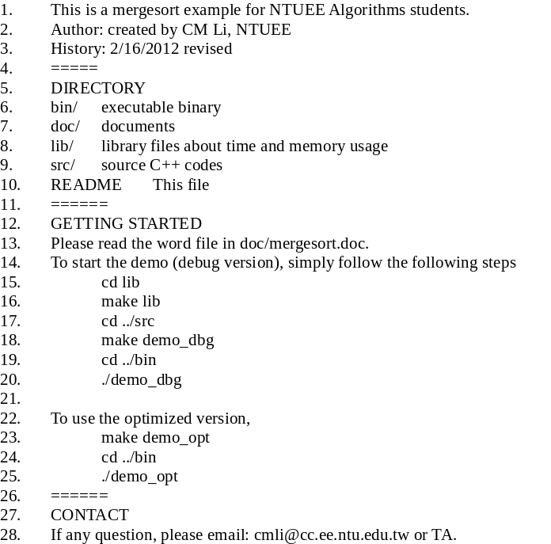
README
2. Time and Memory Usage
A software package is a collection of related classes. Many useful classes are provided in library so that programmers can reuse them easily. Library can be dynamic or static. In this example, we show how to generate a useful static library for time and memory usage. A static library contains an archive of many object files (lib*.a) and a user interface file (*.h).
2.1 tm_usage.h
First, enter the lib directory and read the tm_usage.h header file, which provides an interface of the TmUsage library, please type:
cd lib
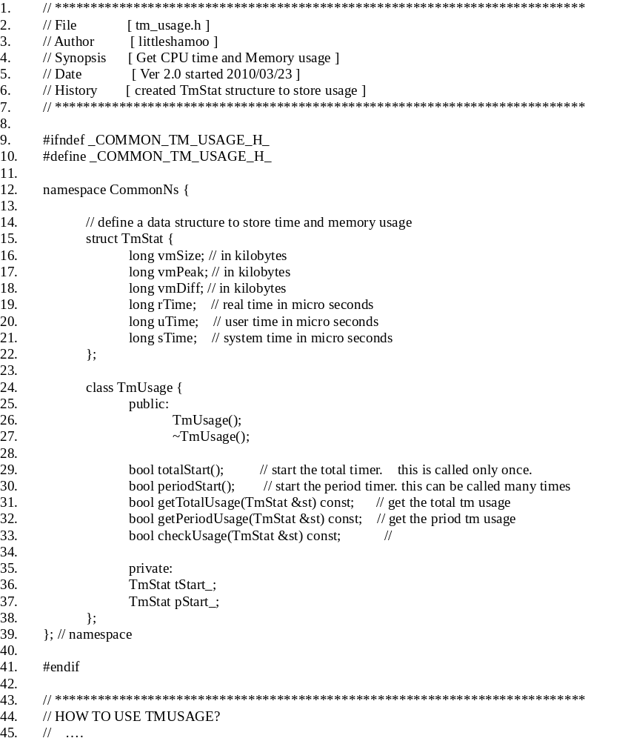
tm_usage.h
Lines 1-7: title of this .h file. Keep information about author, synopsis, and revision date. This is a good habit to write this information for reusability and portability.
Lines 9-10: these two lines are compiler preprocessor that prevent a redundant inclusion of tm_usage.h. Note that _TM_USAGE_H_ start and end with underscores ‘_’. This naming tells us that this word is not a regular variable. The reason for defining this _TM_USAGE_H_ is to prevent the compiler for including the same header file againcd (in case some other programmer also includes this header file in his code. )
Line 12: Define the name space, CommonNs. This is to avoid other programmers use same names in other codes. This is useful when many programmers work together in a large project.
Lines 15-22: Declare a data structure to store time and memory usage. Please note that we have three different time:
real time: the real world time
user time: the time to run your code in your program
system time: that time to run system jobs (such as memory allocation, file I/O) called by your program.
Normally, we use user time + system time as the total run time of your program.
Line 24: Declare class TmUsage. Please note that the class name starts with a capital letter. Each subsequent word also starts with a capital letter.
Lines 25-33: Define the public functions. Please add comments so that users know how to call these functions. We add const to these functions so that they can not change values of any variables.
Lines 35-37: Define the private variable that are used only in the TmUsage class. You can add underscores behind the variable names to remind the programmers that these variables are private.
Lines 43-: Show how to use this TmUsage (not fully shown).
2.3 tm_usage.cpp
The implementation of TmUsage is in the tm_usage.cpp.
- //**************************************************************************
- // File [ tm_usage.cpp ]
- // Author [ littleshamoo ]
- // Synopsis [ functions to calculate CPU time and memory usage ]
- // Date [ Ver 3.0 started 2010/12/20 ]
- //**************************************************************************
- #include <sys/resource.h> // for getrusage()
- #include <sys/time.h> // for gettimeofday()
- #include <cstdio>
- #include <cstring>
- #include <cstdlib>

- #include "tm_usage.h"

- using namespace std;
- using namespace CommonNs;

- TmUsage::TmUsage() {
- tStart_.uTime = 0; tStart_.sTime = 0; tStart_.rTime = 0;
- tStart_.vmSize = 0; tStart_.vmPeak = 0; tStart_.vmDiff = 0;
- pStart_.uTime = 0; pStart_.sTime = 0; pStart_.rTime = 0;
- pStart_.vmSize = 0; pStart_.vmPeak = 0; pStart_.vmDiff = 0;
- }

- TmUsage::~TmUsage() {}

- bool TmUsage::totalStart() {
- return checkUsage(tStart_);
- }

- bool TmUsage::periodStart() {
- return checkUsage(pStart_);
- }

- bool TmUsage::getTotalUsage(TmStat &st) const {
- if (!checkUsage(st))
- return false;
- st.uTime -= tStart_.uTime;
- st.sTime -= tStart_.sTime;
- st.rTime -= tStart_.rTime;
- st.vmDiff = st.vmSize - tStart_.vmSize;
- st.vmPeak = st.vmPeak > tStart_.vmPeak ? st.vmPeak : tStart_.vmPeak;
- return true;
- }

bool TmUsage::getPeriodUsage(TmStat &st) const {
- if (!checkUsage(st))
- return false;
- st.uTime -= pStart_.uTime;
- st.sTime -= pStart_.sTime;
- st.rTime -= pStart_.rTime;
- st.vmDiff = st.vmSize - pStart_.vmSize;
- st.vmPeak = st.vmPeak > pStart_.vmPeak ? st.vmPeak : pStart_.vmPeak;
- return true;
- }

- //…. (details skipped)
tm_usage.cpp
If you want to know the details, you can read this .cpp file and see how we obtain the run time and memory of the program. But if you are not interested, you can only read the .h header file. This is why we want to separate the implementation (.cpp) and header (.h) file.

2.3 Compile library
To compile the tm_usage library, please type:
make lib
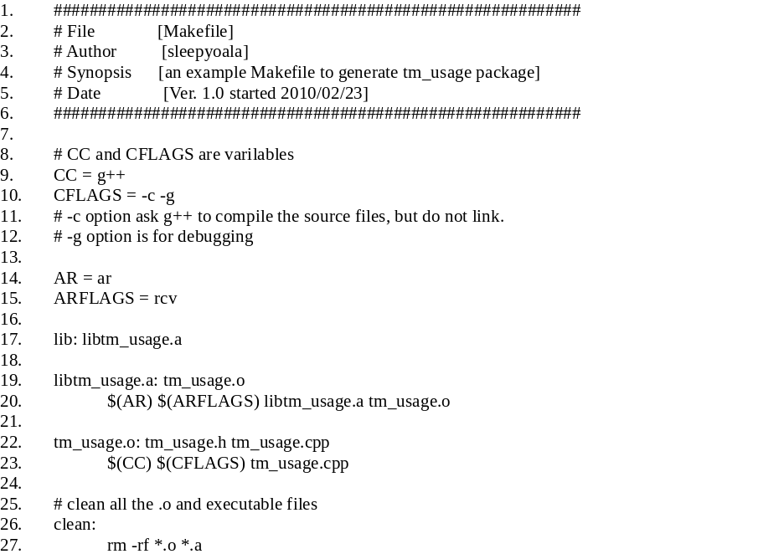
makefile (for tm_usage library)

Line 22-23: compile the object file tm_usage.o from tm_usage.cpp and tm_usage.h
Line 19-20: archive tm_usage.o into a static library file libtm_usage.a. Please note that library must start with lib and ends with .a.
Line 17: this small library has only one object file. In a big library, more than one objective files can be archived into a single lib*.a file like this
ar rcv libx.a file1.o [file2.o …]

In a big project, the libraries are usually pre-compiled by library developers so you usually do not compile the library by yourself.

3. Merge Sort
After the library is ready, please change directory to src.
cd ../src
3.1 mergeSort.h
Let’s look at the coding style of the mergeSort.h header file. It provides an interface of the MergeSort class. The actual implementation is in another file, mergeSort.cpp. This separation provides the user a convenient way to quickly know how to use the class without actually bothering the implementation details.
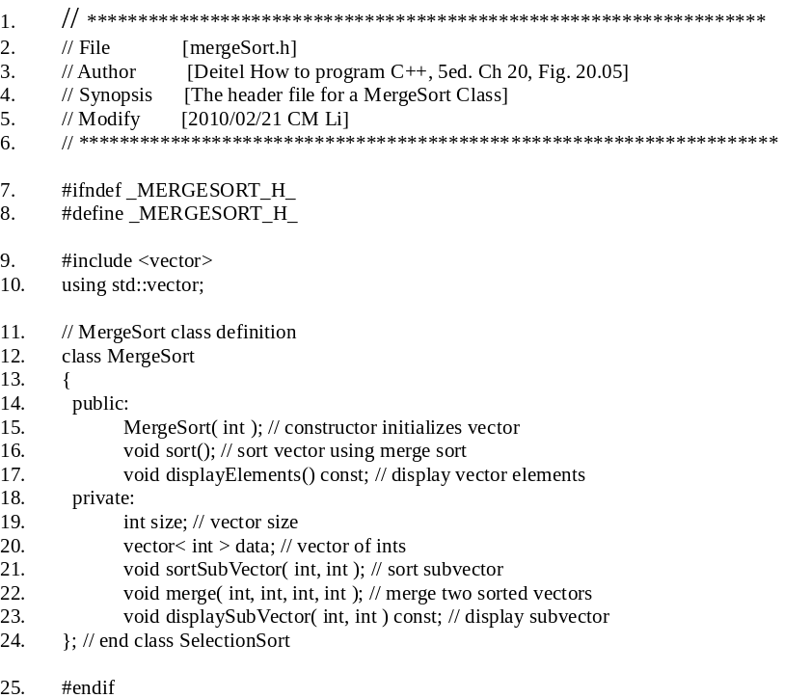
mergeSort.h
Line 1-6: title of this .h file. Provide author and a short synopsis.
Line 7-8: these two lines are compiler preprocessor that prevent a redundant inclusion of mergeSort.h. Note that _MERGESORT_H_ start and end with underscores ‘_’. This naming tells us that this word is not a regular variable.
Line 12: Define the class MergeSort. Please note that the class name starts with a capital letter. Each subsequent word also starts with a capital letter.
Line 14-17: public member functions. Please note that the function names start with small letters. Each subsequent word also starts with a capital letter. Do add comments to describe the function briefly so that users know how to call these functions.
Line 17: displayElements() is a constant so that this function cannot change the values of the object.
Lines 18-23: define private variables and functions. Variables have no parenthesis ‘()’ but functions do.
3.2 mergeSort.cpp
This file actually implements the MergeSort class. You are encouraged to read the implementation and compare it with the pseudo code of our text book. Note that the vector is a container that is defined in STL (standard template library). Using STL helps you to quickly develop your project without worrying about the data structure implementation. Please refer to our reference reading for more information about STL.
- // **************************************************************************
- // File [mergeSort.cpp]
- // Author [Deitel How to program C++, 5ed. Ch 20, Fig. 20.06]
- // Synopsis [The implementation of the MergeSort Class]
- // Modify [2010/02/21 CM Li]
- // **************************************************************************

- #include <iostream>
- using std::cout;
- using std::endl;

- #include <vector>
- using std::vector;

- #include <cstdlib> // prototypes for functions srand and rand
- using std::rand;
- using std::srand;

- #include <ctime> // prototype for function time
- using std::time;

- #include "mergeSort.h" // class MergeSort definition

- // constructor fill vector with random integers
- MergeSort::MergeSort( int vectorSize )
- {
- size = ( vectorSize > 0 ? vectorSize : 10 ); // validate vectorSize
- srand( time( 0 ) ); // seed random number generator using current time

- // fill vector with random ints in range 10-99
- for ( int i = 0; i < size; i++ )
- data.push_back( 10 + rand() % 90 );
- } // end MergeSort constructor

- // split vector, sort subvectors and merge subvectors into sorted vector
- void MergeSort::sort()
- {
- sortSubVector( 0, size - 1 ); // recursively sort entire vector
- } // end function sort

- // recursive function to sort subvectors
- void MergeSort::sortSubVector( int low, int high )
- {
- // test base case; size of vector equals 1
- if ( ( high - low ) >= 1 ) // if not base case
- {
- int middle1; // calculate middle of vector
- int middle2; // calculate next element over
- /*TODO : assign middle1 and middle2

- */
- // output split step

- #ifdef _DEBUG_ON_
- cout << "split: ";
- displaySubVector( low, high );
- cout << endl << " ";
- displaySubVector( low, middle1 );
- cout << endl << " ";
- displaySubVector( middle2, high );
- cout << endl << endl;
- #endif

- /*TODO : recursive function call to split vector in half; sort each half (recursive calls)
- // first half of vector
- // second half of vector
- */

- // merge two sorted vectors after split calls return
- merge( low, middle1, middle2, high );
- } // end if
- } // end function sortSubVector

- // merge two sorted subvectors into one sorted subvector
- void MergeSort::merge( int left, int middle1, int middle2, int right )
- {
- int leftIndex = left; // index into left subvector
- int rightIndex = middle2; // index into right subvector
- int combinedIndex = left; // index into temporary working vector
- vector< int > combined( size ); // working vector

- // output two subvectors before merging
- #ifdef _DEBUG_ON_
- cout << "merge: ";
- displaySubVector( left, middle1 );
- cout << endl << " ";
- displaySubVector( middle2, right );
- cout << endl;
- #endif

- /*TODO : merge vectors until reaching end of either
- while ( leftIndex <= middle1 && rightIndex <= right )
- {
- // place smaller of two current elements into result
- // and move to next space in vector

- } // end while

- if ( leftIndex == middle2 ) // if at end of left vector
- {
- // copy in rest of right vector

- } // end if
- else // at end of right vector
- {
- // copy in rest of left vector

- } // end else
- */

- /*TODO : copy values back into original vector

- */

- // output merged vector
- #ifdef _DEBUG_ON_
- cout << " ";
- displaySubVector( left, right );
- cout << endl << endl;
- #endif
- } // end function merge

- // display elements in vector
- void MergeSort::displayElements() const
- {
- displaySubVector( 0, size - 1 );
- } // end function displayElements

- // display certain values in vector
- void MergeSort::displaySubVector( int low, int high ) const
- {
- // output spaces for alignment
- for ( int i = 0; i < low; i++ )
- cout << " ";

- // output elements left in vector
- for ( int i = low; i <= high; i++ )
- cout << " " << data[ i ];
- } // end function displaySubVector

mergeSort.cpp
Lines 55-63: These lines are debug messages. These lines are compiled only if the _DEBUG_ON_ is defined when we invoke g++ ; otherwise, these lines are NOT compiled for speed optimization.

4. Main
4.1 global.h
This file contains the definition of global variables and constants. The constants are named in all capital letters (such as VECTOR_SIZE) to remind the programmer this is not a regular variable. It is a good habit to define global variables and constants in a head file, instead of the .cpp files, for easy maintenance.
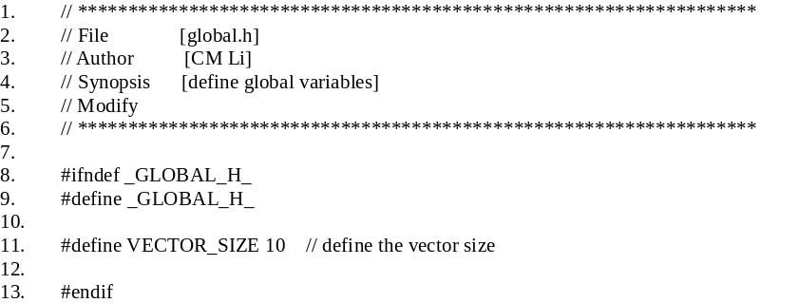
global.h
3.2 main.cpp
This file is the main function of the project. Because most jobs are defined in the library and the class, the main file itself is quite simple.

- //**************************************************************************
- // File [main.cpp]
- // Author [Deitel How to program C++, 5ed. Ch 20, Fig. 20.07]
- // Synopsis [The main program of this demo]
- // Modify [2010/02/21 CM Li]
- //**************************************************************************

- #include <iostream>
- using std::cout;
- using std::endl;

- #include "global.h" // glabl variables
- #include "mergeSort.h" // class MergeSort definition
- #include "tm_usage.h" // the tm_usage library

- int main()
- {
- CommonNs::TmUsage tmusg;
- CommonNs::TmStat stat;
- tmusg.periodStart();

- // create object to perform merge sort
- MergeSort sortVector( VECTOR_SIZE );

- cout << "Unsorted vector:" << endl;
- sortVector.displayElements(); // print unsorted vector
- cout << endl << endl;

- sortVector.sort(); // sort vector

- cout << "Sorted vector:" << endl;
- sortVector.displayElements(); // print sorted vector
- cout << endl;

- tmusg.getPeriodUsage(stat);
- cout <<"user time:" << stat.uTime / 1000000.0 << "s" << endl; // print period user time in seconds
- cout <<"system time:" << stat.sTime / 1000000.0 << "s" << endl; // print period systemtime in seconds
- cout <<"user+system time:" << (stat.uTime + stat.sTime) / 1000000.0 << "s" << endl;
- return 0;
- } // end main
main.cpp

4.3 Compile the debug version
Please type the following commands,
make demo_dbg
cd ../bin
./demo_dbg
Please go to the src directory and read the sample makefile.
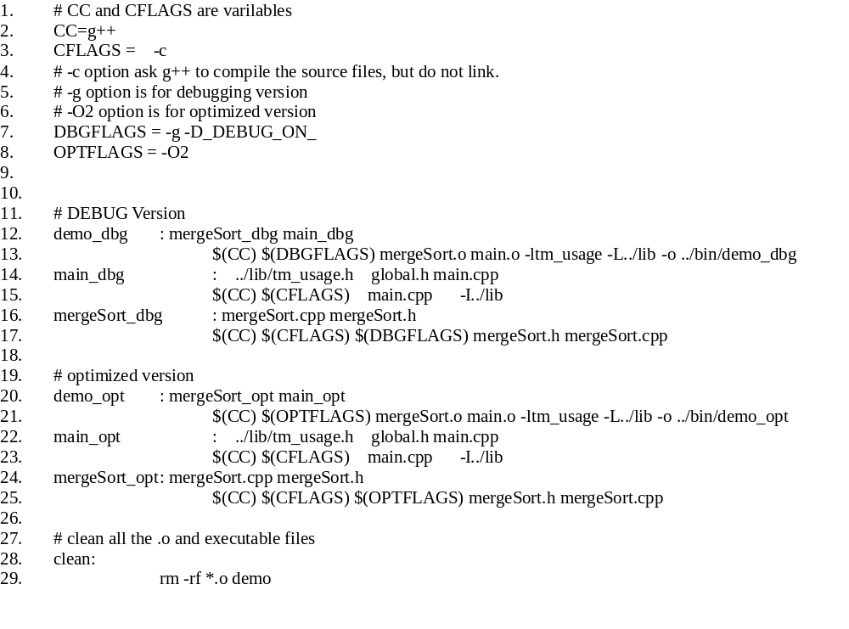
makefile
Lines 11-17: Compile the debug version when we type ‘make demo_dbg’. This version invokes options ‘-g’ (for DDD debugger) and also ‘-D_DEBUG_ON_’ to enable the printing of arrays in mergeSort.cpp.
Lines 19-25: Compile the optimization version when we type ‘make demo_opt’. This version invokes options ‘-O2’ for speed improvement. Also ‘_DEBUG_ON_’ is not defined to disable the printing of arrays in mergeSort.cpp.

4.4 Compile the optimized version
Please type the following commands,
cd ../src
make demo_opt
cd ../bin
./demo_opt

We can summarize the compilation of the whole project in this figure.

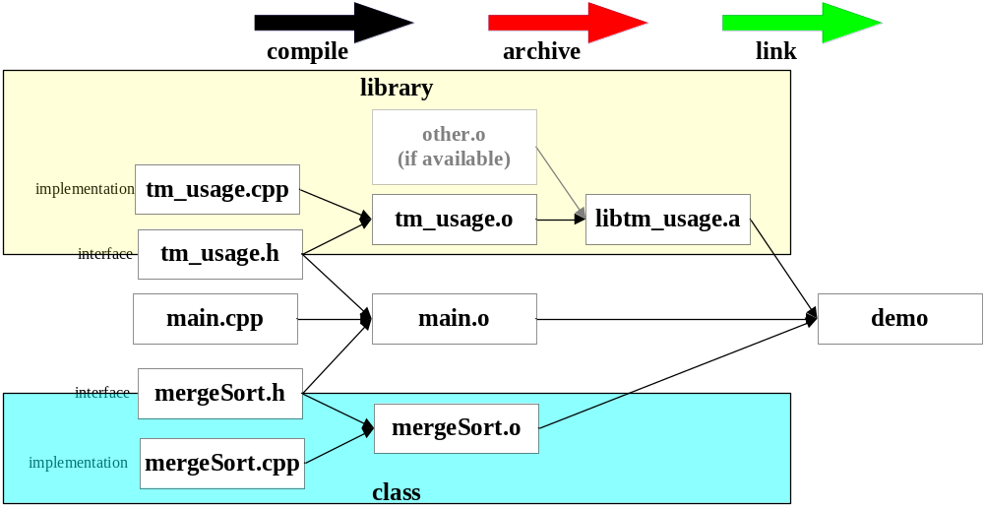
compilation flow of this project

5. Exercise (NO need to submit)
Please finish all TODO to run merge sort example completely.

6. References
about STL:
H. Deiltel, How to Program C++, 5ed. Prentice Hall.
CPLUSPLUS http://www.cplusplus.com/reference/stl/
C++ STL Tutorial http://www.yolinux.com/TUTORIALS/LinuxTutorialC++STL.html
SGI STL Programmer’s Guide http://www.sgi.com/tech/stl/

About Coding Style
http://geosoft.no/development/cppstyle.html
H. Sutter, C++ coding standards, 101 rules, guidelines and best practice, Addison Wesley.

