Report

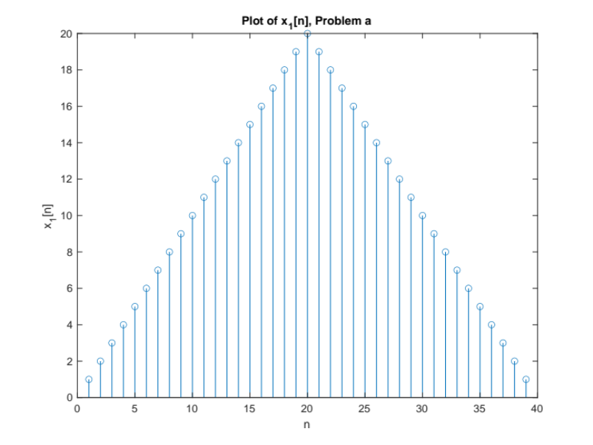
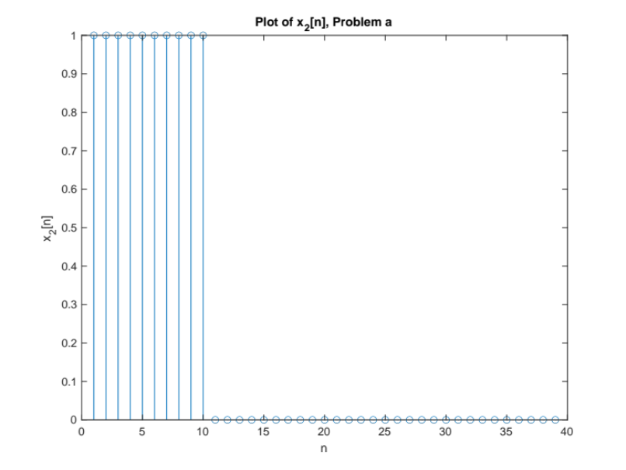
Problem a

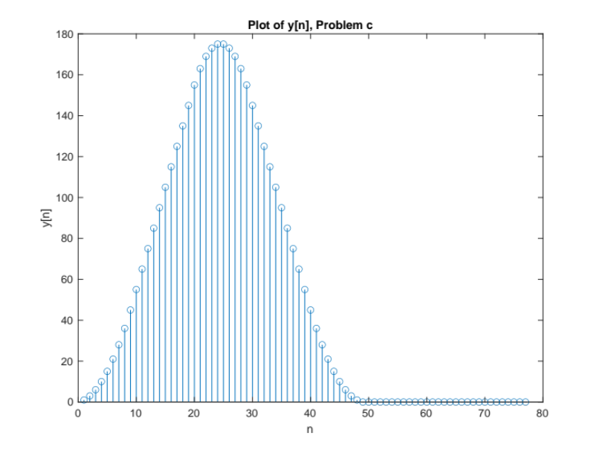
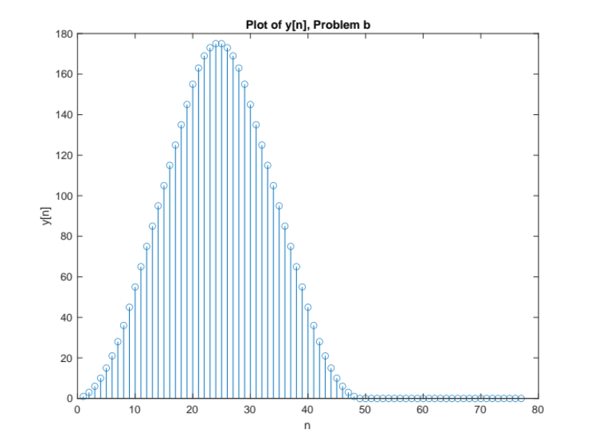
Problem b&c
As we can see, the two figures are the same.
The reason is that the process of the convolution is just the same as the computation of matrices.

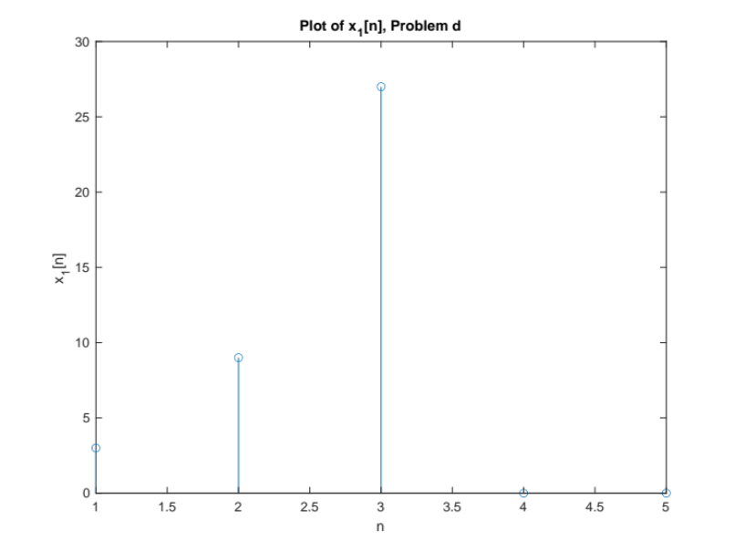
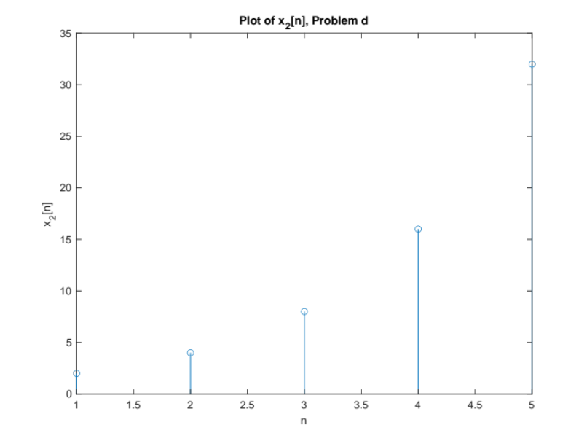
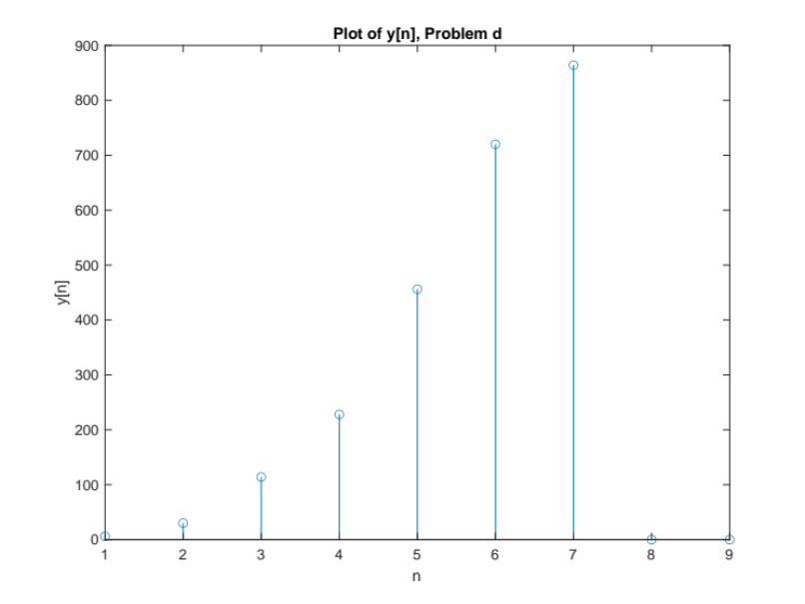
Problem d

As we can see, the two figures above are the same. (The left down is computed by the function convolution in MATLAB, while the right down is computed by the matrices we made.)
They are the same because the process of the convolution is just the same as the computation of matrices.

