eReport
B09901066 謝承修

Problem a
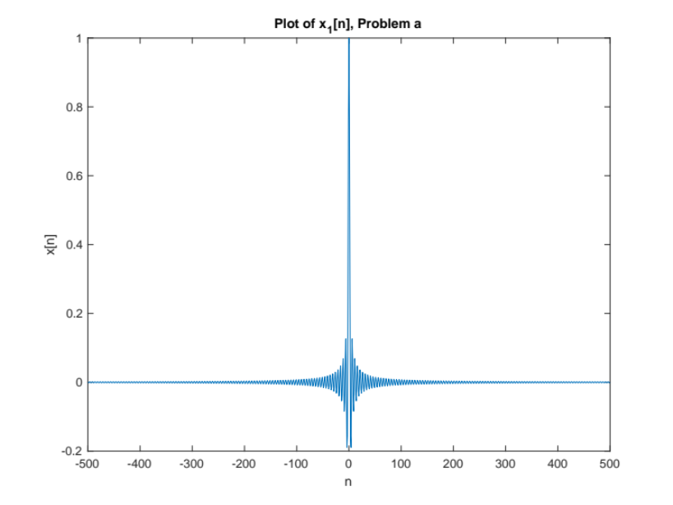

Problem b
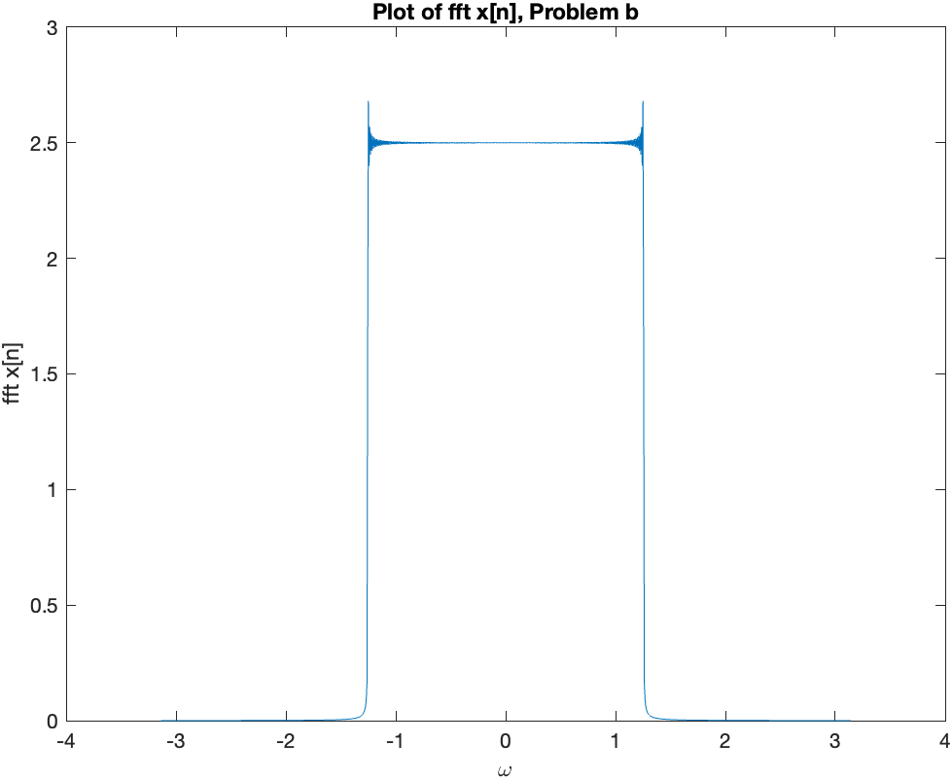

Since N is finite, so F{x[n]} is not perfectly a square wave, instead, the Gibbs phenomenon will happen, and we can see there exists fluctuation at the boundary.

Problem c
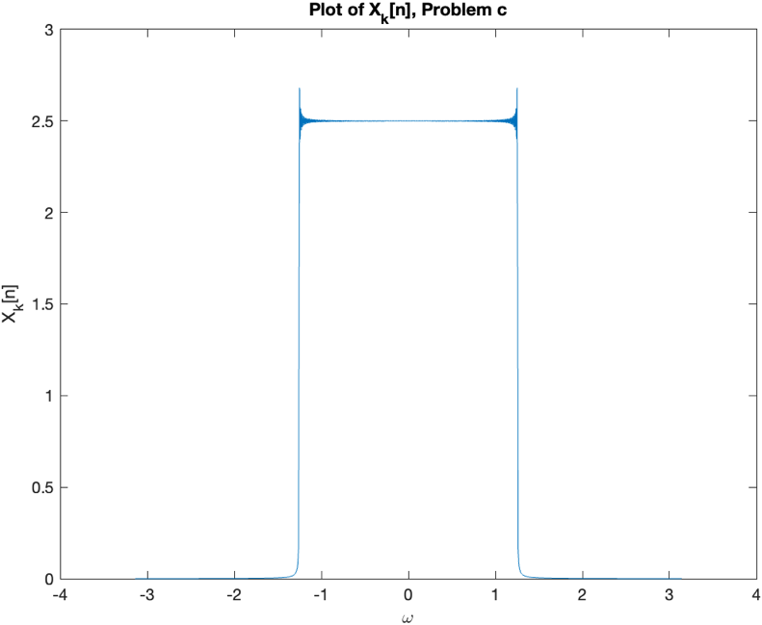

As we can see, the two figures are the same since the calculation process is not different.

Problem d

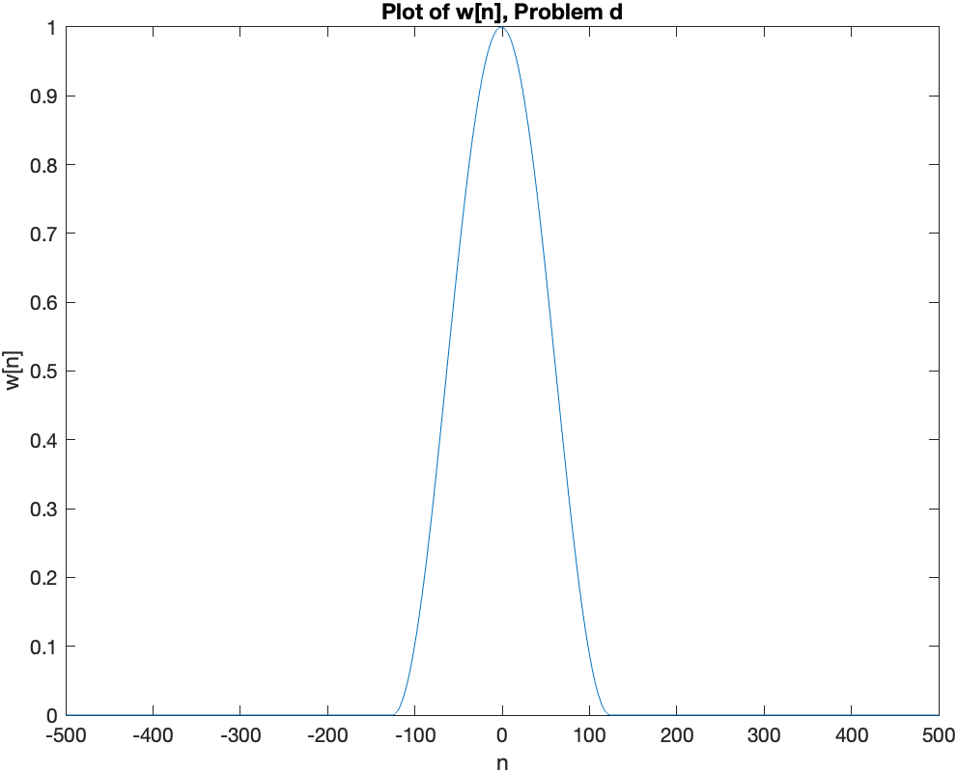

Problem e
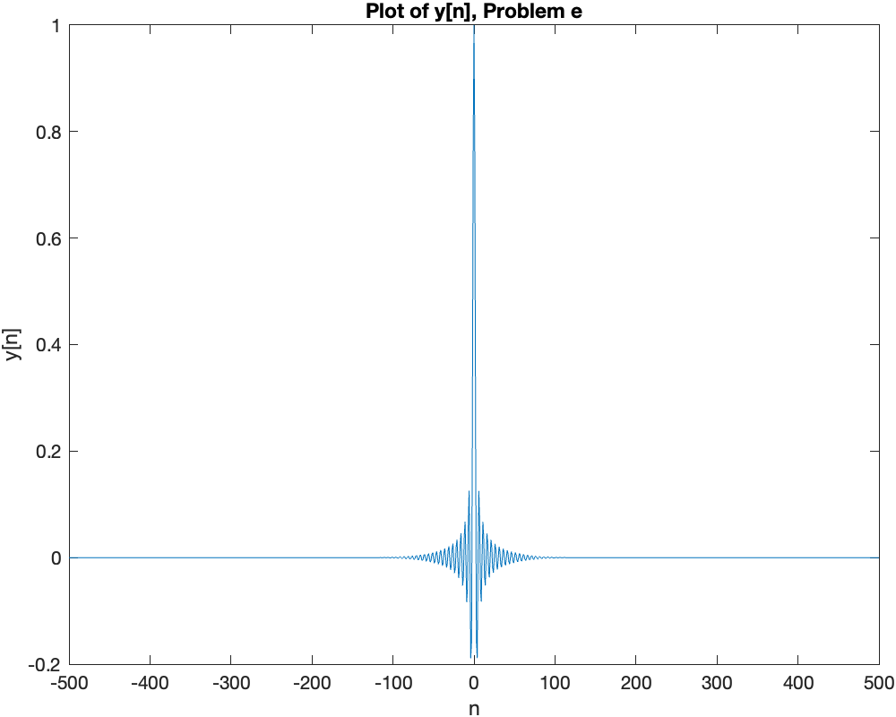

Problem f
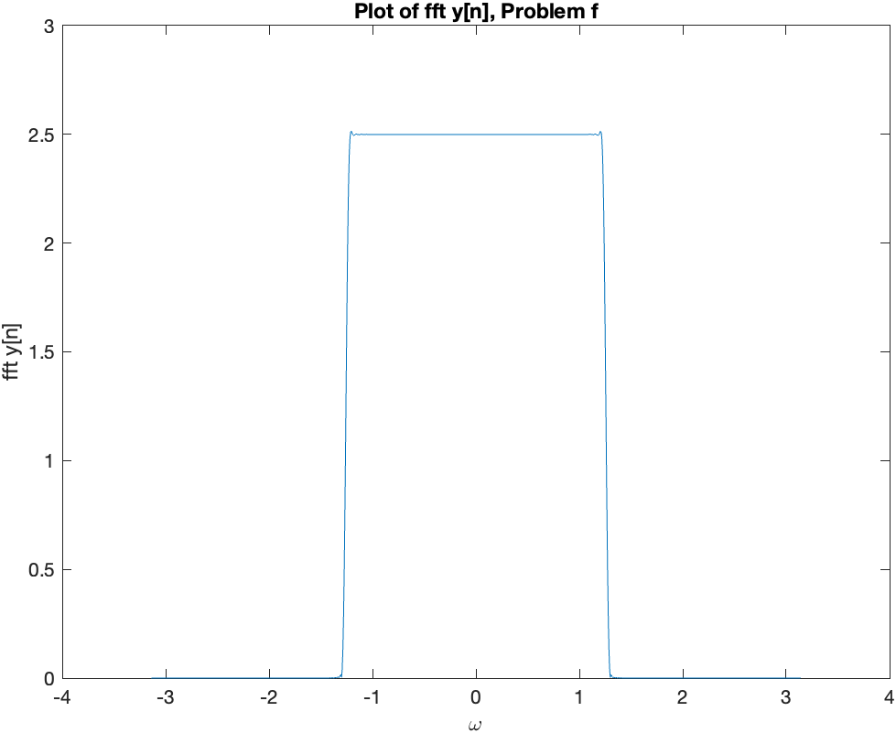

As we can see, fig.b is similar to fig.f but exists more fluctuation at the boundary, the reason why they are similar is that w[n] is like a delta function in the frequency domain, so after convolution, y[n] is similar to F{x[n]}.

