Report
B09901066 謝承修
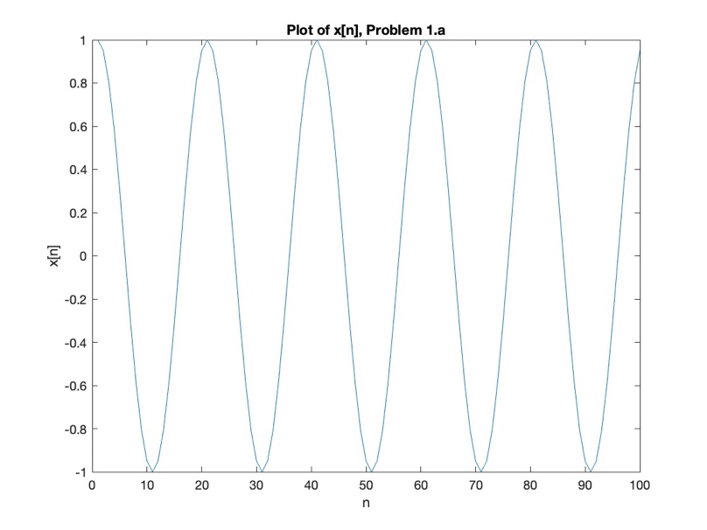
Problem 1.b 1.c 1.d
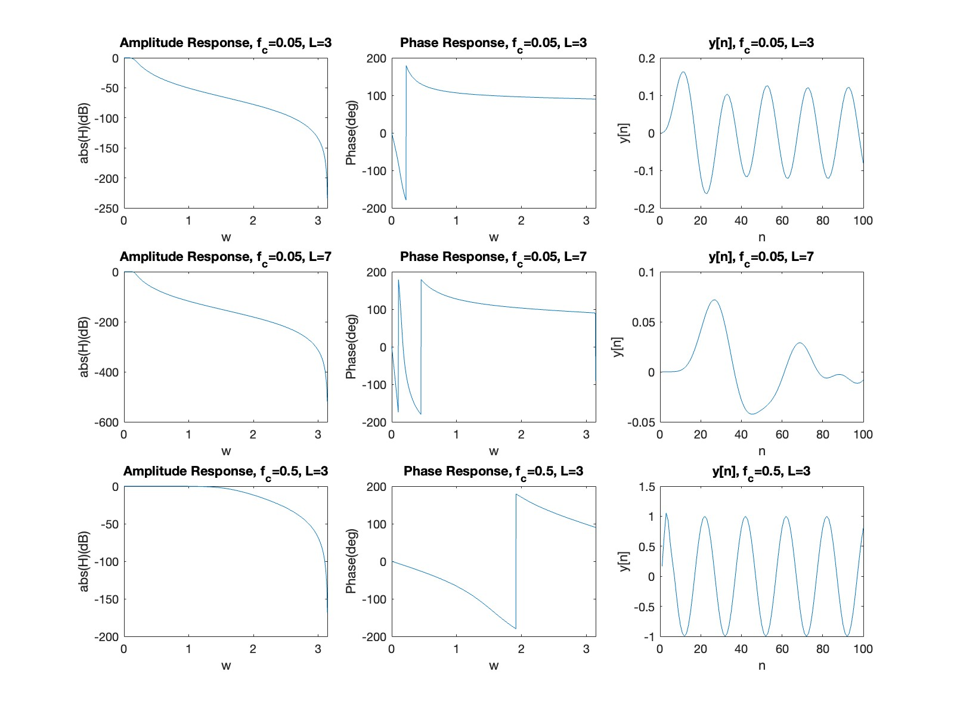

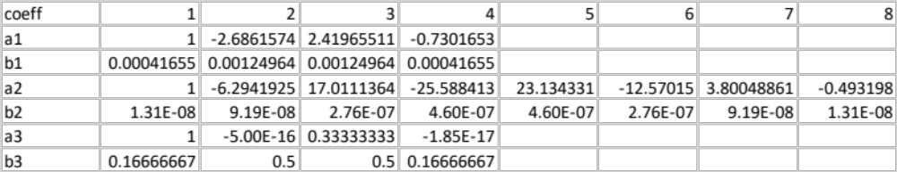
P.S. a1 b1 for 1(b), a2 b2 for 1(c), a3, b3 for 1(d). (Coefficients of transfer function)
Problem 1.e
From the figures above, we can see the larger L is , the quicker roll-off around the cutoff frequency, and the larger cutoff frequency makes more components with lower frequencies cannot pass the filter, it makes sense easily.
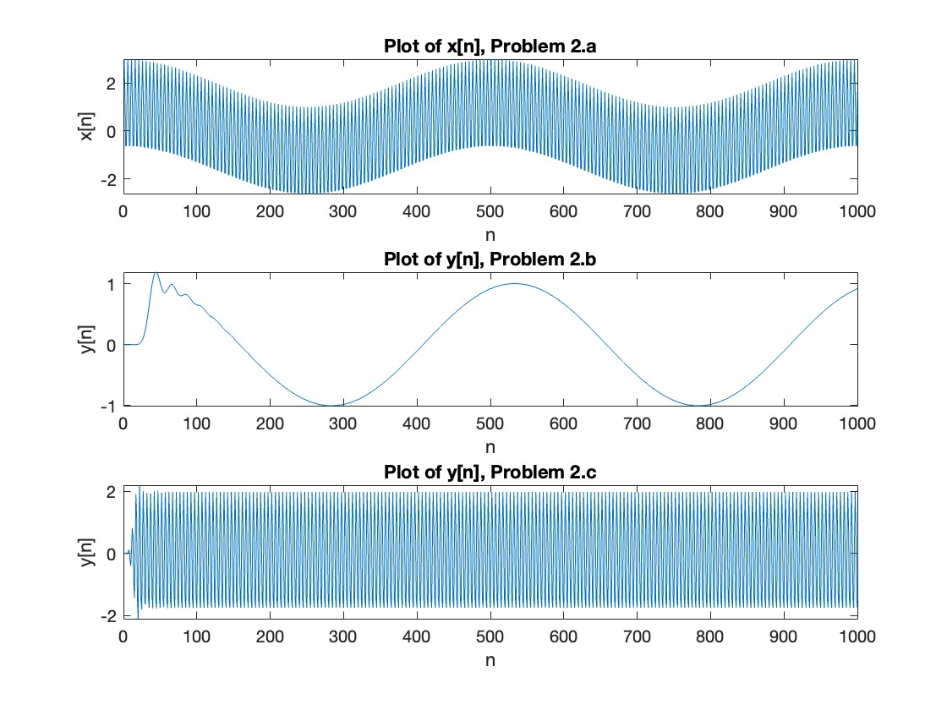
P.S. a1 b1 for 2(b), a2 b2 for 2(c). (Coefficients of transfer function)

Cutoff frequency of 2(b) is 0.1Hz in this case, and bandpass frequency in 2(c) is 0.25Hz and 0.5Hz in this case.

