Report
B09901066 謝承修

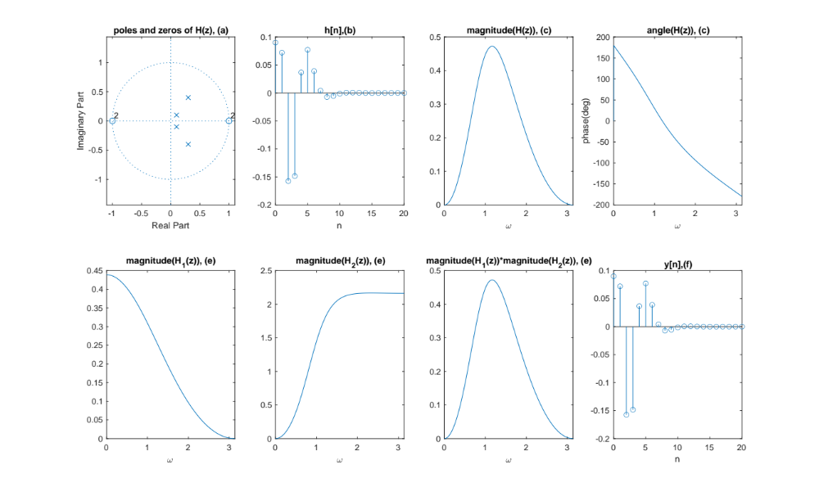
In part(a), ROC : |z| > 0.5.
In part(d),
H_1(z)=[0.09+0.18*z^(-1)+0.09*z^(-2)]/[ 1-0.2*z^(-1)+0.2*z^(-2)], and H_2(z)=[1-2*z^(-1)+z^(-2)]/[ 1-0.06*z^(-1)+0.25*z^(-2)].
In part(e), the magnitude response of the multiplication result is the same as the magnitude of part(c).
In part(f), the result is the same as that of part(b).

