library(forecast)

## Warning: package 'forecast' was built under R version 4.2.3

## Registered S3 method overwritten by 'quantmod':  
## method from  
## as.zoo.data.frame zoo

library(tseries)

## Warning: package 'tseries' was built under R version 4.2.3

dataUAS = read.csv(file = "D:/Semester VIII/Analisis Runtun Waktu/uts 2/dataUAS.csv", header = TRUE, sep = ";")  
attach(dataUAS)  
xT = (dataUAS$Xt)  
# Melakukan tes ADF pada data  
adf.test(Xt)

## Warning in adf.test(Xt): p-value smaller than printed p-value

##   
## Augmented Dickey-Fuller Test  
##   
## data: Xt  
## Dickey-Fuller = -7.3186, Lag order = 5, p-value = 0.01  
## alternative hypothesis: stationary

# Menampilkan plot data  
par(mfrow=c(1,1))  
plot.ts(Xt, lag.max = 200)

## Warning in plot.window(xlim, ylim, log, ...): "lag.max" is not a graphical  
## parameter

## Warning in title(main = main, xlab = xlab, ylab = ylab, ...): "lag.max" is not  
## a graphical parameter

## Warning in axis(1, ...): "lag.max" is not a graphical parameter

## Warning in axis(2, ...): "lag.max" is not a graphical parameter

## Warning in box(...): "lag.max" is not a graphical parameter

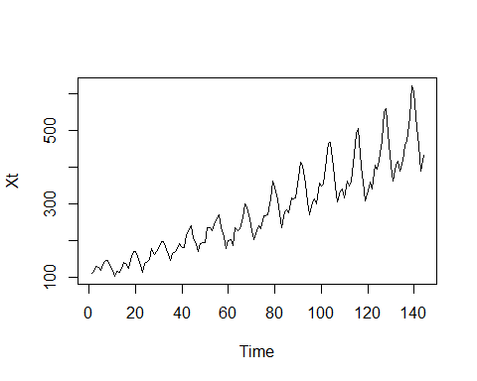

# Menampilkan plot ACF dan PACF  
par(mfrow=c(2,1))  
acf(Xt, lag.max = 120)  
pacf(Xt, lag.max = 120)

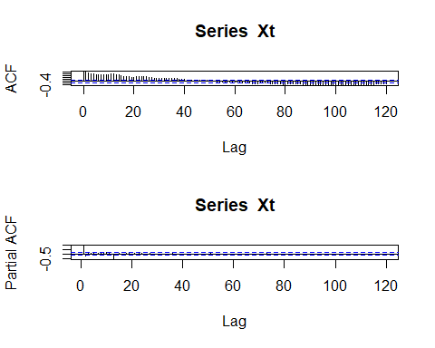

# Melakukan diferensiasi pada data untuk membuatnya stasioner  
differenced_dataUAS <- diff(Xt)  
  
# Menampilkan plot data yang sudah didiferensiasi  
par(mfrow=c(1,1))  
plot.ts(differenced_dataUAS)

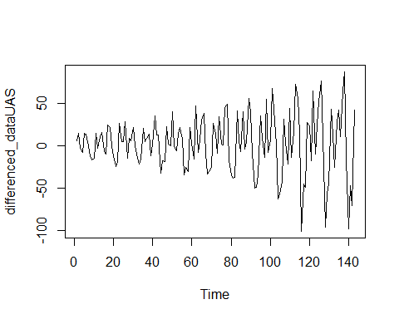

# Melakukan tes ADF pada data yang sudah didiferensiasi  
adf.test(differenced_dataUAS)

## Warning in adf.test(differenced_dataUAS): p-value smaller than printed p-value

##   
## Augmented Dickey-Fuller Test  
##   
## data: differenced_dataUAS  
## Dickey-Fuller = -7.0177, Lag order = 5, p-value = 0.01  
## alternative hypothesis: stationary

# Menampilkan plot ACF dan PACF dari data yang sudah didiferensiasi  
par(mfrow=c(2,1))  
Acf(differenced_dataUAS, lag.max = 200)  
Pacf(differenced_dataUAS, lag.max = 200)

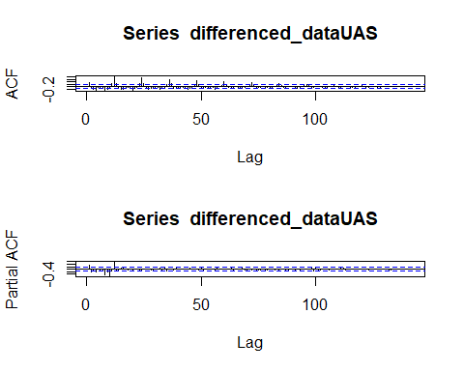

# Melakukan diferensiasi musiman pada data yang sudah didiferensiasi  
musimUAS = diff(differenced_dataUAS, lag=4)  
adf.test(musimUAS)

## Warning in adf.test(musimUAS): p-value smaller than printed p-value

##   
## Augmented Dickey-Fuller Test  
##   
## data: musimUAS  
## Dickey-Fuller = -5.6189, Lag order = 5, p-value = 0.01  
## alternative hypothesis: stationary

par(mfrow=c(1,1))  
plot.ts(musimUAS)

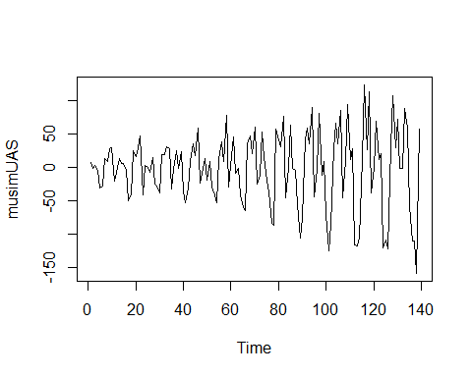

# Menampilkan plot ACF dan PACF dari data yang sudah didiferensiasi musiman  
par(mfrow=c(2,1))  
acf(musimUAS, lag.max = 200)  
pacf(musimUAS, lag.max = 200)

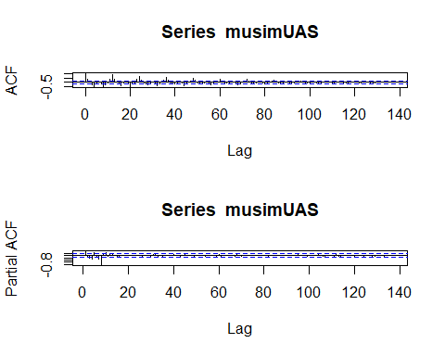

## estimasi  
#estimasi1  
estimasi1=arima(Xt,order=c(0,1,0),seasonal=list(order=c(0,1,0),period = 4))  
estimasi1

##   
## Call:  
## arima(x = Xt, order = c(0, 1, 0), seasonal = list(order = c(0, 1, 0), period = 4))  
##   
##   
## sigma^2 estimated as 2885: log likelihood = -750.97, aic = 1503.94

residual1=resid(estimasi1)  
shapiro.test(residual1)

##   
## Shapiro-Wilk normality test  
##   
## data: residual1  
## W = 0.97485, p-value = 0.009384

Box.test(residual1,lag=6,type="Ljung-Box")

##   
## Box-Ljung test  
##   
## data: residual1  
## X-squared = 58.076, df = 6, p-value = 1.106e-10

#estimasi2  
estimasi2=arima(Xt,order=c(1,1,0),seasonal=list(order=c(0,1,0),period = 4))  
estimasi2

##   
## Call:  
## arima(x = Xt, order = c(1, 1, 0), seasonal = list(order = c(0, 1, 0), period = 4))  
##   
## Coefficients:  
## ar1  
## 0.3517  
## s.e. 0.0793  
##   
## sigma^2 estimated as 2527: log likelihood = -741.8, aic = 1487.61

residual2=resid(estimasi2)  
shapiro.test(residual2)

##   
## Shapiro-Wilk normality test  
##   
## data: residual2  
## W = 0.9914, p-value = 0.5307

Box.test(residual2,lag=6,type="Ljung-Box")

##   
## Box-Ljung test  
##   
## data: residual2  
## X-squared = 36.477, df = 6, p-value = 2.226e-06

#estimasi3  
estimasi3=arima(Xt,order=c(1,1,1),seasonal=list(order=c(0,1,0),period = 4))  
estimasi3

##   
## Call:  
## arima(x = Xt, order = c(1, 1, 1), seasonal = list(order = c(0, 1, 0), period = 4))  
##   
## Coefficients:  
## ar1 ma1  
## -0.4163 1.0000  
## s.e. 0.0814 0.0254  
##   
## sigma^2 estimated as 2086: log likelihood = -730.44, aic = 1466.88

residual3=resid(estimasi3)  
shapiro.test(residual3)

##   
## Shapiro-Wilk normality test  
##   
## data: residual3  
## W = 0.98332, p-value = 0.07763

Box.test(residual3,lag=6,type="Ljung-Box")

##   
## Box-Ljung test  
##   
## data: residual3  
## X-squared = 32.795, df = 6, p-value = 1.148e-05

#estimasi4  
estimasi4=arima(Xt,order=c(1,1,0),seasonal=list(order=c(1,1,0),period = 4))  
estimasi4

##   
## Call:  
## arima(x = Xt, order = c(1, 1, 0), seasonal = list(order = c(1, 1, 0), period = 4))  
##   
## Coefficients:  
## ar1 sar1  
## 0.3503 -0.4976  
## s.e. 0.0793 0.0769  
##   
## sigma^2 estimated as 1936: log likelihood = -723.87, aic = 1453.75

residual4=resid(estimasi4)  
shapiro.test(residual4)

##   
## Shapiro-Wilk normality test  
##   
## data: residual4  
## W = 0.99017, p-value = 0.4113

Box.test(residual4,lag=6,type="Ljung-Box")

##   
## Box-Ljung test  
##   
## data: residual4  
## X-squared = 35.919, df = 6, p-value = 2.858e-06

#estimasi5  
estimasi5=arima(Xt,order=c(1,1,0),seasonal=list(order=c(0,1,1),period = 4))  
estimasi5

##   
## Call:  
## arima(x = Xt, order = c(1, 1, 0), seasonal = list(order = c(0, 1, 1), period = 4))  
##   
## Coefficients:  
## ar1 sma1  
## 0.3321 -1.0000  
## s.e. 0.0803 0.0648  
##   
## sigma^2 estimated as 943.1: log likelihood = -680.45, aic = 1366.9

residual5=resid(estimasi5)  
shapiro.test(residual5)

##   
## Shapiro-Wilk normality test  
##   
## data: residual5  
## W = 0.98302, p-value = 0.07194

Box.test(residual5,lag=6,type="Ljung-Box")

##   
## Box-Ljung test  
##   
## data: residual5  
## X-squared = 28.772, df = 6, p-value = 6.72e-05

#estimasi6  
estimasi6=arima(Xt,order=c(1,1,1),seasonal=list(order=c(1,1,0),period = 4))  
estimasi6

##   
## Call:  
## arima(x = Xt, order = c(1, 1, 1), seasonal = list(order = c(1, 1, 0), period = 4))  
##   
## Coefficients:  
## ar1 ma1 sar1  
## 0.1498 0.2360 -0.4962  
## s.e. 0.2545 0.2572 0.0771  
##   
## sigma^2 estimated as 1917: log likelihood = -723.21, aic = 1454.42

residual6=resid(estimasi6)  
shapiro.test(residual6)

##   
## Shapiro-Wilk normality test  
##   
## data: residual6  
## W = 0.98835, p-value = 0.271

Box.test(residual6,lag=6,type="Ljung-Box")

##   
## Box-Ljung test  
##   
## data: residual6  
## X-squared = 32.555, df = 6, p-value = 1.277e-05

#estimasi7  
estimasi7=arima(Xt,order=c(1,1,0),seasonal=list(order=c(1,1,1),period = 4))  
estimasi7

##   
## Call:  
## arima(x = Xt, order = c(1, 1, 0), seasonal = list(order = c(1, 1, 1), period = 4))  
##   
## Coefficients:  
## ar1 sar1 sma1  
## 0.3013 -0.4351 -0.9404  
## s.e. 0.0816 0.0815 0.0467  
##   
## sigma^2 estimated as 802.3: log likelihood = -668.12, aic = 1344.25

residual7=resid(estimasi7)  
shapiro.test(residual7)

##   
## Shapiro-Wilk normality test  
##   
## data: residual7  
## W = 0.98839, p-value = 0.2741

Box.test(residual7,lag=6,type="Ljung-Box")

##   
## Box-Ljung test  
##   
## data: residual7  
## X-squared = 22.108, df = 6, p-value = 0.001158

#estimasi8  
estimasi8=arima(Xt,order=c(1,1,1),seasonal=list(order=c(0,1,1),period = 4))  
estimasi8

##   
## Call:  
## arima(x = Xt, order = c(1, 1, 1), seasonal = list(order = c(0, 1, 1), period = 4))  
##   
## Coefficients:  
## ar1 ma1 sma1  
## -0.5023 0.8789 -1.0000  
## s.e. 0.1151 0.0770 0.0608  
##   
## sigma^2 estimated as 900.9: log likelihood = -678.32, aic = 1364.65

residual8=resid(estimasi8)  
shapiro.test(residual8)

##   
## Shapiro-Wilk normality test  
##   
## data: residual8  
## W = 0.98778, p-value = 0.2366

Box.test(residual8,lag=6,type="Ljung-Box")

##   
## Box-Ljung test  
##   
## data: residual8  
## X-squared = 28.472, df = 6, p-value = 7.654e-05

#estimasi9  
estimasi9=arima(Xt,order=c(1,1,1),seasonal=list(order=c(1,1,1),period = 4))  
estimasi9

##   
## Call:  
## arima(x = Xt, order = c(1, 1, 1), seasonal = list(order = c(1, 1, 1), period = 4))  
##   
## Coefficients:  
## ar1 ma1 sar1 sma1  
## 0.0776 0.2537 -0.4321 -0.9503  
## s.e. 0.2570 0.2506 0.0819 0.0538  
##   
## sigma^2 estimated as 790.7: log likelihood = -667.46, aic = 1344.93

residual9=resid(estimasi9)  
shapiro.test(residual9)

##   
## Shapiro-Wilk normality test  
##   
## data: residual9  
## W = 0.98867, p-value = 0.2923

Box.test(residual9,lag=6,type="Ljung-Box")

##   
## Box-Ljung test  
##   
## data: residual9  
## X-squared = 19.762, df = 6, p-value = 0.003053

#estimasi10  
estimasi10=arima(Xt,order=c(0,1,1),seasonal=list(order=c(0,1,0),period = 4))  
estimasi10

##   
## Call:  
## arima(x = Xt, order = c(0, 1, 1), seasonal = list(order = c(0, 1, 0), period = 4))  
##   
## Coefficients:  
## ma1  
## 0.4066  
## s.e. 0.0940  
##   
## sigma^2 estimated as 2494: log likelihood = -740.92, aic = 1485.85

residual10=resid(estimasi10)  
shapiro.test(residual10)

##   
## Shapiro-Wilk normality test  
##   
## data: residual10  
## W = 0.98941, p-value = 0.3469

Box.test(residual10,lag=6,type="Ljung-Box")

##   
## Box-Ljung test  
##   
## data: residual10  
## X-squared = 32.756, df = 6, p-value = 1.168e-05

#estimasi11  
estimasi11=arima(Xt,order=c(0,1,1),seasonal=list(order=c(1,1,0),period = 4))  
estimasi11

##   
## Call:  
## arima(x = Xt, order = c(0, 1, 1), seasonal = list(order = c(1, 1, 0), period = 4))  
##   
## Coefficients:  
## ma1 sar1  
## 0.3847 -0.4950  
## s.e. 0.0877 0.0773  
##   
## sigma^2 estimated as 1920: log likelihood = -723.3, aic = 1452.61

residual11=resid(estimasi11)  
shapiro.test(residual11)

##   
## Shapiro-Wilk normality test  
##   
## data: residual11  
## W = 0.98721, p-value = 0.2061

Box.test(residual11,lag=6,type="Ljung-Box")

##   
## Box-Ljung test  
##   
## data: residual11  
## X-squared = 32.746, df = 6, p-value = 1.173e-05

#estimasi12  
estimasi12=arima(Xt,order=c(0,1,1),seasonal=list(order=c(0,1,1),period = 4))  
estimasi12

##   
## Call:  
## arima(x = Xt, order = c(0, 1, 1), seasonal = list(order = c(0, 1, 1), period = 4))  
##   
## Coefficients:  
## ma1 sma1  
## 0.3680 -1.0000  
## s.e. 0.0856 0.0547  
##   
## sigma^2 estimated as 932.4: log likelihood = -679.7, aic = 1365.41

residual12=resid(estimasi12)  
shapiro.test(residual12)

##   
## Shapiro-Wilk normality test  
##   
## data: residual12  
## W = 0.98587, p-value = 0.1478

Box.test(residual12,lag=6,type="Ljung-Box")

##   
## Box-Ljung test  
##   
## data: residual12  
## X-squared = 26.446, df = 6, p-value = 0.0001839

#estimasi13  
estimasi13=arima(Xt,order=c(0,1,1),seasonal=list(order=c(1,1,1),period = 4))  
estimasi13

##   
## Call:  
## arima(x = Xt, order = c(0, 1, 1), seasonal = list(order = c(1, 1, 1), period = 4))  
##   
## Coefficients:  
## ma1 sar1 sma1  
## 0.3250 -0.4319 -0.9538  
## s.e. 0.0818 0.0820 0.0553  
##   
## sigma^2 estimated as 789.6: log likelihood = -667.5, aic = 1343.01

residual13=resid(estimasi13)  
shapiro.test(residual13)

##   
## Shapiro-Wilk normality test  
##   
## data: residual13  
## W = 0.98853, p-value = 0.2827

Box.test(residual13,lag=6,type="Ljung-Box")

##   
## Box-Ljung test  
##   
## data: residual13  
## X-squared = 20.088, df = 6, p-value = 0.002671

#estimasi14  
estimasi14=arima(Xt,order=c(0,1,0),seasonal=list(order=c(1,1,0),period = 4))  
estimasi14

##   
## Call:  
## arima(x = Xt, order = c(0, 1, 0), seasonal = list(order = c(1, 1, 0), period = 4))  
##   
## Coefficients:  
## sar1  
## -0.5024  
## s.e. 0.0775  
##   
## sigma^2 estimated as 2209: log likelihood = -733, aic = 1469.99

residual14=resid(estimasi14)  
shapiro.test(residual14)

##   
## Shapiro-Wilk normality test  
##   
## data: residual14  
## W = 0.9822, p-value = 0.05851

Box.test(residual14,lag=6,type="Ljung-Box")

##   
## Box-Ljung test  
##   
## data: residual14  
## X-squared = 61.458, df = 6, p-value = 2.275e-11

#estimasi15  
estimasi15=arima(Xt,order=c(0,1,0),seasonal=list(order=c(1,1,1),period = 4))  
estimasi15

##   
## Call:  
## arima(x = Xt, order = c(0, 1, 0), seasonal = list(order = c(1, 1, 1), period = 4))  
##   
## Coefficients:  
## sar1 sma1  
## -0.4560 -0.9548  
## s.e. 0.0805 0.0543  
##   
## sigma^2 estimated as 873.8: log likelihood = -674.63, aic = 1355.26

residual15=resid(estimasi15)  
shapiro.test(residual15)

##   
## Shapiro-Wilk normality test  
##   
## data: residual15  
## W = 0.98848, p-value = 0.2795

Box.test(residual15,lag=6,type="Ljung-Box")

##   
## Box-Ljung test  
##   
## data: residual15  
## X-squared = 45.062, df = 6, p-value = 4.549e-08

#estimasi16  
estimasi16=arima(Xt,order=c(0,1,0),seasonal=list(order=c(0,1,1),period = 4))  
estimasi16

##   
## Call:  
## arima(x = Xt, order = c(0, 1, 0), seasonal = list(order = c(0, 1, 1), period = 4))  
##   
## Coefficients:  
## sma1  
## -1.0000  
## s.e. 0.0537  
##   
## sigma^2 estimated as 1060: log likelihood = -688.53, aic = 1381.06

residual16=resid(estimasi16)  
shapiro.test(residual16)

##   
## Shapiro-Wilk normality test  
##   
## data: residual16  
## W = 0.98178, p-value = 0.05251

Box.test(residual16,lag=6,type="Ljung-Box")

##   
## Box-Ljung test  
##   
## data: residual16  
## X-squared = 53.816, df = 6, p-value = 8.036e-10

#estimasi17  
estimasi17=arima(Xt,order=c(0,1,0),seasonal=list(order=c(0,1,2),period = 4))  
estimasi17

##   
## Call:  
## arima(x = Xt, order = c(0, 1, 0), seasonal = list(order = c(0, 1, 2), period = 4))  
##   
## Coefficients:  
## sma1 sma2  
## -0.1371 -0.8629  
## s.e. 0.0652 0.0619  
##   
## sigma^2 estimated as 1271: log likelihood = -701.45, aic = 1408.91

residual17=resid(estimasi17)  
shapiro.test(residual17)

##   
## Shapiro-Wilk normality test  
##   
## data: residual17  
## W = 0.99113, p-value = 0.5031

Box.test(residual17,lag=6,type="Ljung-Box")

##   
## Box-Ljung test  
##   
## data: residual17  
## X-squared = 51.496, df = 6, p-value = 2.355e-09

#estimasi18  
estimasi18=arima(Xt,order=c(1,1,0),seasonal=list(order=c(0,1,2),period = 4))  
estimasi18

##   
## Call:  
## arima(x = Xt, order = c(1, 1, 0), seasonal = list(order = c(0, 1, 2), period = 4))  
##   
## Coefficients:  
## ar1 sma1 sma2  
## 0.2274 -1.6797 0.7920  
## s.e. 0.0846 0.0619 0.0585  
##   
## sigma^2 estimated as 557.9: log likelihood = -644.95, aic = 1297.9

residual18=resid(estimasi18)  
shapiro.test(residual18)

##   
## Shapiro-Wilk normality test  
##   
## data: residual18  
## W = 0.99221, p-value = 0.6185

Box.test(residual18,lag=6,type="Ljung-Box")

##   
## Box-Ljung test  
##   
## data: residual18  
## X-squared = 12.424, df = 6, p-value = 0.05315

#estimasi19  
estimasi19=arima(Xt,order=c(0,1,1),seasonal=list(order=c(0,1,2),period = 4))  
estimasi19

##   
## Call:  
## arima(x = Xt, order = c(0, 1, 1), seasonal = list(order = c(0, 1, 2), period = 4))  
##   
## Coefficients:  
## ma1 sma1 sma2  
## 0.2242 -1.6852 0.7928  
## s.e. 0.0790 0.0616 0.0587  
##   
## sigma^2 estimated as 556.5: log likelihood = -644.88, aic = 1297.77

residual19=resid(estimasi19)  
shapiro.test(residual19)

##   
## Shapiro-Wilk normality test  
##   
## data: residual19  
## W = 0.99284, p-value = 0.6882

Box.test(residual19,lag=6,type="Ljung-Box")

##   
## Box-Ljung test  
##   
## data: residual19  
## X-squared = 12.605, df = 6, p-value = 0.04975

#estimasi20  
estimasi20=arima(Xt,order=c(0,1,0),seasonal=list(order=c(1,1,2),period = 4))  
estimasi20

##   
## Call:  
## arima(x = Xt, order = c(0, 1, 0), seasonal = list(order = c(1, 1, 2), period = 4))  
##   
## Coefficients:  
## sar1 sma1 sma2  
## -0.6033 -0.0406 -0.9594  
## s.e. 0.0887 0.0797 0.0784  
##   
## sigma^2 estimated as 910.6: log likelihood = -679.61, aic = 1367.23

residual20=resid(estimasi20)  
shapiro.test(residual20)

##   
## Shapiro-Wilk normality test  
##   
## data: residual20  
## W = 0.97242, p-value = 0.005256

Box.test(residual20,lag=6,type="Ljung-Box")

##   
## Box-Ljung test  
##   
## data: residual20  
## X-squared = 52.72, df = 6, p-value = 1.336e-09

#estimasi21  
estimasi21=arima(Xt,order=c(1,1,1),seasonal=list(order=c(0,1,2),period = 4))  
estimasi21

##   
## Call:  
## arima(x = Xt, order = c(1, 1, 1), seasonal = list(order = c(0, 1, 2), period = 4))  
##   
## Coefficients:  
## ar1 ma1 sma1 sma2  
## 0.1098 0.1285 -1.6815 0.7909  
## s.e. 0.2324 0.2233 0.0622 0.0588  
##   
## sigma^2 estimated as 556.3: log likelihood = -644.78, aic = 1299.56

residual21=resid(estimasi21)  
shapiro.test(residual21)

##   
## Shapiro-Wilk normality test  
##   
## data: residual21  
## W = 0.99294, p-value = 0.7001

Box.test(residual21,lag=6,type="Ljung-Box")

##   
## Box-Ljung test  
##   
## data: residual21  
## X-squared = 12.006, df = 6, p-value = 0.06183

#estimasi22  
estimasi22=arima(Xt,order=c(1,1,0),seasonal=list(order=c(1,1,2),period = 4))  
estimasi22

##   
## Call:  
## arima(x = Xt, order = c(1, 1, 0), seasonal = list(order = c(1, 1, 2), period = 4))  
##   
## Coefficients:  
## ar1 sar1 sma1 sma2  
## 0.3276 -0.6269 -0.0244 -0.9756  
## s.e. 0.0808 0.0893 0.1131 0.1124  
##   
## sigma^2 estimated as 807.2: log likelihood = -671.86, aic = 1353.71

residual22=resid(estimasi22)  
shapiro.test(residual22)

##   
## Shapiro-Wilk normality test  
##   
## data: residual22  
## W = 0.98689, p-value = 0.1905

Box.test(residual22,lag=6,type="Ljung-Box")

##   
## Box-Ljung test  
##   
## data: residual22  
## X-squared = 30.605, df = 6, p-value = 3.015e-05

#estimasi23  
estimasi23=arima(Xt,order=c(0,1,1),seasonal=list(order=c(1,1,2),period = 4))  
estimasi23

##   
## Call:  
## arima(x = Xt, order = c(0, 1, 1), seasonal = list(order = c(1, 1, 2), period = 4))  
##   
## Coefficients:  
## ma1 sar1 sma1 sma2  
## 0.3645 -0.6275 -0.0283 -0.9717  
## s.e. 0.0885 0.0897 0.1009 0.1002  
##   
## sigma^2 estimated as 801.4: log likelihood = -671.21, aic = 1352.42

residual23=resid(estimasi23)  
shapiro.test(residual23)

##   
## Shapiro-Wilk normality test  
##   
## data: residual23  
## W = 0.98511, p-value = 0.1222

Box.test(residual23,lag=6,type="Ljung-Box")

##   
## Box-Ljung test  
##   
## data: residual23  
## X-squared = 28.399, df = 6, p-value = 7.904e-05

#estimasi24  
estimasi24=arima(Xt,order=c(1,1,1),seasonal=list(order=c(1,1,2),period = 4))  
estimasi24

##   
## Call:  
## arima(x = Xt, order = c(1, 1, 1), seasonal = list(order = c(1, 1, 2), period = 4))  
##   
## Coefficients:  
## ar1 ma1 sar1 sma1 sma2  
## 0.0926 0.2722 -0.6297 -0.0259 -0.9741  
## s.e. 0.3227 0.3274 0.0898 0.1074 0.1068  
##   
## sigma^2 estimated as 800.1: log likelihood = -671.19, aic = 1354.37

residual24=resid(estimasi24)  
shapiro.test(residual24)

##   
## Shapiro-Wilk normality test  
##   
## data: residual24  
## W = 0.98566, p-value = 0.1402

Box.test(residual24,lag=6,type="Ljung-Box")

##   
## Box-Ljung test  
##   
## data: residual24  
## X-squared = 28.256, df = 6, p-value = 8.408e-05

# SAIMA (1,1,1,0,1,2)  
library(astsa)

## Warning: package 'astsa' was built under R version 4.3.0

##   
## Attaching package: 'astsa'

## The following object is masked from 'package:forecast':  
##   
## gas

Xt5<-sarima(Xt,1,1,1,0,1,2,4)

## initial value 3.987248   
## iter 2 value 3.619139  
## iter 3 value 3.609560  
## iter 4 value 3.573574  
## iter 5 value 3.569111  
## iter 6 value 3.566032  
## iter 7 value 3.564273  
## iter 8 value 3.561425  
## iter 9 value 3.560810  
## iter 10 value 3.543078  
## iter 11 value 3.539794  
## iter 12 value 3.460655  
## iter 13 value 3.447574  
## iter 14 value 3.311735  
## iter 15 value 3.269198  
## iter 16 value 3.201161  
## iter 17 value 3.200046  
## iter 18 value 3.199488  
## iter 19 value 3.199310  
## iter 20 value 3.199023  
## iter 21 value 3.198579  
## iter 22 value 3.198556  
## iter 23 value 3.198478  
## iter 24 value 3.198418  
## iter 25 value 3.198396  
## iter 26 value 3.198353  
## iter 27 value 3.198275  
## iter 28 value 3.198266  
## iter 29 value 3.198266  
## iter 29 value 3.198266  
## iter 29 value 3.198266  
## final value 3.198266   
## converged  
## initial value 3.222760   
## iter 2 value 3.222300  
## iter 3 value 3.221881  
## iter 4 value 3.221383  
## iter 5 value 3.220489  
## iter 6 value 3.219957  
## iter 7 value 3.219816  
## iter 8 value 3.219785  
## iter 9 value 3.219783  
## iter 9 value 3.219783  
## iter 9 value 3.219783  
## final value 3.219783   
## converged

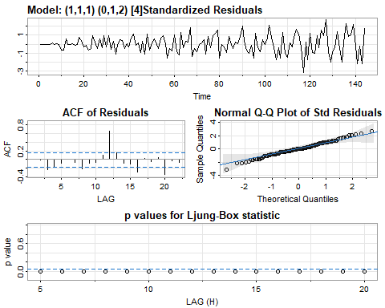

Xt5$ttable

## Estimate SE t.value p.value  
## ar1 0.1098 0.2324 0.4725 0.6374  
## ma1 0.1285 0.2233 0.5755 0.5659  
## sma1 -1.6815 0.0622 -27.0304 0.0000  
## sma2 0.7909 0.0588 13.4550 0.0000

## Peramalan  
library(astsa)  
par(mfrow = c(1, 1))  
sarima.for(Xt, n.ahead = 3, 1, 1, 0, 0, 1, 2, 4, main = "Peramalan")

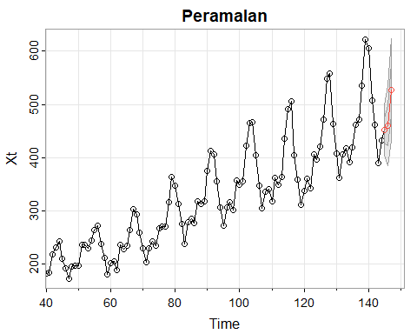

## $pred  
## Time Series:  
## Start = 145   
## End = 147   
## Frequency = 1   
## [1] 451.1692 460.0787 527.4001  
##   
## $se  
## Time Series:  
## Start = 145   
## End = 147   
## Frequency = 1   
## [1] 23.62114 37.39658 48.07671

## Perbandingan  
library(forecast)  
fit <- Arima(Xt, order = c(1, 1, 0), seasonal = list(order = c(0, 1, 2), period = 4))  
plot.ts(Xt, col = "red", main = "Perbandingan")  
lines(fitted(fit), col = "blue")

