library(forecast)

## Warning: package 'forecast' was built under R version 4.2.3

## Registered S3 method overwritten by 'quantmod':  
## method from  
## as.zoo.data.frame zoo

library(tseries)

## Warning: package 'tseries' was built under R version 4.2.3

## 1  
usip = read.csv(file = "D:/Semester VIII/Analisis Runtun Waktu/uts 2/DATA USIP2.csv", header = TRUE, sep = ";")  
attach(usip)  
usip

## TAHUN BULAN JUMLAH  
## 1 2018 jan 7092  
## 2 2018 feb 5278  
## 3 2018 mar 6525  
## 4 2018 apr 6888  
## 5 2018 mei 8646  
## 6 2018 jun 10388  
## 7 2018 jul 8417  
## 8 2018 agu 6877  
## 9 2018 sep 743  
## 10 2018 okt 698  
## 11 2018 nov 9505  
## 12 2018 des 1272  
## 13 2019 jan 8970  
## 14 2019 feb 6676  
## 15 2019 mar 10427  
## 16 2019 apr 8933  
## 17 2019 mei 12299  
## 18 2019 jun 14578  
## 19 2019 jul 9651  
## 20 2019 agu 11844  
## 21 2019 sep 11162  
## 22 2019 okt 13570  
## 23 2019 nov 12757  
## 24 2019 des 14699  
## 25 2020 jan 5785  
## 26 2020 feb 3636  
## 27 2020 mar 4956  
## 28 2020 apr 4208  
## 29 2020 mei 8336  
## 30 2020 jun 6996  
## 31 2020 jul 4907  
## 32 2020 agu 6570  
## 33 2020 sep 5562  
## 34 2020 okt 6383  
## 35 2020 nov 6501  
## 36 2020 des 9101  
## 37 2021 jan 5871  
## 38 2021 feb 4822  
## 39 2021 mar 4889  
## 40 2021 apr 6287  
## 41 2021 mei 7837  
## 42 2021 jun 5397  
## 43 2021 jul 5571  
## 44 2021 agu 3924  
## 45 2021 sep 2737  
## 46 2021 okt 3406  
## 47 2021 nov 3552  
## 48 2021 des 5735  
## 49 2022 jan 5525  
## 50 2022 feb 5311  
## 51 2022 mar 5144  
## 52 2022 apr 5417  
## 53 2022 mei 7681  
## 54 2022 jun 3787  
## 55 2022 jul 6879  
## 56 2022 agu 5802  
## 57 2022 sep 5492  
## 58 2022 okt 6146  
## 59 2022 nov 6176  
## 60 2022 des 10863

Xt = (usip$JUMLAH)  
Xt

## [1] 7092 5278 6525 6888 8646 10388 8417 6877 743 698 9505 1272  
## [13] 8970 6676 10427 8933 12299 14578 9651 11844 11162 13570 12757 14699  
## [25] 5785 3636 4956 4208 8336 6996 4907 6570 5562 6383 6501 9101  
## [37] 5871 4822 4889 6287 7837 5397 5571 3924 2737 3406 3552 5735  
## [49] 5525 5311 5144 5417 7681 3787 6879 5802 5492 6146 6176 10863

# Melakukan tes ADF pada data  
adf.test(Xt)

##   
## Augmented Dickey-Fuller Test  
##   
## data: Xt  
## Dickey-Fuller = -2.7998, Lag order = 3, p-value = 0.2515  
## alternative hypothesis: stationary

# Menampilkan plot data  
par(mfrow=c(1,1))  
plot.ts(Xt)

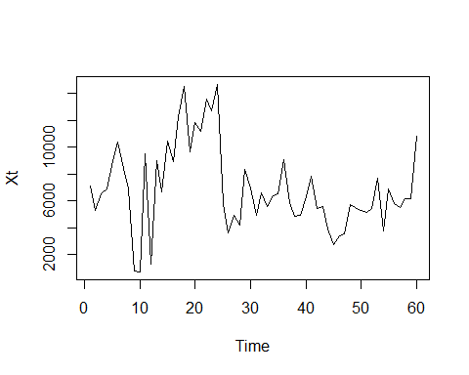

# Menampilkan plot ACF dan PACF  
par(mfrow=c(2,1))  
acf(Xt, lag.max = 120)  
pacf(Xt, lag.max = 120)

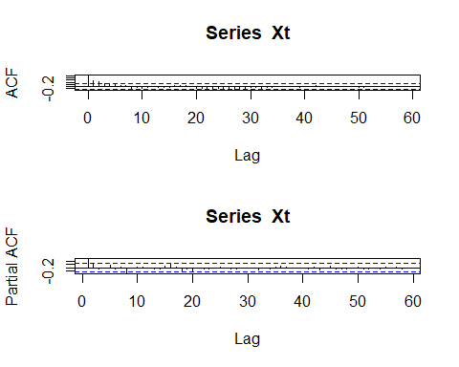

# Melakukan diferensiasi pada data untuk membuatnya stasioner  
differenced_usip <- diff(Xt)  
  
# Menampilkan plot data yang sudah didiferensiasi  
par(mfrow=c(1,1))  
plot.ts(differenced_usip)

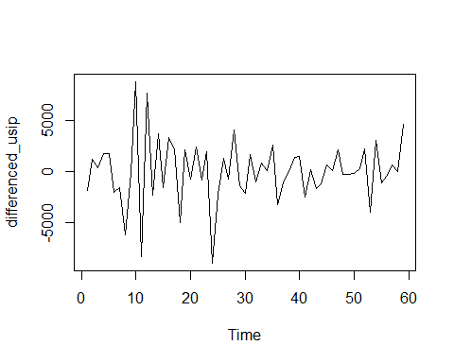

# Melakukan tes ADF pada data yang sudah didiferensiasi  
adf.test(differenced_usip)

## Warning in adf.test(differenced_usip): p-value smaller than printed p-value

##   
## Augmented Dickey-Fuller Test  
##   
## data: differenced_usip  
## Dickey-Fuller = -5.2144, Lag order = 3, p-value = 0.01  
## alternative hypothesis: stationary

# Menampilkan plot ACF dan PACF dari data yang sudah didiferensiasi  
par(mfrow=c(2,1))  
Acf(differenced_usip, lag.max = 120)  
Pacf(differenced_usip, lag.max = 120)

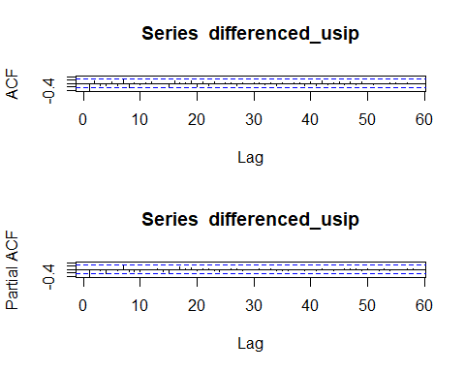

fit = auto.arima(Xt)  
summary(fit)

## Series: Xt   
## ARIMA(0,1,1)   
##   
## Coefficients:  
## ma1  
## -0.4855  
## s.e. 0.1349  
##   
## sigma^2 = 7635568: log likelihood = -550.87  
## AIC=1105.75 AICc=1105.96 BIC=1109.9  
##   
## Training set error measures:  
## ME RMSE MAE MPE MAPE MASE  
## Training set 54.28668 2716.809 1949.862 -33.80457 55.76716 0.9057632  
## ACF1  
## Training set -0.001985753

## estimasi  
#estimasi2  
estimasi2=arima(Xt,order=c(0,1,0))  
estimasi2

##   
## Call:  
## arima(x = Xt, order = c(0, 1, 0))  
##   
##   
## sigma^2 estimated as 9206750: log likelihood = -556.76, aic = 1115.53

residual1=resid(estimasi2)  
shapiro.test(residual1)

##   
## Shapiro-Wilk normality test  
##   
## data: residual1  
## W = 0.94845, p-value = 0.01317

Box.test(residual1,lag=6,type="Ljung-Box")

##   
## Box-Ljung test  
##   
## data: residual1  
## X-squared = 16.507, df = 6, p-value = 0.01128

#estimasi2  
estimasi2=arima(Xt,order=c(1,1,0))  
estimasi2

##   
## Call:  
## arima(x = Xt, order = c(1, 1, 0))  
##   
## Coefficients:  
## ar1  
## -0.4283  
## s.e. 0.1192  
##   
## sigma^2 estimated as 7538668: log likelihood = -550.97, aic = 1105.94

residual2=resid(estimasi2)  
shapiro.test(residual2)

##   
## Shapiro-Wilk normality test  
##   
## data: residual2  
## W = 0.95066, p-value = 0.01673

Box.test(residual2,lag=6,type="Ljung-Box")

##   
## Box-Ljung test  
##   
## data: residual2  
## X-squared = 4.3917, df = 6, p-value = 0.6238

#estimasi3  
estimasi3=arima(Xt,order=c(0,1,1))  
estimasi3

##   
## Call:  
## arima(x = Xt, order = c(0, 1, 1))  
##   
## Coefficients:  
## ma1  
## -0.4855  
## s.e. 0.1349  
##   
## sigma^2 estimated as 7506151: log likelihood = -550.87, aic = 1105.75

residual3=resid(estimasi3)  
shapiro.test(residual3)

##   
## Shapiro-Wilk normality test  
##   
## data: residual3  
## W = 0.96369, p-value = 0.07141

Box.test(residual3,lag=6,type="Ljung-Box")

##   
## Box-Ljung test  
##   
## data: residual3  
## X-squared = 4.2163, df = 6, p-value = 0.6474

#estimasi4  
estimasi4=arima(Xt,order=c(1,1,1))  
estimasi4

##   
## Call:  
## arima(x = Xt, order = c(1, 1, 1))  
##   
## Coefficients:  
## ar1 ma1  
## 0.5415 -0.9842  
## s.e. 0.1574 0.1784  
##   
## sigma^2 estimated as 7195012: log likelihood = -550.56, aic = 1107.12

residual4=resid(estimasi4)  
shapiro.test(residual4)

##   
## Shapiro-Wilk normality test  
##   
## data: residual4  
## W = 0.96979, p-value = 0.1425

Box.test(residual4,lag=6,type="Ljung-Box")

##   
## Box-Ljung test  
##   
## data: residual4  
## X-squared = 6.8429, df = 6, p-value = 0.3356

## 3. Persamaan  
# ARMA (0,1,1)  
library(astsa)

## Warning: package 'astsa' was built under R version 4.3.0

##   
## Attaching package: 'astsa'

## The following object is masked from 'package:forecast':  
##   
## gas

Xt3<-sarima(Xt,0,1,1,0,0,0,0)

## initial value 8.017502   
## iter 2 value 7.918634  
## iter 3 value 7.917425  
## iter 4 value 7.916216  
## iter 5 value 7.915639  
## iter 6 value 7.915633  
## iter 7 value 7.915633  
## iter 7 value 7.915633  
## iter 7 value 7.915633  
## final value 7.915633   
## converged  
## initial value 7.917696   
## iter 2 value 7.917672  
## iter 3 value 7.917639  
## iter 4 value 7.917628  
## iter 4 value 7.917628  
## iter 4 value 7.917628  
## final value 7.917628   
## converged

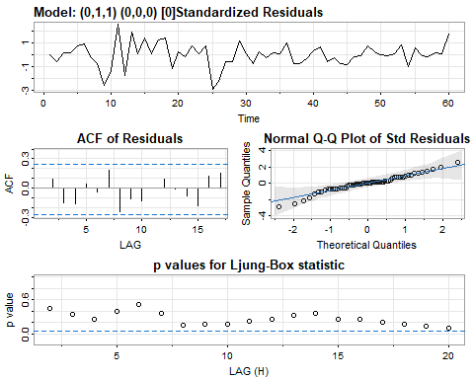

Xt3$ttable

## Estimate SE t.value p.value  
## ma1 -0.4850 0.1347 -3.6010 0.0007  
## constant 33.0827 187.0056 0.1769 0.8602

auto.arima(Xt)

## Series: Xt   
## ARIMA(0,1,1)   
##   
## Coefficients:  
## ma1  
## -0.4855  
## s.e. 0.1349  
##   
## sigma^2 = 7635568: log likelihood = -550.87  
## AIC=1105.75 AICc=1105.96 BIC=1109.9

## 4. Peramalan  
library(forecast)  
# ARIMA (0,1,1)  
fit <- Arima(Xt, order = c(0, 1, 1))  
forecasted_values <- forecast(fit, h = 7)  
forecasted_values

## Point Forecast Lo 80 Hi 80 Lo 95 Hi 95  
## 61 8528.797 4987.545 12070.05 3112.9201 13944.67  
## 62 8528.797 4546.312 12511.28 2438.1112 14619.48  
## 63 8528.797 4149.309 12908.28 1830.9477 15226.65  
## 64 8528.797 3785.418 13272.18 1274.4248 15783.17  
## 65 8528.797 3447.520 13610.07 757.6550 16299.94  
## 66 8528.797 3130.733 13926.86 273.1699 16784.42  
## 67 8528.797 2831.532 14226.06 -184.4177 17242.01

# Plot  
plot(forecasted_values)  
  
# ARIMA (1,1,1)  
fit <- Arima(Xt, order = c(1, 1, 1))  
forecasted_values <- forecast(fit, h = 7)  
forecasted_values

## Point Forecast Lo 80 Hi 80 Lo 95 Hi 95  
## 61 9054.743 5548.653 12560.83 3692.6407 14416.85  
## 62 8075.582 4053.742 12097.42 1924.7082 14226.46  
## 63 7545.372 3365.790 11724.95 1153.2524 13937.49  
## 64 7258.266 3023.054 11493.48 781.0684 13735.46  
## 65 7102.800 2845.214 11360.39 591.3842 13614.22  
## 66 7018.616 2750.594 11286.64 491.2398 13545.99  
## 67 6973.031 2699.298 11246.76 436.9200 13509.14

# Plot  
plot(forecasted_values)

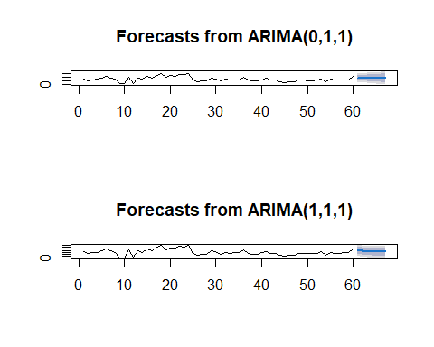

## 5. Perbandingan  
# ARIMA (0,1,1)  
library(forecast)  
par(mfrow=c(1,1))  
fit<-Arima(Xt,order=c(0,1,1))  
plot.ts(fit$x,col="red")  
lines(fitted(fit),col="blue")

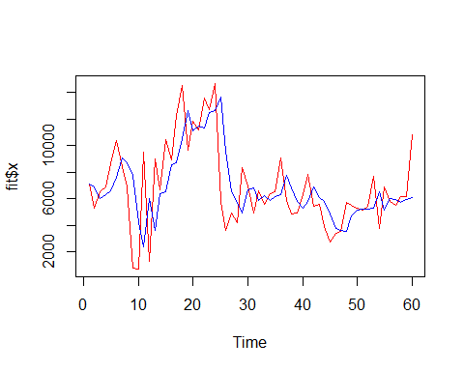

#ARIMA (1,1,1)  
library(forecast)  
par(mfrow=c(1,1))  
fit<-Arima(Xt,order=c(1,1,1))  
plot.ts(fit$x,col="red")  
lines(fitted(fit),col="blue")

