# GoalSync: A Collaborative Flask Football Project

**Open Source Technology Project Report**

**Submitted By:**

Alankar Tripathi (23070123015)  
Ashutosh Singh (23070123033)  
Labdhi Mandovara (23070123078)  
Aamir Quraishi (23070123002)

## Problem Statement

The primary objective of this project is to create a simple yet functional Flask-based web application that displays football player details such as their names, clubs, and countries. This project was developed as part of the Open Source Technology course, emphasizing collaboration, issue tracking, and contribution management through GitHub.

## Objective

The goal of this project is to gain hands-on experience with Flask web framework and collaborative software development using GitHub. The project focuses on building a small-scale football player information system while learning how to raise, resolve, and manage issues collaboratively.

## Tools and Technologies Used

- Flask (Python Web Framework)  
- HTML, CSS (Frontend Design)  
- Git and GitHub (Version Control and Collaboration)  
- Virtual Environment (venv)  
- PyCharm (IDE)

## Methodology

1. Designed a simple Flask app to display football player data.  
2. Structured the project using templates and static files for clean code organization.  
3. Created a GitHub repository and added all contributors as collaborators.  
4. Each team member cloned the repository and set up the virtual environment.  
5. Collaborators raised meaningful GitHub issues, such as missing requirements.txt, README.md, and environment variable management.  
6. The team resolved these issues and pushed commits to reflect the changes.

## Some Snapshots:

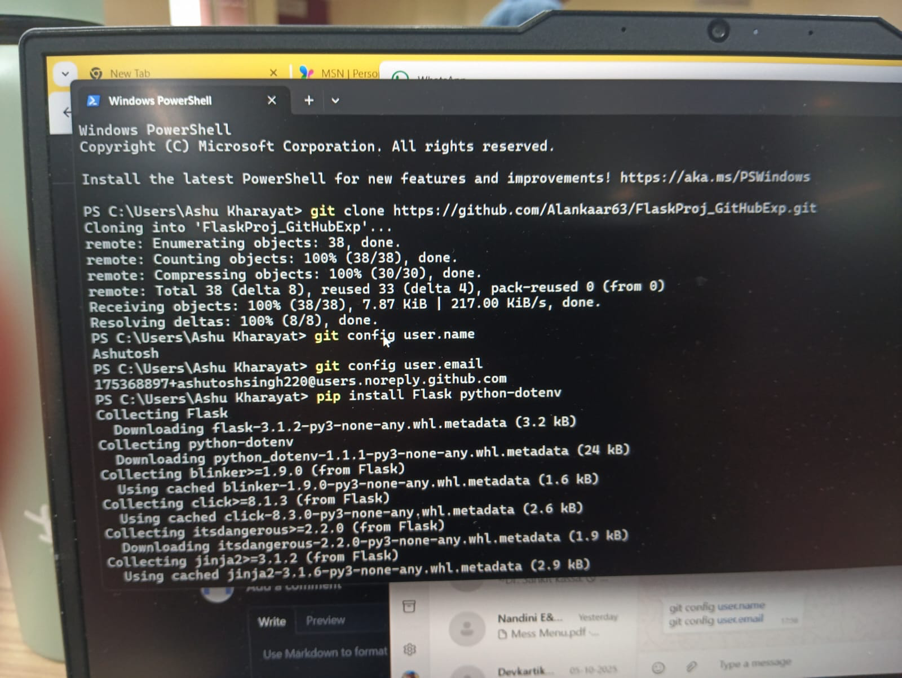

## Collaboration and GitHub Workflow

The project was a collaborative effort conducted via GitHub. All four members actively participated in the development and issue resolution process. Key activities included:  
- Creating and managing issues raised by other team members.  
- Setting up the requirements.txt file to list dependencies.  
- Writing a detailed README.md file.  
- Configuring virtual environments and ensuring the app runs consistently across systems.  
- Discussing enhancements like deploying the app and improving code structure.

## Issues Raised and Solved

1. Missing README.md file — A comprehensive README was added explaining the project.  
2. Missing requirements.txt — The team created it using pip freeze.  
3. Environment variable configuration — Discussed improving security using .env files.  
4. GitIgnore file addition — Added to prevent venv and cache files from being pushed.  
5. Deployment-related improvement suggestions for future updates.

## Results / Output

The Flask web app successfully runs locally on http://127.0.0.1:5000/, displaying a list of football players with their respective clubs and countries. The collaboration workflow enhanced our understanding of version control, branch management, and issue tracking on GitHub.

## Conclusion

This project provided valuable insights into collaborative development using GitHub while building a small-scale Flask application. The teamwork improved our understanding of environment setup, dependency management, and best practices for open-source project collaboration.

## References

- Flask Documentation: https://flask.palletsprojects.com/  
- GitHub Guides: https://guides.github.com/  
- Python Documentation: https://docs.python.org/3/