

**School of Computing**

**SRM IST, Kattankulathur – 603 203**

**Course Code: 18CSC206J**

**Course Name: Software Engineering and Project Management**

| **Experiment No** | 6 |
| --- | --- |
| **Title of Experiment** | Design a System Architecture, Use Case and Class Diagram |
| **Name of the candidate** | **Alankriti Dadlani** |
| **Team Members** | **Aritra Karar , Sanjay.P** |
| **Register Number** | **RA2111028010010** |
| **Date of Experiment** | **11/03/2023** |

**Mark Split Up**

| **S.No** | **Description** | **Maximum Mark** | **Mark Obtained** |
| --- | --- | --- | --- |
| 1 | Exercise | 5 |  |
| 2 | Viva | 5 |  |
| **Total** | | **10** |  |

**Staff Signature with date**

**Aim**

To Design a System Architecture, Use case and Class Diagram

**Team Members:**

| **Sl No** | **Register No** | **Name** | **Role** |
| --- | --- | --- | --- |
| **1** | **RA2111028010020** | **Aritra karar** | **Rep** |
| **2** | **RA2111028010010** | **Alankriti Dadlani** | **Member** |
| **3** | **RA2111028010012** | **Sanjay.P** | **Member** |

Requirements

<System Architecture, Use Case>

Result:

Thus, the system architecture, use case and class diagram created successfully.

**SYSTEM ARCHITECTURE**

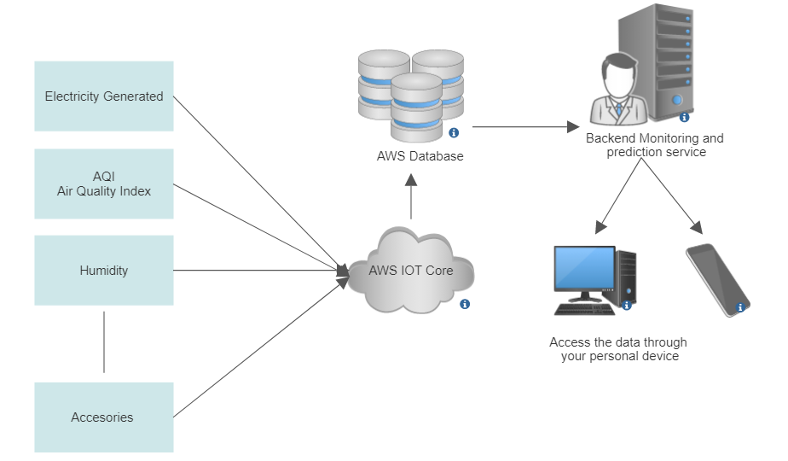

**USE CASE DIAGRAM – Example**

