**Skibbereen & District Car Club Newsletter – April 2015**

If any club member wants to send me on info/results/photos/in-cars/etc. please feel free to send them onto [info@skibbdcc.com](mailto:info@skibbdcc.com).

Circuit of Ireland Rally – Apr 3rd/4th:

Round 3 of the European Rally Championship and also round 3 of The Clonakilty Blackpudding Irish Tarmac Championship. Three club members took part in this rally. Aileen Kelly who was navigating Richard Tannihall (Peugeot 208 R2) came 2nd in class 2 and 12th O/A in the national section of the rally. William Lynch who was navigating for Philip Greenlee (Ford Escort Mk2) also did the national section of the rally. Eamon Hayes also did the rally and was navigating for Tommy Doyle (Skoda Fabia S2000) and they came 7th O/A in the International section of the rally. Well done to all.

Clare Autotest – Apr 11th/12th:

Round 2/3 of The Premier Auto Parts Munster Autotest Championship saw a good lot of club members take part. On Saturday Don Giles (Westfield) came 3rd O/A and 1st in his class. Martin Walsh (Starlet Special) came 5th O/A and 1st in his class. Alan Clarke (Mini Special) was 6th O/A and 2nd in his class. Michael Lynch (Starlet) also got 1st in his class. On Sunday Don Giles (Westfield) was 4th O/A and 2nd in his class. Alan Clarke (Mini Special) was 5th O/A and 1st in his class. Martin Walsh (Starlet Special) came 6th O/A and 1st in his class. Michael Lynch (Starlet) was again 1st in his class. Well done to all.

Moonraker Forestry Rally – Apr 12th:

Round 3 of The Valvoline National Forest Rally Championship was The Abbey Hotel Moonraker Forest Rally based in Ballyvourney. First of all a big thank you to all the marshals from Skibbereen & District Car Club that marshalled on Stage 2/4 of this rally. Yet again it was great to see such a strong turnout of marshals from our club. Well done to all.

A good few club members competed on this rally. JJ Cremin who was navigating for Gerard Lucey (Mitsubishi Evo 8) had a superb run in getting 1st in class 20 and a strong 4th O/A. Michael Kearney who was navigating for James Lucey (Honda Civic) got 3rd in class 11F. Other club members that competed on the rally were David Beamish/Muireann Hayes (Opel Corsa), Henry Jennings/Finbar Jennings (Opel Corsa) and Iarla Mc Carthy/Eoghan Mc Carthy (Honda Civic). Well done to Finbar Jennings who was doing his very first rally. Well done to all club members that took part.

Circuit of Kerry Rally – Apr 19th:

The Fels Point Hotel sponsored Circuit of Kerry Rally was a counting round of The Top Part West Coast Rally Championship. A good number of Skibbdcc club members took part in this rally. Club member Adrian Deasy guided Alan Ring (Subaru WRC S12B) to an outright win on this rally. Well done lads on getting 1st O/A. Ella Ryan who was navigating for Don Keating (Subaru Impreza) were 10th O/A and 1st in Class 20. Fintan Canty/Denis O’Mahony (Ford Escort Mk2) also took part in the rally and finished 17th O/A and 5th in Class 13. Club member Breda O’Driscoll also did the rally and was navigating for Sean Moran (Toyota Corolla RWD). In the junior section club member Eric Calnan was navigating for Anthony Sheehan (Honda Civic) and they were 6th O/A in the junior section. Well done to all club members that took part.

Monaghan Stages Rally – Apr 26th:

Round 3 of the Triton Showers & Accessories National Rally Championship in which the Fastnet Rally will be the final round of this newly sponsored championship in the end of October. The Hillgrove Hotel Monaghan Stages Rally saw only one club member take part. Club member Adrian Deasy who was navigating for Alan Ring (Subaru Impreza S12B) came 12th O/A and 3rd in class 7.

Other News:

Skibbereen & District Car Club would like to congratulate Kris Meeke/Paul Nagle (Citroen DS3 WRC) who took a very well deserved 1st WRC victory in Rally Argentina recently. Paul Nagle was the special guest at the Skibbereen & District Car Club and Southern Four Prize giving in January earlier this year. Paul was always a regular competitor in the Fastnet Rally throughout the years and now he and Kris have a WRC O/A rally win to their name. Well done to both Kris and Paul on this massive WRC rally win and hopefully there will be many more to come.

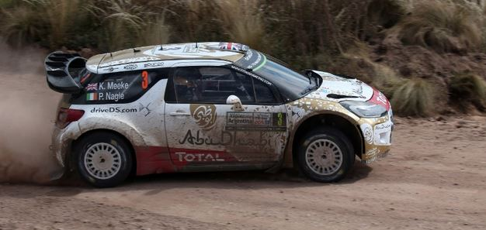

Iarla Mc Carthy (Skibbereen & District Car Club PRO)