Lec5:

import pandas as pd

from sklearn.model_selection import train_test_split

from sklearn.tree import DecisionTreeClassifier

from sklearn.metrics import accuracy_score

from sklearn.tree import export_graphviz

import graphviz

import matplotlib.pyplot as plt

import io

data = pd.DataFrame({

    'Credit score': [700, 600, 750, 650, 800],

    'Income': [5000, 3000, 7000, 4000, 6000],

    'Loan amount': [10000, 5000, 15000, 8000, 12000],

    'Loan term': ['short-term', 'long-term', 'short-term', 'long-term', 'short-term'],

    'Employment status': ['employed', 'self-employed', 'unemployed', 'employed', 'other'],

    'Previous delinquencies': ['no', 'yes', 'no', 'no', 'yes'],

    'Loan Approval': ['yes', 'no', 'yes', 'no', 'yes']

})

# Split the dataset into features (X) and target variable (y)

X = data.drop('Loan Approval', axis=1)

y = data['Loan Approval']

# Convert categorical variables to numerical using one-hot encoding

X = pd.get_dummies(X)

# Split the dataset into training and test sets

X_train, X_test, y_train, y_test = train_test_split(X, y, test_size=0.2, random_state=42)

# Build the decision tree classifier

clf = DecisionTreeClassifier()

# Train the decision tree classifier on the training data

clf.fit(X_train, y_train)

# Use the trained classifier to predict loan approvals for the test data

y_pred = clf.predict(X_test)

# Evaluate the accuracy of the model

accuracy = accuracy_score(y_test, y_pred)

print("Accuracy: {:.2f}%".format(accuracy * 100))

# Visualize the decision tree

dot_data = export_graphviz(clf, out_file=None, feature_names=X.columns, class_names=['No', 'Yes'], filled=True, rounded=True)

graph = graphviz.Source(dot_data)

# Save the decision tree plot as a file

image_data = io.BytesIO()

graph.format = 'png'

graph.render('loan_decision_tree', format='png', view=False)

graph.render(filename='loan_decision_tree', format='png', view=False)

# Load and display the decision tree plot

image = plt.imread('loan_decision_tree.png')

plt.imshow(image)

plt.axis('off')

plt.show()

B:

import pandas as pd

import numpy as np

import matplotlib.pyplot as plt

from sklearn.datasets import make_blobs

from sklearn.model_selection import train_test_split, GridSearchCV

from sklearn.neighbors import KNeighborsClassifier

from sklearn.metrics import accuracy_score

# Generate a random dataset with two features (x1, x2)

DIM = 20      # Number of features (dimension)

CLASSES = 4   # Number of classes

N = 1000      # Number of samples

X, y = make_blobs(n_samples=N, centers=CLASSES, n_features=DIM, cluster_std=3)

print(np.unique(y))

X[:, 2] = X[:, 2] * 1000

X[:, 4] = X[:, 4] * 10000

X[:, 15] = X[:, 15] * 100

# Divide the dataset into training and test sets

X_train, X_test, y_train, y_test = train_test_split(X, y, test_size=0.3)

print(X_train.shape, X_test.shape)

# Implement the KNN classification

k = KNeighborsClassifier(n_neighbors=2)

k.fit(X_train, y_train)

print("KNeighborsClassifier(n_neighbors=2)")

y_pred = k.predict(X_test)

accuracy = accuracy_score(y_test, y_pred)

print("accuracy =", accuracy)

# Train the KNN classifier on the training set and determine the optimal value of k using

# cross-validation.

param_grid = {'n_neighbors': [1, 2, 3, 4, 5, 6, 7, 8, 9, 10, 11, 12]}

cv = GridSearchCV(k, param_grid, refit=True, verbose=3, n_jobs=-1)

cv.fit(X_train, y_train)

print(cv)

print("print(cv.best_params_) =", cv.best_params_)

k2 = KNeighborsClassifier(n_neighbors=cv.best_params_['n_neighbors'])

k2.fit(X_train, y_train)

y_pred2 = k2.predict(X_test)

accuracy2 = accuracy_score(y_test, y_pred2)

print("accuracy2 =", accuracy2)

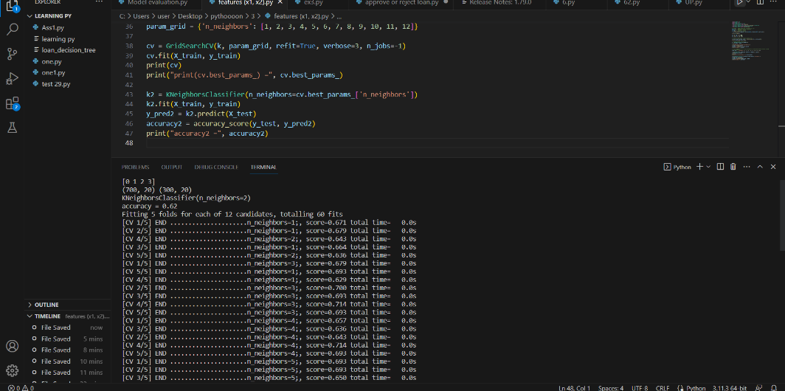

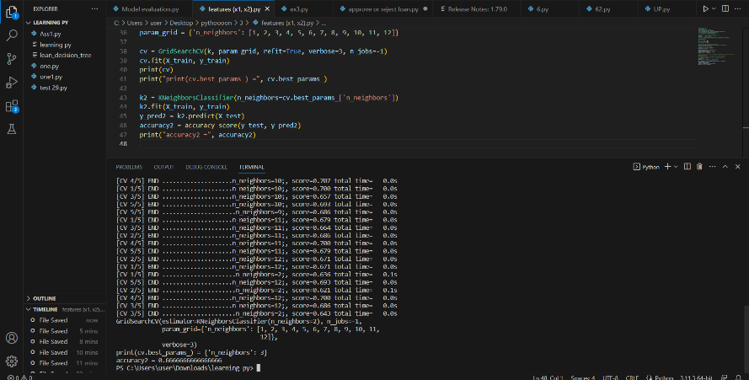

C:

Regression:

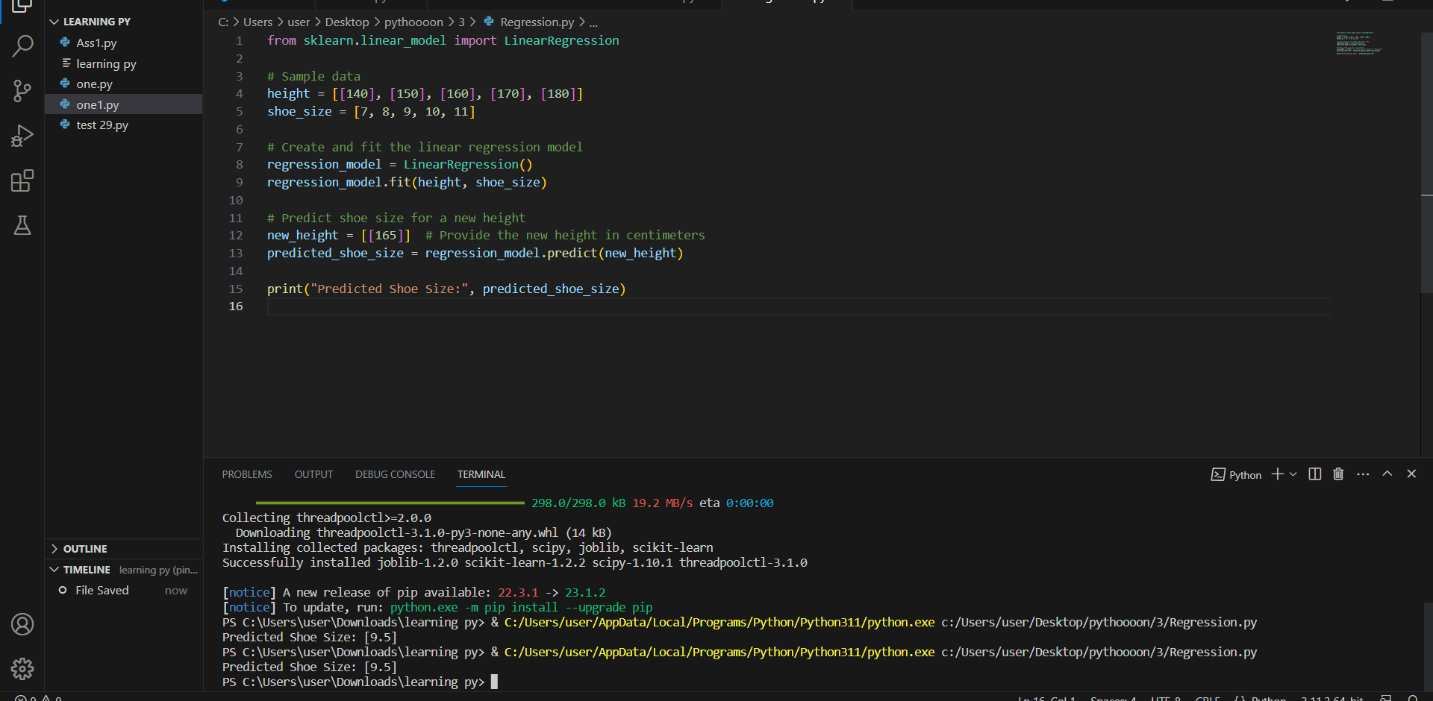

Model evaluation B :

Accuracy = TN+TP/ TN+ FP + TP + FN

=(20+30)/(20+10+30+30)=0.5

0.5 accuracy means that the model predict 50% of the actual values are correct which means that this result not good because it's not help us to make a good decision>

Precision = TP/ TP + FP

=(20)/(30+20)=0.4

0.4 of the precision means that the model is not very good.

The model predict the positive class correctly for 40%, where the model predict the positive class negative for 60%.

Recall =TP/ TP + FN

=(20)/(20+10)=0.6

Recall of 0.6 means that out of all the actual positive class, the model correctly identified 60% of them.

F1 Score = 2 * Precision * Recall / Precision + Recall

=(2*0.4*0.6)/(0.4+0.6)=0.48

Ex3:

*#imported library*

**from** random **import** randint

*#create a list of integers*

rand_int**=**[]

**for** i **in** range(1,11):

num**=**randint(1,10)

rand_int**.**append(num)

rand_int

*#calculate mean*

mean **=** sum(rand_int) **/** len(rand_int)

mean

*#calculate standard deviation*

differences **=** [(value **-** mean)**\*\***2 **for** value **in** rand_int]*#x-mean*

sum_diff**=**sum(differences) *#sum of x-mean*

stand_d**=**(sum_diff **/** (len(rand_int) **-** 1)) **\*\*** 0.5

stand_d

*#calculate z-score*

z_scores **=** [(value **-** mean) **/** stand_d **for** value **in** rand_int]

z_scores

min_x**=**min(rand_int)

max_x**=**max(rand_int)

*#calculate min-max*

min_max**=**[(value**-**min_x)**/**(max_x**-**min_x) **for** value **in** rand_int]

min_max

