Name: Alanoud AlHwaireny

GitHub: [AlanoudAlHw@gmail.com](mailto:AlanoudAlHw@gmail.com)

**STC customer churn prediction Report**

**Abstract**

The goal of this project was to use Classification algorithms to predict the STC customer churn to help improve operations, quality and gain customer satisfaction. I worked with data provided by Kaggle. After refining a dataset, I used 4 models to optimize and communicate my results using Python and the seaborn library.

**Design**

The objective of this study is to use past application data to predict customer churn for STC and avoid the reason for churns, because it aspires to increase the quality of customer satisfaction and to know the reasons for customer churn. in addition to predicting behavior to retain customers.

**Data**

In view of solving the problem and obtaining a realistic result, we decided to use the Dataset from Kaggle. The data set has 7043rows and 21 columns.

**Algorithm**

In the data cleaning stage, I observe that the dataset contain a few NULL values, and there is some outliers were found in the dataset all I removed before working on it.

**Tools**

* Python programming language
* Pandas, Numpy, Matplotlib, Sklearn, seaborn
* Jupyter notebook.

**Communication**

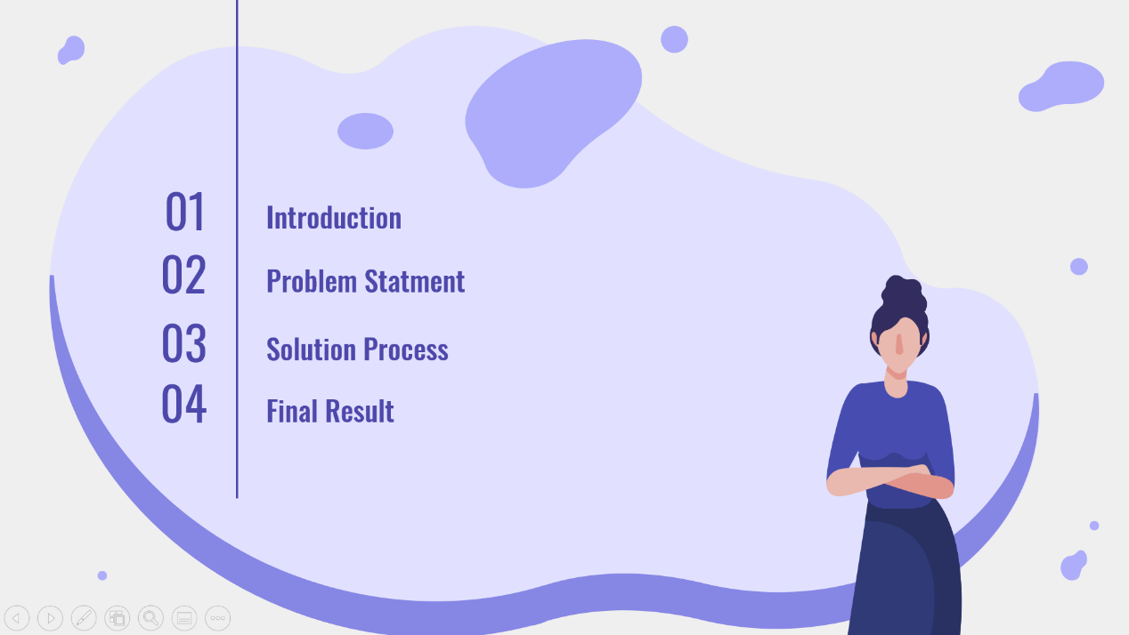

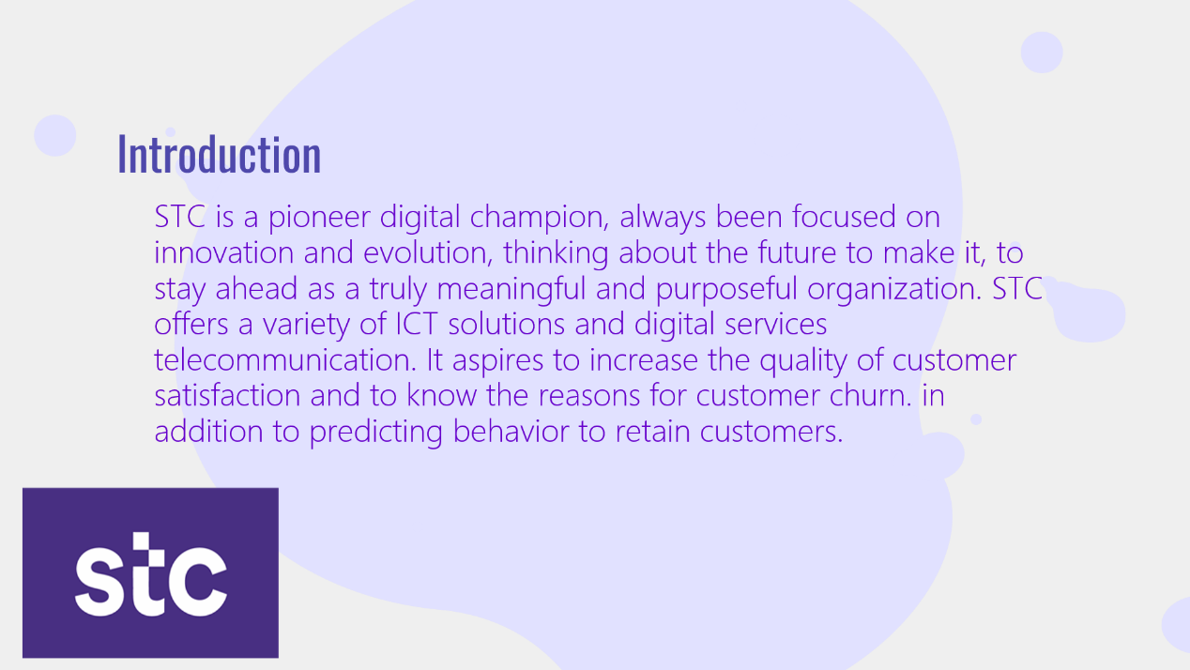

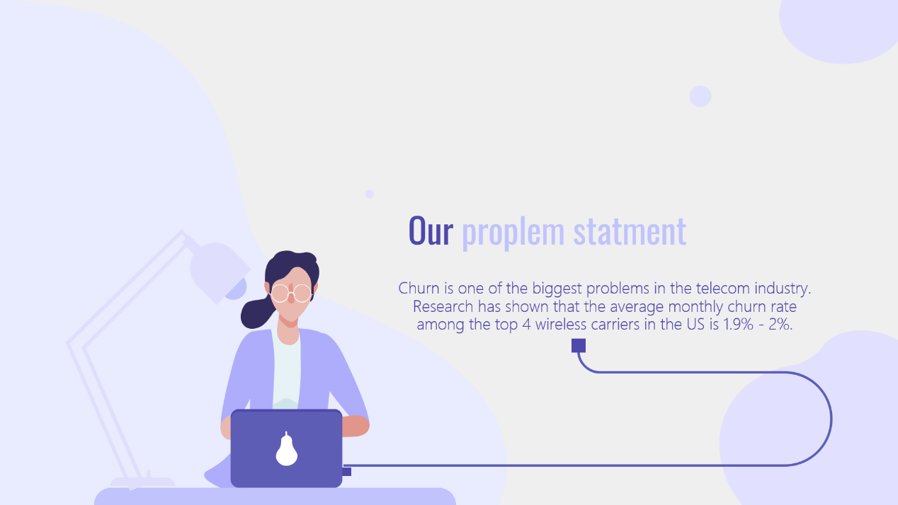

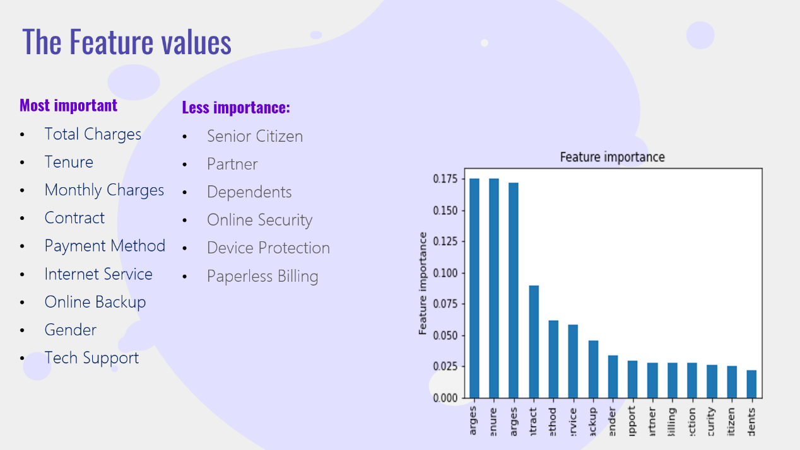

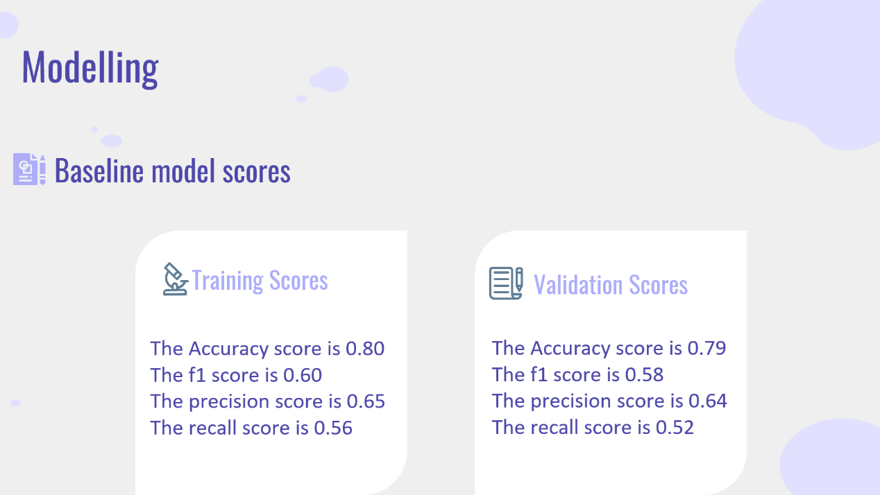

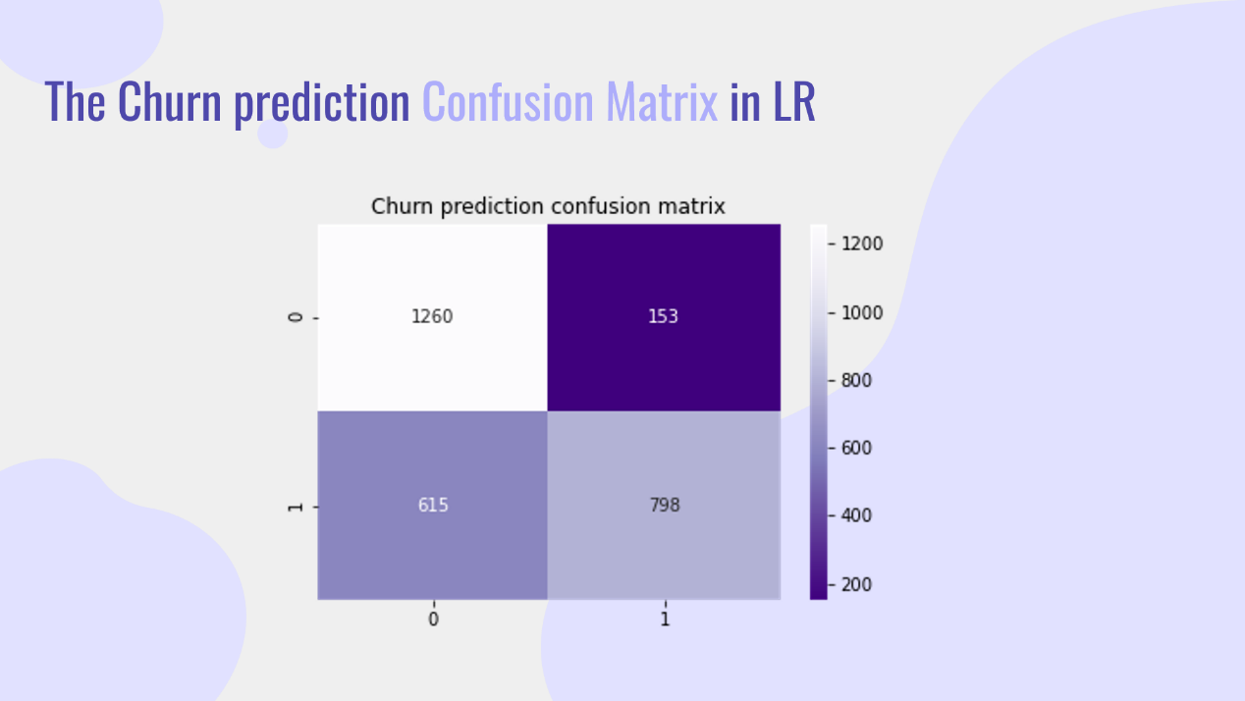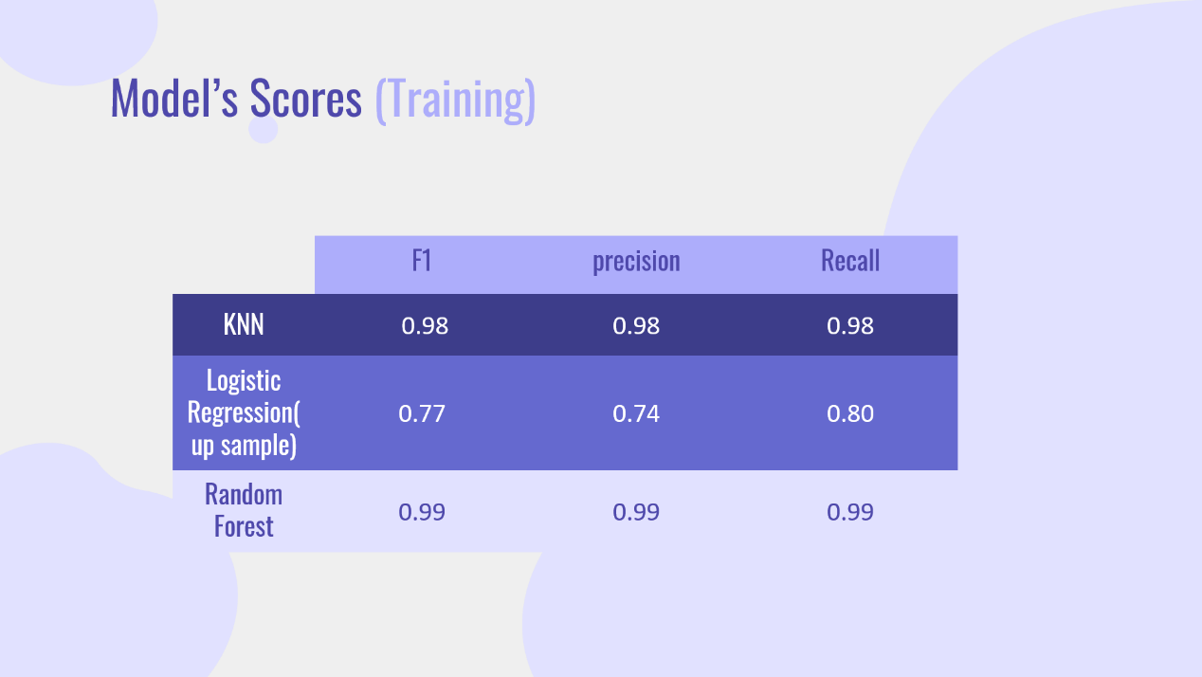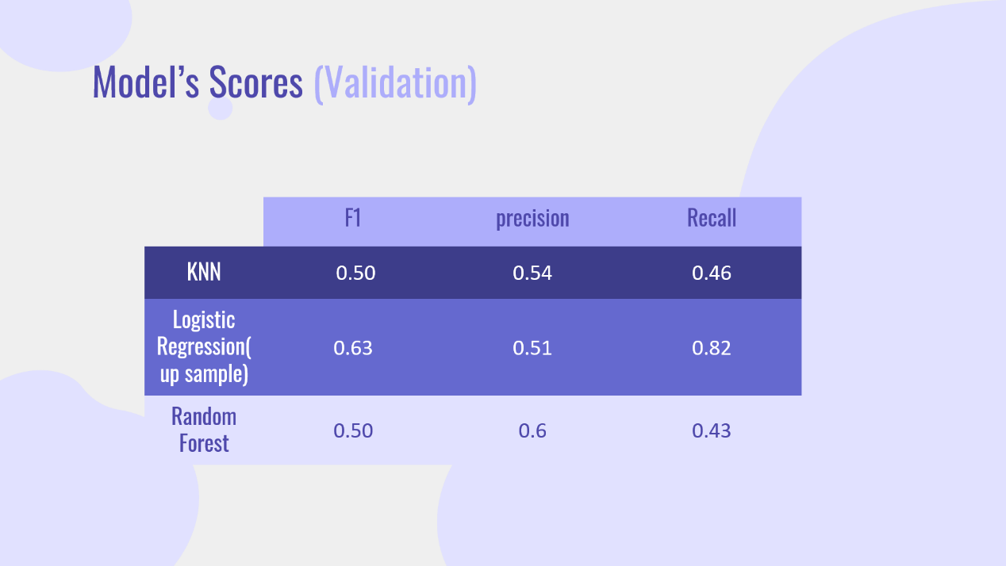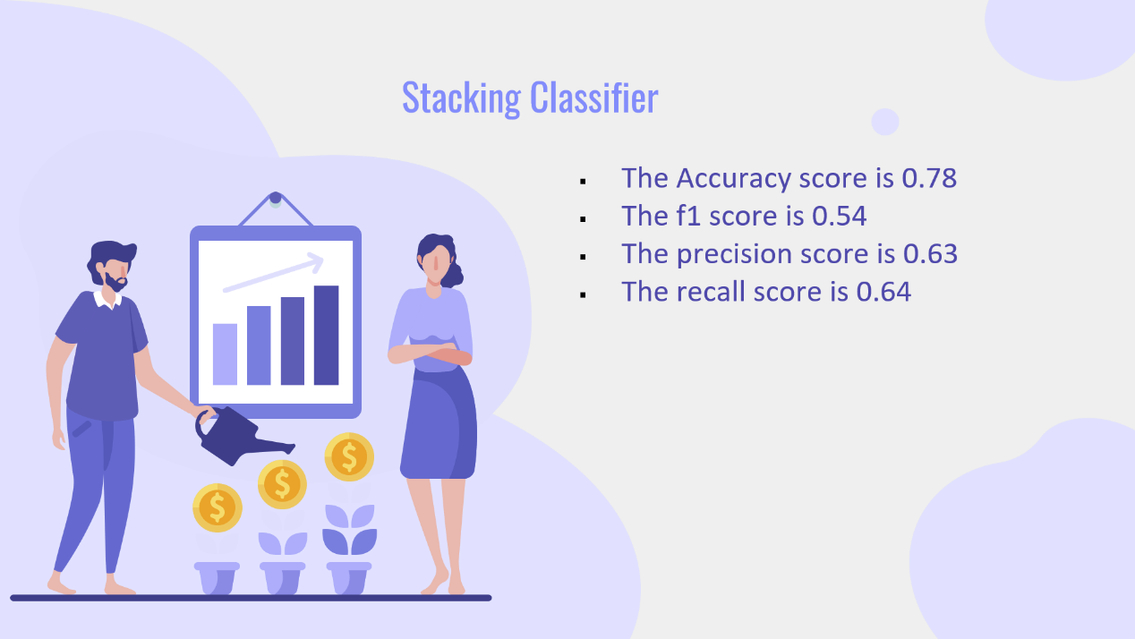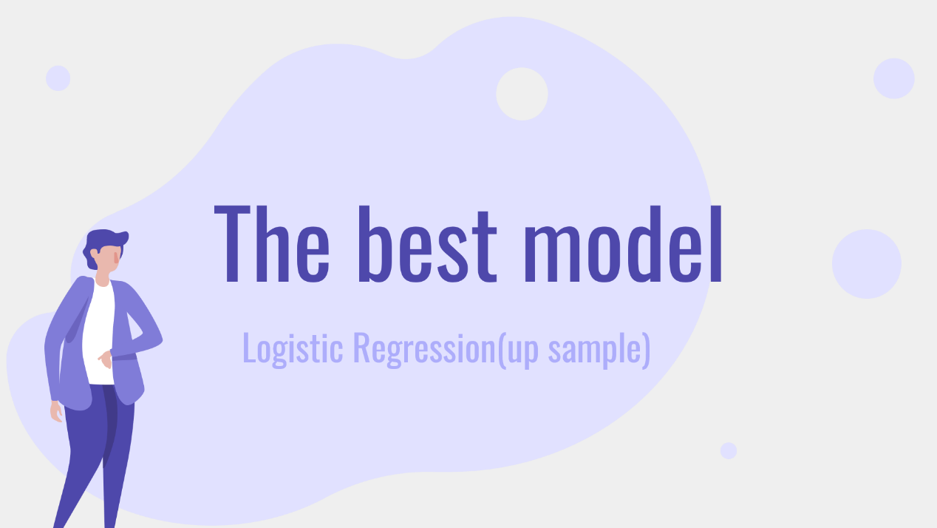

**The Graphs:**

