

COMP5138

Services Science Management

Group Assignment

Students Name:

11500811G QING Pei

10670906G YIP Chung Chung

10606122G MO Lee Chun

11521100G SO Chun Fai

Table of Contents

[**1.** **INTRODUCTION** 1](#_Toc310161878)

[**2.** **SERVICE ANALYSIS** 1](#_Toc310161879)

[**2.1 Service Encounter** 1](#_Toc310161880)

[**2.2 4Is and 3Ps** 2](#_Toc310161881)

[**2.3 Service Quality Dimensions (RATER)** 3](#_Toc310161882)

[**3.** **SERVICE REDESIGN** 5](#_Toc310161883)

[**3.1** **Critical provider gap** 5](#_Toc310161884)

[**3.2** **Define the current process** 5](#_Toc310161885)

[**3.3** **Measurement of key aspects** 6](#_Toc310161886)

[**3.4** **Improvement plan** 6](#_Toc310161887)

[**3.5** **Implementation plan with ITIL framework** 11](#_Toc310161888)

[**4.** **Conclusion** 15](#_Toc310161889)

[**Reference** 16](#_Toc310161890)

1. **INTRODUCTION**

This paper is discussed about the current services of Health care center in terms of services science management concepts. From this paper, we’ll analysis the services provided by Health care center in several dimension. First, we present the services with service encounter model, and identify the incidents with 4Is and 3Ps, thus, analysis the service quality with RATER and hence, to identify the provider gaps. Then, redesign the service base on IT improvement in terms of six sigma project and the ITIL framework.

**1.1 Background**

Health care center is large health center that contain 3,000 employee and 200,000 members, providing health consultation services for members and other new visit patients, it provides health consultation, medical treatment and pharmacy. Moreover, based on the analysis, there’s a great problem of the services provided at reception area, hence, suggested an I.T. improvement to improve the services by redesign the process.

1. **SERVICE ANALYSIS**

**2.1 Service Encounter**

As customers would be unhappy if the reception process takes too long. There are two critical incidents that take up most of the time: registration and waiting.

In this case study, we will focus on improving the registration time.

During registration, the roles are patient and one or more receptionists.

A patient provides basic information by telling his/her name, ID number, phone number or address. Receptionist then search for the medical history record of that patient. The records are sorted using own Record ID. The mapping from patient demographic information to the Record ID is time consuming if manually done.

If the search fails, (i.e. the patient is a new customer), the receptionist needs to create a new record. The patient also has to wait for the receptionist’s handwriting or keyboard typing. This not only makes the process time longer but also poses a risk of data input errors.

**2.2 4Is and 3Ps**

From the incident above, we’ll identify the service characteristic by 4I and the service management by 3P.

4Is

Intangible:

Receptionist greeting manner for the patients is intangible.

Personal information of each patient and the symptoms on each time visited is a variant.

Inventory:

Each visited patient will have their own personal information, referrals, insurance, allergies and diagnostic records stored in paper at the shelf, located at back side of the reception area.

Inconsistent:

The number of patient visited on each day is different, and the reception greeting manner is different on every time to every patients and the patients’ personal information and the symptoms on each time visited is inconsistent. More, the queuing time required for patient to register the service is different each time, and it’s depends on number of registered patients at the same time.

Inseparable:

Reception manner and the patients’ manner will affect each other feelings. While patients are waiting in the reception area, patient’s behavior will affect another patient. The more patients registered at the same time, the more patients have to be waiting.

3Ps

People:

Receptionist helps to answer patient’s enquiry, register patients’ personal information and help patient to register the consultation services, retrieve the patient personal information, last visited data and diagnostic records. Nurses will bring those patients’ file including diagnostic records to the consultation room to the doctors.

Physical:

Reception waiting area contains several chairs for patient to sit while waiting, a drink machine for patient while they are waiting, some desks for patient or their relatives to fill in their personal information. And there’re some big shelves, which is used to storing patients’ personal information and their previous diagnostic records.

Process:

Whenever each patients walk in, they need to queue up in front of the reception area to finish the consultation registration process.

During the registration, receptionist has to confirm the correctness of the information provided from the patients. After finish the registration process, receptionist will give a ticket to the patients, with that ticket patient will queue up outside of the general consultation room.

**2.3 Service Quality Dimensions (RATER)**

For the registration process, the following service quality dimensions are critical:

Assurance:

Is private information of patients well protected from unauthorized access? This is very important to the patients as they do not expect any leak of the personal information they provide for registration purpose.

Responsiveness:

Patients’ satisfaction in the registration process depends mainly on the time spent on retrieving the record or creating a new record.

Meanwhile, if there is only one receptionist and he or she is busy finding the record and thus becomes unable to talk to the patient, the patient’s new requests or questions will not be responded promptly.

**2.4 Gaps Model analysis**

Gaps Model analysis

As stated before, the bottleneck is occurred at the “Patients’ information registration”, the bottleneck is mainly caused by several weakness on “people” and “process”, which can be classified into three gap: “Knowledge Gap”, “Designs and Standards Gap” and “Performance Gap”.

Knowledge Gap is the weakness on the searching, understanding and analysis on the customer expectation. The management of QC put all their concentration on their customer, they do the survey based on the patients who stay at the waiting area, they have miss the one who is dissatisfied and leaved in reception area, hence they can just got the feedback as “the cure quality is good” or “the waiting time to see a doctor is too long”, and neglected the critical weakness in reception area. John Sitzia and Neil Wood (1997)[1] had concluded a Fitzpatrick framework in there research which stated that the receptionist is one of the factor affecting the accessibility of a hospital, customer may leave if they are hard to access to the doctor. Due to the miss of the opinions from the dissatisfied customer, the management of QC may have wrong decision in the reception service design which causes the critical weakness from the registration part.

Designs and Standards Gap is the weakness on the design of the system and standard to provided satisfactory service which the management will to provide after the analysis of customer expectation. Although the service of the reception is underestimated as the fail on the Knowledge Gap, the current registration system is too inefficiency to fulfill the daily operation of the hospital. The system only allow the staff to record the information in hand writing, in the survey from Jill Gladstone(1995)[2], most of the medical errors were caused by the illegible hand writing, and there are 12.7% of error is caused by “incorrect patient”, nurses or doctors may have made mistake on the patient’s information from the handwriting registration record, this may also cause the redundancy of registration if the nurse fail to search for the existing patient’s record with the bad handwriting; the huge amount of the physical record is not able to provide a efficiency searching environment, nurses need to search the record from drawers after asking the basic information to check whether he or she is a registered patient, then there will be a waiting time before registration, which longer the time of registration process; the registered patient is served with the unregistered in a same line, the query may get stuck to wait for the registration.

Performance Gap is the weakness of the staffs or customer to use the designed system to provide or enjoy satisfactory service, which is mainly base on the ability and characteristic individually; there may be error input caused by spelling mistake and time spent on the correction; the staff is too slow in recording and searching so that the query stuck at the peak time; the staff may be confused by the hand-writing record in file searching; the staff do not pay enough attention on registration; the staff may be stressed by the complex operation of the registration; the patient may be stressed by the illness; the patient is not able to present their personal information and the staff is not helpful enough to help them; and there are still many of unexpected matter occur as the ability and characteristic is not identical.

1. **SERVICE REDESIGN**
   1. **Critical provider gap**

The Designs and Standards Gap is decided to be the critical provider gap, the analysis is stated below:

To improve the Knowledge Gap, the sampling base should have to be redesign to cover the entire target market, and the survey should have to be redesign to cover the entire services provided. However improving this gap can just help to identify the customer expectation and the problem of service for feather improvement, which is not critical to deal with.

To improve the Performance Gap, some training can be provided to improve the skill of shorthand, filing and searching document, stress and emotion handling for the staff; hire additional staff to do the searching or open more line for registration. However, the limitation of the system cause bottleneck in the registration: for example it is hard for more than one person searching the file in the same drawer, the improvement may not be significant.

For the Designs and Standards Gap, there is an obviously critical problem that the handwriting system and the disordered operation process has limited the efficiency of performance, hence the system and process have to be redesign.

* 1. **Define the current process**

The fish bone diagram is used to clarify cause-and-effect in the current process:



Various causes of long processing time can be found. Some of them can be improved with the help of automated IT systems.

* Record searching is one of the most time consuming task in the manual workflow. Utilizing computer systems to assist the searching staff will reduce the amount of time patients have to wait as well as the repetitious and tedious work of receptionists’.
* The customer authentication process can be improved by accepting more than just ID cards. Fingerprint, palm print or iris recognition can also be accepted as an authentication method in case the customer forget to take his or her ID card. This is a relatively bigger change to customers which needs further investigation.
  1. **Measurement of key aspects**

The total amount of time a patient spends in the reception flow is used as the measurement of the current process. Then data is collected and visualized in a Pareto chart to spot the greatest potential for improvement.

The general registration process (incidents in the service encounter we focus on) takes up 72% of total time spent. Consultation, which is the key service patients want, only takes a quarter. This imbalanced time distribution affects customer satisfaction. Improving registration time will make customers happier.

* 1. **Improvement plan**

Analysis

Service blueprinting of the current reception flow

**Line of**

**Internal Interactive**

**Line of Visibility**

**Line of Interaction**

**Front**

**Stage**

Arrive

Gather patient information

Patient registration

Wait

Go to consultation room

Receptionist

Greeting to patient

Receptionist

Listen to the patient’s enquiry

Receptionist

Collect patient’s personal information

Receptionist

Find the patient’s file

Health care database

(Several shelves with all the patients’ file

Receptionist

Verify with insurance company

Insurance company

Receptionist

Give the waiting ticket

Receptionist

Put the patient’s file into queuing tray

Nurse

Bring patients’ file to general doctor

**BackstagBackstage**

When patient arrive the reception area, receptionist will greeting to the patient, then patient tells receptionist his/her needs, receptionist will help patient to register the service, first receptionist will check whether the patient is member or not by searching the patient’s file in alphabet order of the name and patient’s ID card number from the database (Several big shelves which contains lot of all the existing patients’ files), then verify the patient’s insurance record with corresponding insurance company. After that, receptionist will put the patient’s file into a queuing tray for consultation.

Hence, receptionist will give a waiting ticket to the patient, which tells him/her which consultation room should go to. In the meanwhile, nurse will took the patients’ files from the queuing tray and bring them to the specific consultation room in batch.

Process Flow Diagram of current flow

Greeting

General enquiry

CT=3mins

Get the basic information

CT=3mins

Search file

CT=5mins

Registration

CT=15mins

Consultation

CT=10mins

It show that the reception process take around 26 minutes for a new patient, and nearly 15 minutes for the patient who is registered before. As there is no separation of those two types of patients, all of them may have to wait a long time in the queue of the reception. The diagram also show that the registration and the file searching take longest time in the reception, especially the registration is the bottleneck, as this part is not necessary for a registered patient, a method has to been designed to have a quick validation on the registered patient, and also separate the file searching from the registration.

Improvement

Based on our analysis above, we come to the improvement as below.

To eliminate the confusing or delighting to customer, only a small implementation will be developing in each step to modernization the whole caring system.

The first implementation is to minimize the time to verify the patients who have use QC’s care service before. Currently, the receptionist need to look for the patient’s diagnose record to confirm whether the patient is a new patient to QC or not, the patients need to stand in line to wait for the long searching process, which may cause stress and confusing in the query.

Service blueprinting of improved reception flow

**Line of**

**Internal Interaction**

**Line of Visibility**

**Line of Interaction**

**BackstagBackstage**

**Front**

**Stage**

Arrive

Gather patient information

Patient registration

Wait

Go to consultation room

Receptionist

Greeting to patient

Receptionist

Listen to the patient’s enquiry

Receptionist

Collect patient’s personal information

Health care database

Receptionist

Give the waiting ticket

Staff

Put the patient’s file

And put into queuing tray

Nurse

Bring patients’ files to general doctor

Digitalized patients’ database

Receptionist

Verify insurance data

Receptionist

Register for consultation

Insurance company

Staff

Find/Prepare the patient’s file

Receptionist

Register patient’s data

Optional

With the blueprint above, a new digitalized patients’ database is suggested, it will not replace the existing health care database, it mainly focus on the indexing the patients’ file for easy searching, and it will be setup to provide a fast and accuracy search for the registered patients; the database contains the basic personal information of the registered patients, with the new system, receptionist just need to key in patient ID number, the system will tell the receptionist where the patient file is at, for example, located at shelf A, Row 2, Column 13, file #4; unlike the current flow, receptionist has to check against with all the patients file in order to get the correct one. Moreover, it helps to reduce some human mistake of getting the incorrect patient file which will affect the later procedure. Thus, after receptionist found the patient’s record from the system, receptionist will then print out the location of the patient file is located. Then there’ll be another staff go to get the patient file from the shelves according to the given location, then continue with the current flow, put the file into the tray, soon or later, nurse will comes to get the patients files and bring to consultation room to doctor.

Process Flow Diagram (Improved)

Greeting

General enquiry

CT=3mins

Get the basic information

CT=3mins

Search file

CT=2mins

Registration of   
New patient

CT=5mins

Consultation

CT=10mins

System report the patient is registered before

Registration for consultation and give ticket

CT=1mins

Yes

No

Reception

Waiting for consultation

The new system can validate whether a patient is registered or not from the database, if a patient is found to be new for QC, he will be ask to go to the queue of the new registration, so the queue of the reception will not be stuck by the new patients. Since the validation is done by the system, the search of the diagnostic file for the patient can be delay to after reception and the job can pass to the backstage staff, and also the searching time can be reduced by the index system. Also the system can fasten the process by automatic searching and duplicating the data for registration, so the time for the new patients registration can be reduce. The estimated time for the reception is reduce to at most seven minutes for the registered patients and twelve minutes for the new patients, which is a great improvement for the queuing time in reception.

The Gantt chart

With the Gantt chart above, we define the schedule of the whole service improvement. Since we’ve outsourcing the system development part to specific vendor for implementation, we need to negotiate with the vendor about the requirement, thus, after the system is done, we’ll start the user acceptance test. After that, we’ll parallel start the user training and re-allocate the reception area for placing the new system and re-arrange the shelves where used to store the patient’s files in order to coordinate with the new system database indexing. Hence, need to import the existing patients’ personal information into the system together with indexing patients’ file with the shelves (existing database). After that, verify the correctness of patients’ file indexing.

The Control

After Hospital have implemented the new receptionist system and launched it to production environment. This included the Mistake-Proofing devices into Registration process to control the variation.

LEVEL 1: After the patient registered, system have automatic log down the start time of customer, once the waiting time was reach the Lower Control Limit. The record will be high-light it into system display to indicate and measure existing service level.

*(Sample User Interface of the system and Waiting Display.)*

|  |  |
| --- | --- |
| I:\Users\RaymondSo\Dropbox\Study\COMP5138_20111_B\Assignment\LB-81-11Ys.jpg | I:\Users\RaymondSo\Dropbox\Study\COMP5138_20111_B\Assignment\SW_Display_250x250.jpg |

LEVEL 2: As the system collected the waiting information of customer, system will monthly generate Control Charts for SPC Key Characteristics.

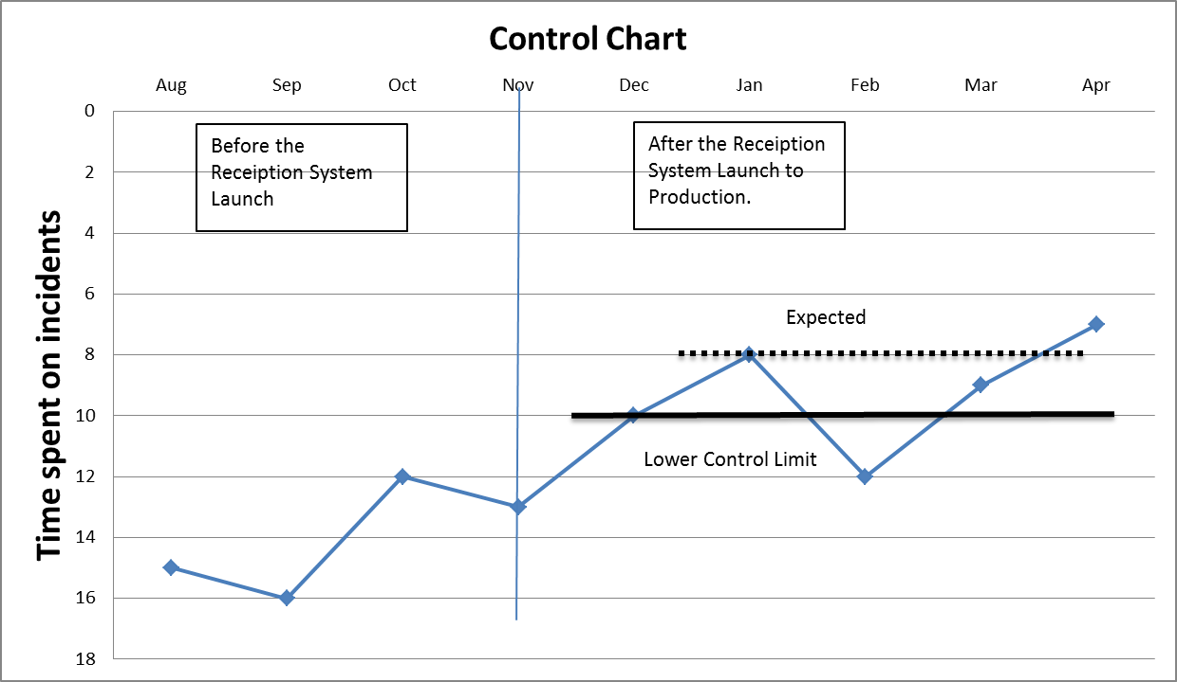

* 1. **Implementation plan with ITIL framework**

As we have to make an IT improvement project to our service, We should to make use of ITIL framework: Service Level Management, Availability Management in Service Design Processes and Access Management, Incident Management in Service Operation Processes to keep our service quality to satisfactory our customer.

**S**ervice Level Management --- Since the new “Receptionist System” will be implemented with the external Vendor, so that we have to manage our expectation and vendor’s perception to reduce the service gap between us. And we use Service Level Management to define the scope, document it and let both management team agree the term and sign-off. To ensure that specific and measurable targets are developed for vendor provided IT services.

It can Manages the expectation and perception of the business, customers and users and ensures that the quality of service delivered by the IT service matches those expectations and needs. After the system development were done and deploy into hospital successful, SLM can help us to establish and maintains SLAs for current live services and manages the level service provided to meet the targets and quality measurements contained within the SLAs. Moreover, for support on-going business change, SLM produces and agrees to Service Level Requirements (SLRs) for all planned new or changed services.

To keep our service level were on target, we can make use of Key Performance Indicators (KPIs) and metrics can be used to judge the efficiency and effectiveness of the SLM activities and the progress of a Service Improvement Program (SIP).

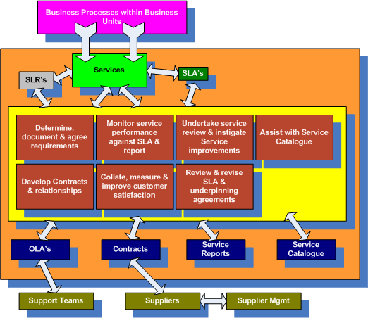

Availability Management --- as our hospital switch one of our critical service encounter process into system, so we have to make use of Availability Management process to ensure that the level of service availability delivered in all services is matched to or exceeds the current and future agreed needs of the business, in a cost-effective manner.

As the important of this IT service, Availability Management produces and maintains an appropriate and up-to date Availability Plan, which reflects the current and future needs of the business. And to ensure that service availability achievements meet or exceed all of their agreed targets by managing the services and resources that are related to availability performance. Such like Backup Plan for DB Server, Network Connection failover plan, hot stand-by technical.

(The over view of Availability Management.)

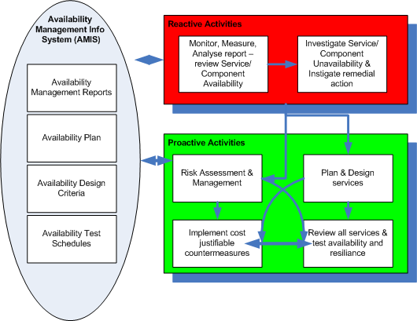

Access Management --- Since our system were holding our most personal confidential information, so that we have to better control / manage the right person in right process to access right patient’s information. Access Management grant authorized users the right to use a service while preventing access to unauthorized users and making sure that the policies and actions defined in Security and Availability Management are executed appropriately by three difference area:

Access --- The level and extent of a service’s functionality or data that a user is entitled to use.

Identity --- Information about the users that distinguishes them as individuals and verifies their status within the organization. By definition, the identity of a user is unique to that user.

Rights --- Also called privileges, right refer to the actual settings where a user is provided access to a service or group of services. Typical rights, or levels of access, include read, write, execute, change, and delete.

Services or Service Groups --- Users performing a similar set of activities will use a similar set of services. Instead of providing access to each service for each user separately, it is more efficient to be able to grant each user or group of users access to the entire set of services that the user is entitled to use at the same time.

Directory Services --- Refers to a specific type of tool that is used to manage access and rights.

(The over view of Access Management.)

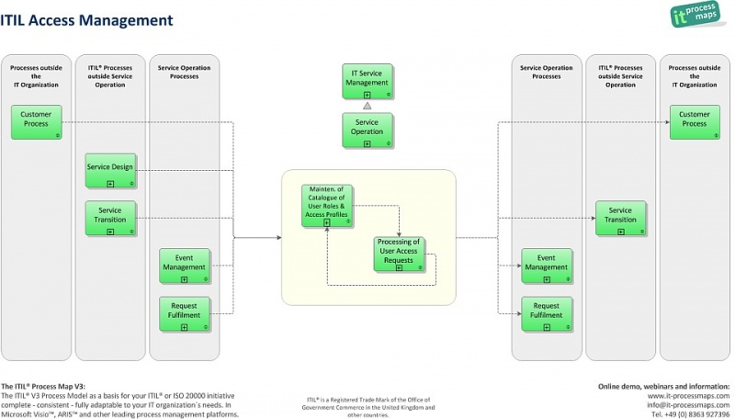

Incident Management --- Since the IT service were important, and we have to make use of Incident Management to handle the unexpected incident to restore normal service operations as quickly as possible and minimize the adverse impact on business operations. Which ensure that the best possible levels of service quality and availability are maintained as we already defined within agreed Service Level Agreement (SLA) limits.

Moreover, the incident management sub-process incident Closure and Evaluation now states more clearly that it is important to check whether there are new Problems, Workarounds or Known Errors that must be submitted to Problem Management.

(The sample flow of Incident Management.)

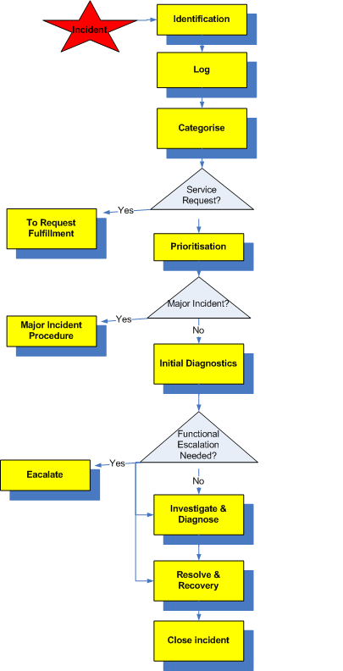

1. **Conclusion**

After the several analysis process, we identify the waiting queue in reception area is the major critical problem. Therefore, we’ll focus on how to improve this service by redesign it in term of six sigma and ITIL framework. Moreover, since customer mostly do not like a big change and it’s not a good idea of delighting customer based on expectation and perception model. Therefore, we decide to redesign the service by indexing the patients’ file, which only improve a small step of the way where receptionist looks for the patient’s file. Whereas this small changes could speed up the whole process, also the correctness of the output.

**Reference**

[1] Sitzia J, Wood N.(1997) Patient satisfaction: a review of issues and concepts. Worthing Nursing Development Unit, Worthing Hospital, U.K.

[2] Gladstone J.(1995) Drug administration errors: a study into the factors underlying the occurrence and reporting of drug errors in a district general hospital. Royal Devon and Exeter Hospital, England.

[3] IT Process Maps - A fresh Approach to implementing ITIL

<http://en.it-processmaps.com/>

[4] Health Care Home Work flow guide for primary care – Institute for clinical system improvement

<http://www.icsi.org/clinical_work_flow_guide_for_primary_care/hch_clinical_work_flow_guide_for_primary_care.html>

[5] LONBON QUEUING --- Hospital Diagnosis Queuing System

<http://www.lonbon.com/doce/L2-5.htm>