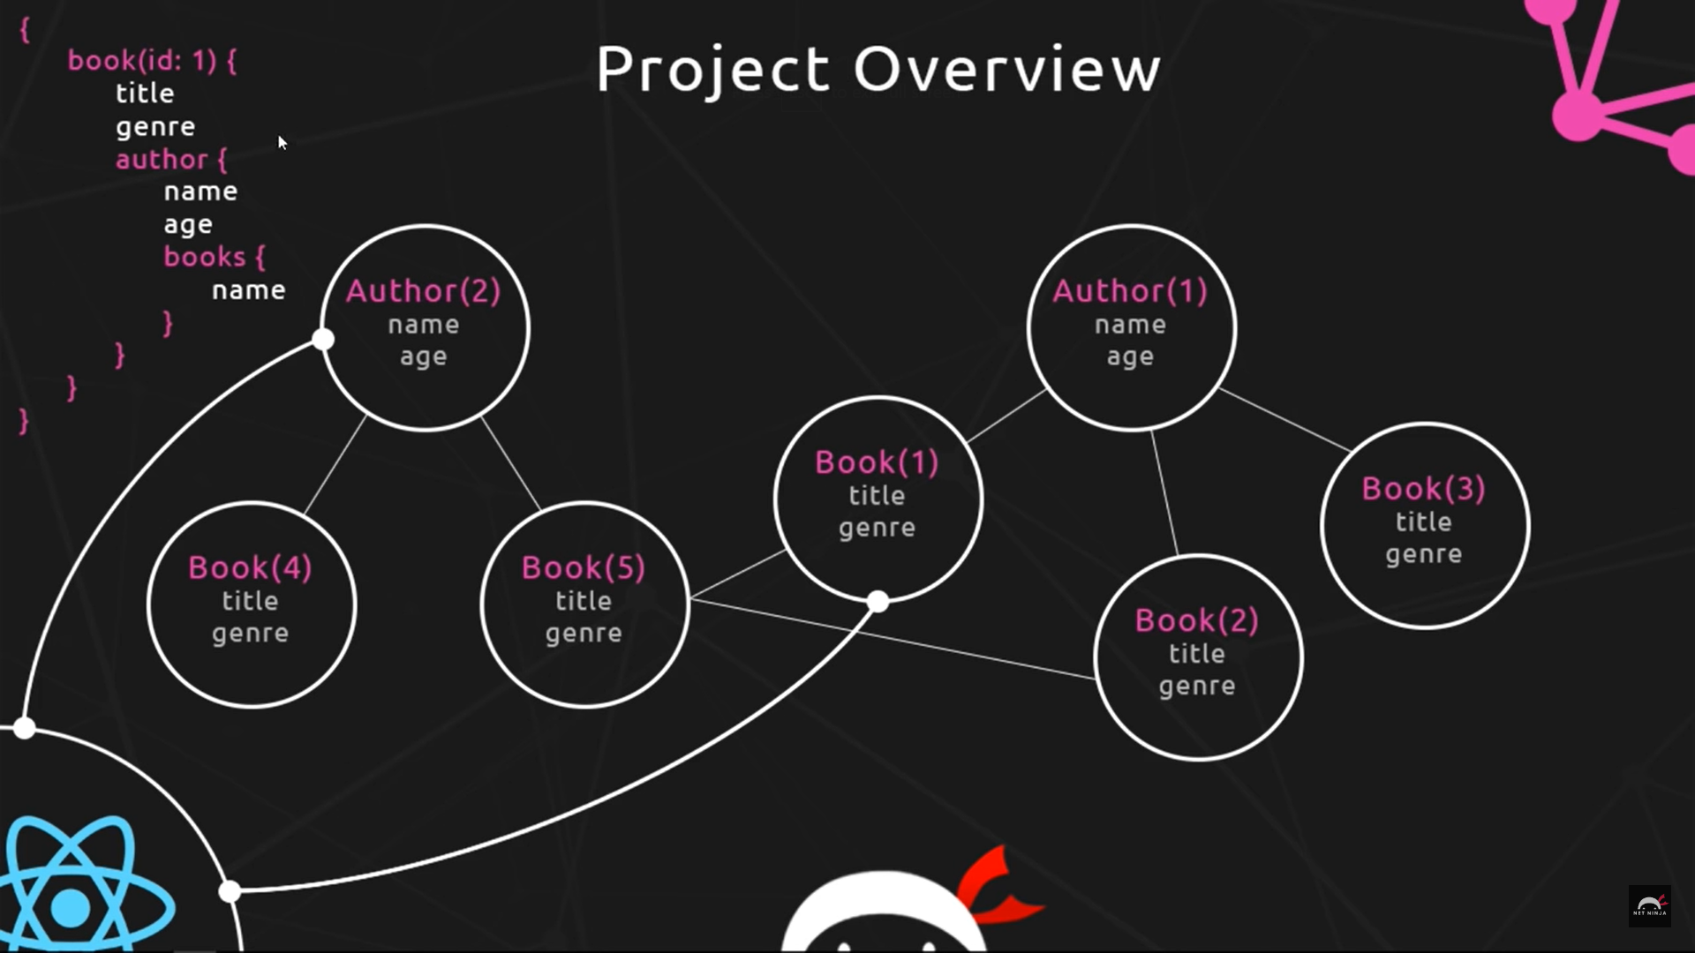

graphQL is another alternative to rest – it’s a query language

it is highly flexible

here im trying to make a graphql server and work on it’s api

will be using react , mongodb, express etc