**Comp3900_Proposal**

**Read-recommend website**

**Group name: Dota_3900**

**Submission Date: 21/06/2020**

***Group member:***

*Yefeng Niu--z5149500, z5149500@ad.unsw.edu.au (Developer &product owner)*

*Siyao Jiang—z5111316, z5111316 @ad.unsw.edu.au (Developer)*

*Haozhe Chen--z5142012,* [*z5142012@ad.unsw.edu.au*](mailto:z5142012@ad.unsw.edu.au) *(Developer)*

*Haiyan Xu--z5135077, z5135077@ad.unsw.edu.au (Scrum Master)*

Table of Content

Background 1

User story - User Aspect 1

User story – Admin role Aspect 13

How project objectives are satisfied? 13

Novel functionality compared to existing systems 16

Sprint and screenshots 17

ER diagram 20

UML diagram 21

System architecture 21

Interface and diagram 22

# Background

With the rapid development of technology, it has become more and more convenient for people to read. They can read on mobile phones or e-readers (e.g. kindle) anytime and anywhere. However, the huge distribution book market and uneven book quality cause that consumer will need to spend enormous time on choosing the book they want. Thus, this website aims to help consumers with exploring the interesting book efficiency and effectively, encouraging them to read interest book on daily life. Also, editors or publishers can familiar with reading trends more efficiency from the website, then publish books that will meet consumers' desire better.

Competitive Product Analysis (System and drawback)

For read recommendation domain, Goodread and Amazon are two well-known and representative websites. Goodread provide recommendation based on books that the user or their friends had already read. They highlight the trends and new releasing books in the main page, allowing user to set up bookshelves, participate in book discussion and leave rating & review. However, the user interface of GoodRead website consists of too much section per page, (12 sections in the main page), listing all the information in one page without hierarchy will distract users’ attention and reducing user experience.

For amazon, if consumer search a book, there will be a “Customers who bought this item also bought,” section jump out. On the plus side, this website also provided rating, reviewing section for each book, also the preview section. However, the recommendation is limited since it only lists the book that purchased from amazon. User can only rate and leave reviews after they purchased the book from amazon. Consumer cannot share opinions freely and the limitation of chosen sample will lead to inaccurate recommendation.

# User story - User Aspect

###1 us point means the task will take 2 hrs to completed####

## Epic story1: Basic account setting

1.1 As a user, I want to be able to register so that I can log in and access to feature functions of the website

*Acceptance Criteria:*

* Need to show sign up button on the top of each page.
* Once the button pressed, the registration page will show up.
* The registration page should contain a form with an Email address, username, password, Submit fields. Meanwhile, there should be a small button named “Already has an account? Please log in” below.
* Email must in the correct format, contains “@xxx.com”
* The email field must contain a valid email address, otherwise, show a message with “Invalid addresses, please try again”.
* If the input email address has already been registered, show a message with “Already registered, please log in”.
* The length of Username should between 5-12 characters.
* If the username is not unique in the database (had been registered already), show an error message with “Already registered, please try other names”.
* The password field must contain a letter and number, at least 6 characters long but shorter than 12 characters.
* If the password is invalid, show an error message with “Invalid password”.
* There should be a button placed after the password field, click the button then inputted password will become visible.
* Submitting the registration forms will create a new account for users
* The browser should jump to the dashboard with automatic log in once successfully sign up.

*Priority: 5/5 Difficulty:1/5 US point: 1*

1.2 As a User, I want to be able to log in so that I can access my own account and feature functions on any service.

*Acceptance Criteria:*

* Need to show the “Log in” button on the top of each page.
* The login page required user to input the username and password.
* If the username has not been registered yet, show a message with “Had not been registered yet, please sign up”.
* Upon successful login, User should be directed to the personal dashboard page.
* If the password did not match the username, show an error message stating “failure login, please try again”.

*Priority: 5/5 Difficulty:1/5 US point: 1*

1.3 As a user, I want to be able to find my password, so that I will be able to access my account in case I forgot the password.

*Acceptance Criteria:*

* Log in page should have the “Forgot my password” button above
* The “forgot password” page should contain a form with an Email address and submit button named “Find your password now”.
* By clicking the submit button, if the email is invalid, show a message with “Invalid addresses, please try again”. if the email is not registered, show a message with “Had not been registered yet, please sign up”.
* By clicking the submitting button, if the email is valid and registered, then an email will be sent to the given email address, containing the reset link.
* User will need to input new password that contain a letter and number, at least 6 characters long but shorter than 12 characters. Show an error message if password invalid
* There should be a button placed after the password field, click the button then inputted password will become visible.
* User clicks ok, then reset user password in the database.

*Priority:1/5 Difficulty:3/5 US point: 2*

1.4 As a user, I want to be able to change my password so that I can update my password freely as I wish.

*Acceptance Criteria:*

* In personal dashboard page, there should be a button “Change my password”
* User will need to input old password number firstly, if the old password number does not match with user name, jump out error message.
* New password needs to contain letter and number, at least 6 characters long but shorter than 12 characters.
* User need to input new password twice, if these two inputs do not match, jump out error message.
* Once successfully update, show message “Updated already”

*Priority:1/5 Difficulty:1/5 US point: 1*

1.5 As a user, I want to be able to update my email address so that I can receive notification from website timely

*Acceptance Criteria:*

* In personal dashboard page, there should be a button “Update my email”
* The email field must contain a valid email address, otherwise, show a message with “Invalid addresses, please try again”.
* If the input email address has already been registered, show a message with “This address had already registered, cannot update”.
* If successfully update, show message “Updated already”

*Priority:1/5 Difficulty:1/5 US point: 1*

## Epic story2: Explore interesting book and save

2.1 As a User, I want to be able to search for a certain book so that I can explore potentially interesting book easily.

*Acceptance Criteria:*

* User can use this function with/without login.
* Search bar will show on the top of each page
* Users can search for a book by name or author.
* If the book or author does not exist in our database, then return “we cannot find what you want, sorry for the inconvenience.”
* If the book or author exists in our database, then return the list of results.
* Each book should display as a small card, and only show basic details---photo, name, author and published year. By clicking the book card, user will be redirected to the detail page of the book.

*Priority:4/5 Difficulty:4/5 US point: 2*

2.2 As a user, I want to be able to filter out items that do not satisfy the specific criteria so that I can find the book more accurately

*Acceptance Criteria:*

* After user search for book and get return lists, there will be a filter section
* User can use this function with/without login.
* User can set the acceptance range of rating level and type of category.
* Then reload the page, show the list of results.
* Each book should display as a small card, and only show basic detail---- photo, name, author and published year. By clicking the book card, user will be redirected to the detail page of the book.

*Priority:3/5 Difficulty:3/5 US point: 1.5*

2.3 As a User, I want to be able to view full details by clicking on specific book section so that I can get comprehensive understanding about the book

*Acceptance Criteria:*

* User can use this function with/without login.
* Detail page of each book should contain book photo, name, author, published year, average rating, the number of people read the book in the past and reviews.
* Users should be able to tag the book as “Read” or “unread”.
* If user want to tag the book from read to unread, need to warn user “previous review will be deleted permanently, are you sure to continue?”. If user choose sure, delete previous review from database.
* If a user has read the book, then they should be able to write a review and rate.

*Priority:5/5 Difficulty:2/5 US point:1*

2.4 As a User, I want to be able to add a book to any collection folders so that I can save interesting books for later viewing at any time.

*Acceptance Criteria:*

* In the book detail page, there should be a button above “save to my collection”
* After the user clicks the button, users will be provided with a list of all the collections and be able to choose multiple folders from the list (“save” screen).
* In this screen, if the book already exists in any collection folders, the collection field will be grey and unclickable. Show a message next to the collection field “The book already exists in this collection”
* In this screen, the user can create new collection folder and name it. If the name already been used, then show a message with “Collection name already exists, please try another name”.
* Upon successfully create new collection, reload the “save” screen and the new collection should be listed above.
* If successfully added, show a message “Successfully add to chosen Collections”

*Priority:5/5 Difficulty:1/5 US point: 1*

## Epic story3: Get recommendation

* 1. As a User, I want to be able to view recommendation book lists with selected book and recommendation mode so that I can customize recommendation by my preference.

*Acceptance Criteria:*

* User can use this function with/without login.
* Users will need to select a book as a reference and choose their preferred recommendation mode.
* Users can select the reference book by searching or directly selecting from collections.
* User goes to the book detail page, then at the bottom of the page, there should be a “recommendation “section.
* In that section, user will be able to choose from various recommendation modes, such as categories, average rating, popular and so on.
* After user chooses the mode, the page will reload and show lists of recommended books.
* In that section, user will only see 5 most recommended book, user can click “view all” button to check full set.
* In the full results page, the user can filter out books by rating or category.

*Priority:3/5 Difficulty:4/5 US point: 2*

* 1. As a User, I want to be able to view top10 most popular books so that I can know reading trend and explore popular books easily.

*Acceptance Criteria:*

* User can use this function with/without login.
* In the homepage, there should be a “top10 popular books” section
* The section will list 10 most recently popular books (this algorithm will consider rating, added to collections frequency and number of people read)
* Each book should display as a small card, and only show basic details---photo, name, author, category, published year and “read/not read” label. By clicking the book card, user will be redirected to the detail page of the book.

*Priority:1/5 Difficulty:5/5 US point:3*

* 1. As a User, I want to be able to view books by category so that I can explore each category and access to book under my interested category easily.

*Acceptance Criteria:*

* User can use this function with/without login.
* In the homepage, there should be a “Book category” section
* The section will list all book category.
* User can click a category then will be redirected to category book page. For example, if user click romantic category, then will show lists of books that under romantic category.
* In category book page, each book should display as a small card, and only show basic details---photo, name, author, category, published year and “read/not read” label. By clicking the book card, user will be redirected to the detail page of the book.

*Priority:1/5 Difficulty:2/5 US point:1*

## Epic story4: Managing Collections

4.1 As a User, I want to be able to create a collection folder so that I can categorize all interesting books based on my preferences or style, which will help me to find books easily.

*Acceptance Criteria:*

* After User registered, there should be a default collection folder named “Default collection” in my collection page.
* In my collection page, there should be a button named “Create new collection”
* After clicking on the “Create new collection button”, User will need to fill the name field “Name your new collection” and then process.
* If the name already been used, create failed, then show a message with “Collection name already exists, please try another name” and reload.
* Upon successfully created, user should be redirected to the “My collection” page which lists all collection folders.

*Priority:5/5 Difficulty:1/5 US point: 1*

* 1. As a User, I want to be able to delete any collection folders so that I can update the folders.

*Acceptance Criteria:*

* In my collection page, there should be a “delete” button for each collection.
* After clicking on the “delete” button, before processing the deletion, users must be warned about the potential risk “Collection will be deleted permanently, are you sure to continue?”
* Page will reload once successfully delete the collection.
* “Default” collection folder cannot to delete.

*Priority:2/5 Difficulty:1/5 US point: 1*

* 1. As a user, I want to be able to view books in my collection so that I can access to my saved book easily.

*Acceptance Criteria:*

* By clicking on the collection, the users should be able to view a list of books that saved in the collection.
* Each book should display as a small card, and only show basic details---photo, name, author, category, published year and “read/not read” label. By clicking the book card, user will be redirected to the detail page of the book.
* If the book had already been tagged as “read”, then show “read” Label
* If the book had not been read, show “not read” Label

*Priority:4/5 Difficulty:1/5 US point: 1*

* 1. As a User, I want to be able to remove books from any one of my collections so that I can update my collections and delete those books I had read or not attract me anymore.

*Acceptance Criteria:*

* In the detail page for each collection folder, each book will be shown as a small card and there should be a button for each book card named” remove”. By clicking the book card, user will be redirected to the detail page of the book.
* By clicking on the “remove” button, users will be warned about the potential risk Before processing the removal---“Books will be deleted permanently, are you sure to continue?”
* Once successfully removed, show the message “Successfully removed”

*Priority:4/5 Difficulty:1/5 US point: 1*

* 1. As a User, I want to be able to view top 10 recently added books to all my collections so that I can easily access to books that attracted to me recently.

*Acceptance Criteria:*

* In my collection page, there should be a “Top 10 recently added books” section.
* “Top 10 recently added books” section will list 10 books that most recently added to all collections, sort by added date. For example, book A (added on Jun 15th) should list after book B (added on Jun 17th),
* If total amount of added books is less than 10 then show all books.
* If no book been added yet, show a message “no book been added yet”

*Priority:2/5 Difficulty:4/5 US point: 2*

## Epic story5: Visit other users ‘collections

5.1 As a User, I want to be able to search other users that so that I can visit other users who have similar taste and access to their collections to explore interesting books.

*Acceptance Criteria:*

* User can use this function with/without login.
* In the homepage, user should be able to search other users by name or email.
* If system cannot find the username or email, return error message.
* Once successfully find the user via username or email, then users will access to other’s personal pages and be able to explore all collection folders.

*Priority:3/5 Difficulty:4/5 US point: 2*

5.2 As a User, I want to be able to view other users’ book collections so that I can access to their collections to explore interesting books easily and get to know my friend’s book preference.

*Acceptance Criteria:*

* User can use this function with/without login.
* User can access other users’ collection by clicking on username in review board. Then they will be redirected to other users’ dashboard.
* Also, user can access others’ collection by search other users.
* By clicking on other users’ collection, the users should be able to view a list of books that saved in the collection.
* Each book should display as a small card, and only show basic details---photo, name, author, category, published year. By clicking the book card, user will be redirected to the detail page of the book.
* If the book had already been tagged as “read”, then show “read” Label

*Priority:3/5 Difficulty:1/5 US point: 1*

5.3 As a User, I want to be able to add other collections to my collection lists so that I can easily save a list of interesting books instead of wasting time to add books repeatedly.

*Acceptance Criteria:*

* In the page of other users’ collection, there should be a button above named” Save to my collection lists”. If the collection folder has already been saved to the user’s collection lists, show a message “Already saved”. For instance: if saved, can show a hollow star image, if save, show solid star image.
* when adding the collection, if the same name is used by another collection folder, jump error messages that state the conflict. Also, a “Renamed” button will be provided.
* Upon successfully added, show the message “Successfully add to your Collection list” and remain in the collection page.

*Priority:3/5 Difficulty:2/5 US point: 1*

## Epic story6: Rating and review

* 1. As a User, I want to be able to tag a book as read so that I can leave rate and review, also help to differentiate with the book I have not read yet.

*Acceptance Criteria:*

* In the detail page for each book, initial tag should be “unread”.
* Users can tag it as read, then be able to write a review and leave rating.
* If the user has already tagged the book, then the book page will show “Read”. Otherwise, show “Unread”.

*Priority:4/5 Difficulty:2/5 US point: 1*

* 1. As a User, I want to be able to tag book from read to “Unread” so that I update the statement in case I want to read the book again

*Acceptance Criteria:*

* In the detail page of book, users should be able to tag the book from “read” to “unread”.
* If user want to tag the book from read to unread, need to warn user “previous review will be deleted permanently, are you sure to continue?”.
* If user choose sure, delete previous rating and review from database.

*Priority: 1/5 Difficulty:3/5 US point: 2*

* 1. As a User, I want to be able to rate books and leave reviews so that I can express my opinion and provide information to help other users make decisions.

*Acceptance Criteria:*

* User can only rate and write a review for the book after tag it as “read”. Thus, if the book statement is “unread” there will be no “rate and write review button”
* In the detail page for each book, there should be a button “Rate and write review” if the book statement is “read”.
* By clicking on the button, user can rate the book out of 5 and write a review.
* The maximum length of review is 1200 words. If exceed, show a message “Exceed the maximum length”.
* This two filed cannot be left empty.
* After the user submits the review and rating, the review will be shown in the review section immediately.

*Priority: 4/5 Difficulty:4/5 US point: 2*

* 1. As a User, I want to be able to track books that I had already read so that I can access to book I had read and know how is going with my reading progress

*Acceptance Criteria:*

* In the personal dashboard page, there should be a button named “Read History”
* Click on this button, user will be redirected to “Read history” Page.
* If user had not read any book yet, show message “Start to read today, explore books now”
* Otherwise, list all the book that user had already read and sort by the order of finished-date, from most recently to latest.

*Priority: 4/5 Difficulty:4/5 US point: 2*

* 1. As a user, I want to be able to view my past rating and review so that I can access to my previous opinion easily.

*Acceptance Criteria:*

* In the dashboard page, there should be a “My rating and review” section.
* “My rating and review” page will list all past reviews and ratings
* There will also be an “edit button” above each review section.
* If the user clicks on one rating and review section, the browser will indirect to the corresponding book page.

*Priority: 3/5 Difficulty:4/5 US point: 2*

* 1. As a user, I want to be able to edit or delete my review and rate so that I can update my opinion and provide better instructions for other users.

*Acceptance Criteria:*

* In the detail page of each book. There should be a “review” section. If the user had already rate and review the book, user’s review will be placed in the top and have a “edit” button above
* Meanwhile, the “my review” page (on my dashboard) will list all past review, and there will also be a “edit button” above each review.
* Clicking on the edit button, user should be able to change their rating and review.
* If user change the rating and review section to empty, then click submit, their rating and review will be delete.
* Reload the page once successfully update the rating and review.

*Priority: 1/5 Difficulty:4/5 US point: 2*

## Epic story7: Reading goal

7.1 As a User, I want to be able to set an ideal number of books to read per month, track the progress anytime so that I can motivate myself to read more books.

*Acceptance Criteria:*

* In the personal dashboard page, users should be able to set a monthly reading goal by inputting a number for current month.
* Read/goal number will be shown as a ratio in the personal dashboard page.
* After the user sets the goal, every book they tag as read will be shown in the goal detail page.
* At the end of a month, If the user finishes the goal, then jumping out a window shows “Congratulations, you achieved your monthly goal (earlier)” and display the historical record.
* If the user did not finish the goal at the end of a month, then jumping out a window shows “Last xxx more books to read, need to work harder next month”
* After displaying a message, users will be required to fill next month’s goal. They will be able to jump over and fill later.

*Priority: 2/5 Difficulty:4/5 US point: 2*

# User story – Admin role Aspect

1. As a user with Admin role, I want to be able to delete review so that I can control the review quality in case sensitive words or non-relevant reviews occur.

Acceptance Criteria:

* In the detail page for the book, the admin should be able to see lists of reviews.
* Admin can delete certain reviews
* Before successfully deleting the review, jump out windows with a warning “Cannot recover, still want to delete?”
* After successfully deleting the reviews, show message “successfully delete”
* Admin are required to send an email to the user (whose review had been deleted) and explained why

*Priority: 1/5 Difficulty:4/5 US point: 2*

1. As a user with admin role, I want to be able to send users an email or leave a message on the website so that I can communicate with users to explain the reason why deleting reviews.

Acceptance Criteria:

* After deleting any review, there should be a text box in the middle of page
* Admin will need to write down the reason why deleting the review into the text box
* The box cannot be left as empty.
* After the admin fills the text box, an email will be sent to the user’s registered email with the reason.

Priority: 2/5 Difficulty:2/5 US point: 2

# How project objectives are satisfied?

*Objective 1: Readers must be able to keep track of books they have read in one of many easily identifiable book collections on their account.*

Referring to epic story 6: Rating and review --- user story 6.1 user can tag a book as read. It is mentioned in acceptance criteria that If the user has already tagged the book, then the book page will show “Read”. Otherwise, show “Unread”. User story 6.2 user can update reading statement, tag the book from read to unread. User story 6.7 user can track finished book, In the personal dashboard page, there should be a button named “Read History”. Click on this button, user will be redirected to “Read history” Page, listing all the book that user had already read and sort by the order of finished-date, from most recently to latest.

Also, no matter user checks the book from collections (user story 4.3) or by searching(user story 2.1), the book will list as a small card, shown basic detail and “read/unread” label above. It is mentioned in acceptance criteria, each book should display as a small card, and only show basic details and “read/not read” label. It can help user to easily track the book they had read already.

*Objective 2: They must be able to look through any such collection (their own and that of other readers).*

Referring to epic story 4: managing collections --- user story 4.3 As a user, I want to be able to view books in my collection so that I can access to my saved book easily. By clicking on the collection, the users should be able to view a list of books that saved in the collection. Each book should display as a small card, and only show basic details---photo, name, author, category, published year and “read/not read” label. By clicking the book card, user will be redirected to the detail page of the book. If the book had already been tagged as “read”, then show “read” Label If the book had not been read, show “not read” Label

Meanwhile, referring to epic story5: Visit other users ‘collections --- user story 5.1 search other users, user story 5.2 view other users’ collections and user story 5.3 saved other users’ collections. In the homepage, user should be able to search other users by name or email or click other users’ name on rating and review board (book detail page). By clicking on other users’ collection, the users should be able to view a list of books that saved in the collection. In the page of other users’ collection, there should be a button above named” Save to my collection lists”

*Objective 3: To help with selecting the right book, readers must be able to write reviews for a given book, including leaving a rating out of 5.*

Referring to epic story6: rating and reviews --- user story6.1 to us6.6, users will be able to tag a book as read/finished, then users will be able to rate “read/finished” book and leave review. User can also check past rating and reviews and edit them. The detailed steps is mentioned in acceptance criteria.

*Objective 4: Readers must be able to view the full details of any book, (including all reviews), in any book collection.*

Referring to epic story 4: managing collections --- user story 4.3 As a user, I want to be able to view books in my collection so that I can access to my saved book easily. By clicking on the collection, the users should be able to view a list of books that saved in the collection. Each book should display as a small card, and only show basic details---photo, name, author, category, published year and “read/not read” label. By clicking the book card, user will be redirected to the detail page of the book. If the book had already been tagged as “read”, then show “read” Label If the book had not been read, show “not read” Label

*Objective 5: This full detail view must also display multiple aggregate statistics, including the book's average rating.*

Referring to epic story 2 explore interesting book and save--- user story 2.3 As a User, I want to be able to view full details when clicking on specific book section so that I can get comprehensive understanding about the book. It is mentioned in acceptance criteria that user can use this function with/without login.

Detail page of each book should contain book photo, name, author, published year, average rating, the number of people read the book in the past and reviews. Users should be able to tag the book as “Read” or “unread”. If user want to tag the book from read to unread, need to warn user “previous review will be deleted permanently, are you sure to continue?”. If user choose sure, delete previous review from database. If a user has read the book, then they should be able to write a review and rate.

*Objective 6: To more easily locate books, readers must be able to easily search for books by name, author, or most recently added books to their collections.*

Referring to epic story Epic story2: Explore interesting book and save----user story 2.1 search for certain books. It is mentioned in acceptance criteria that user can search book by input book name or author.

Also, in the epic story 4: managing collections --- 4.5 As a User, be able to view top 10 recently added books to all my collections so that I can easily access to books that attracted to me recently. User can easily check recently added book in “my collection” pages.

*Objective 7: They must be able to filter out books from search results that are under a given average rating.*

Referring to epic story 2: explore interesting book and save---user story 2.2 As a user, I want to be able to filter out items that do not satisfy the specific criteria so that I can find the book I want more accurately. It is mentioned in acceptance criteria, After user search for book and get return lists, there will be a filter section, user can use this function with/without login, user can set the acceptance range of rating level and type of category. Then reload the page, show the list of results.

*Objective 8: Finally, given a book specified by the reader, the platform must also be able to provide the reader with multiple recommendation modes that can be used to recommend a book.*

Referring to epic story 3: get recommendation--- user story 3.1 As a User, I want to be able to view recommendation book lists with selected book and recommendation mode. It is mentioned in acceptance criteria that users will need to select a book as a reference and choose their preferred recommendation mode. Users can select the reference book by searching or directly selecting from collections.

User goes to the book detail page, then at the bottom of the page, there should be a “recommendation “section. In that section, user will be able to choose from various recommendation modes, such as categories, average rating, popular and so on.

After user chooses the mode, the page will reload and show lists of recommended books. In that section, user will only see 5 most recommended book, user can click “view all” button to check full set. In the full results page, the user can filter out books by rating or category.

# Novel functionality compared to existing systems

1. Firstly, our website UI design is more in line with the principles of human-computer interaction. Comparing to Goodread (Diagram 1)

2. Secondly, User can be able to set monthly reading instead of yearly reading goal (refer to Goodread, Diagram2). Monthly goal function of our website is more. reasonable and being able to check historical record at the end of the month.

3. This website has lots of functions that opened for public user (without register and login), user can share idea freely. However, Amazon only allow user to leave rate and review after they purchase the book from amazon.

*Diagram1: Refer to ‘GoodRead’ Website*

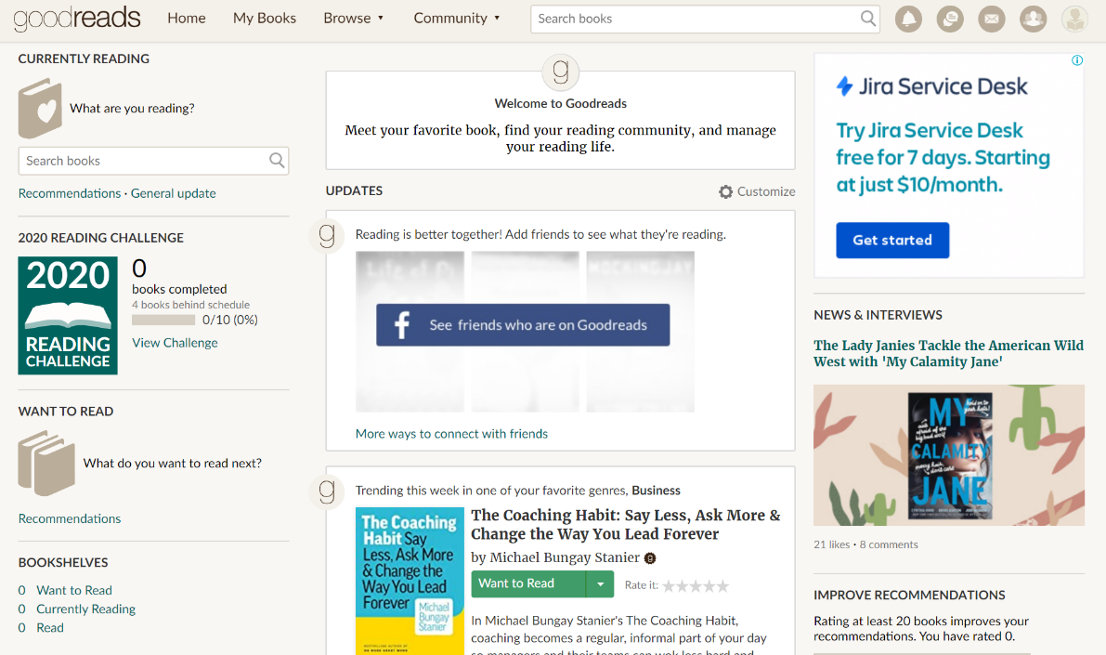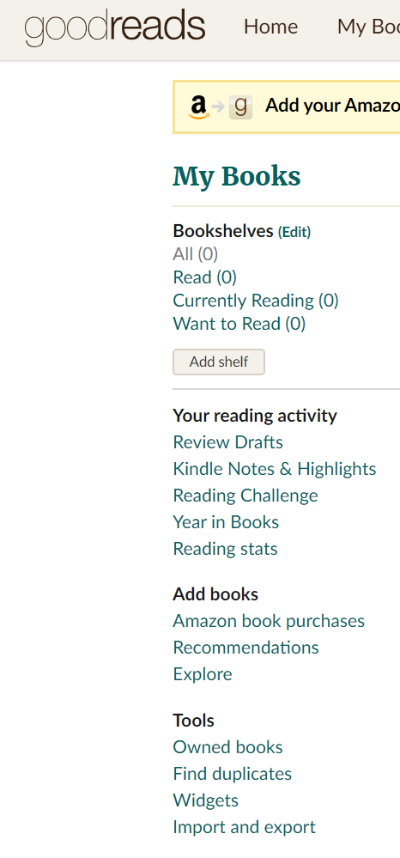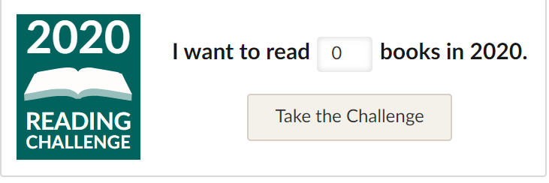

*Diagram 2: Refer to ‘GoodRead’ Website*

# Sprint and screenshots

Sprint 1--- Week4 6.22-6.28

Register, login, search, view book details, add book to collections, view collection books

Sprint 2--- Week5 6.29-7.5

Remove book, tag book as read, rate and leave review, view past rating and reviews, delete rating and reviews

Sprint 3--- Week6 7.6-7.12

Filter out, search user, view other users’ collections, add named collections, top10 recently added book.

Sprint 4--- Week7 7.13-7.19

Get recommendation, monthly goal, tag from read to unread, delete folder.

Sprint 5--- Week8 7.20-7.26

Top10 popular book, check category, update email, update password, find password

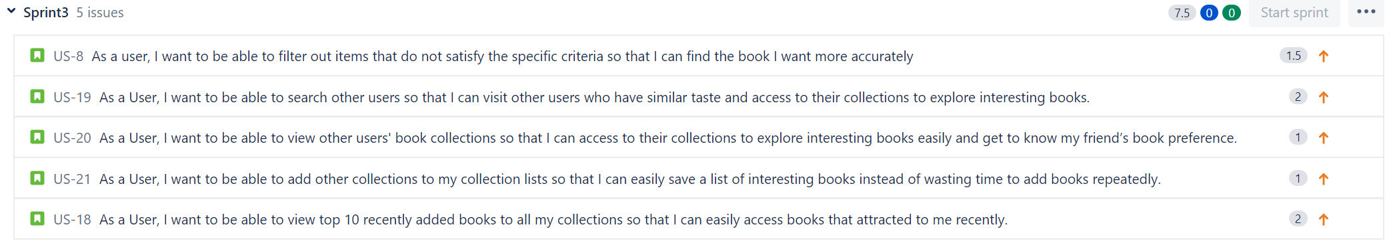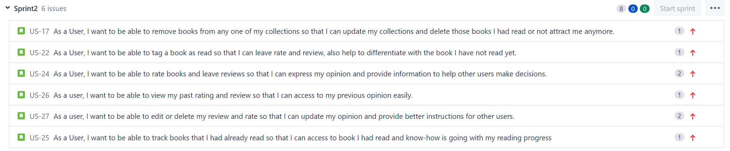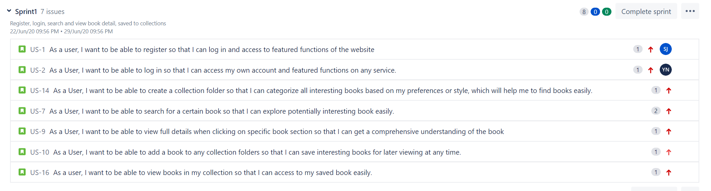

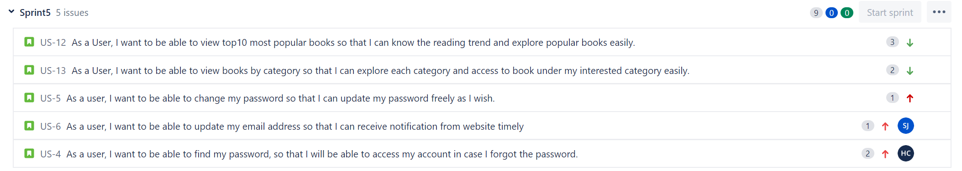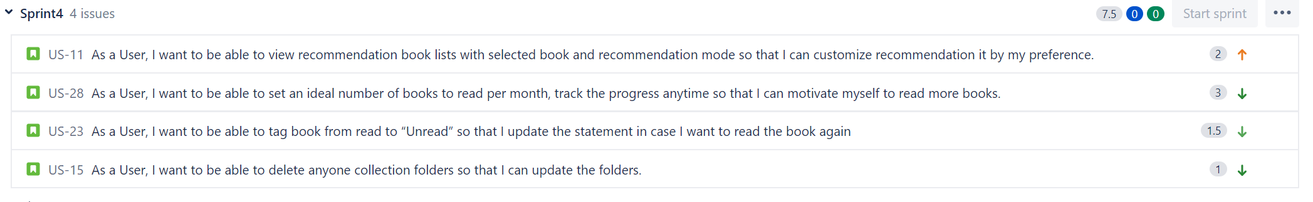

# ER diagram

# UML diagram

# System architecture

# 

# Interface and diagram