The repaired net model accuracy on clean test and attack success rate (ASR) on poisoned test data is shown below. The repaired net is a ensemble of the original backdoored network and a network that has been pruned to remove inactive neurons by increasing order of their average activation values.

|  |  |  |  |
| --- | --- | --- | --- |
| Neurons Pruned | Fraction of Neurons Pruned | Clean Test Accuracy | Poisoned Test ASR |
| 0 | 0.00000 | 98.62042% | 100.00000% |
| 1 | 0.01667 | 98.62042% | 100.00000% |
| 2 | 0.03333 | 98.62042% | 100.00000% |
| 3 | 0.05000 | 98.62042% | 100.00000% |
| 4 | 0.06667 | 98.62042% | 100.00000% |
| 5 | 0.08333 | 98.62042% | 100.00000% |
| 6 | 0.10000 | 98.62042% | 100.00000% |
| 7 | 0.11667 | 98.62042% | 100.00000% |
| 8 | 0.13333 | 98.62042% | 100.00000% |
| 9 | 0.15000 | 98.62042% | 100.00000% |
| 10 | 0.16667 | 98.62042% | 100.00000% |
| 11 | 0.18333 | 98.62042% | 100.00000% |
| 12 | 0.20000 | 98.62042% | 100.00000% |
| 13 | 0.21667 | 98.62042% | 100.00000% |
| 14 | 0.23333 | 98.62042% | 100.00000% |
| 15 | 0.25000 | 98.62042% | 100.00000% |
| 16 | 0.26667 | 98.62042% | 100.00000% |
| 17 | 0.28333 | 98.62042% | 100.00000% |
| 18 | 0.30000 | 98.62042% | 100.00000% |
| 19 | 0.31667 | 98.62042% | 100.00000% |
| 20 | 0.33333 | 98.62042% | 100.00000% |
| 21 | 0.35000 | 98.62042% | 100.00000% |
| 22 | 0.36667 | 98.62042% | 100.00000% |
| 23 | 0.38333 | 98.62042% | 100.00000% |
| 24 | 0.40000 | 98.62042% | 100.00000% |
| 25 | 0.41667 | 98.62042% | 100.00000% |
| 26 | 0.43333 | 98.62042% | 100.00000% |
| 27 | 0.45000 | 98.62042% | 100.00000% |
| 28 | 0.46667 | 98.62042% | 100.00000% |
| 29 | 0.48333 | 98.62042% | 100.00000% |
| 30 | 0.50000 | 98.62042% | 100.00000% |
| 31 | 0.51667 | 98.62042% | 100.00000% |
| 32 | 0.53333 | 98.62042% | 100.00000% |
| 33 | 0.55000 | 98.62042% | 100.00000% |
| 34 | 0.56667 | 98.61263% | 100.00000% |
| 35 | 0.58333 | 98.60483% | 100.00000% |
| 36 | 0.60000 | 98.59704% | 100.00000% |
| 37 | 0.61667 | 98.59704% | 100.00000% |
| 38 | 0.63333 | 98.57366% | 100.00000% |
| 39 | 0.65000 | 98.52689% | 100.00000% |
| 40 | 0.66667 | 98.44115% | 100.00000% |
| 41 | 0.68333 | 98.40998% | 100.00000% |
| 42 | 0.70000 | 98.11380% | 100.00000% |
| 43 | 0.71667 | 97.74747% | 100.00000% |
| 44 | 0.73333 | 97.50585% | 100.00000% |
| 45 | 0.75000 | 95.74435% | 100.00000% |
| 46 | 0.76667 | 95.34684% | 99.97662% |
| 47 | 0.78333 | 94.90257% | 99.98441% |
| 48 | 0.80000 | 92.12783% | 99.98441% |
| 49 | 0.81667 | 91.58223% | 99.98441% |
| 50 | 0.83333 | 91.13016% | 99.97662% |
| 51 | 0.85000 | 89.68044% | 80.64692% |
| 52 | 0.86667 | 84.33359% | 77.20966% |
| 53 | 0.88333 | 76.16524% | 36.26656% |
| 54 | 0.90000 | 54.67654% | 6.96025% |
| 55 | 0.91667 | 27.06937% | 0.42089% |
| 56 | 0.93333 | 13.70226% | 0.00000% |
| 57 | 0.95000 | 6.56274% | 0.00000% |
| 58 | 0.96667 | 1.51988% | 0.00000% |
| 59 | 0.98333 | 0.64692% | 0.00000% |
| 60 | 1.00000 | 0.07015% | 0.00000% |

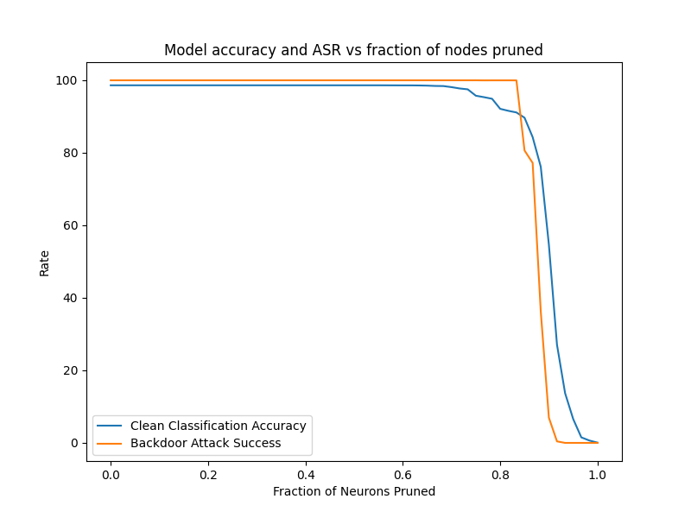

According to Liu et al. the pruning defense happens in 3 phases. In the first phase, neurons that neither effect the activation on clean or poisoned inputs are removed. These neurons are dormant so removing them neither effects the model accuracy nor the backdoor ASR. This correlates to the removal of the first 33 neurons where model accuracy and ASR are unchanged shown above.

The second phase removes neurons that are activated by the poisoned data but not the clean input. This is the area where the model accuracy remains high but the backdoor ASR starts to dip. However, unlike the paper, we see the model accuracy dipping before the backdoor ASR. Model ASR remains generally high until the 51st neuron is removed, when we see a sharp decline in ASR. The sweet spot for accuracy and ASR seems to be when 53 neurons are removed (0.833 neurons removed as a fraction of total neurons) where the model accuracy is 76% while ASR is 36%.

The last phase removes neurons that correspond to clean inputs leading to a sharp decline in accuracy. This happens right after the sweet spot discussed above. After removing the final neuron the accuracy drops to 0.07% which is what you would expect from a completely random network (1/1283 = 0.078%).

In general, the pruning defense was not as successful as expected since model accuracy had to be sacrificed significantly without seeing a complete elimination of ASR.

**References:**

1. Liu, K., Dolan-Gavitt, B., &amp; Garg, S. (2018). Fine-pruning: Defending against backdooring attacks on Deep Neural Networks. Research in Attacks, Intrusions, and Defenses, 273–294. https://doi.org/10.1007/978-3-030-00470-5_13