Contents

Question 2. Write MongoDB queries for (4 points each): 100 points 1

1. Count the number of documents in the collection. 1

2. Display all the documents in the collection. 1

3. Display: restaurant_id, name, borough and cuisine for all the documents 2

4. Display: restaurant_id, name, borough and cuisine, but exclude field _id, for all the documents in the collection 2

5. Display: restaurant_id, name, borough and zip code, exclude the field _id for all the documents in the collection. 3

6. Display all the restaurants in the Bronx. 3

7. Display the first 5 restaurants in the Bronx 3

8. Display the second 5 restaurants (skipping the first 5) in the Bronx 4

9. Find the restaurants with a score more than 85. 4

# Question 2. Write MongoDB queries for (4 points each): 100 points

## 1. Count the number of documents in the collection.



## 2. Display all the documents in the collection.

db.restaurants.find()

## 3. Display: restaurant_id, name, borough and cuisine for all the documents

db.restaurants.find( { }, { restaurant_id: 1, name: 1, borough: 1, cuisine: 1 })

## 4. Display: restaurant_id, name, borough and cuisine, but exclude field _id, for all the documents in the collection

## 5. Display: restaurant_id, name, borough and zip code, exclude the field _id for all the documents in the collection.

## 6. Display all the restaurants in the Bronx.

## 7. Display the first 5 restaurants in the Bronx

db.restaurants.find( { borough: "Bronx" } ).limit(5)

## 8. Display the second 5 restaurants (skipping the first 5) in the Bronx

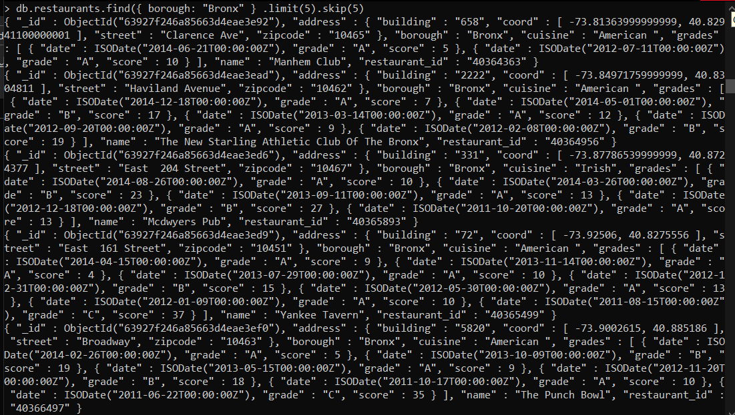

## 9. Find the restaurants with a score more than 85.

## 10. Find the restaurants that achieved a score, more than 80 but less than 100.

