Software Requirements Specification (SRS)
AI-Generated Image Detection System

1. Introduction
1.1 Purpose
This Software Requirements Specification (SRS) describes the requirements for the AI-Generated Image Detection System (Version 1.0).
The purpose of this system is to detect whether a given digital image is:
- Real (captured by a camera)
- AI-generated (created using generative AI models such as GANs or diffusion models)
This SRS covers the complete standalone detection system including:
- Image upload interface
- Detection engine
- Result visualization module
- Administrative monitoring panel

1.2 Document Conventions
- All functional requirements are labeled as REQ-XX.
- High priority requirements are marked as (High).
- Medium priority requirements are marked as (Medium).
- Low priority requirements are marked as (Low).
- “Shall” indicates mandatory requirements.
- “May” indicates optional requirements.
- TBD indicates “To Be Determined”.

1.3 Intended Audience and Reading Suggestions
This document is intended for:
- Developers – For implementation guidance.
- Project Managers – For planning and tracking.
- Testers – For validation and verification.
- UI Designers – For interface design.
- Stakeholders – For understanding system capabilities.
Reading order suggestion:
- Introduction
- Overall Description
- System Features
- Nonfunctional Requirements
- Project Plan

1.4 Product Scope
The AI-Generated Image Detection System is a web-based application designed to identify synthetic images generated by artificial intelligence models.
Objectives:
- Combat misinformation and deepfakes
- Support digital forensics
- Assist media verification agencies
- Enhance cybersecurity systems
The system supports corporate goals of digital trust, media authentication, and responsible AI usage.

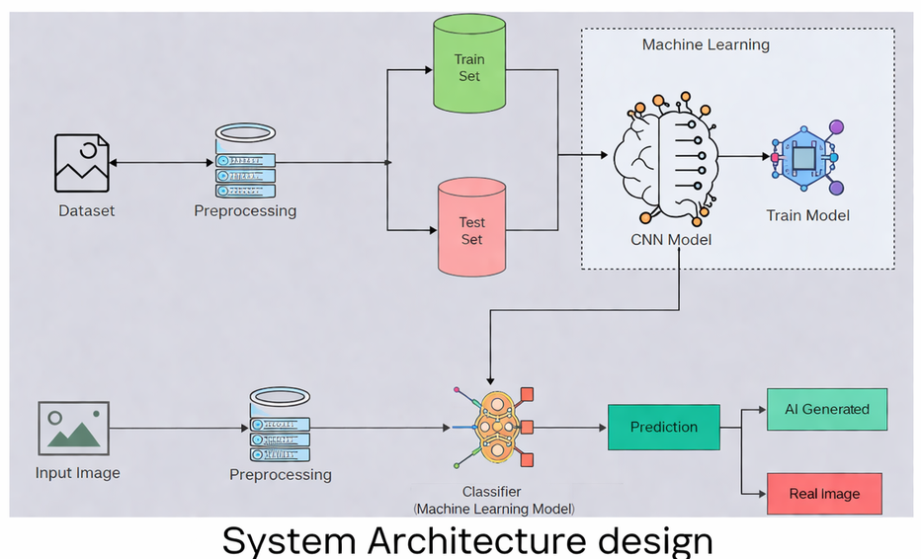
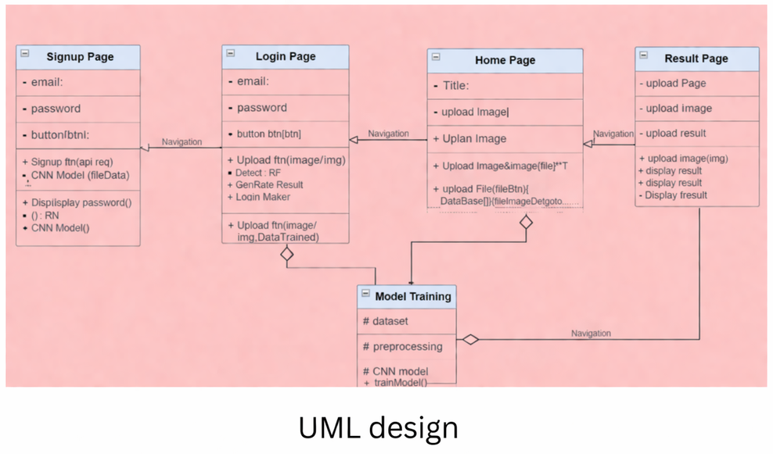

2. Overall Description
2.1 Product Perspective
The system is a new standalone application.
It consists of:
- Frontend Web Interface
- Backend Detection Engine
- Machine Learning Model
- Database (for logging results)
System Context Diagram:
User → Web Interface → Detection Engine → ML Model → Result Display

2.2 Product Functions
The system shall:
- Allow users to upload images
- Preprocess uploaded images
- Extract image features
- Classify image as Real or AI-Generated
- Display confidence score
- Store detection history
- Provide admin analytics dashboard

2.3 User Classes and Characteristics
- 1. General Users
- Upload images for verification
- Basic technical knowledge
- Most important user class
- 2. Admin Users
- Manage system logs
- Monitor system performance
- Technical expertise required
- 3. Researchers (Optional)
- Analyze detection accuracy
- Export detection reports

2.4 Operating Environment
- Platform: Web-based application
- Backend: Python
- Framework: TensorFlow / PyTorch
- Operating System: Windows / Linux / macOS
- Browser: Chrome, Firefox, Edge
- Hardware: Minimum 8GB RAM (16GB recommended for training)

2.5 Design and Implementation Constraints
- Must use deep learning-based classification
- Model training requires GPU support
- Must comply with data privacy standards
- Internet connectivity required for web version
- Image size limited to 10MB
- Supported formats: JPG, PNG

2.6 User Documentation
The following documents will be delivered:
- User Manual (PDF)
- Installation Guide
- API Documentation
- Online Help Section
- FAQ Page

2.7 Assumptions and Dependencies
Assumptions:
- Users have internet access
- Uploaded images are not corrupted
- Pretrained models are available
Dependencies:
- Deep learning libraries (TensorFlow/PyTorch)
- Hosting server availability
- Dataset availability for training
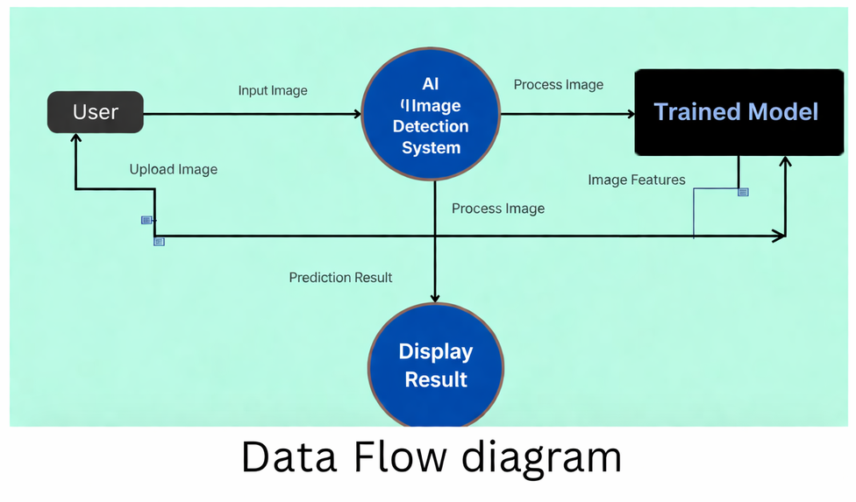

3. External Interface Requirements
3.1 User Interfaces
The system shall provide:
- Image upload button
- Drag-and-drop interface
- Display area for uploaded image
- Detection result label
- Confidence score bar
- Error message display
- Admin dashboard interface
GUI Standards:
- Clean and responsive design
- Consistent navigation bar
- Help button on all screens

3.2 Hardware Interfaces
- Compatible with standard CPU/GPU
- Supports optional NVIDIA GPU acceleration
- Works with standard storage devices

3.3 Software Interfaces
The system interacts with:
- TensorFlow/PyTorch (ML framework)
- OpenCV (image processing)
- SQL/NoSQL database
- Web server (Flask/Django)
Input:
- Image file (JPG/PNG)
Output:
- Classification label
- Confidence percentage

3.4 Communications Interfaces
- HTTP/HTTPS protocol
- REST API for detection requests
- JSON response format
- SSL encryption for secure communication

4. System Features

4.1 Image Upload and Validation
4.1.1 Description and Priority
Detects whether the image is AI-generated or real.
Priority: High
4.1.2 Stimulus/Response Sequences
User selects image →
System validates format →
System checks size →
System accepts or rejects file.
4.1.3 Functional Requirements
REQ-1: The system shall allow users to upload JPG and PNG images.
REQ-2: The system shall reject unsupported formats.
REQ-3: The system shall limit image size to 10MB.
REQ-4: The system shall display an error message for invalid uploads.

4.2 Image Classification Feature
4.2.1 Description and Priority
Detects whether the image is AI-generated or real.
Priority: High
4.2.2 Stimulus/Response Sequences
User uploads image →
System preprocesses image →
Model performs classification →
System displays result.
4.2.3 Functional Requirements
REQ-5: The system shall preprocess the image before classification.
REQ-6: The system shall classify images into two categories: Real or AI-Generated.
REQ-7: The system shall display a confidence score.
REQ-8: The system shall complete detection within 5 seconds.

4.3 Detection History Management
4.3.1 Description and Priority
Stores past detection results.
Priority: Medium
4.3.2 Stimulus/Response Sequences
Detection completed →
System logs result →
Admin can view logs.
4.3.3 Functional Requirements
REQ-9: The system shall store image name and result.
REQ-10: The system shall allow admin to view detection logs.
REQ-11: The system shall allow deletion of old logs.

4.4 Admin Dashboard
4.4.1 Description and Priority
Provides analytics and monitoring tools.
Priority: Medium
4.4.2 Stimulus/Response Sequences
Admin logs in →
System displays analytics dashboard.
4.4.3 Functional Requirements
REQ-12: The system shall require admin authentication.
REQ-13: The dashboard shall display total detections.
REQ-14: The dashboard shall display detection statistics.
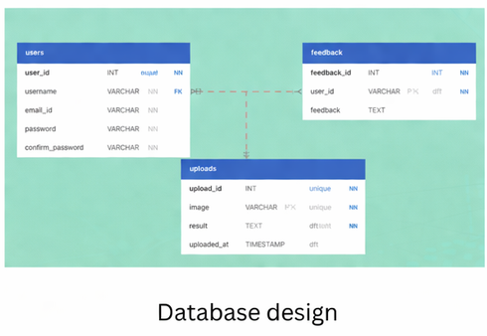

5. Nonfunctional Requirements
5.1 Performance Requirements
- Detection must complete within 5 seconds.
- System shall support at least 100 concurrent users.
- Accuracy must be ≥ 90%.
- System uptime shall be 95% or higher.

5.2 Safety Requirements
- The system shall not modify original uploaded images.
- The system shall prevent harmful file uploads.
- The system shall prevent execution of malicious scripts.

5.3 Security Requirements
- User data shall be encrypted using HTTPS.
- Admin login shall require authentication.
- Stored data shall be protected from unauthorized access.
- System shall prevent SQL injection attacks.

5.4 Software Quality Attributes
- Reliability: ≥ 95% uptime.
- Usability: Simple 3-step detection process.
- Maintainability: Modular architecture.
- Portability: Cross-platform compatibility.
- Scalability: Cloud deployment ready.
- Robustness: Handles invalid inputs gracefully.
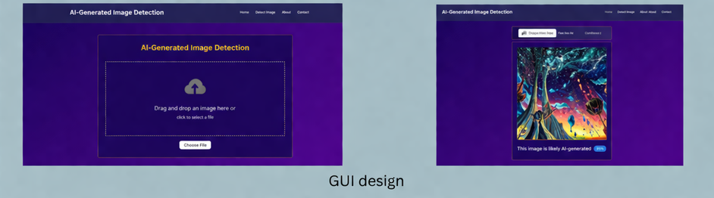

6. Project Plan
6.1 Team Members
- Member 1 – Alaqmar Kanchwala (Backend/Tester)
- Member 2 – Ali Asger Ginwala (Documentation/Tester)
- Member 3 – Ali Saifee (Frontend Developer)

6.2 Division of Work
Analysis:
- Requirements gathering – Alaqmar Kanchwala & Ali Asger Ginwala
Design:
- Architecture design – Alaqmar Kanchwala
- Database design – Ali Saifee
- UI design – Ali Saifee
Implementation:
- Model development – Alaqmar Kanchwala
- Backend development – Alaqmar Kanchwala
- Frontend development – Ali Saifee
Testing:
- System testing – Alaqmar Kanchwala & Ali Asger Ginwala
- Model evaluation – Ali Saifee
Documentation:
- Ali Asger Ginwala

6.3 Time Schedule
Phase | Duration
Requirement Analysis | 1 Week
System Design | 1 Week
Model Development | 2 Weeks
Backend & Frontend | 2 Weeks
Testing | 1 Week
Deployment | 1 Week
Total Duration: 8 Weeks

- Appendix A: Glossary
AI – Artificial Intelligence
GAN – Generative Adversarial Network
CNN – Convolutional Neural Network
Deepfake – Synthetic media generated using AI
ML – Machine Learning
SRS – Software Requirements Specification

- Appendix B: To Be Determined List
TBD-1: Final dataset size
TBD-2: Final model architecture
TBD-3: Hosting platform
TBD-4: Exact concurrency limit

