**Name: Shangirne Kharbanda**

**Registration Number: 20BAI1154**

**LAB – 4**

**NAT CONFIGURATION**

To configure NAT in CPT, we will first create the topology like this:

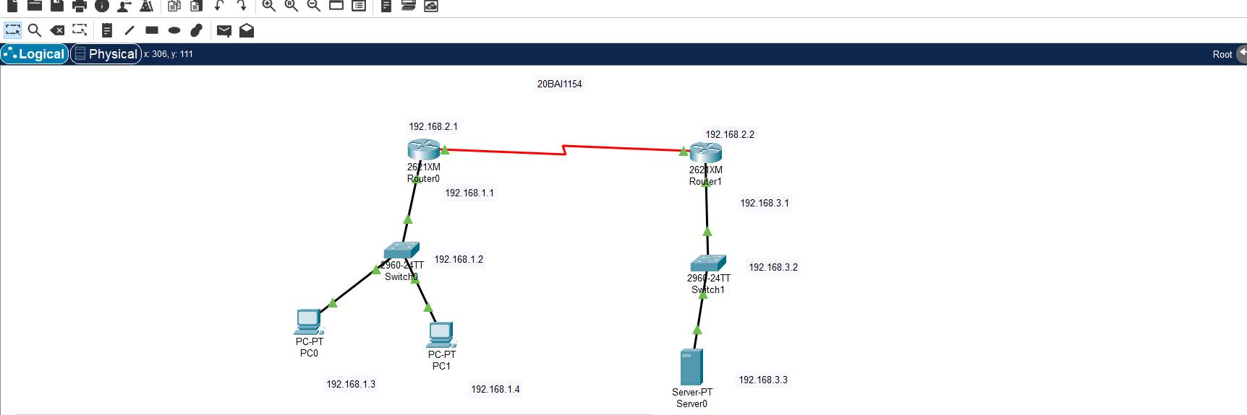

We will now configure the switch as follows:

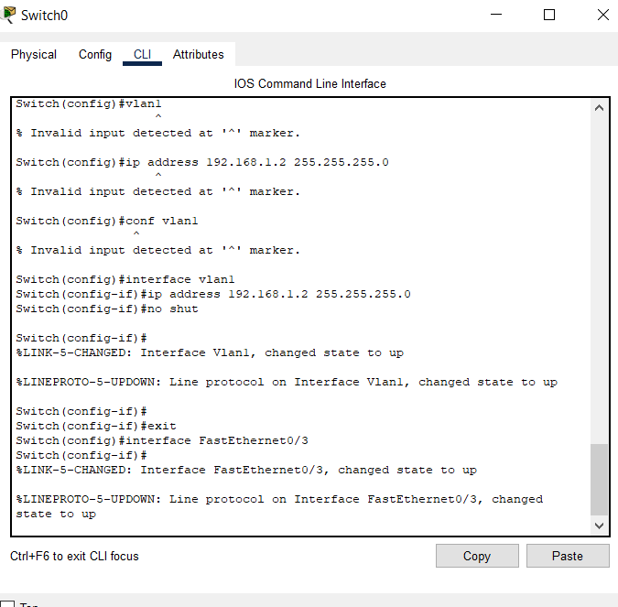

We will configure PCs like this:

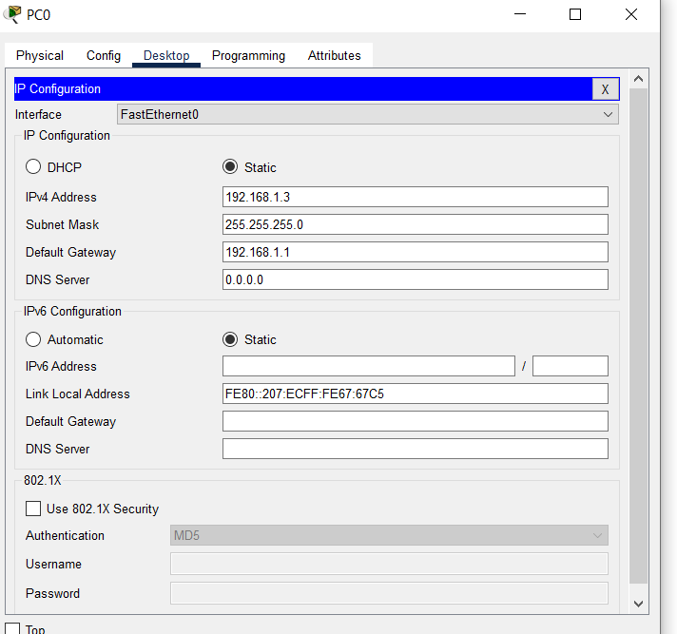

We will now make sure whether our network is working after configuring routing.

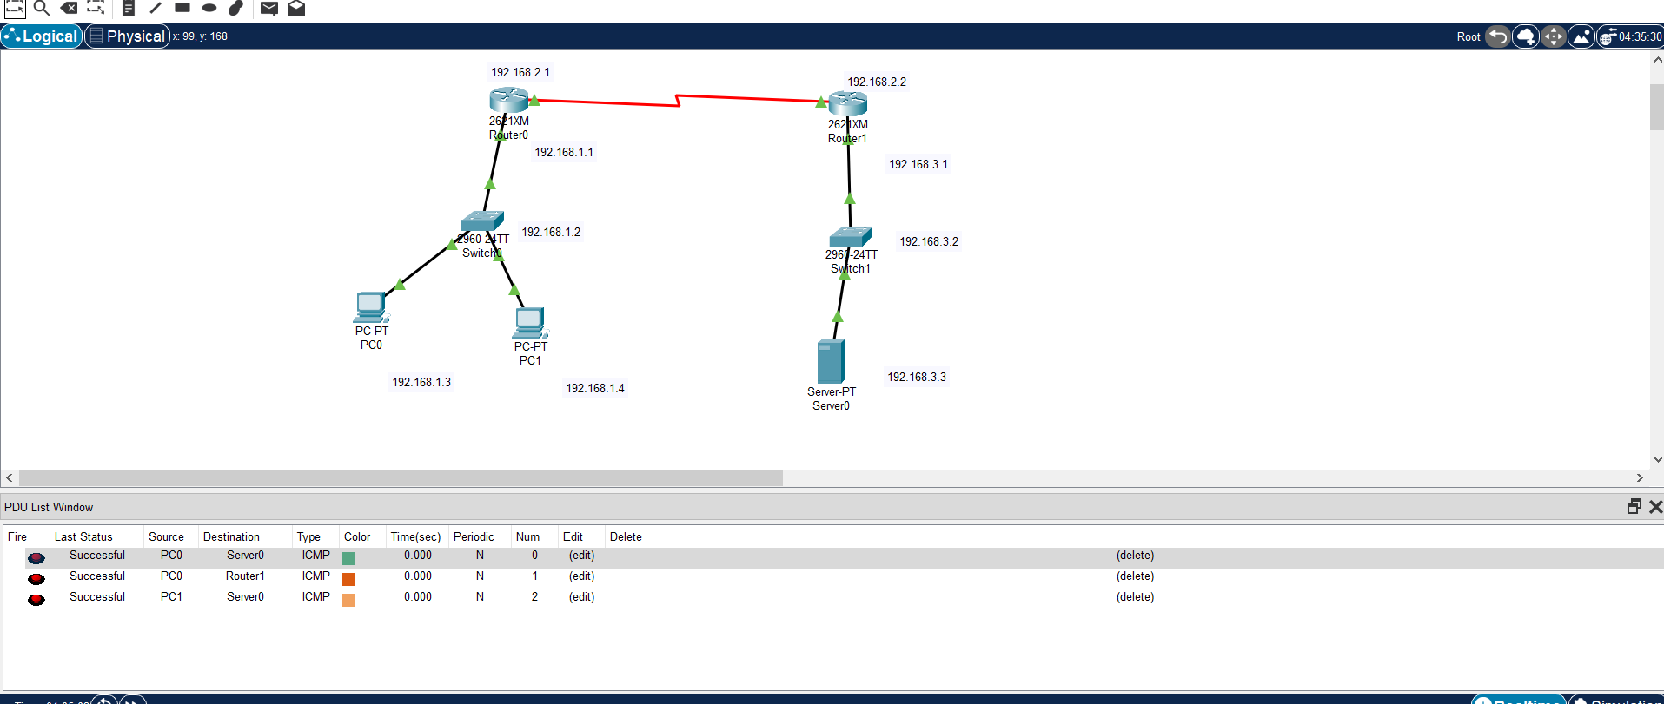

To configure routers for NAT, we follow the following steps:

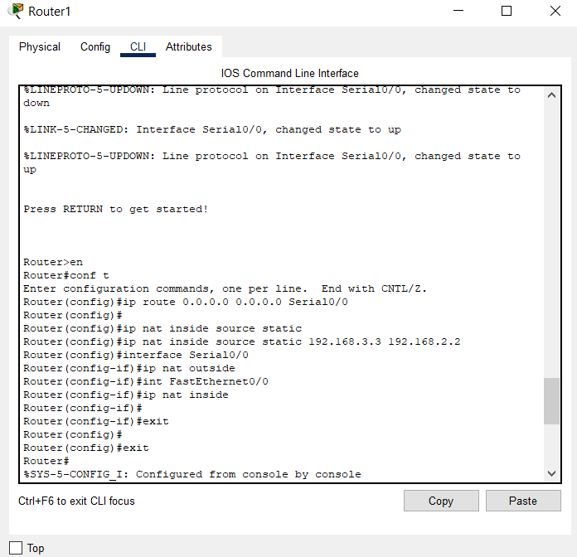

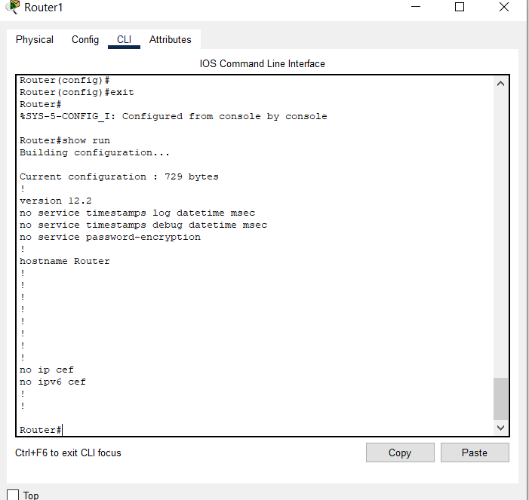

Now that we have configured NAT on the Router, our PCs from the other network will be able to access the Web server running and the private address of the web server will be statically mapped to a public ip address of the router on Serial0/0 interface and the PC will be able to connect to the web server using the public IP address.

This is illustrated in the following screenshot.

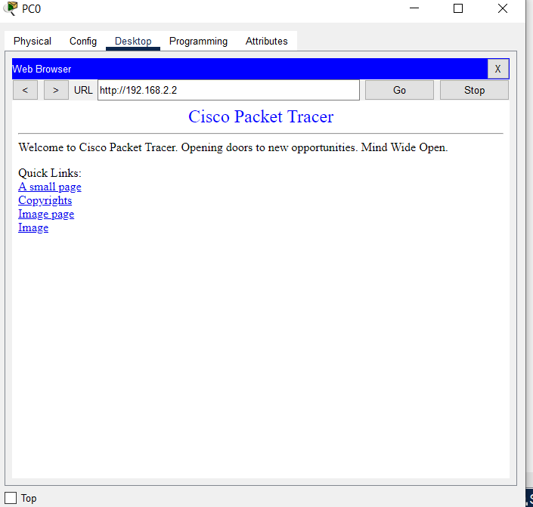

Therefore, we have successfully configured NAT on a working network.