**Name: Shangirne Kharbanda**

**Registration Number: 20BAI1154**

**ISAA LAB-10**

**NESSUS AND NMAP**

**Nessus scanning:**

We will go to <https://kali:8834/> and run a Nessus scan on the target machine i.e. **192.168.197.135**.

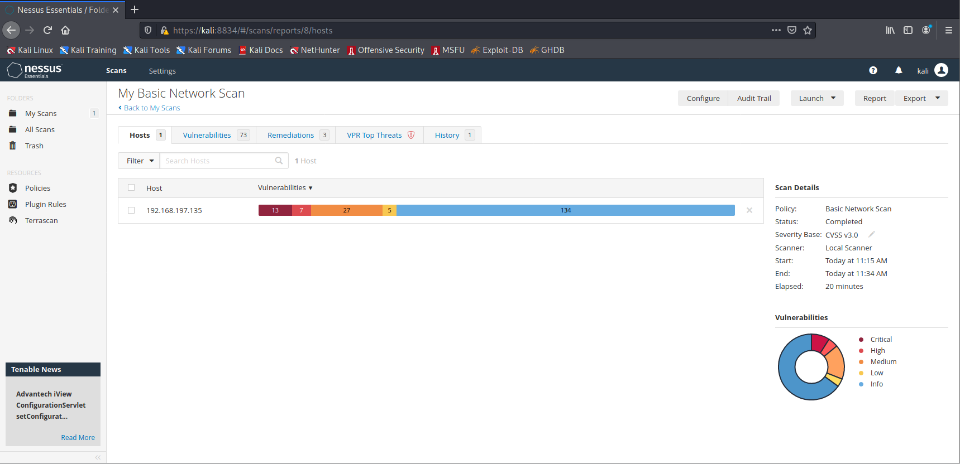

Our Nessus scan found 73 vulnerabilities including 13 critical vulnerabilities with a CVSS score of 10.

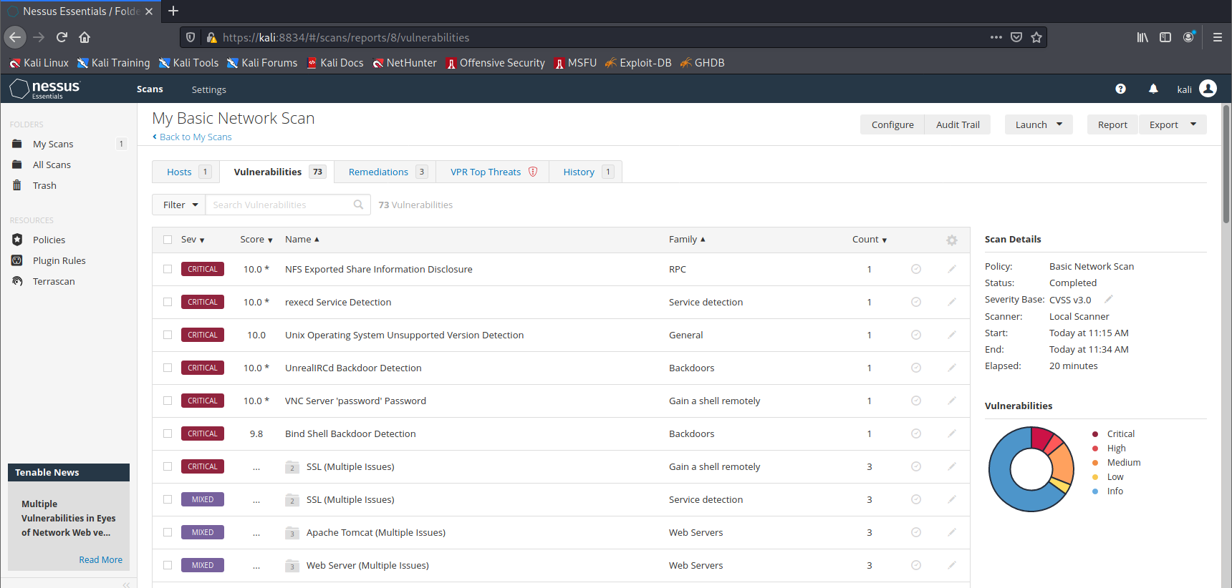

Our Nessus scan also provided us with some remediations to remediate.

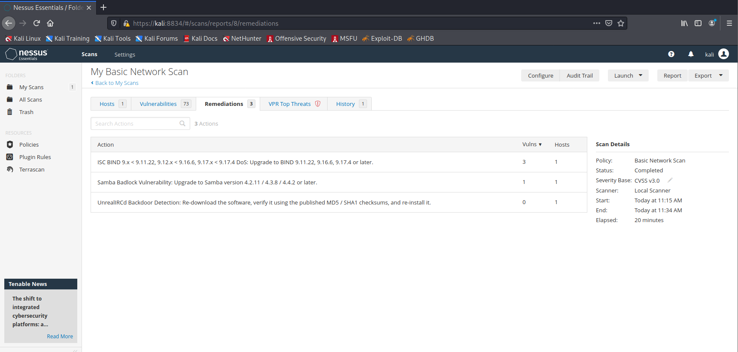

Generating report in Nessus:

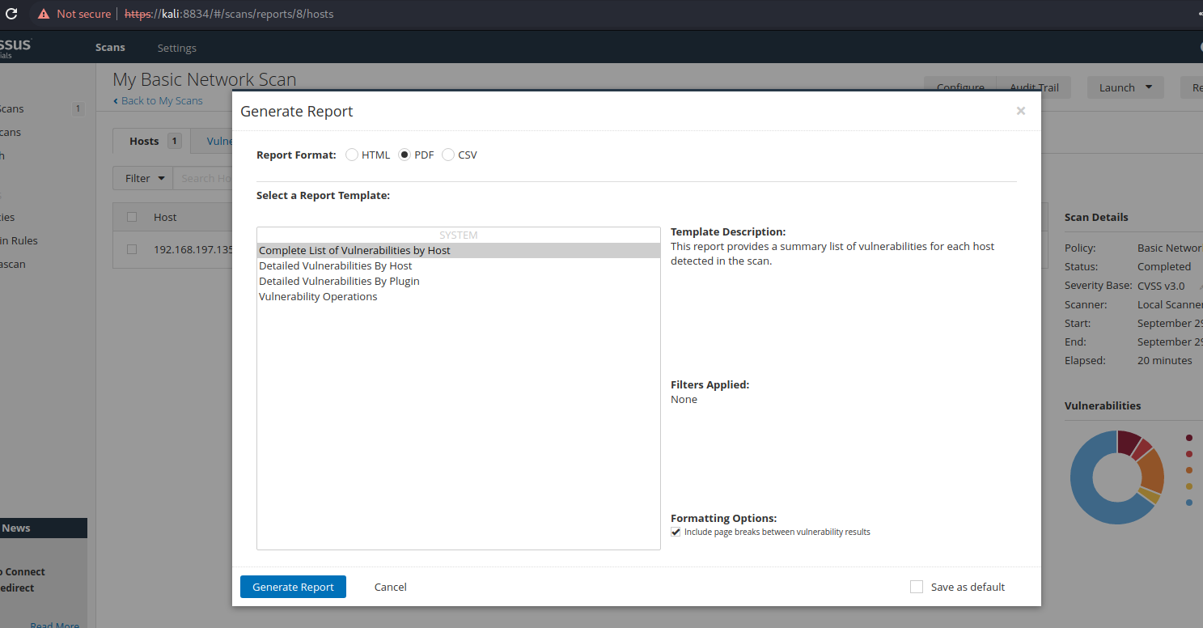

The report:

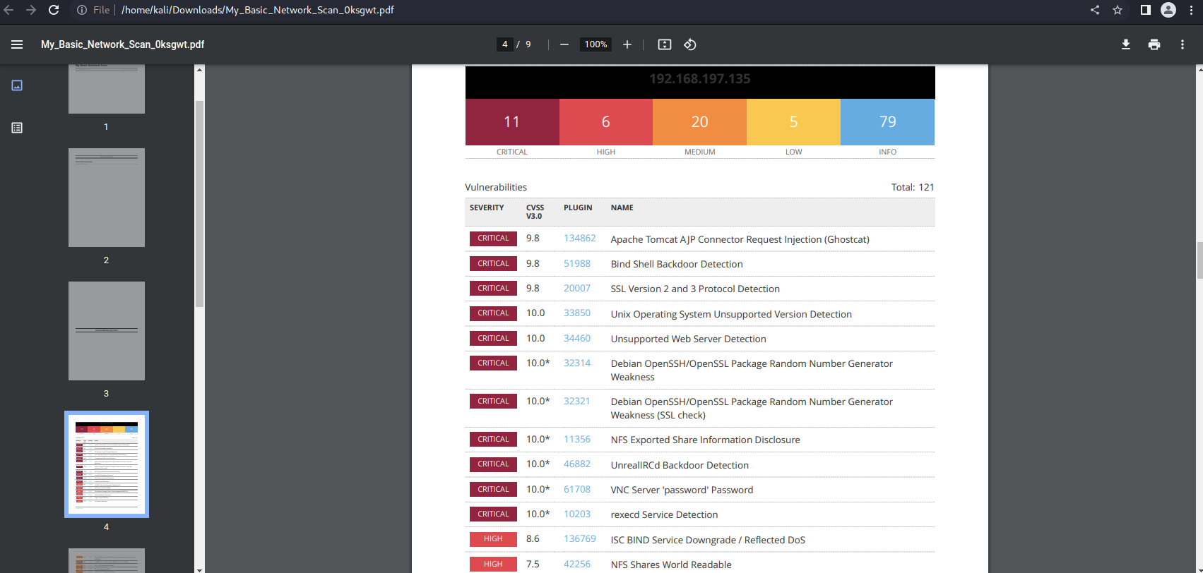

**Nmap scanning:**

Scanning an IP address:

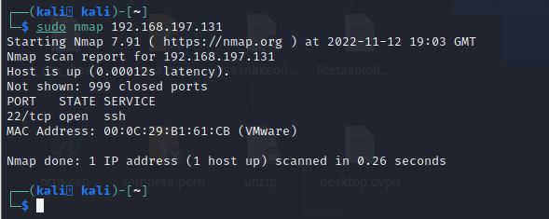

Scanning a range of IP addresses:

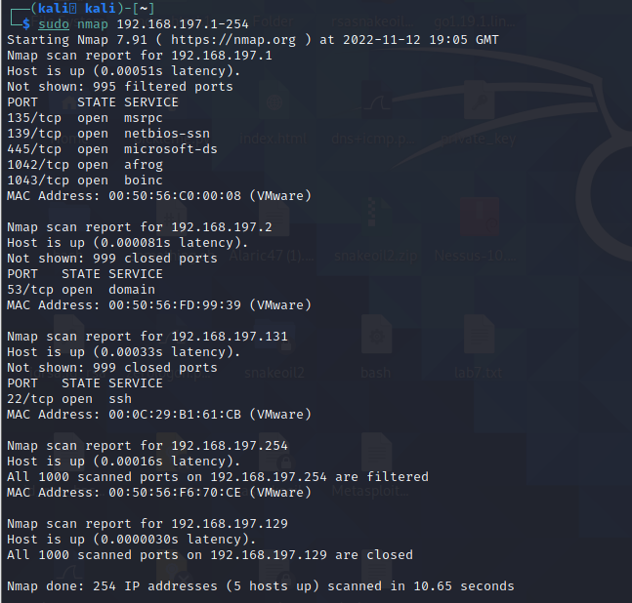

Scanning a domain name:

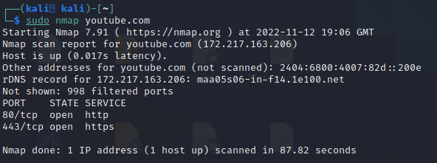

Scanning IP for a range of ports:

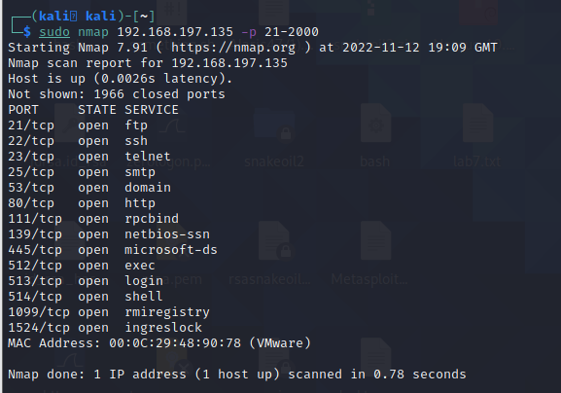

Scanning IP for a specific port:

