**Name: Shangirne Kharbanda**

**Registration Number: 20BAI1154**

**ISAA LAB-11**

**ARMITAGE**

We will first **install armitage and start is as follows**:

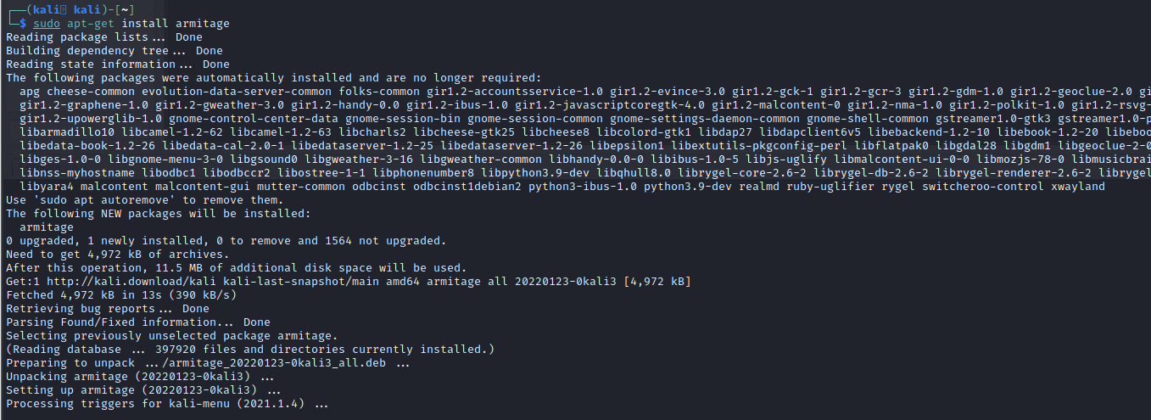

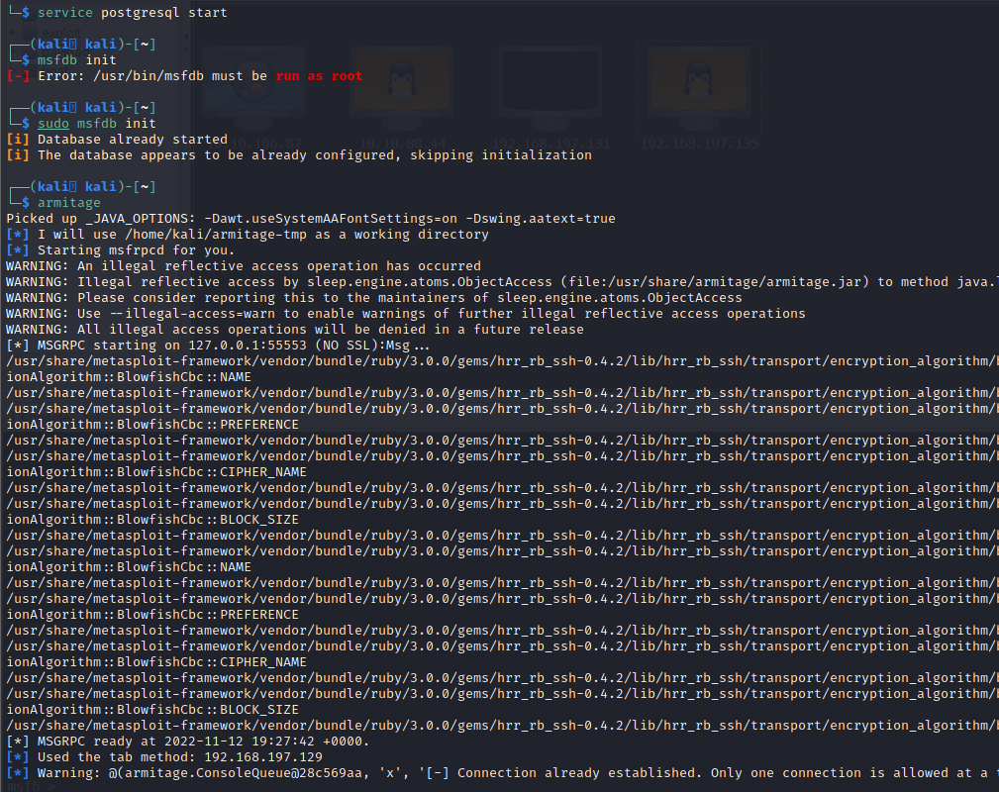

We will click on scan on our target machine and **scan it in armitage**.

We will go to Hosts options, choose **nmap quick scan os detect**, and type the IP.

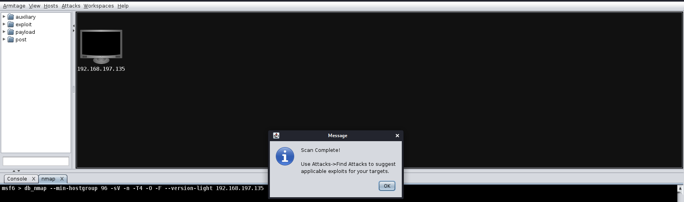

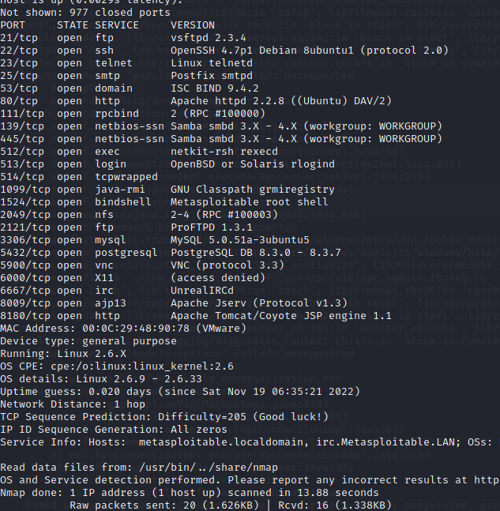

We can use the **vsftpd 2.3.4 exploit in armitage**.

After running it ,we get a **shell.**

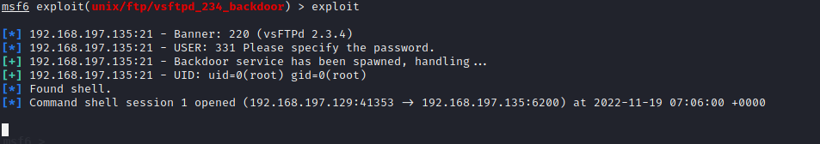

Next up, we can perform **Hail Mary in armitage on the target machine**.

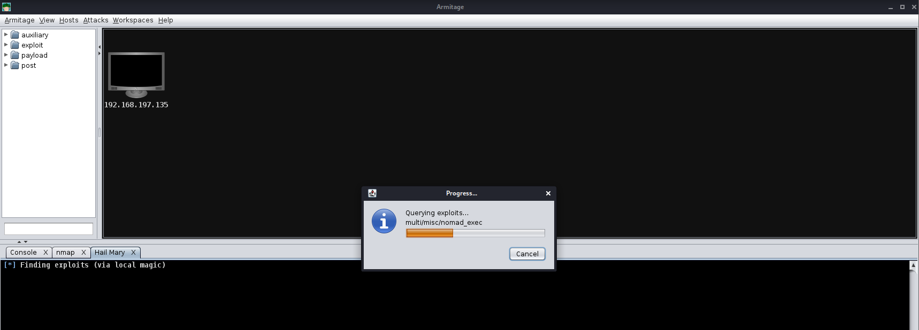

After performing it, **we will get 3 sessions in armitage**.

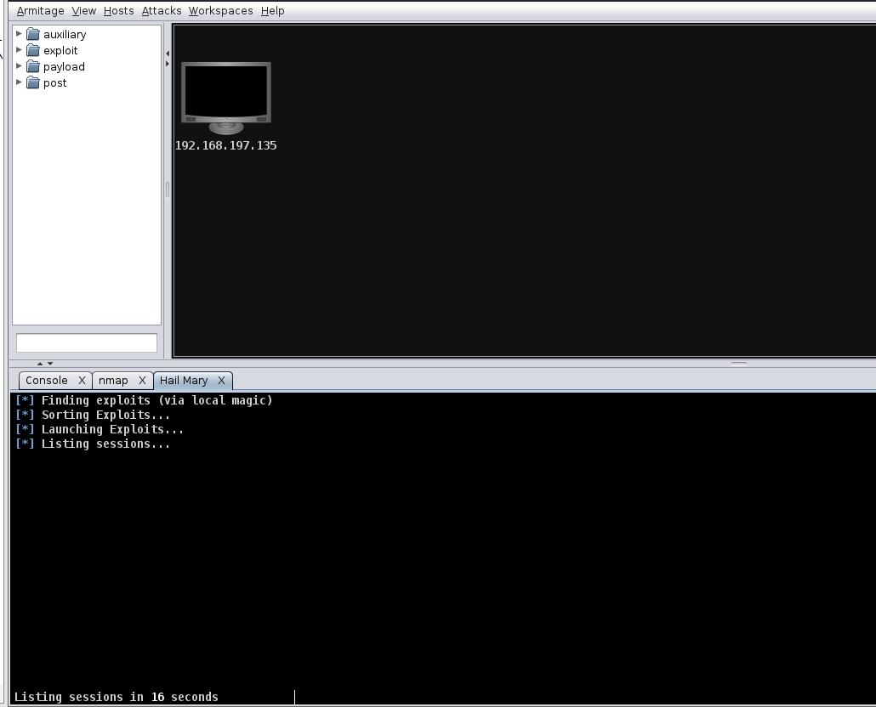

We can interact with any session and get a shell.

Therefore, **4 of our exploits were successful** as we got **1 session from our manual exploit** and **3 sessions from Armitage’s Hail Mary functionality which exploited 3 more vulnerabilities** for us automatically.

**Our Armitage functions are now complete.**