**Name: Shangirne Kharbanda**

**Registration Number: 20BAI1154**

**LAB-1**

**SWITCH AND ROUTER CONFIG**

**SWITCH CONFIGURATION:**

For a switch network, add 2 end devices to every switch.

Assign IP addresses to all the end devices in the network.

Configure a switch using CLI as follows:

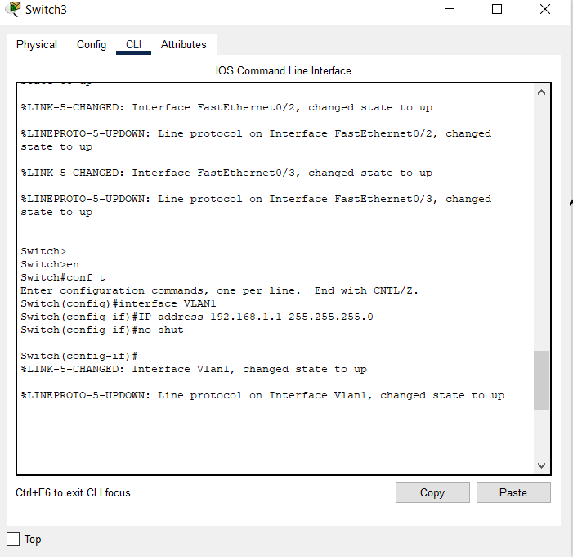

Configure your network as shown:

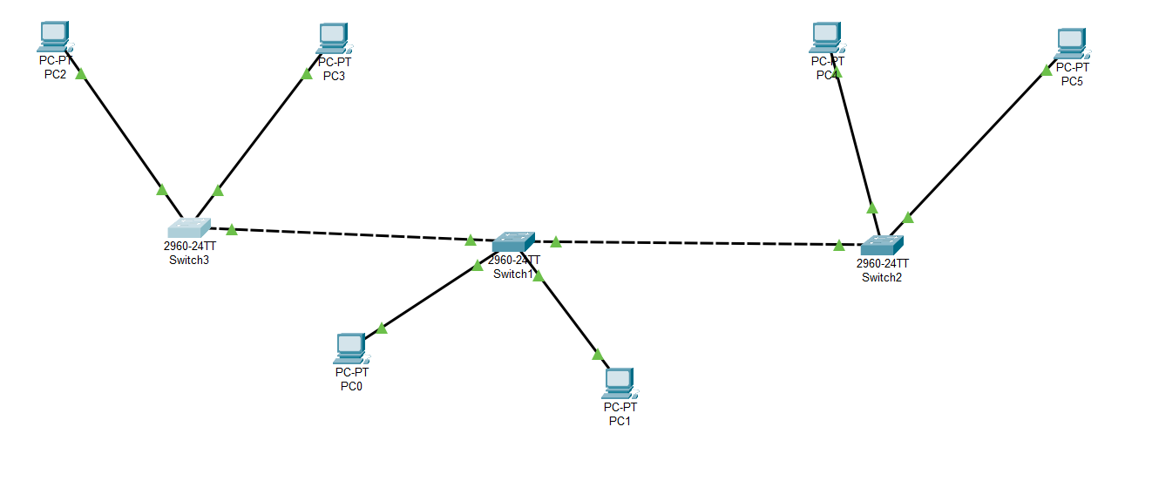

Add IPs to end devices

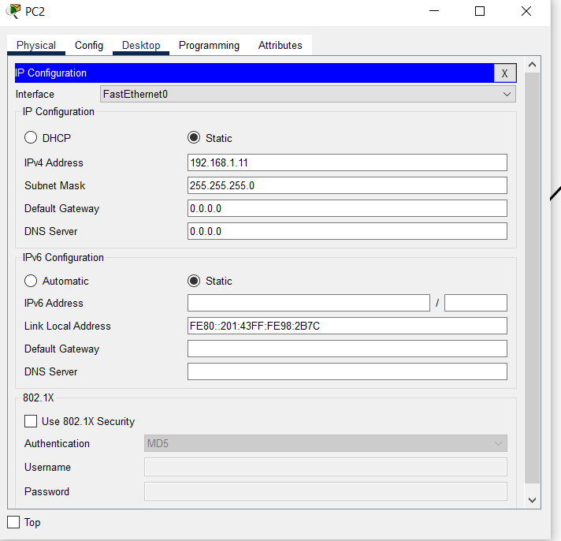

Send packets

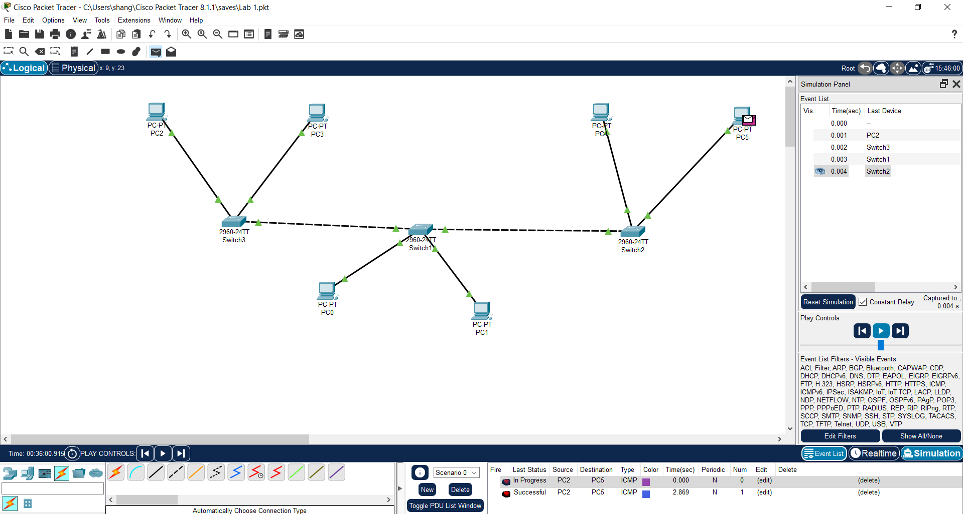

**ROUTER CONFIGURATION:**

For a router configuration, connect it all as shown:

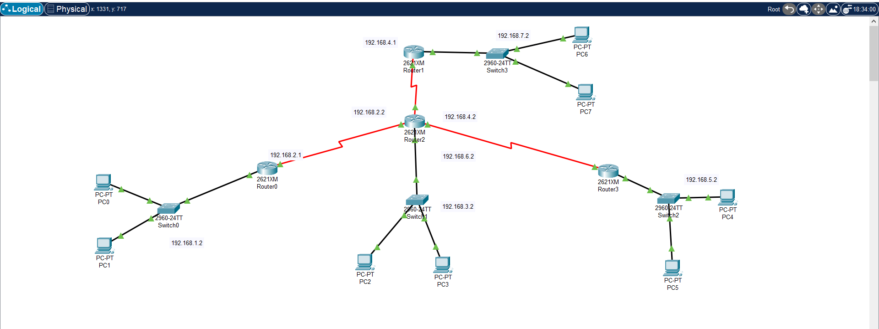

Connect the switches and routers in the topology shown and assign IP addresses to end devices.

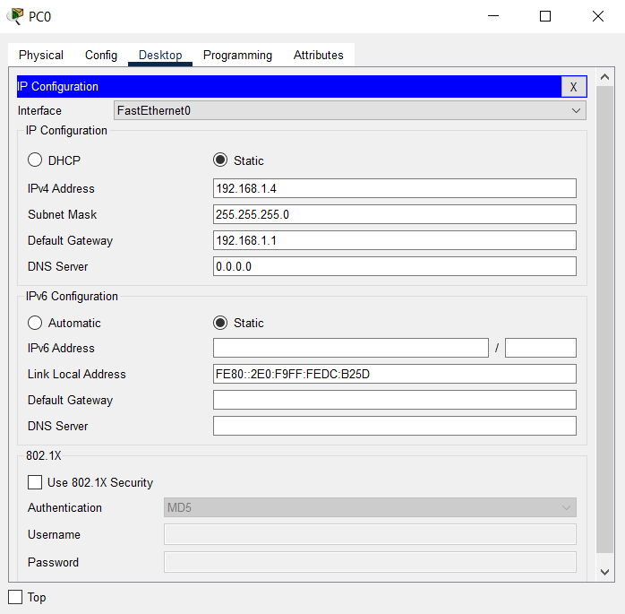

The default gateway has to be the IP address of the router’s interface connecting to the switch in that network.

Configure all the switches as shown before.

Configure the routers by assigning IPs to the interfaces and use a serial connection to connect all the routers together.

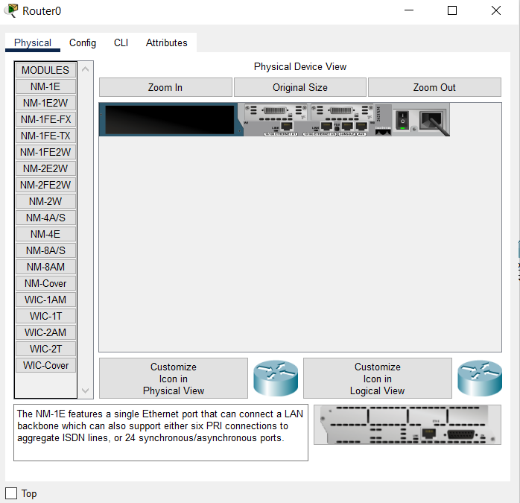

To connect all the different networks together, use the IP route command in the CLI for multiple networks and make a routing table for each network for the router to route traffic to and from.

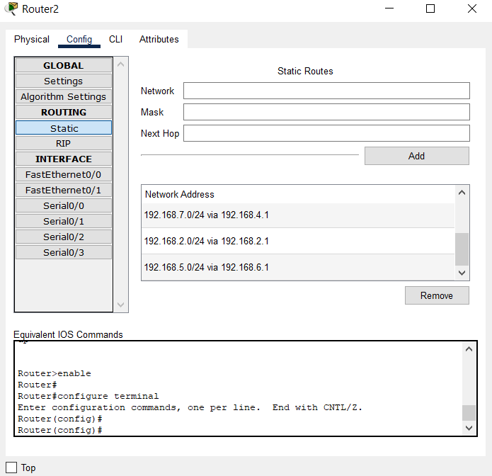

While making these routing tables using the IP route command, make sure to choose the correct interface for the network you want to route the packets to.

Now after making the routing tables for all the routers like that, send packets from one network to the other.

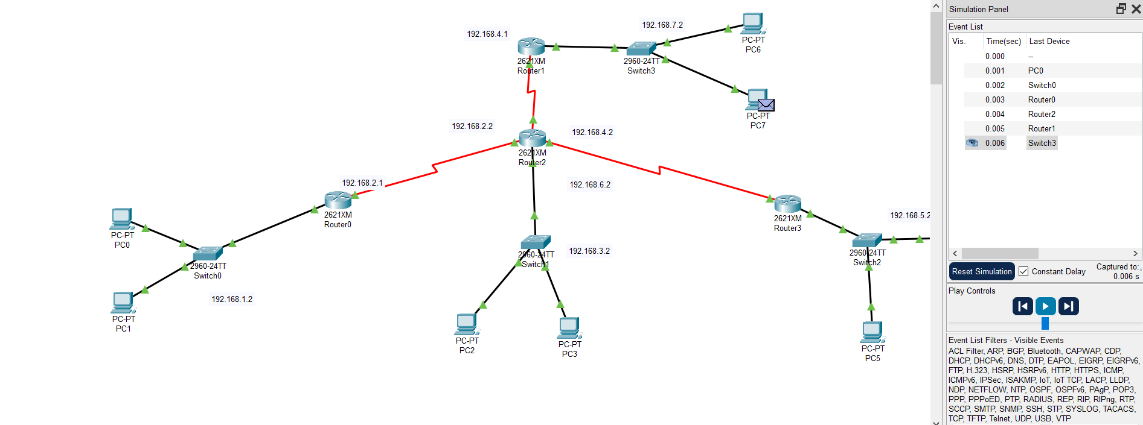

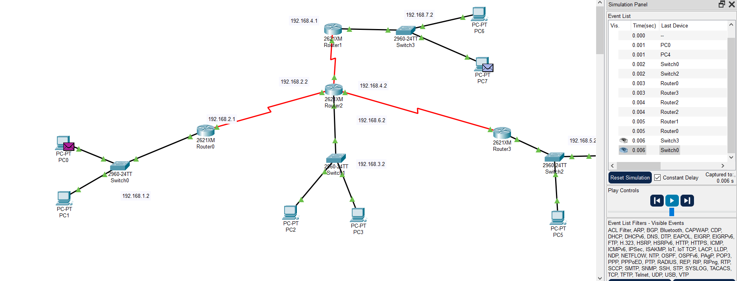

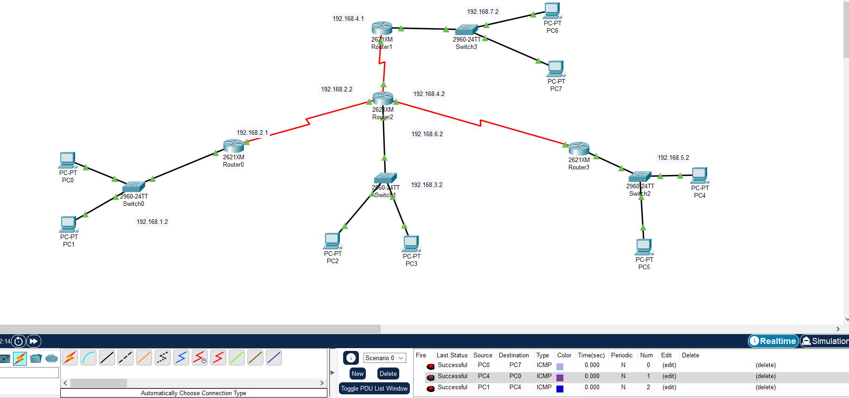

We can send messages to and from every network and communicate between all the PCs in different networks. Therefore, our topology works.

This is how we configure a switch and a router in cisco packet tracer.