**Name: Shangirne Kharbanda**

**Registration Number: 20BAI1154**

**ISAA LAB-9**

**LYNIS AUDIT TOOL**

First, we will begin by installing Lynis on our Kali system.

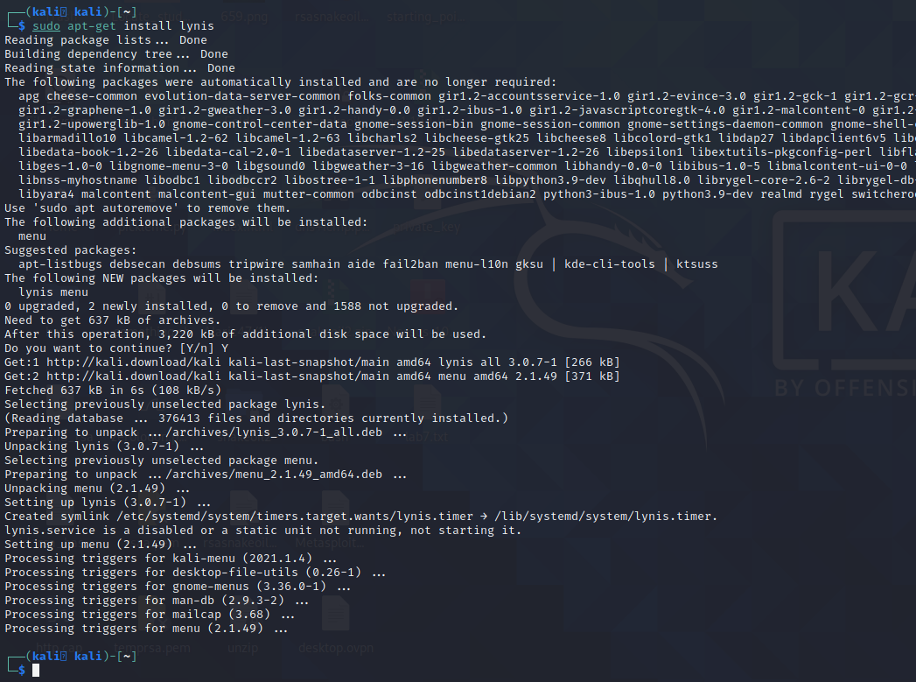

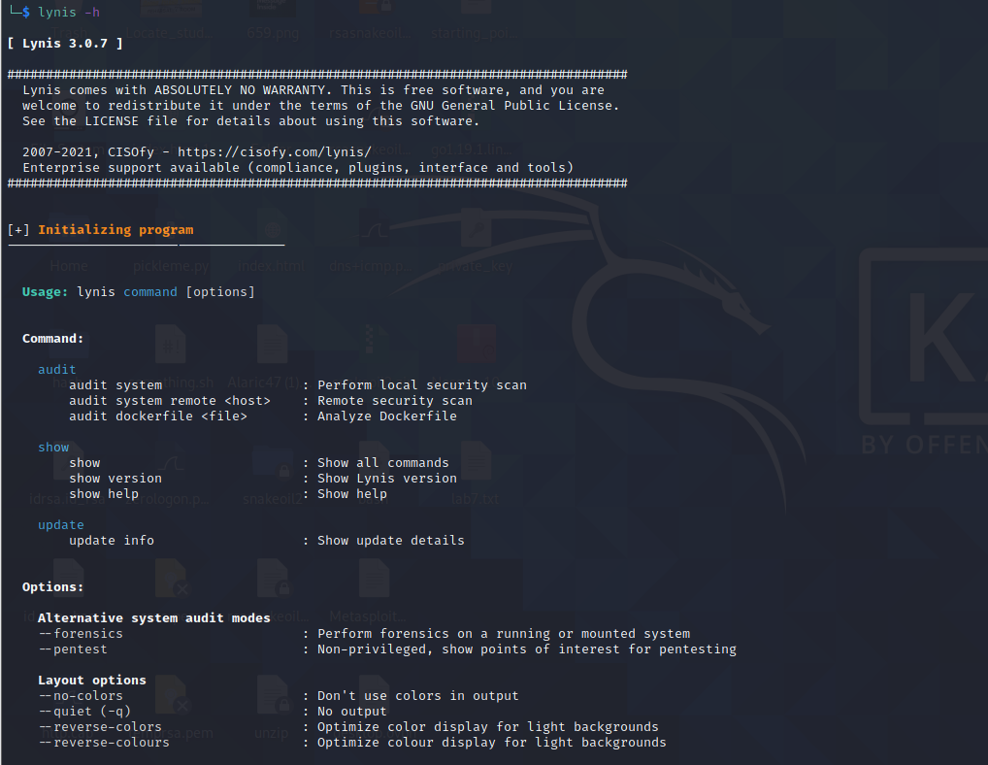

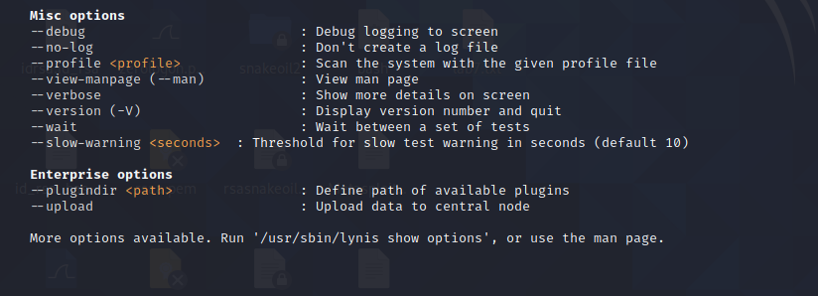

Now we will run the command to audit the system.

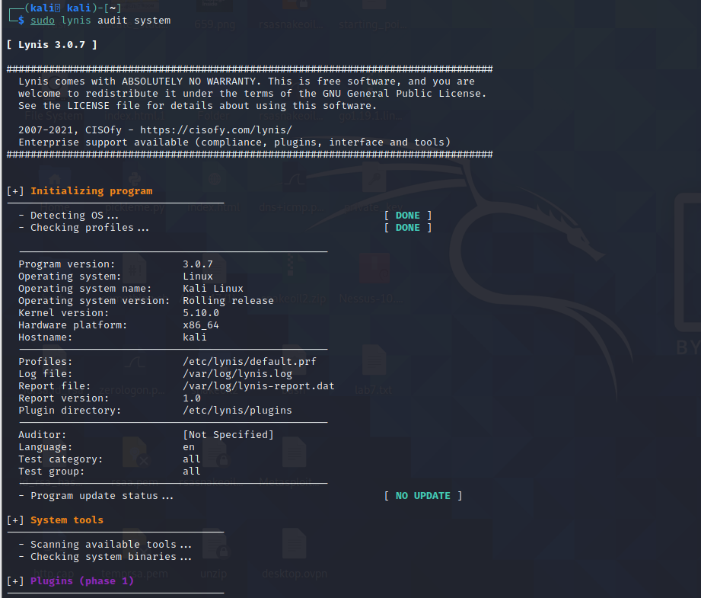

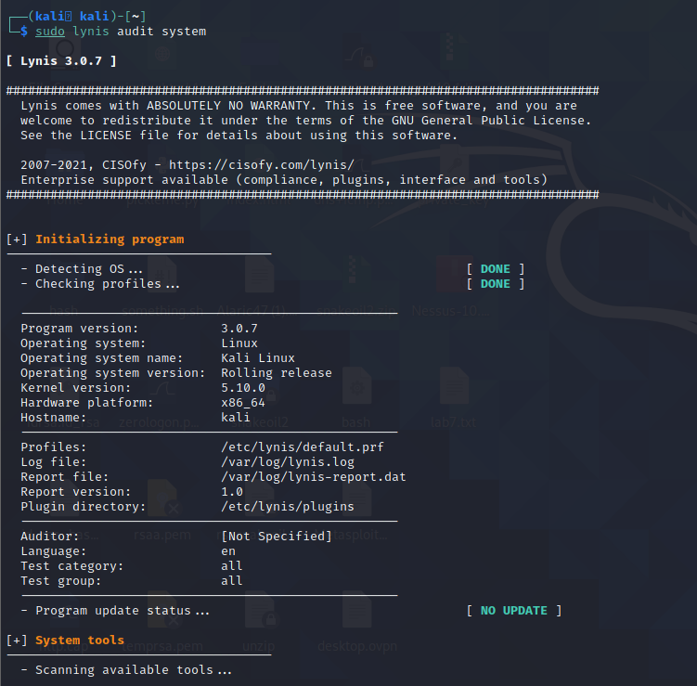

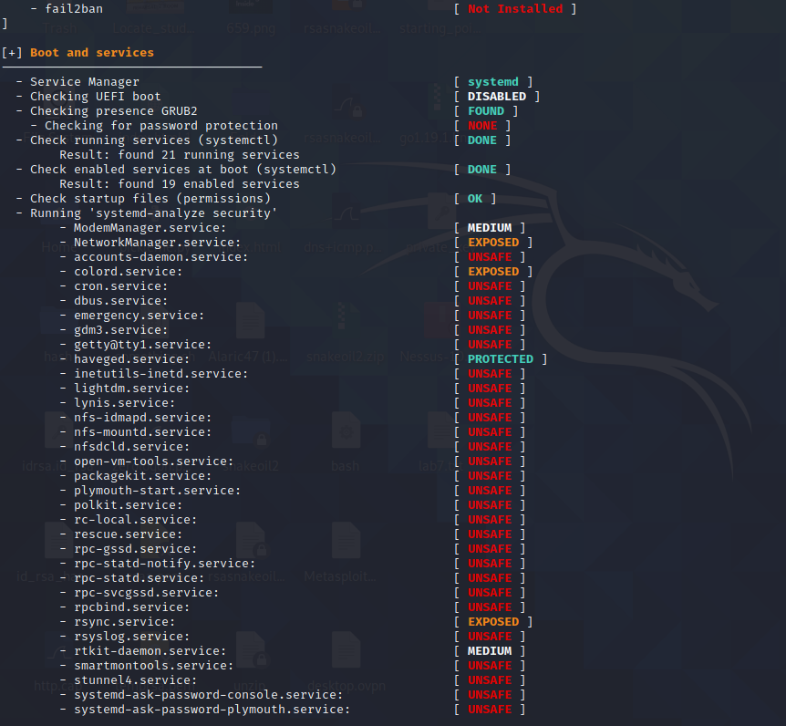

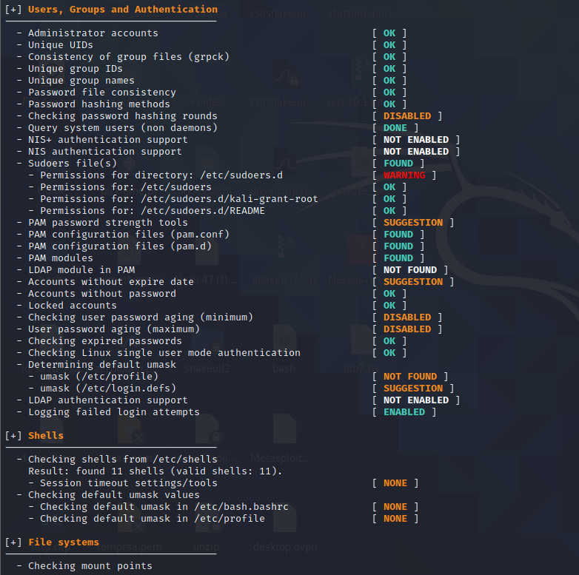

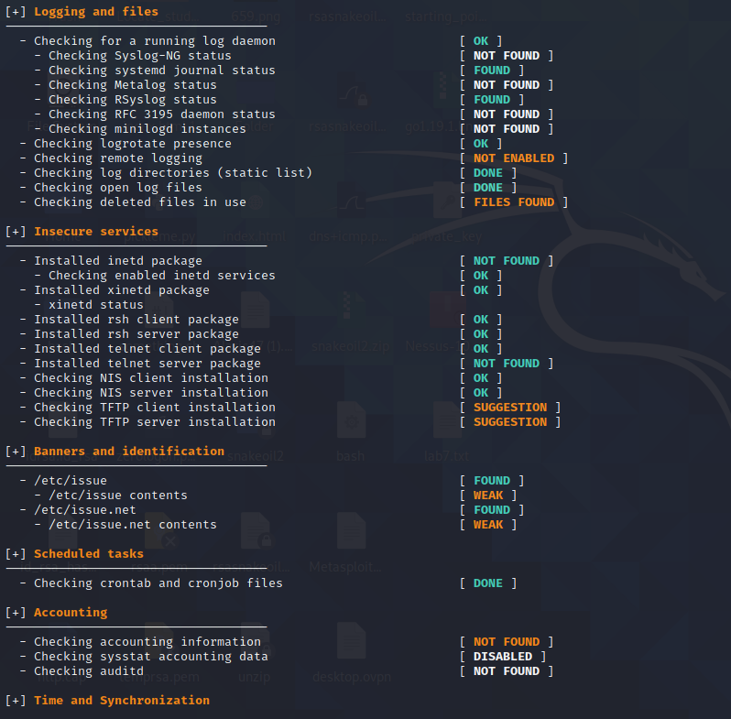

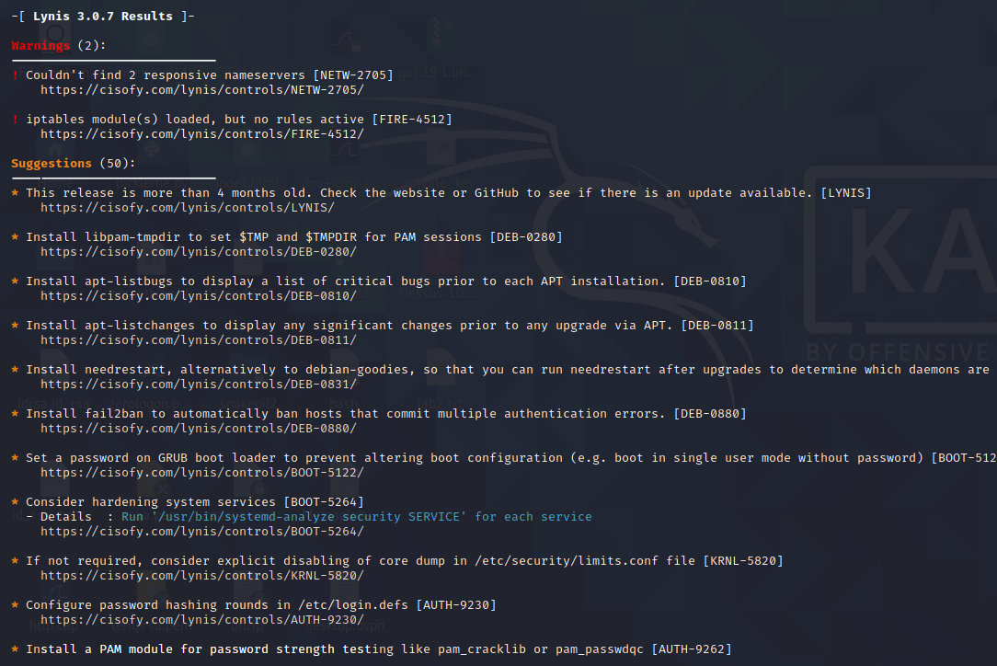

After making some changes, our hardening index goes up as shown in the following screenshot.

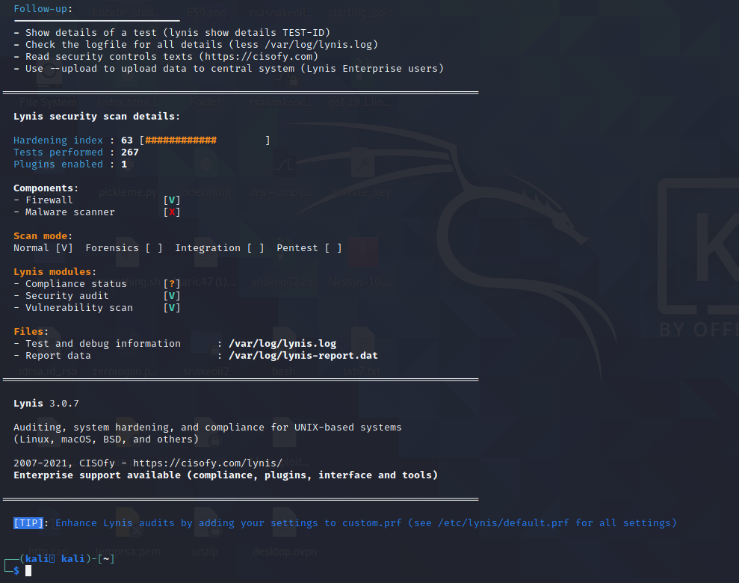

Inferences:

Successfully audited our system using Lynis audit tool and improved hardening index by making the changes recommended by the Lynis audit tool.

Conclusion:

Successfully audited our system using Lynis audit tool and improved hardening index by making the changes recommended by the Lynis audit tool.