**Name: Shangirne Kharbanda**

**Registration Number: 20BAI1154**

**ISM LAB – 12**

**Steganography using steghide on Kali**

Step 1. Installing the Steghide tool on Kali

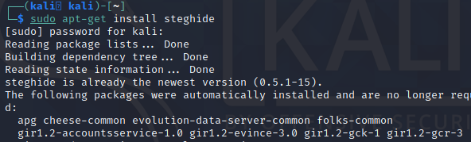

Step 2. Creating a simple text file which will be used to embed inside a .jpg image file

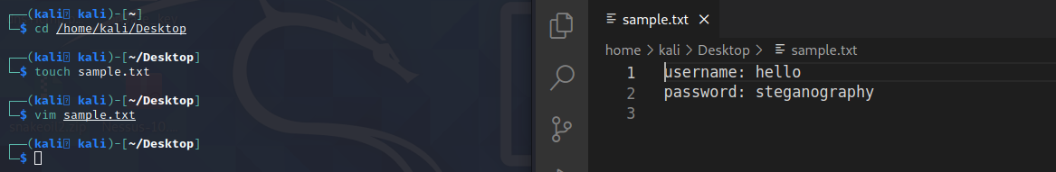

Step 3. We can now use steghide to embed this sample.txt inside the image

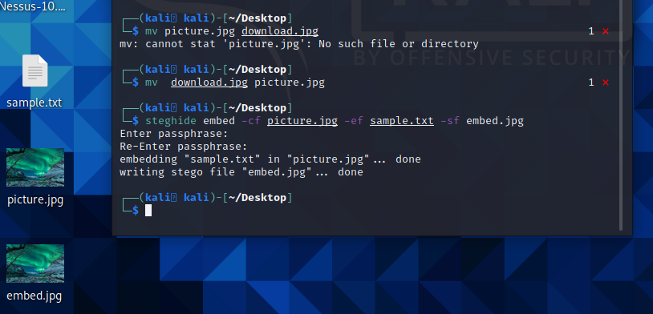

Step 4. Now we will try and take out the embedded image from the file.

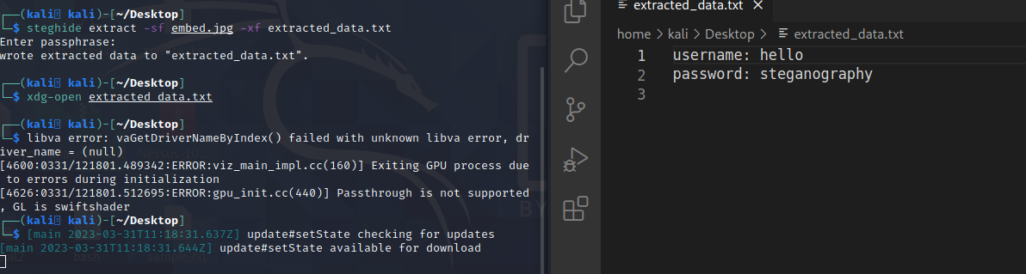

View the extracted data from the embed.jpg file.

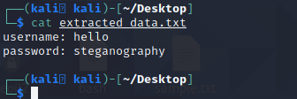

Step 5. Now we will use AES encryption to first encrypt the text file and then embed it into an image.

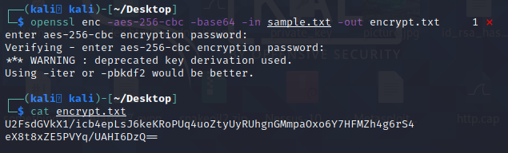

Now we will embed this.

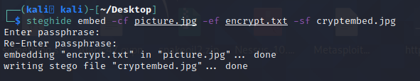

Step 6. Now we will decrypt the AES encrypted file.

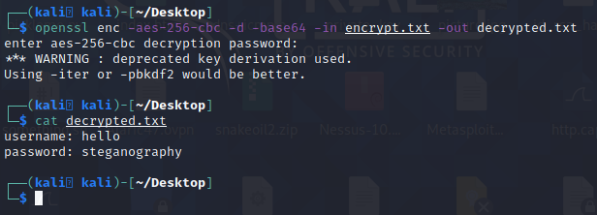

Step 7. We will use Stegsnow for bigger files as shown below.

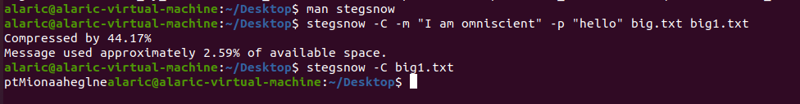

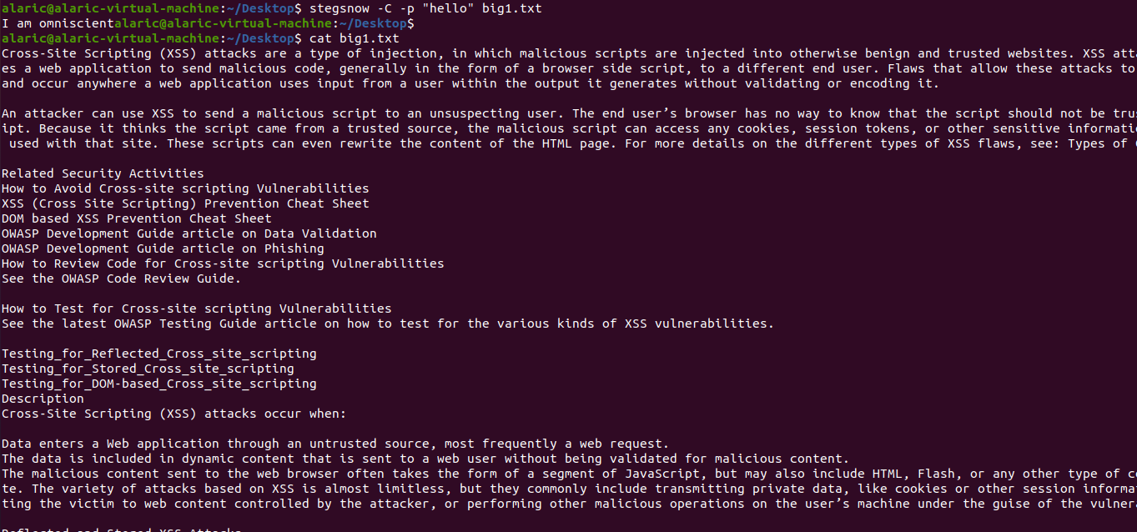

**Thus, we have successfully hidden and retrieved information in and from an image file using steghide and in a text file using stegsnow.**

**Lab successfully completed.**