**Name: Shangirne Kharbanda**

**Registration Number: 20BAI1154**

**ISM LAB – 2**

**TOPOLOGY WITH RIP PROTOCOL IN CISCO PACKET TRACER**

**Make a topology in Cisco packet tracer with 2 routers, 4 switches and 7 end devices and routing is to be done using the RIP protocol.**

We will first make a topology in CPT as shown below.

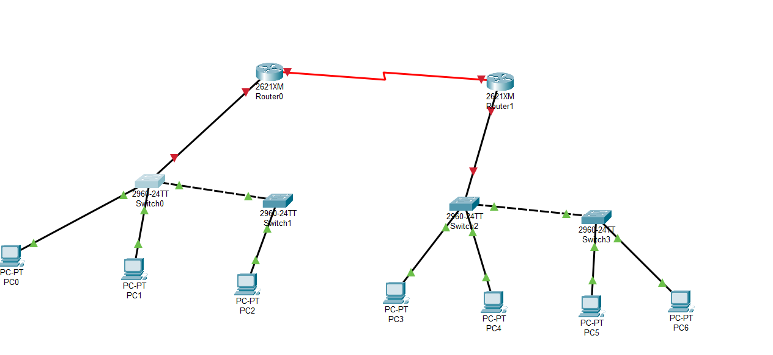

We will now configure a switch as shown below:

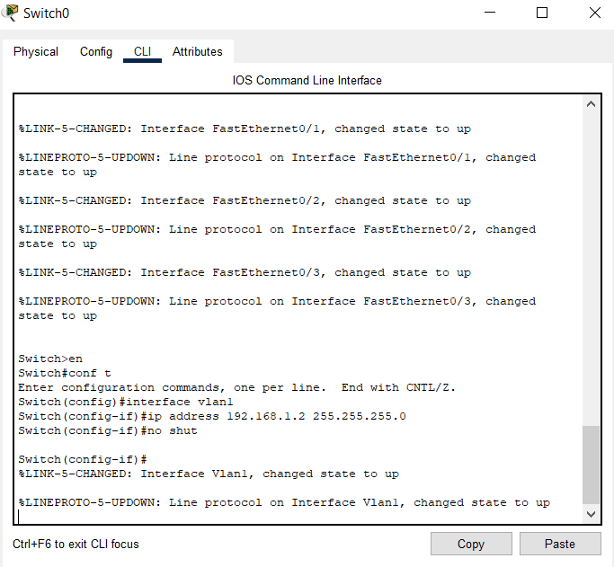

We will configure and assign an endpoint as shown below:

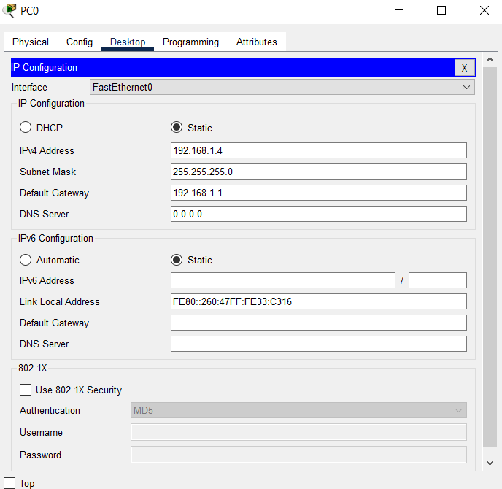

For routers, we will use serial connection so for that we will use WIC-2T as follows and assign IPs to Serial interfaces.

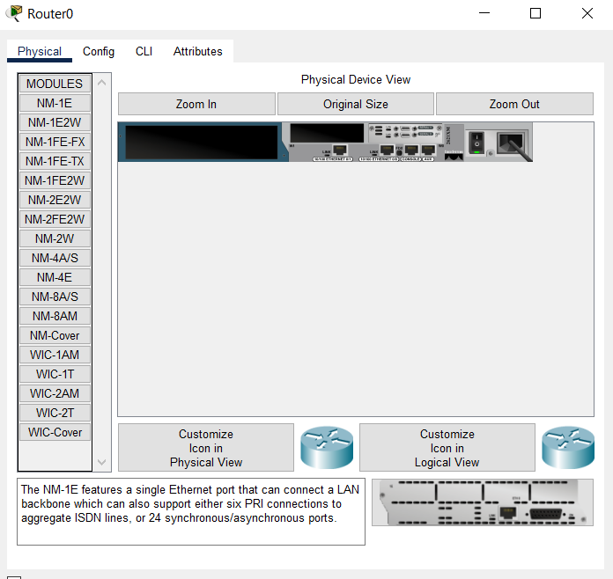

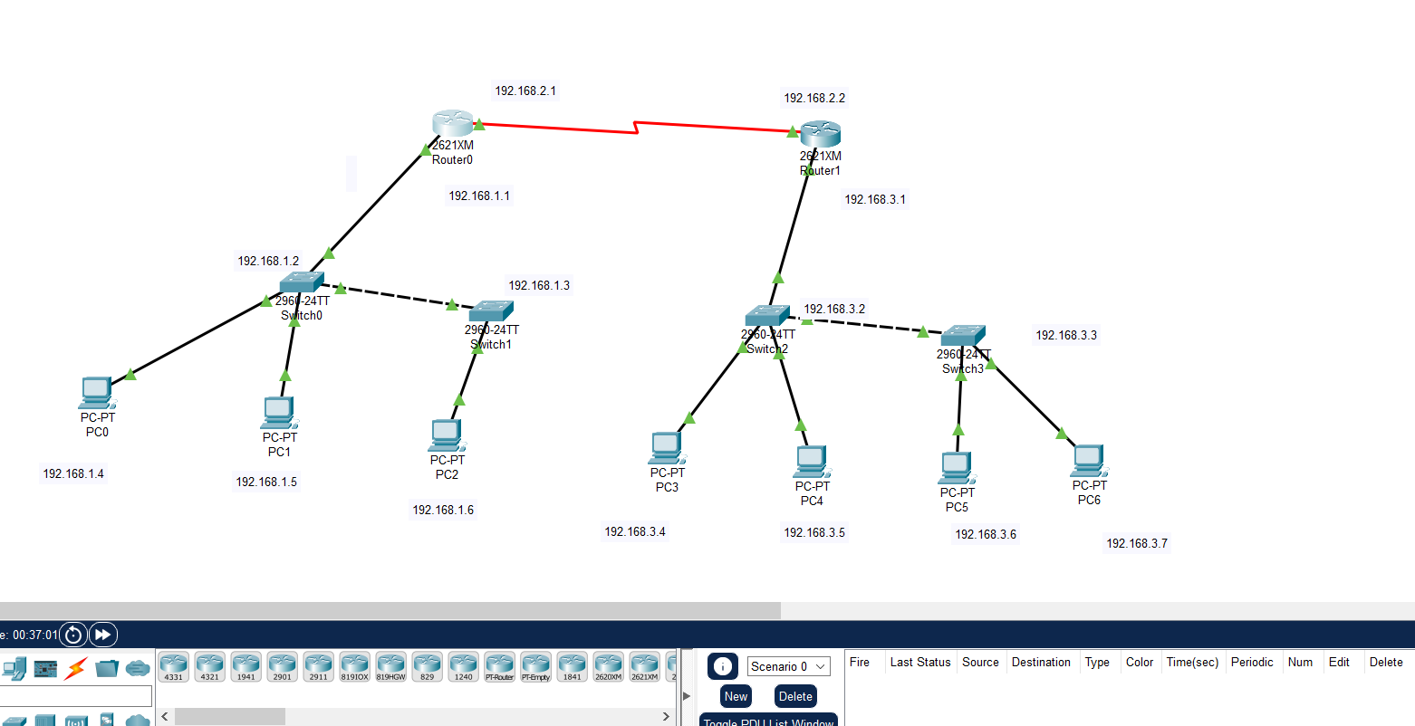

Now we will use the RIP protocol to add routing between the two routers. We will do that for Router0 as follows:

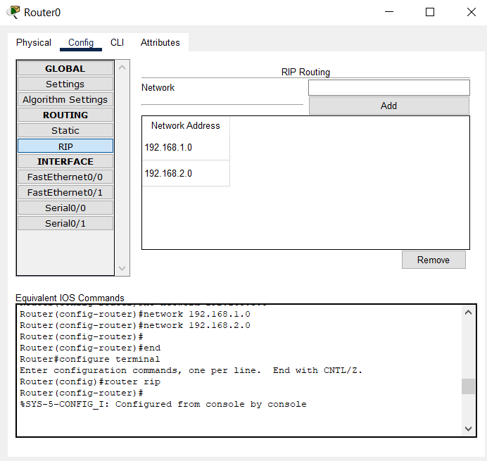

And we will do that for Router1 as follows:

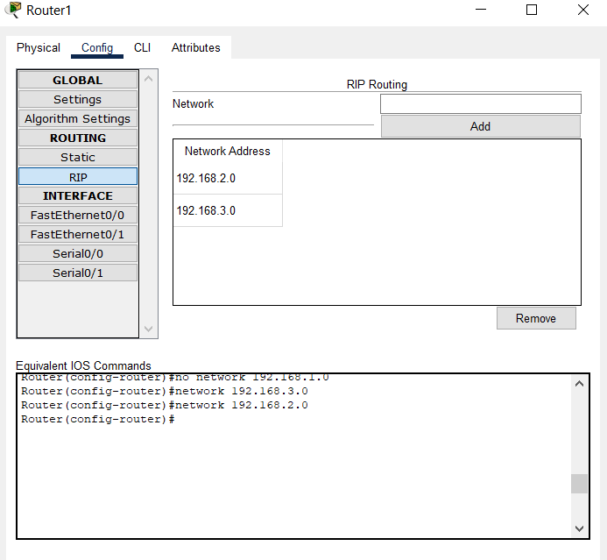

Now we will send packets from one network to another to see if it works.

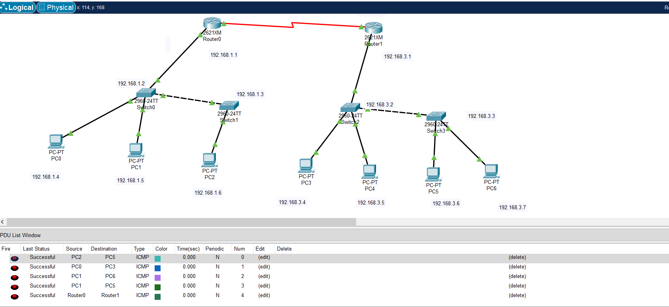

Thus, we can see that we are successfully able to send packets in our desired network using the RIP protocol routing.