**Name: Shangirne Kharbanda**

**Registration Number: 20BAI1154**

**ISM LAB – 3**

**CISCO PACKET TRACER: VLAN**

**To configure various VLANs in CPT, we will first create the following topology.**

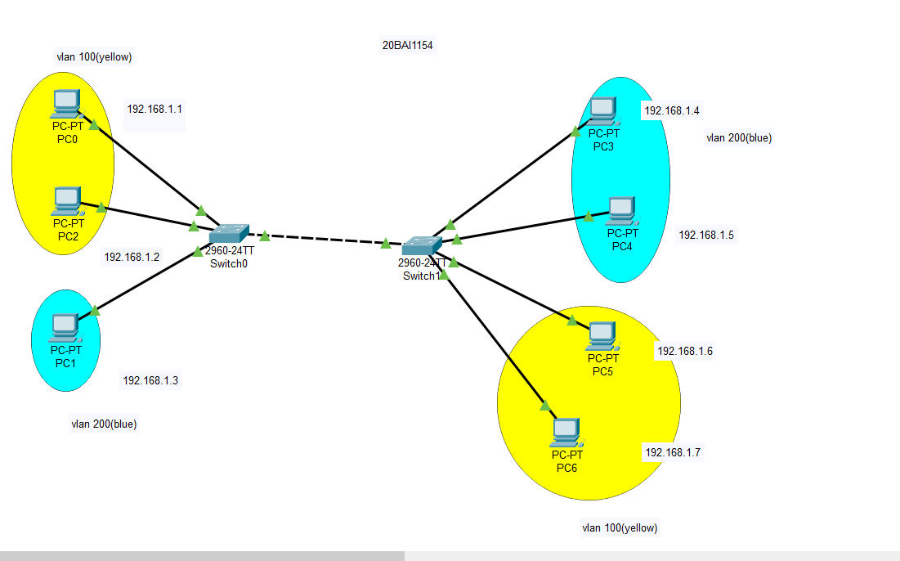

Now we will configure our VLANs in a way that devices in the VLAN 100 (yellow) can only ping to devices in the same VLAN and devices in the VLAN 200(blue) can also ping in the same VLAN 200.

To do this we will configure our 2 switches as follows:

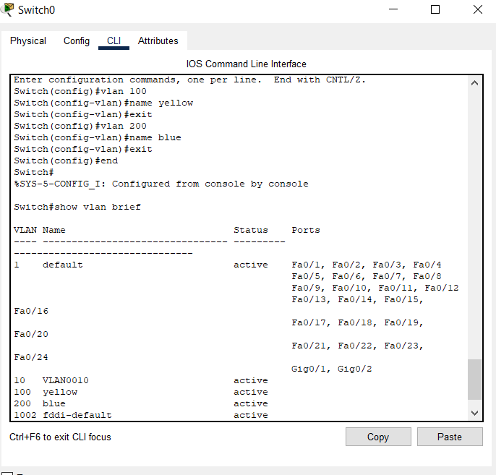

After configuring the VLAN names, we will add switch ports to our VLAN next.

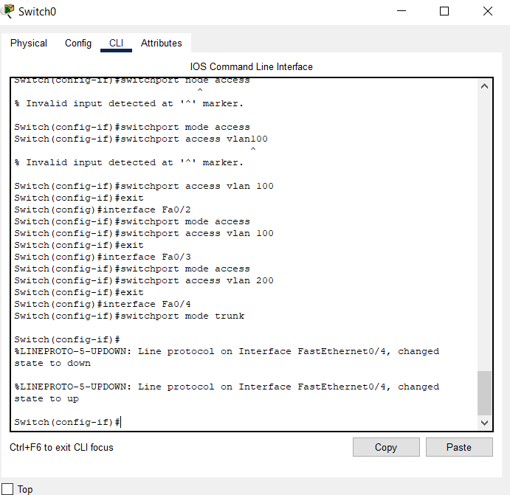

Similarly we will configure Switch 1 in the same way.

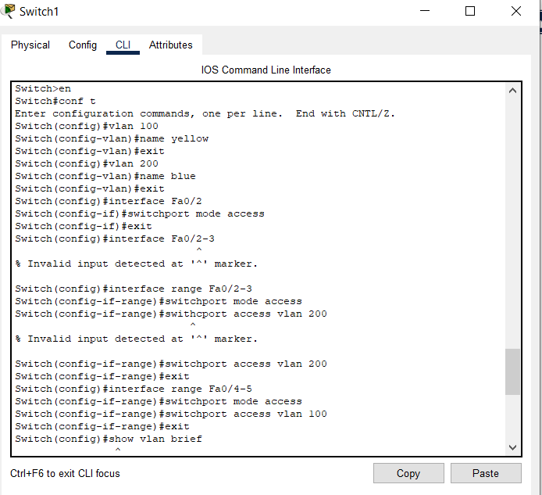

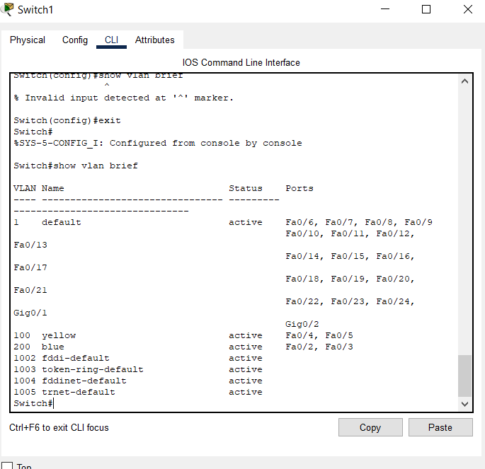

After configuring the switches and the VLANs, we will now send packets in our topology between different VLANs.

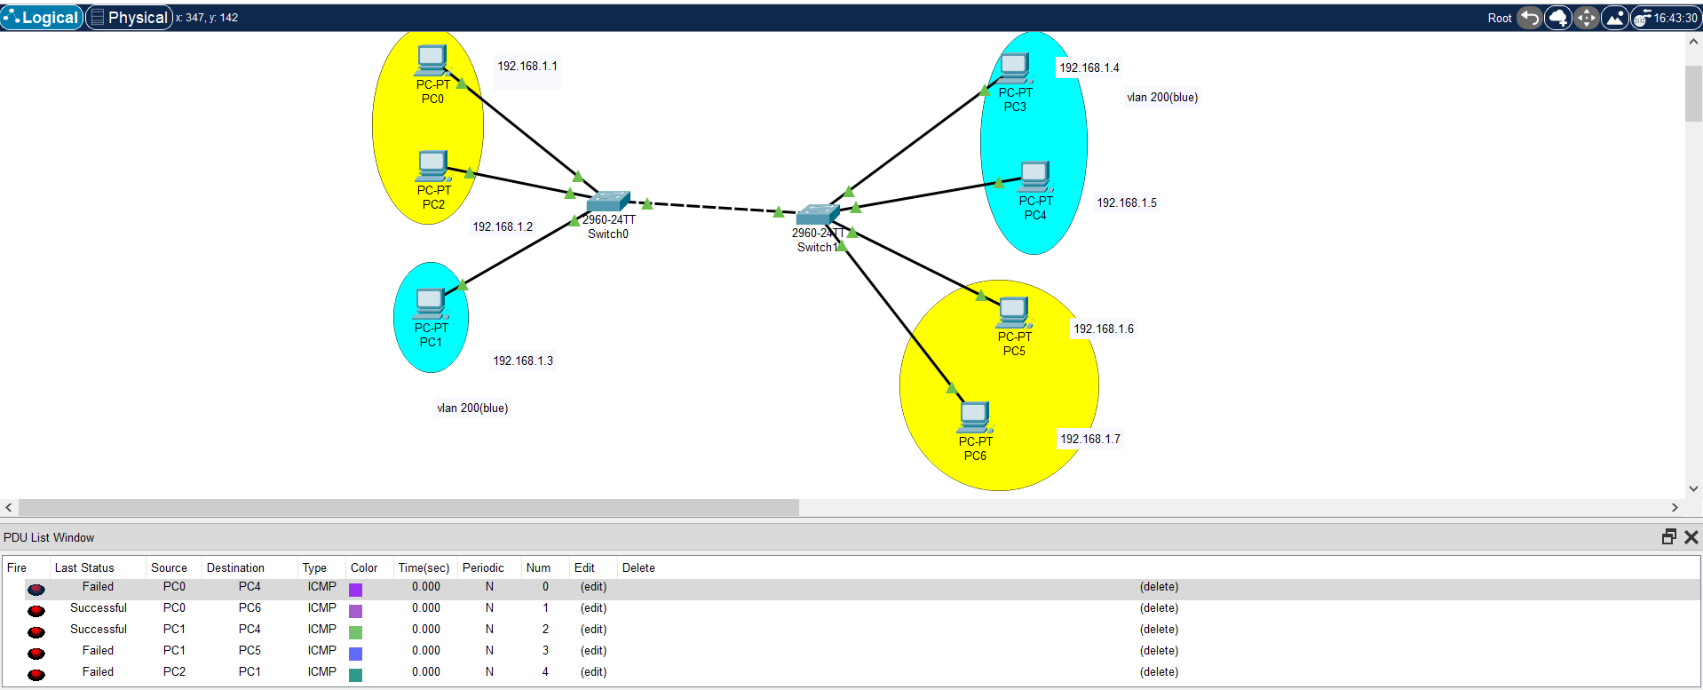

We can see that the PCs in the yellow VLAN are able to send packets to PCs in the yellow VLAN and PCs in the blue VLAN are only able to send packets to PCs in the blue VLAN from the PDU List Window.

Thus we have successfully configured VLANs in Cisco Packet Tracer and made them work.