**Name: Shangirne Kharbanda**

**Registration Number: 20BAI1154**

**LAB – 6**

**FIREWALL CONFIGURATION**

Our network topology will be constructed as follows:

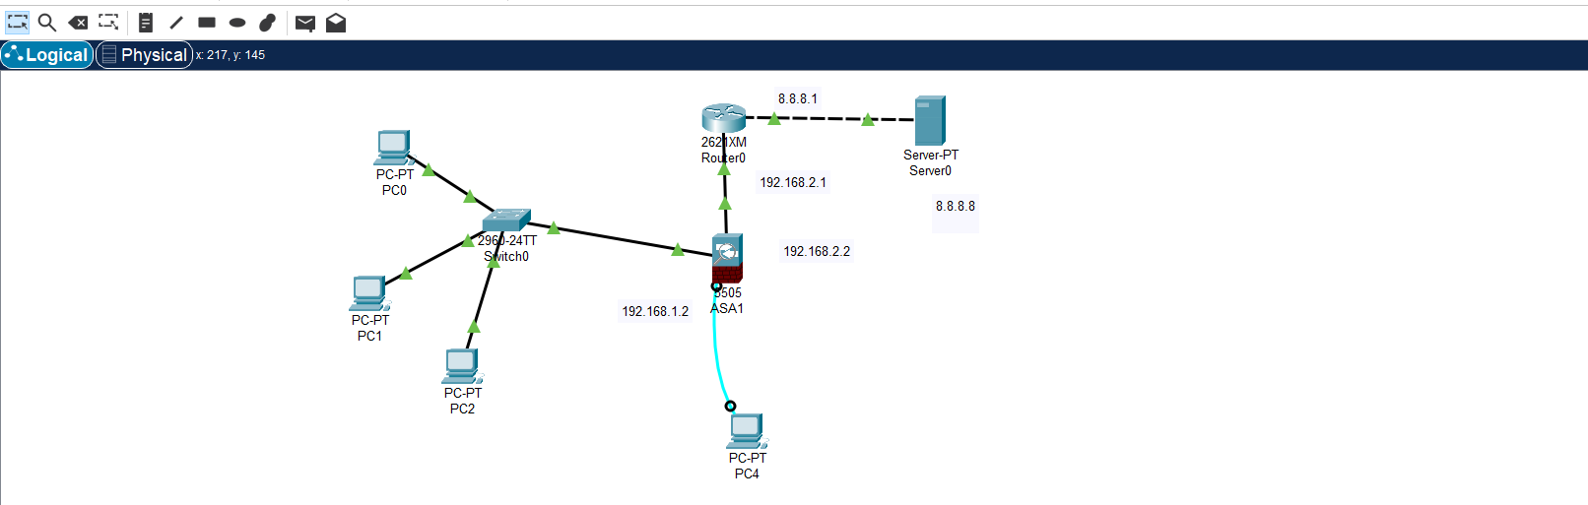

We will configure firewall as shown in the screenshots below:

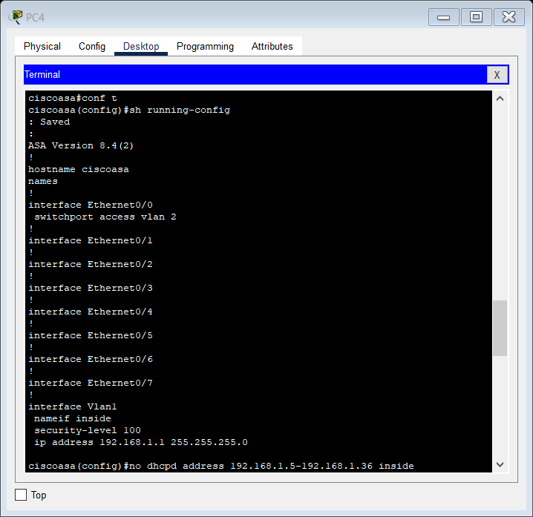

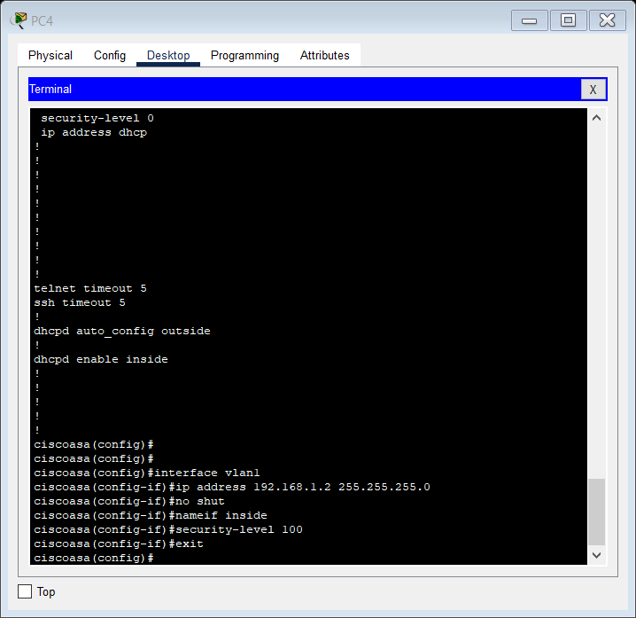

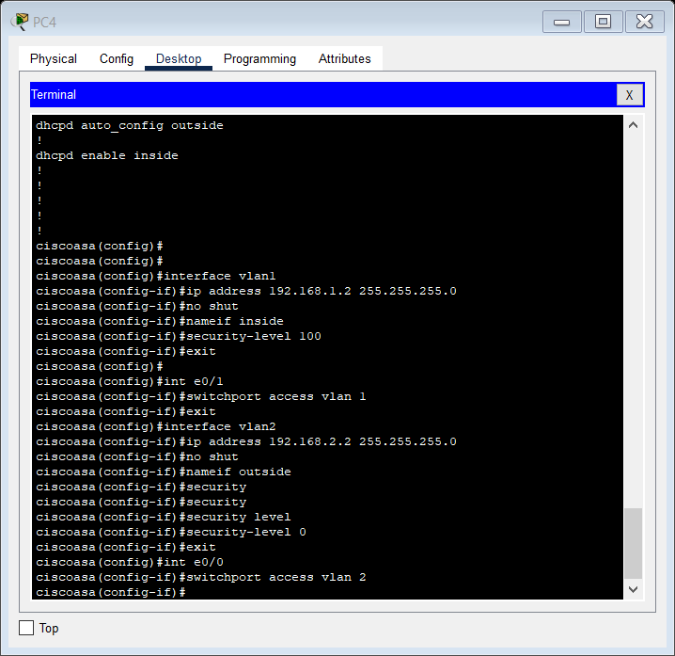

Configuring Router0:

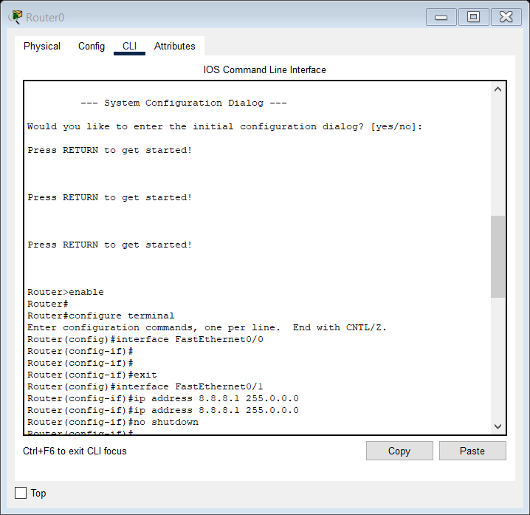

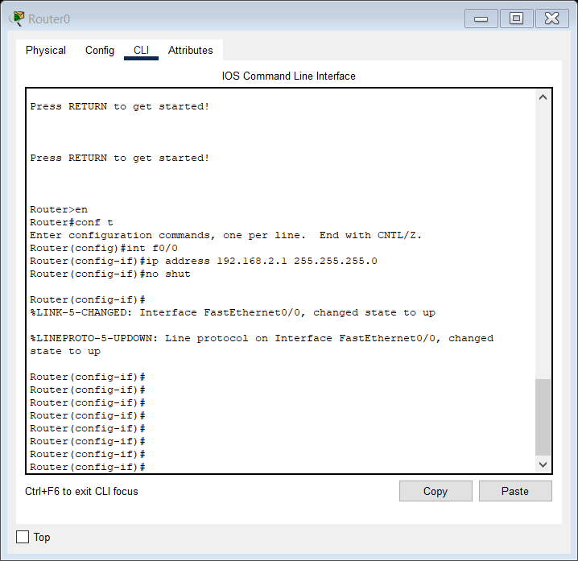

Enabling IP address and Default gateway on Server.

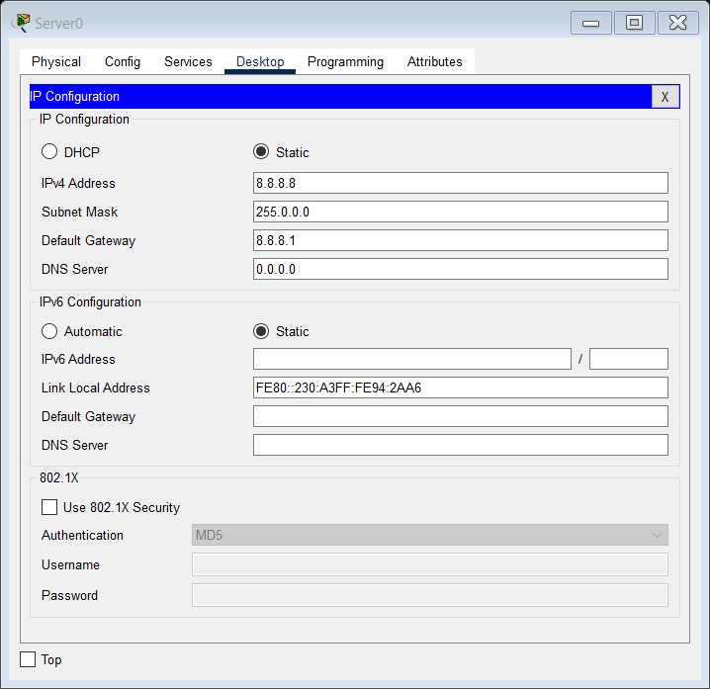

Change the PCs to DHCP and go to PC4 to configure ASA as shown:

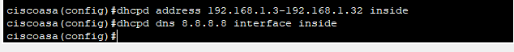

Now PCs are getting DHCP requests and default gateway, alongwith DNS servers as shown:

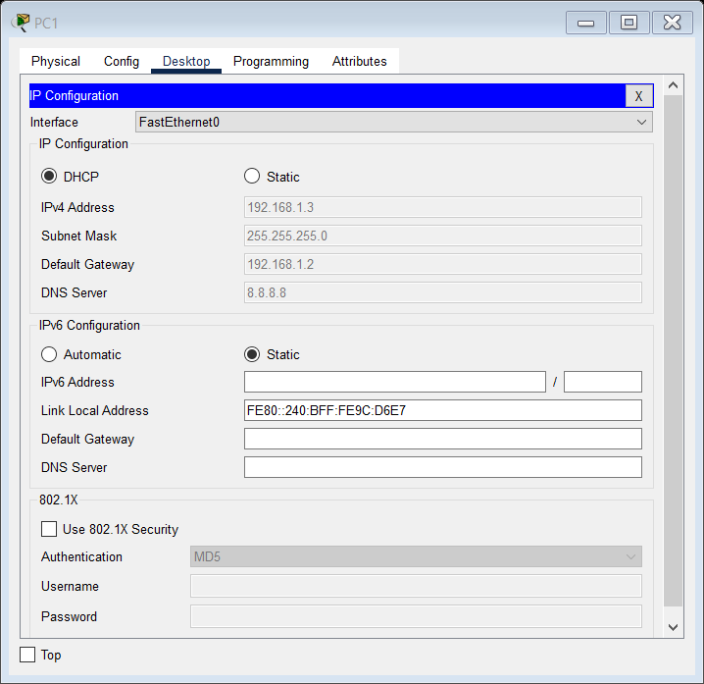

Enabling default routing on Router0:

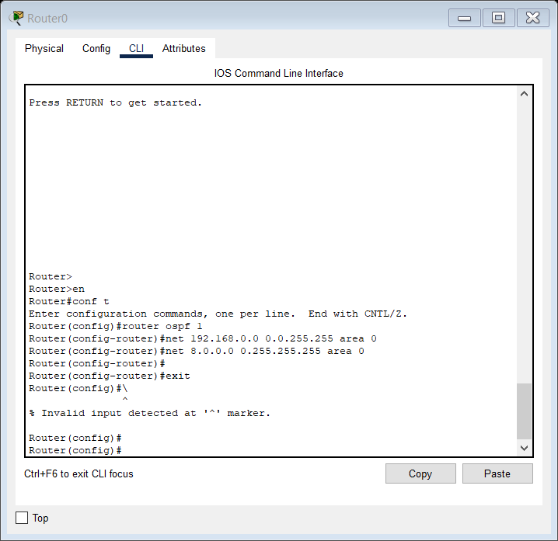

Configuring NAT and ACL on ASA:

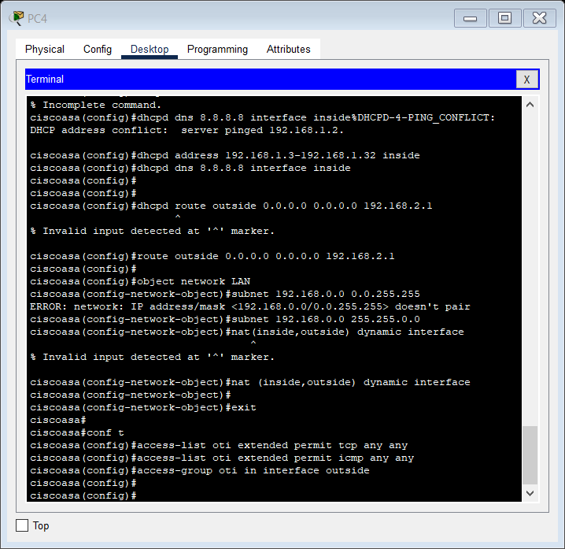

The connection of PCs with the server is working as intended.

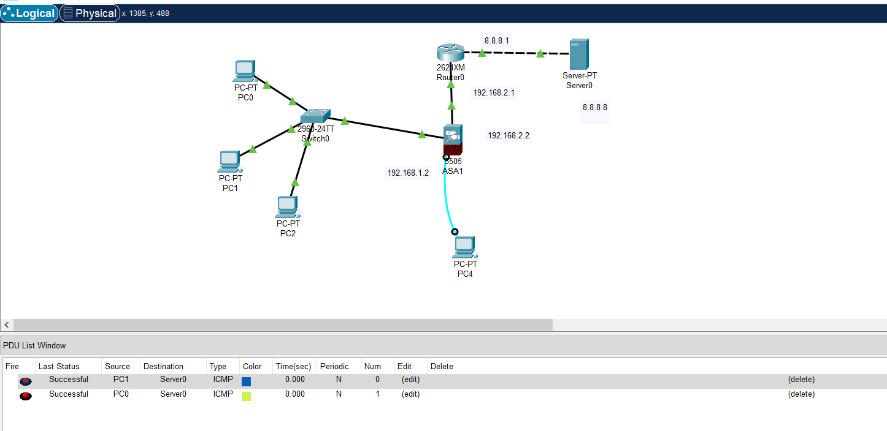

Now we configure Switch0 to allow PC1 to communicate with servers and block connection to all other PCs

We do this as follows:

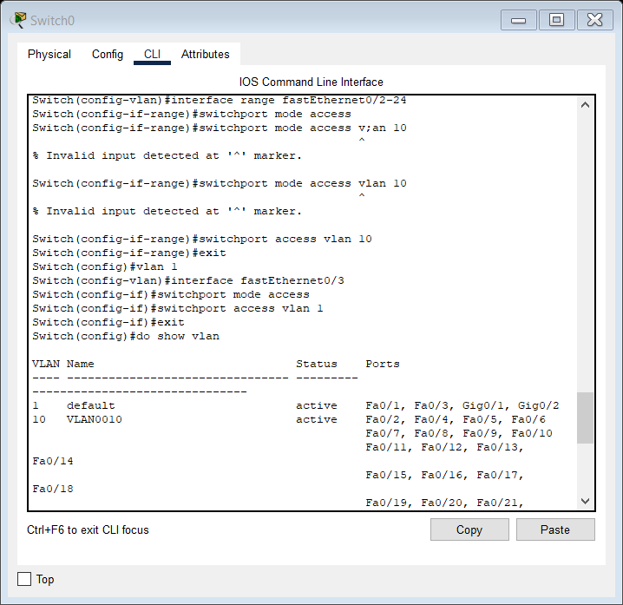

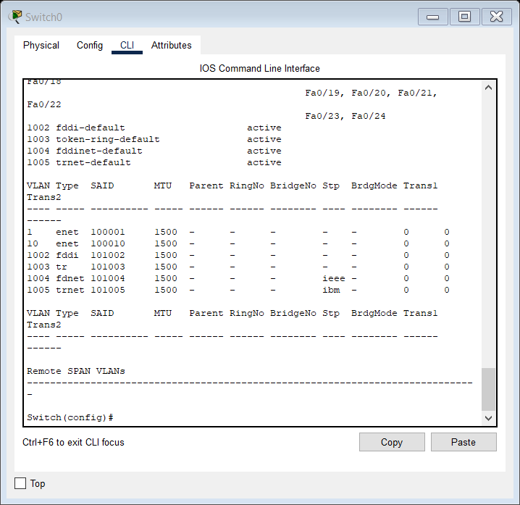

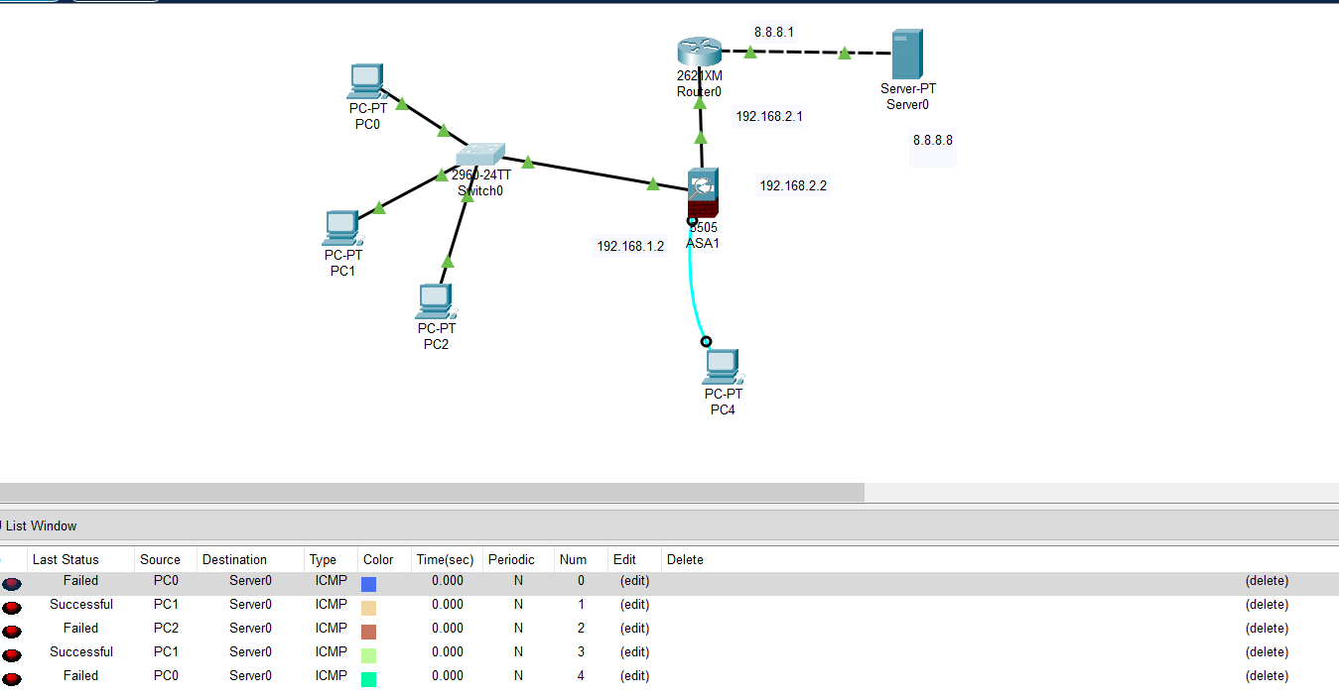

**Thus we have successfully configured the firewall by creating our own network topology and following the steps given.**