NavAlert
Development Gantt & Component Timeline
Capstone Project - BSIT, Polytechnic University of the Philippines · Version 1.0.0 · ph.edu.pup.navalert

Project overview
Development schedule for NavAlert v1.0.0, delivered as a BSIT team capstone over the June to August semester. Every screen, service, view-model, native class, asset, generator, and test suite appears on the timeline, sequenced the way the team worked: design before build, services before the screens that consume them, and features before the tests that cover them. Parallel tracks let the app core, routing, safety, and interface progress at the same time; weekends are left clear on every chart.
Work ran in weekly cycles around class schedules, anchored by regular adviser consultations, a midterm demo, and a focused revision pass after each round of feedback before the final defense build.

Workstreams
- App core & data — architecture, encrypted storage, view-models, app shell
- Routing & maps — GTFS pipeline, Dijkstra multimodal router, offline tiles
- Guide & alarm — step-by-step commute guide, adaptive destination alarm
- Safety — SOS, verified SMS delivery, fake incoming call
- UI / UX — screens, design system, layout parity
- Native Android — SMS bridge, media-session volume, home-screen widget
- QA — unit, widget, and full trip-flow simulation suites
- Design & assets — branding, sounds, tutorial artwork, generators

Key dates
Concept Jun 1 · proposal defense Jun 5 · foundation ready Jul 16 · adviser midterm demo Jul 24 · router online Jul 30 · feature-complete Aug 6 · v1.0.0 defense build and capstone defense Aug 8.

1. Master feature Gantt (3 pages)
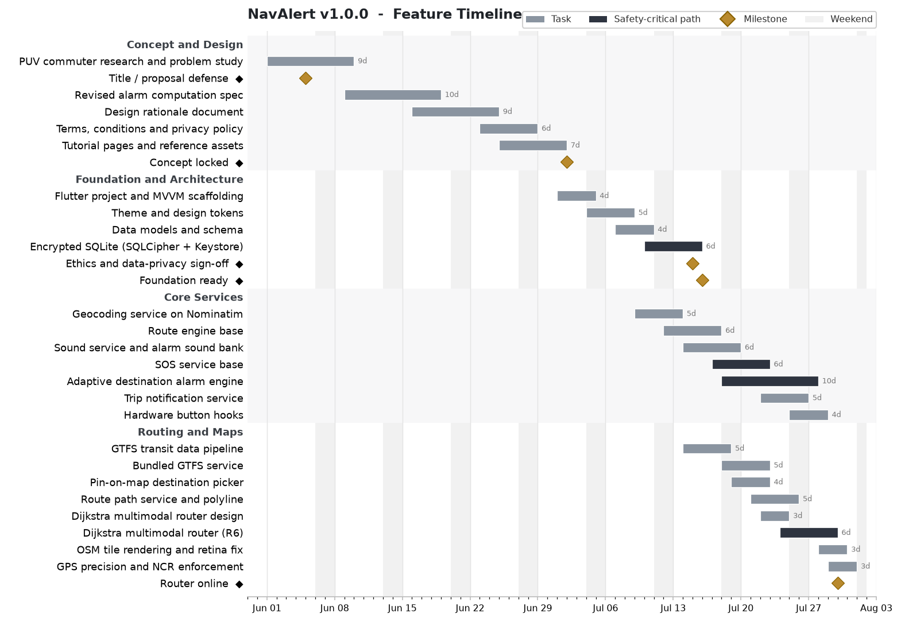

1. Master feature Gantt (continued - Part 2 of 3)
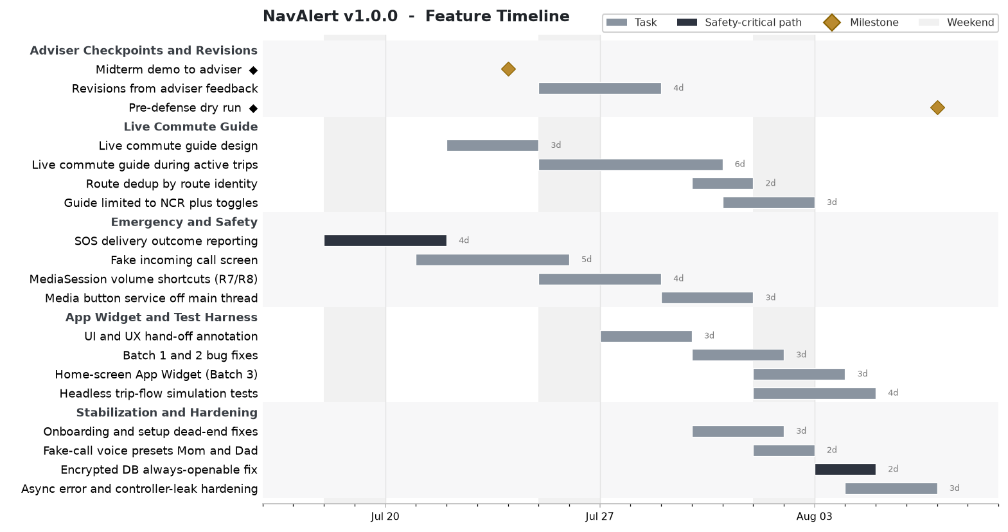

1. Master feature Gantt (continued - Part 3 of 3)
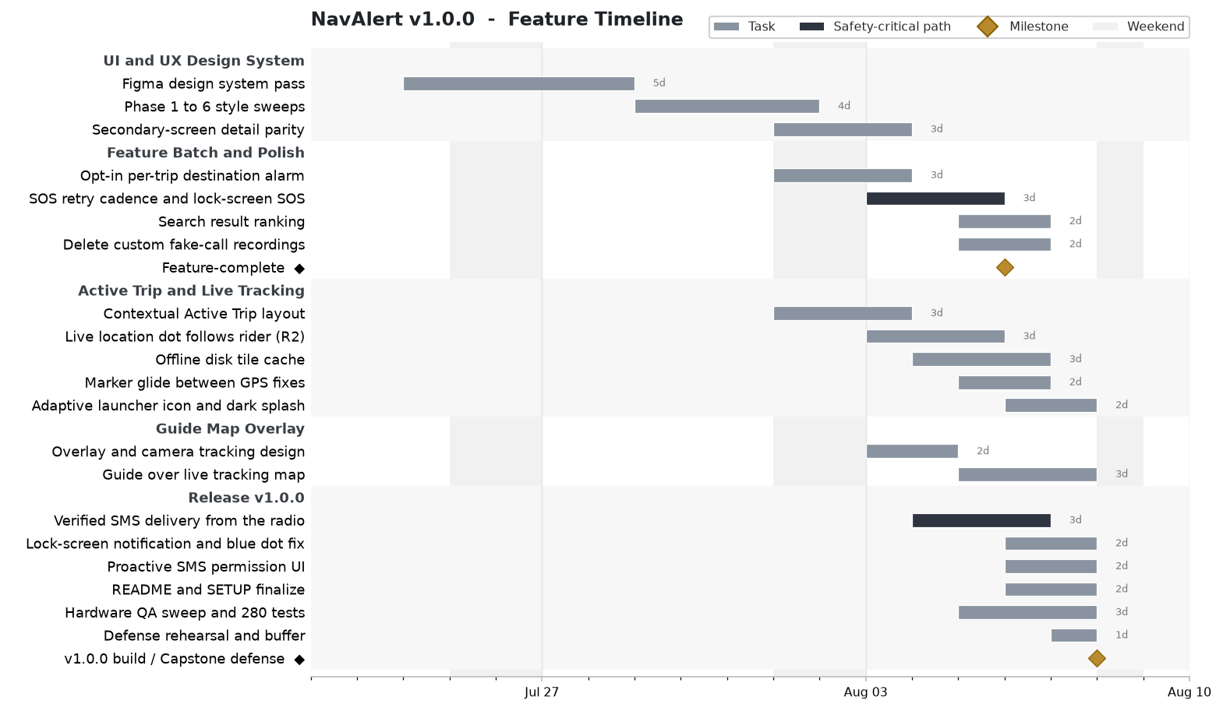

2. Services layer (lib/services/) - all 20 files
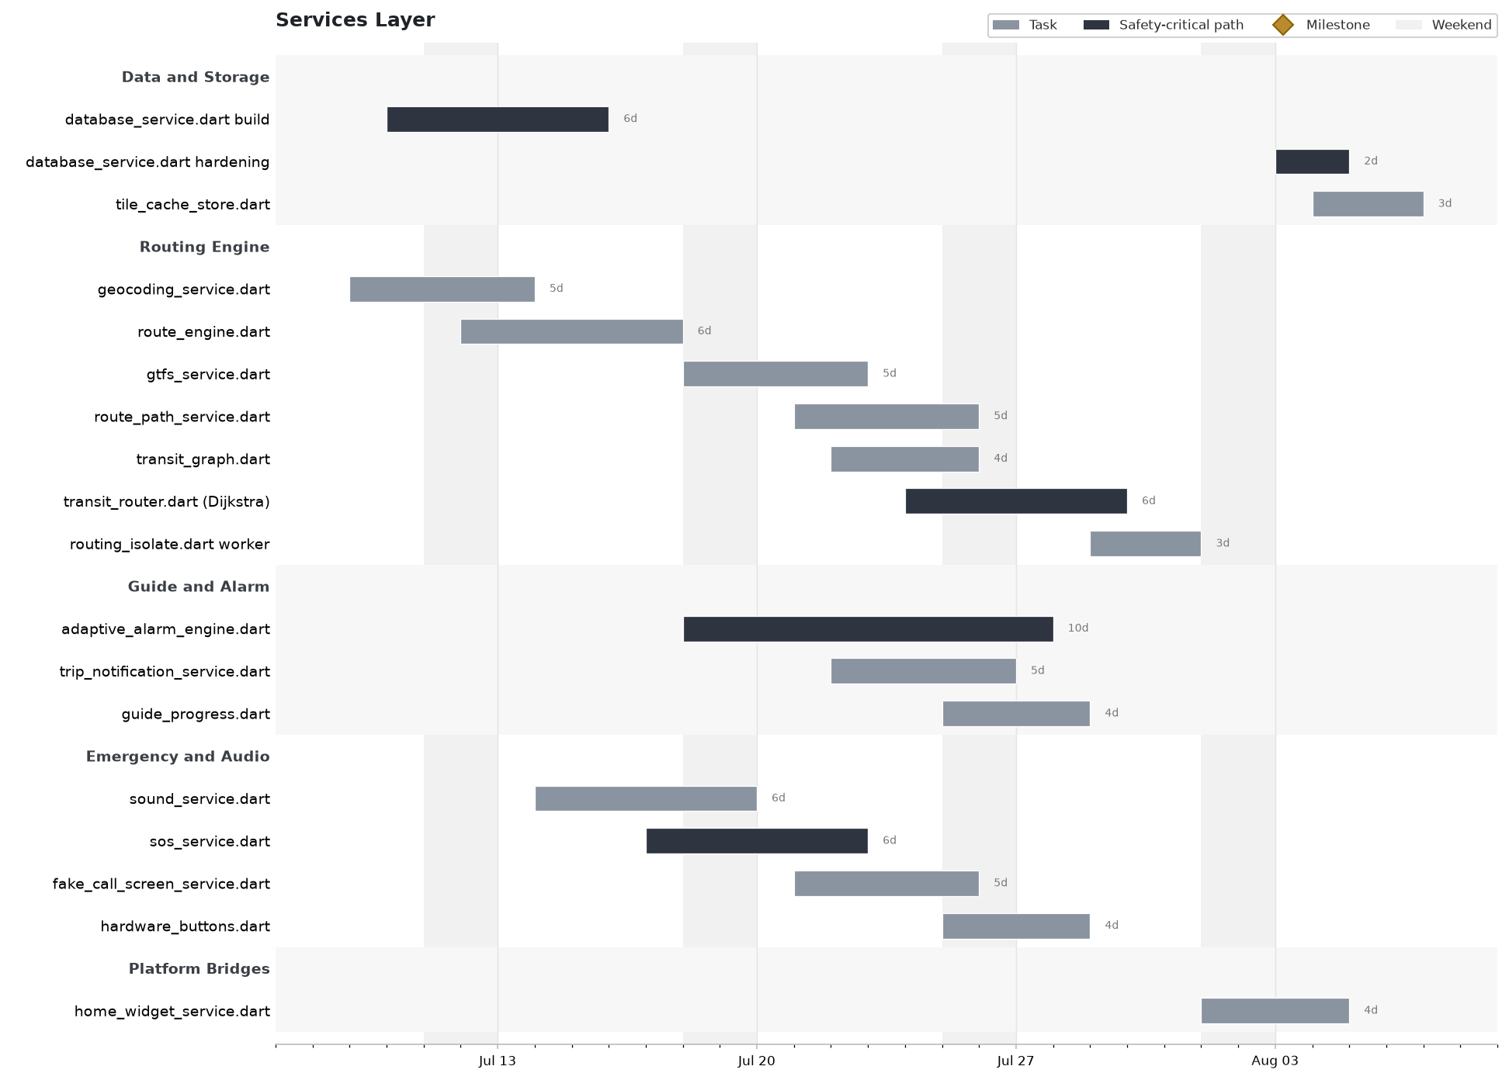

3. UI / Views (lib/views/) - all 17 screens and widgets
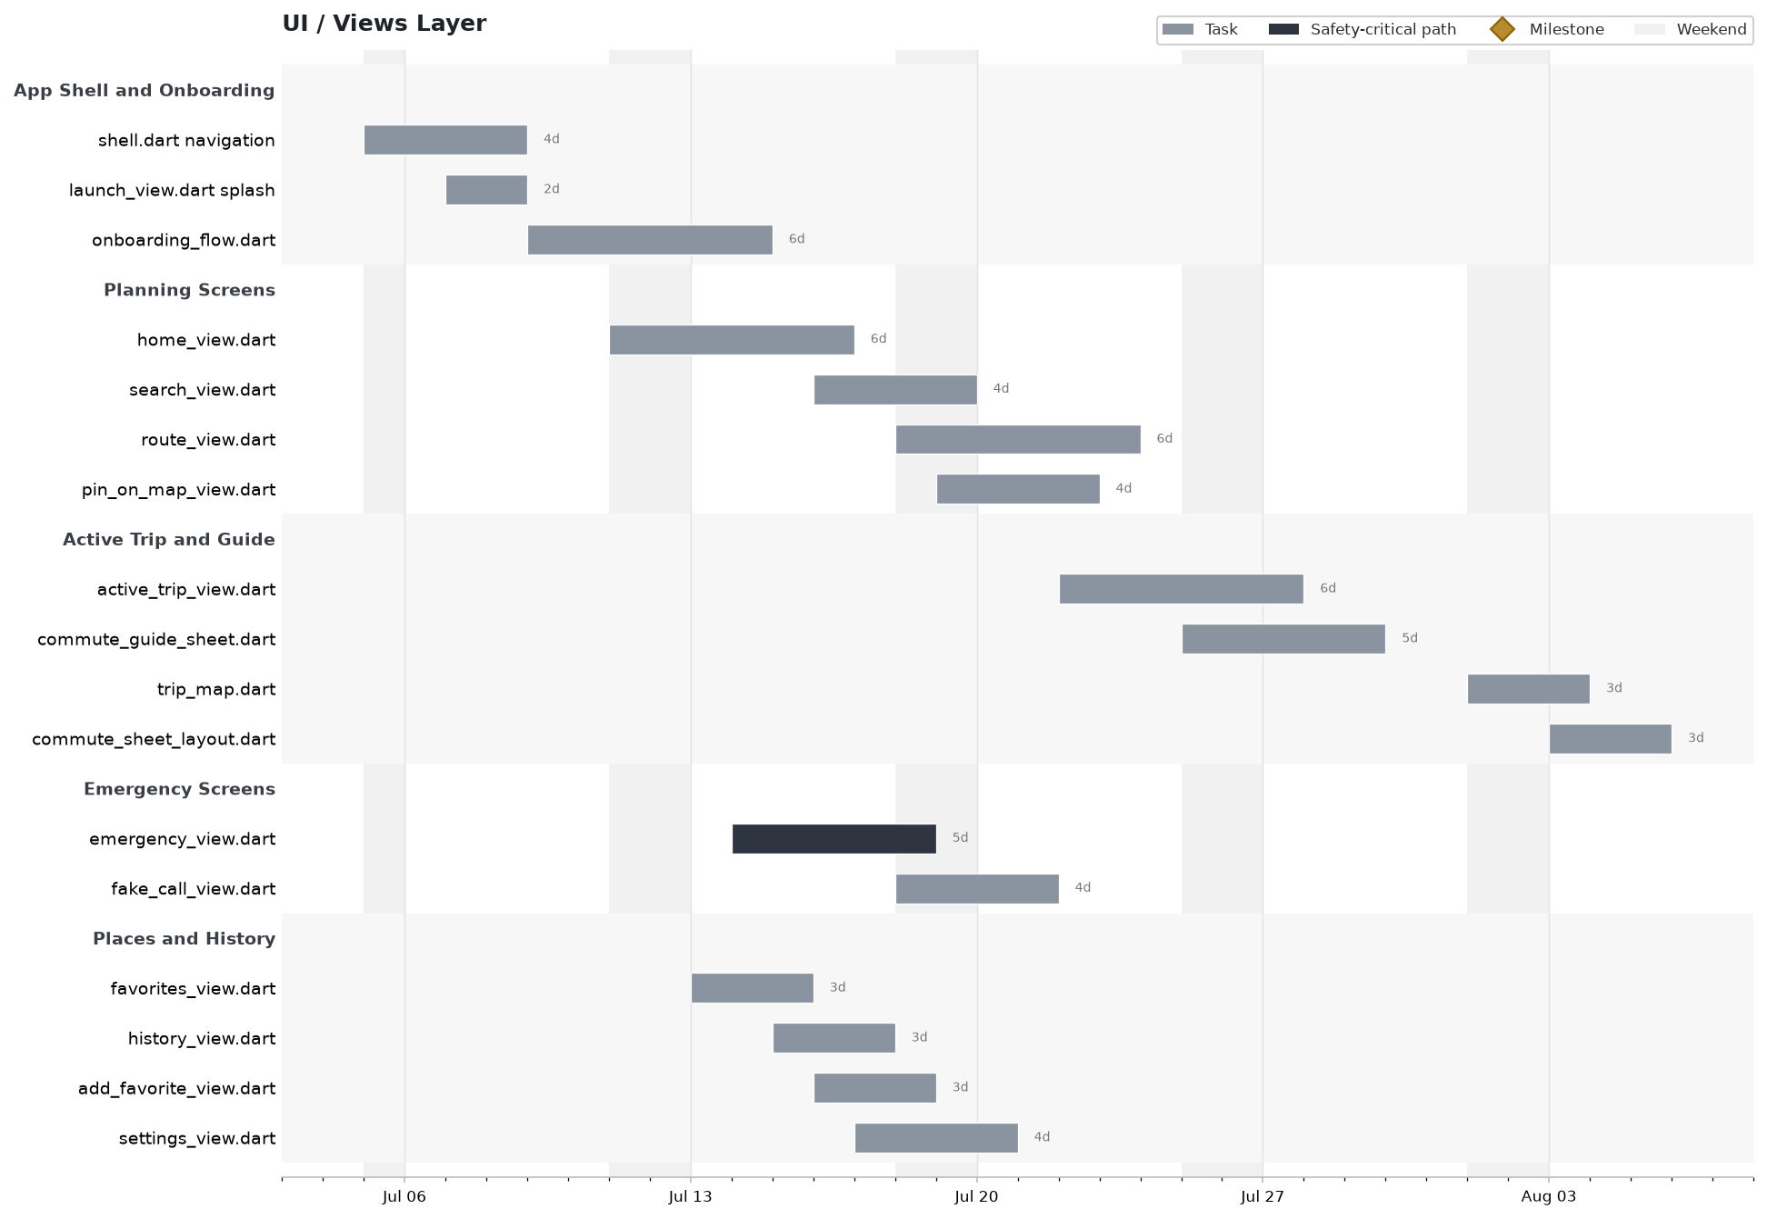

4. ViewModels & Core (viewmodels / core / models)
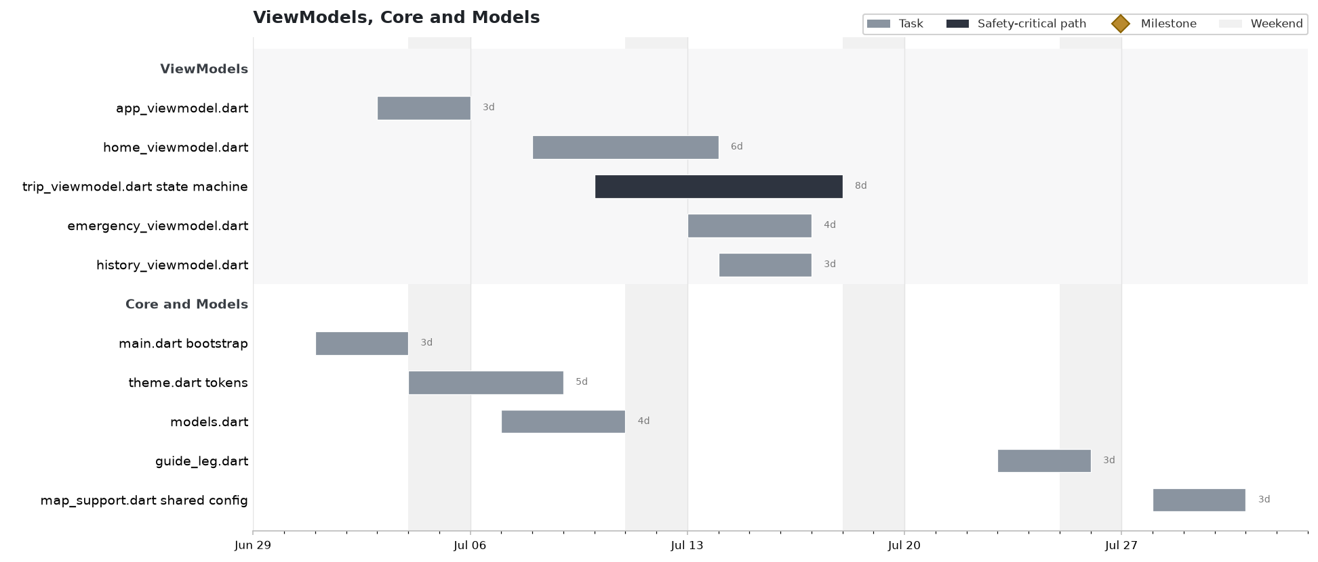

5. Native Android (kotlin + resources)
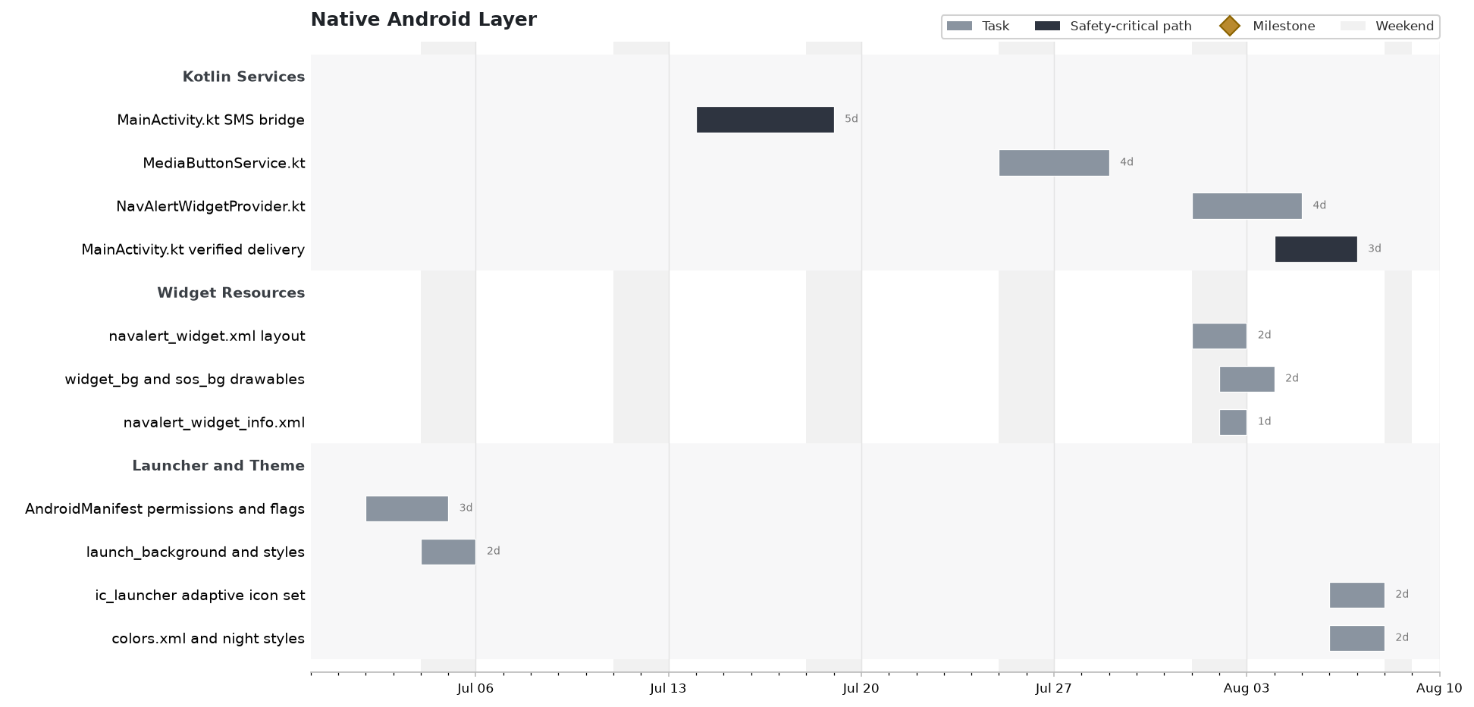

6. Assets & tooling (assets/ , tool/)
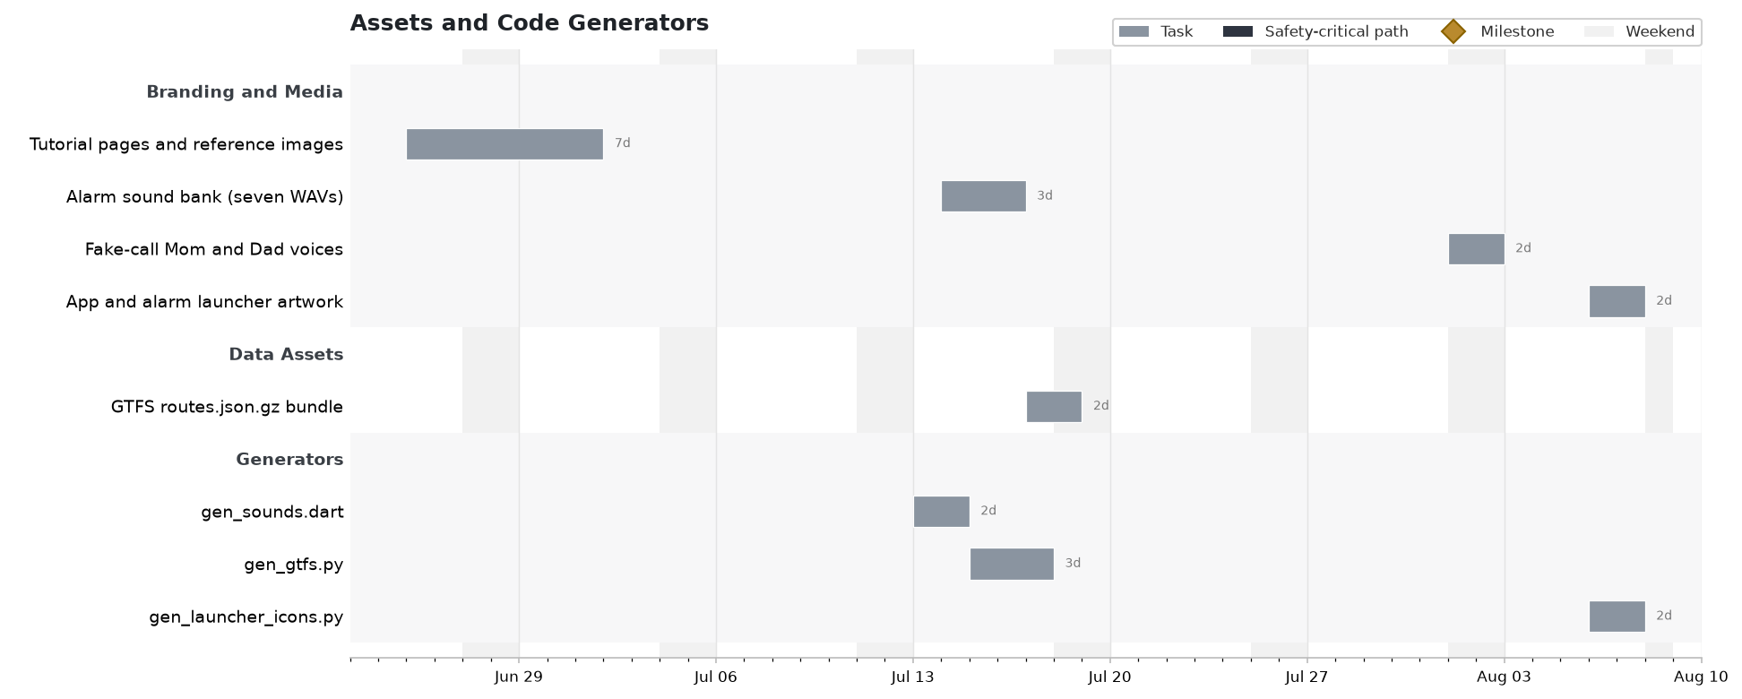

7. Test suite (test/ , integration_test/) - 21 suites, 280 tests
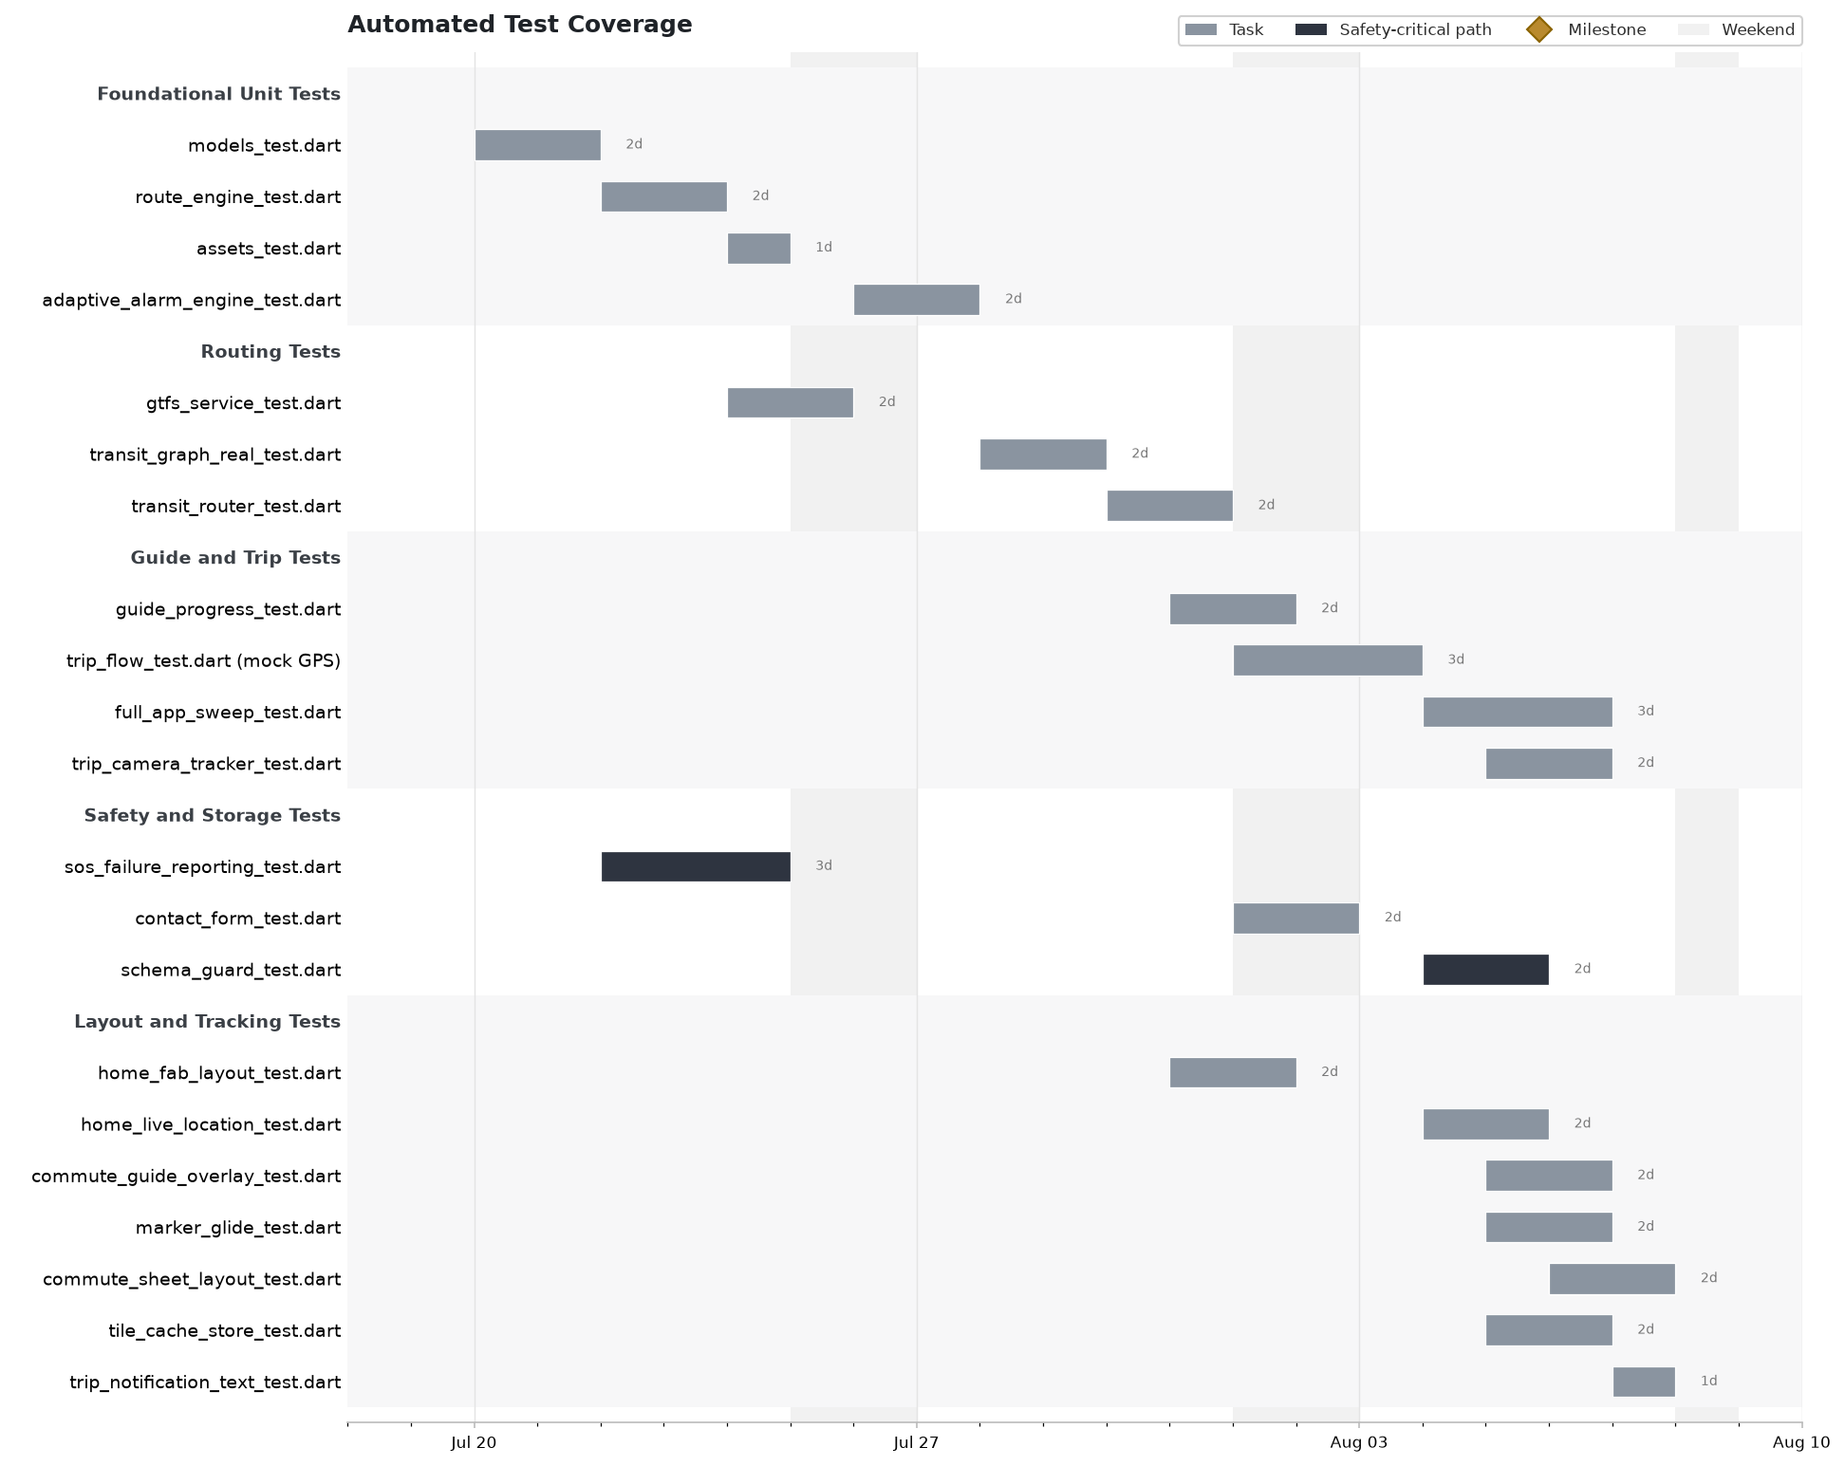

8. Milestones
Milestone | Date | What it marks
Title / proposal defense | 2026-06-05 | Topic and scope approved by the panel; problem and objectives set
Concept locked | 2026-07-02 | Alarm math, design rationale, legal docs, and tutorial assets finalized
Ethics & data-privacy sign-off | 2026-07-15 | Encrypted storage and consent flow cleared for user testing
Foundation ready | 2026-07-16 | Flutter + MVVM scaffold, theme, and encrypted storage in place
Adviser midterm demo | 2026-07-24 | Working planning flow shown to the adviser; feedback logged
Router online | 2026-07-30 | Dijkstra multimodal routing over bundled GTFS working end to end
Feature-complete | 2026-08-06 | All primary and secondary features present, opt-in alarm wired
Pre-defense dry run | 2026-08-07 | Full walkthrough on hardware; last blocking bugs triaged
v1.0.0 defense build / Capstone defense | 2026-08-08 | Verified-SMS, offline maps, 280 tests passing — presented

9. Appendix - every file, its window, and its track
Every source file, asset, generator, and test suite in the build, grouped by the workstream that owned it, with the date work started and the working window on the schedule.
Dart - core, models, view-models
File | Started | Working window | Track
lib/main.dart | Jul 01 | 3d | App core
lib/core/theme.dart | Jul 04 | 5d | App core
lib/core/map_support.dart | Jul 28 | 3d | Routing
lib/models/models.dart | Jul 07 | 4d | App core
lib/models/guide_leg.dart | Jul 23 | 3d | Guide & alarm
lib/viewmodels/app_viewmodel.dart | Jul 03 | 3d | App core
lib/viewmodels/home_viewmodel.dart | Jul 08 | 6d | App core
lib/viewmodels/trip_viewmodel.dart | Jul 10 | 8d | Guide & alarm
lib/viewmodels/emergency_viewmodel.dart | Jul 13 | 4d | Safety
lib/viewmodels/history_viewmodel.dart | Jul 14 | 3d | App core

Dart - services
File | Started | Working window | Track
lib/services/database_service.dart | Jul 10 -> Aug 03 | 6d + 2d | Data
lib/services/geocoding_service.dart | Jul 09 | 5d | Routing
lib/services/route_engine.dart | Jul 12 | 6d | Routing
lib/services/route_path_service.dart | Jul 21 | 5d | Routing
lib/services/sound_service.dart | Jul 14 | 6d | Safety
lib/services/sos_service.dart | Jul 17 | 6d | Safety
lib/services/adaptive_alarm_engine.dart | Jul 18 | 10d | Guide & alarm
lib/services/trip_notification_service.dart | Jul 22 | 5d | Guide & alarm
lib/services/hardware_buttons.dart | Jul 25 | 4d | Safety
lib/services/gtfs_service.dart | Jul 18 | 5d | Routing
lib/services/transit_graph.dart | Jul 22 | 4d | Routing
lib/services/transit_router.dart | Jul 24 | 6d | Routing
lib/services/routing_isolate.dart | Jul 29 | 3d | Routing
lib/services/guide_progress.dart | Jul 25 | 4d | Guide & alarm
lib/services/fake_call_screen_service.dart | Jul 21 | 5d | Safety
lib/services/home_widget_service.dart | Aug 01 | 4d | Native bridge
lib/services/tile_cache_store.dart | Aug 04 | 3d | Data

Dart - views
File | Started | Working window | Track
lib/views/shell.dart | Jul 05 | 4d | UI / UX
lib/views/launch_view.dart | Jul 07 | 2d | UI / UX
lib/views/onboarding_flow.dart | Jul 09 | 6d | UI / UX
lib/views/home_view.dart | Jul 11 | 6d | UI / UX
lib/views/search_view.dart | Jul 16 | 4d | UI / UX
lib/views/route_view.dart | Jul 18 | 6d | UI / UX
lib/views/pin_on_map_view.dart | Jul 19 | 4d | UI / UX
lib/views/active_trip_view.dart | Jul 22 | 6d | UI / UX
lib/views/commute_guide_sheet.dart | Jul 25 | 5d | UI / UX
lib/views/trip_map.dart | Aug 01 | 3d | UI / UX
lib/views/commute_sheet_layout.dart | Aug 03 | 3d | UI / UX
lib/views/emergency_view.dart | Jul 14 | 5d | Safety
lib/views/fake_call_view.dart | Jul 18 | 4d | Safety
lib/views/favorites_view.dart | Jul 13 | 3d | UI / UX
lib/views/history_view.dart | Jul 15 | 3d | UI / UX
lib/views/add_favorite_view.dart | Jul 16 | 3d | UI / UX
lib/views/settings_view.dart | Jul 17 | 4d | UI / UX

Native Android
File | Started | Working window | Track
MainActivity.kt (SMS bridge) | Jul 14 -> Aug 04 | 5d + 3d | Native
MediaButtonService.kt | Jul 25 | 4d | Native
NavAlertWidgetProvider.kt | Aug 01 | 4d | Native
res/layout/navalert_widget.xml | Aug 01 | 2d | Native
res/drawable/widget_bg.xml, widget_sos_bg.xml | Aug 02 | 2d | Native
res/xml/navalert_widget_info.xml | Aug 02 | 1d | Native
res/mipmap-anydpi-v26/ic_launcher.xml | Aug 06 | 2d | Native
res/drawable/launch_background.xml + styles.xml | Jul 04 | 2d | Native
res/values/colors.xml + values-night/styles.xml | Aug 06 | 2d | Native
AndroidManifest.xml | Jul 02 | 3d | Native

Assets & tooling
File | Started | Working window | Track
assets/images/tutorial/* + reference/* | Jun 25 | 7d | Design & assets
assets/images/branding/main_bg.png | Jun 25 | 7d | Design & assets
assets/icons/ALARMA APP ICON.png | Aug 06 | 2d | Design & assets
assets/sounds/*.wav (7 alarm sounds) | Jul 14 | 3d | Design & assets
assets/sounds/fake_call_mom.wav, fake_call_dad.wav | Aug 01 | 2d | Design & assets
assets/gtfs/routes.json.gz + NOTICE.md | Jul 17 | 2d | Routing
tool/gen_sounds.dart | Jul 13 | 2d | Tooling
tool/gen_gtfs.py | Jul 15 | 3d | Tooling
tool/gen_launcher_icons.py | Aug 06 | 2d | Tooling

Test suites
File | Started | Working window | Track
test/models_test.dart | Jul 20 | 2d | QA
test/route_engine_test.dart | Jul 22 | 2d | QA
test/assets_test.dart | Jul 24 | 1d | QA
test/adaptive_alarm_engine_test.dart | Jul 26 | 2d | QA
test/gtfs_service_test.dart | Jul 24 | 2d | QA
test/transit_graph_real_test.dart | Jul 28 | 2d | QA
test/transit_router_test.dart | Jul 30 | 2d | QA
test/guide_progress_test.dart | Jul 31 | 2d | QA
test/trip_flow_test.dart | Aug 01 | 3d | QA
integration_test/full_app_sweep_test.dart | Aug 04 | 3d | QA
test/trip_camera_tracker_test.dart | Aug 05 | 2d | QA
test/sos_failure_reporting_test.dart | Jul 22 | 3d | QA
test/contact_form_test.dart | Aug 01 | 2d | QA
test/schema_guard_test.dart | Aug 04 | 2d | QA
test/home_fab_layout_test.dart | Jul 31 | 2d | QA
test/home_live_location_test.dart | Aug 04 | 2d | QA
test/commute_guide_overlay_test.dart | Aug 05 | 2d | QA
test/marker_glide_test.dart | Aug 05 | 2d | QA
test/commute_sheet_layout_test.dart | Aug 06 | 2d | QA
test/tile_cache_store_test.dart | Aug 05 | 2d | QA
test/trip_notification_text_test.dart | Aug 07 | 1d | QA

NavAlert v1.0.0 development schedule — BSIT capstone, Polytechnic University of the Philippines, culminating in the defense build on 2026-08-08.

