sCRM Run Report: Collision Risk Estimates

13 July 2022

This is an automatically generated report created by the stochastic Collision Risk Model (sCRM) web application ([website](https://dmpstats.shinyapps.io/sCRM), [repository](https://github.com/dmpstats/sCRM)), which acts as a wrapper for the {stochLAB} [package](https://www.github.com/HiDef-Aerial-Surveying/stochLAB). The seabird collision risk model was originally developed by [Band (2012)](https://www.bto.org/sites/default/files/u28/downloads/Projects/Final_Report_SOSS02_Band1ModelGuidance.pdf), and subsequently extended by [Masden (2015)](https://data.marine.gov.scot/dataset/developing-avian-collision-risk-model-incorporate-variability-and-uncertainty) to incorporate uncertainty of input parameters in collision estimates. This report presents the main results of a user’s specified sCRM run. Summary graphs and tables are provided for each one of the species considered within the specified wind farm scenarios.

NB: This is a prototype document. The inclusion of additional sections (e.g. tables with input values for each scenario) is currently under consideration.

# sCRM Run Overview

* Simulation mode: Stochastic
* Number of iterations: 10
* Wind farm scenarios specified:
  + **Demo Windfarm**, containing the following species:
    - Demo Species
    - Demo Species 2
  + **Demoniac Windy**, containing the following species:
    - Demo Species
    - Demo Species 2
    - Demo Species 3

# Demo Windfarm

## Demo Species

**Figure** : Collision risk estimates of Demo Species at Demo Windfarm, by Season . Density distribution, median, 66% and 95% quantile intervals and quantile dotplots (each dot represents ~2% chance outcome) of simulated values

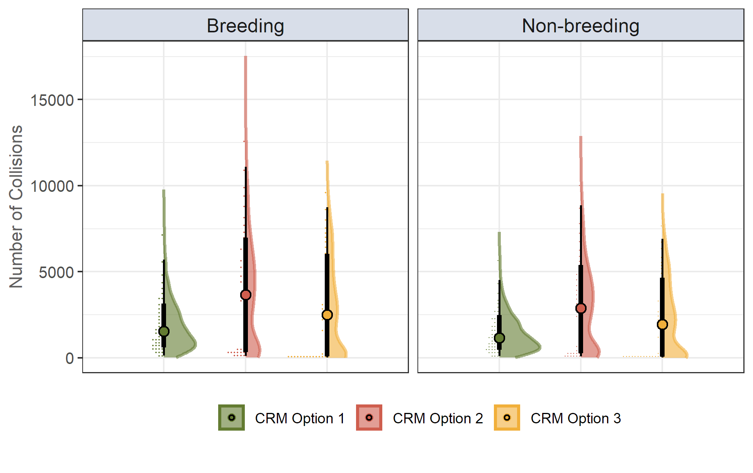

**Table** : Collision estimates of Demo Species at Demo Windfarm, by Season

| **Season** | **Time Period** | **CRM Option** | **Mean** | **Median** | **SD** | **CV** | **2.5%** | **97.5%** |
| --- | --- | --- | --- | --- | --- | --- | --- | --- |
| Breeding | April - August | Option 1 | 1 903.590 | 1 529.806 | 1 509.248 | 79.284 | 136.308 | 5 699.256 |
| Option 2 | 3 902.801 | 3 654.649 | 3 261.046 | 83.557 | 103.687 | 11 085.914 |
| Option 3 | 2 952.145 | 2 492.675 | 2 741.390 | 92.861 | 26.633 | 8 732.436 |
| Non-breeding | September - March | Option 1 | 1 479.928 | 1 168.119 | 1 181.634 | 79.844 | 102.770 | 4 510.316 |
| Option 2 | 3 030.418 | 2 874.454 | 2 545.564 | 84.000 | 78.319 | 8 850.169 |
| Option 3 | 2 291.336 | 1 937.249 | 2 138.197 | 93.317 | 20.027 | 6 915.299 |

## Demo Species 2

**Figure** : Collision risk estimates of Demo Species 2 at Demo Windfarm, per Annum . Density distribution, median, 66% and 95% quantile intervals and quantile dotplots (each dot represents ~2% chance outcome) of simulated values

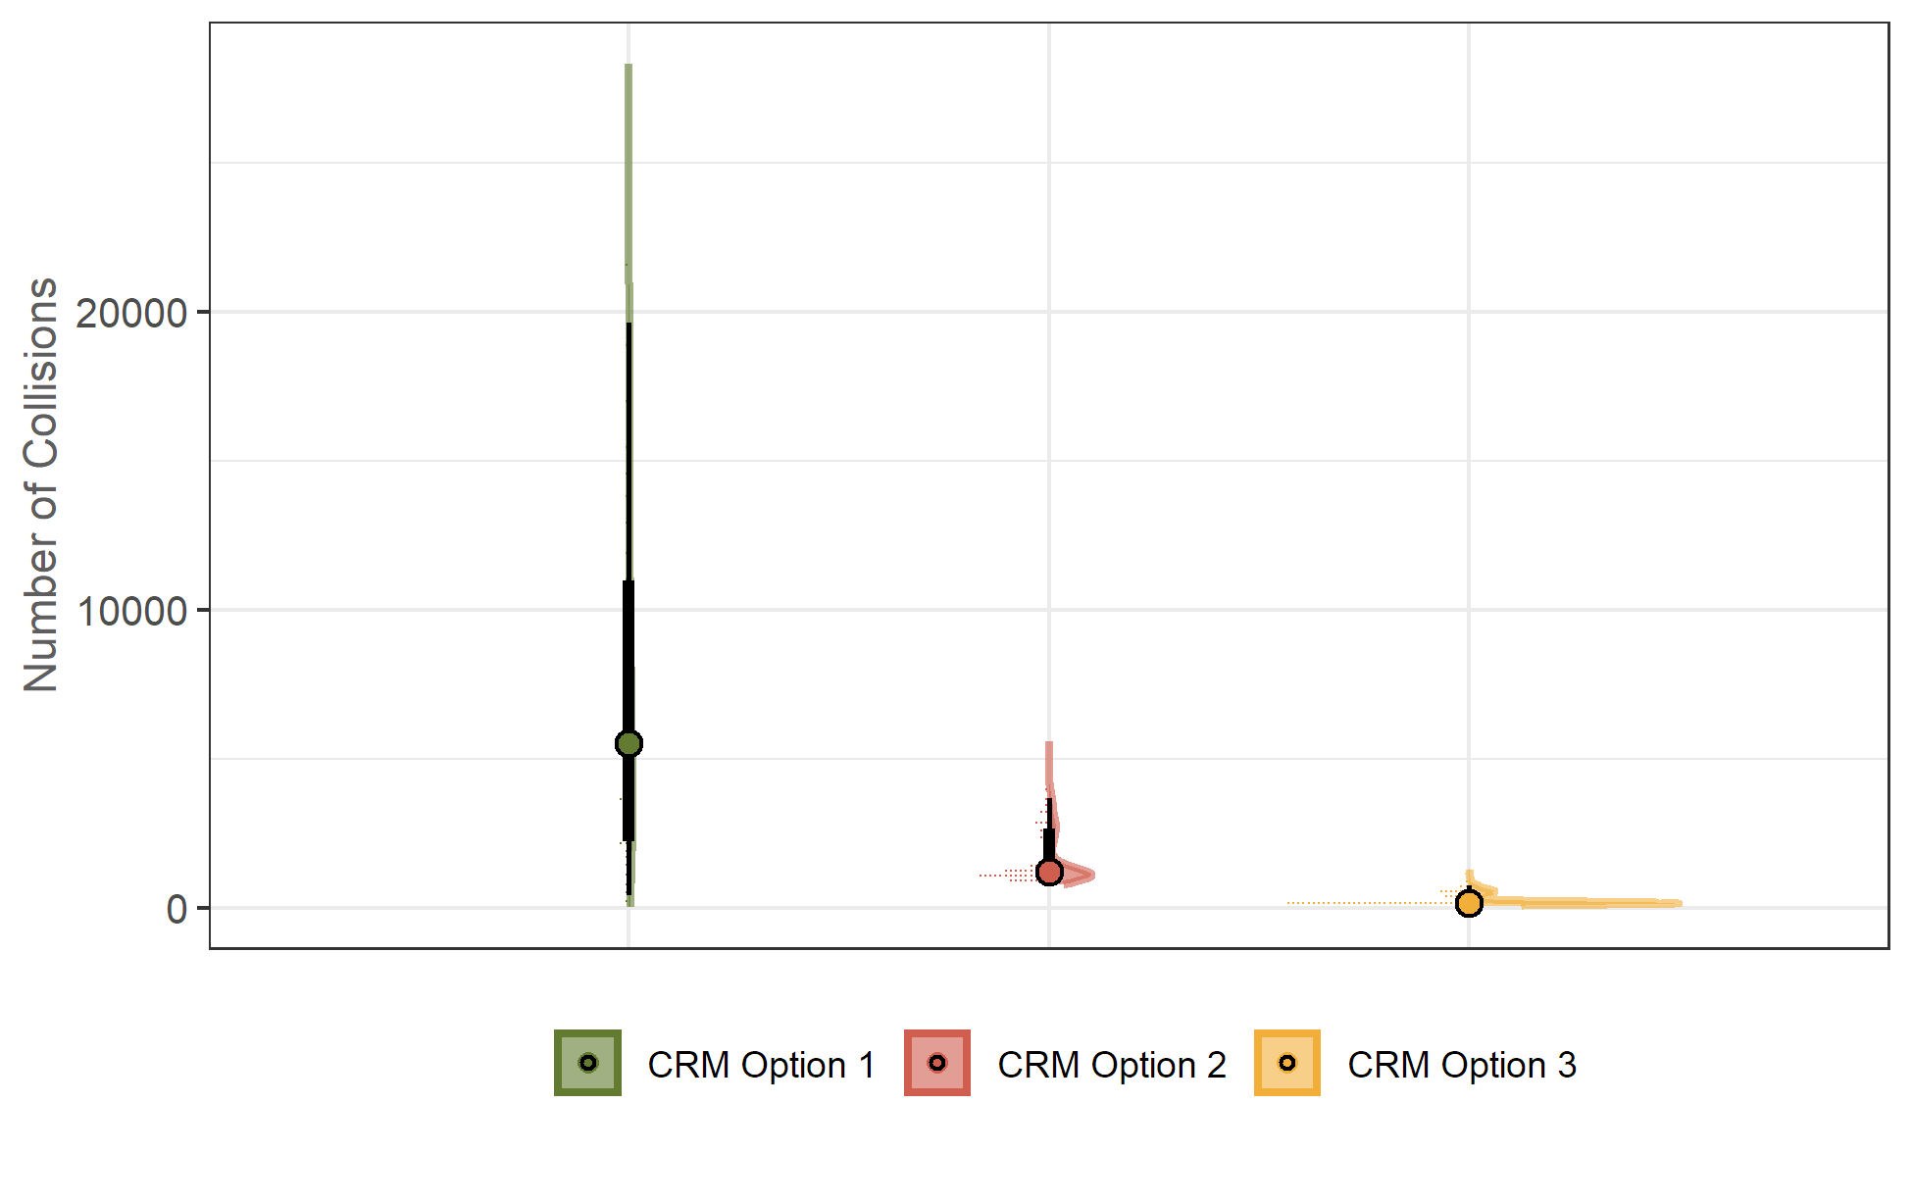

**Table** : Collision estimates of Demo Species 2 at Demo Windfarm, per Annum

| **CRM Option** | **Mean** | **Median** | **SD** | **CV** | **2.5%** | **97.5%** |
| --- | --- | --- | --- | --- | --- | --- |
| Option 1 | 6 757.370 | 5 532.154 | 5 021.838 | 74.316 | 413.882 | 19 627.113 |
| Option 2 | 1 626.873 | 1 214.688 | 853.337 | 52.453 | 888.456 | 3 680.440 |
| Option 3 | 269.184 | 176.444 | 197.767 | 73.469 | 106.283 | 766.585 |

# Demoniac Windy

## Demo Species

**Figure** : Collision risk estimates of Demo Species at Demoniac Windy, per Annum . Density distribution, median, 66% and 95% quantile intervals and quantile dotplots (each dot represents ~2% chance outcome) of simulated values

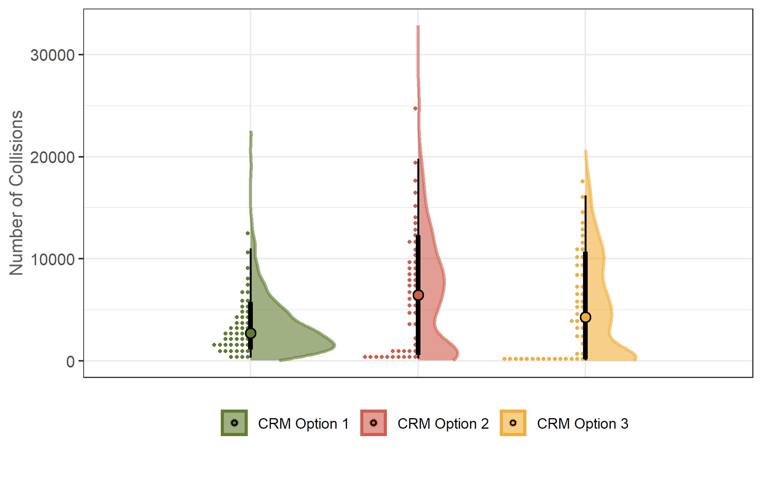

**Table** : Collision estimates of Demo Species at Demoniac Windy, per Annum

| **CRM Option** | **Mean** | **Median** | **SD** | **CV** | **2.5%** | **97.5%** |
| --- | --- | --- | --- | --- | --- | --- |
| Option 1 | 3 472.991 | 2 709.544 | 2 841.651 | 81.821 | 309.288 | 11 018.976 |
| Option 2 | 6 817.432 | 6 444.119 | 5 849.457 | 85.801 | 228.405 | 19 779.892 |
| Option 3 | 5 273.401 | 4 270.448 | 4 967.006 | 94.190 | 53.557 | 16 212.745 |

## Demo Species 2

**Figure** : Collision risk estimates of Demo Species 2 at Demoniac Windy, by Season . Density distribution, median, 66% and 95% quantile intervals and quantile dotplots (each dot represents ~2% chance outcome) of simulated values

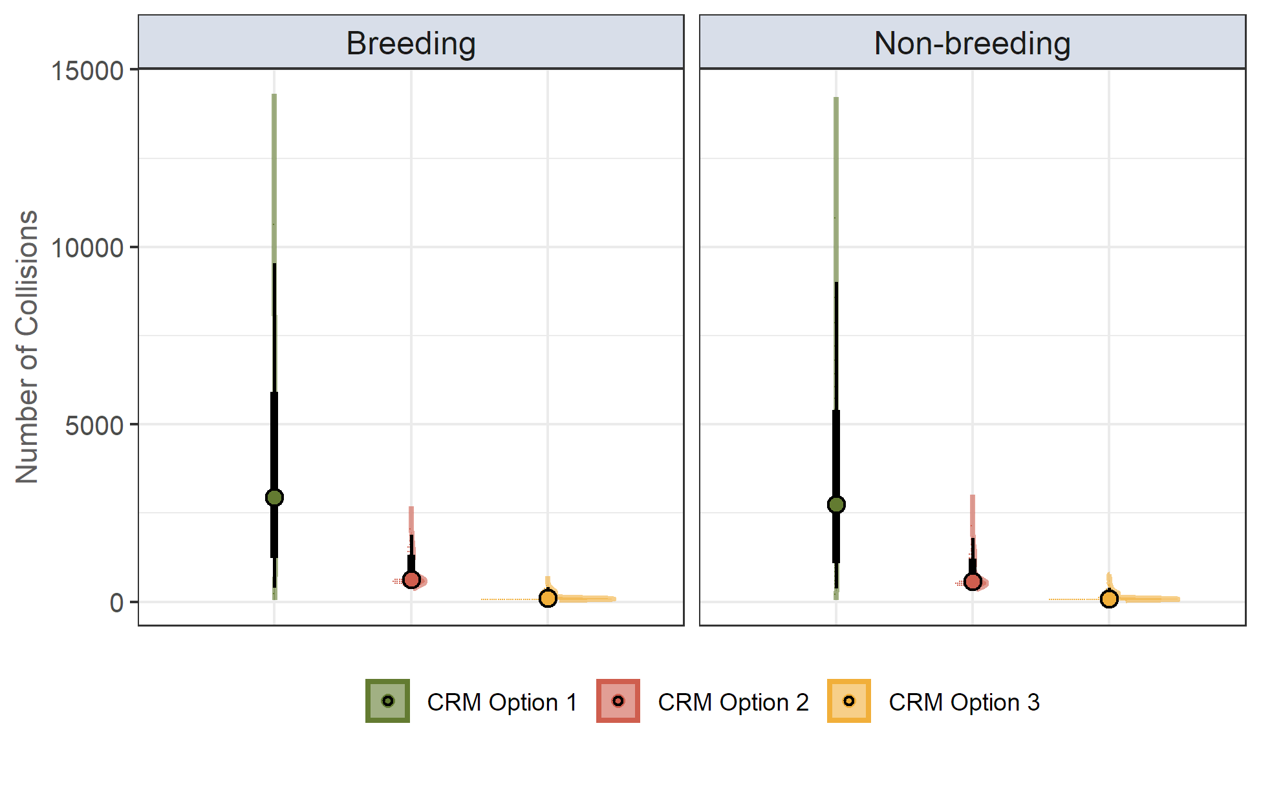

**Table** : Collision estimates of Demo Species 2 at Demoniac Windy, by Season

| **Season** | **Time Period** | **CRM Option** | **Mean** | **Median** | **SD** | **CV** | **2.5%** | **97.5%** |
| --- | --- | --- | --- | --- | --- | --- | --- | --- |
| Breeding | April - August | Option 1 | 3 528.936 | 2 944.014 | 2 474.892 | 70.131 | 396.254 | 9 538.906 |
| Option 2 | 833.755 | 633.730 | 425.260 | 51.005 | 459.729 | 1 886.665 |
| Option 3 | 139.833 | 91.572 | 103.448 | 73.980 | 56.155 | 406.745 |
| Non-breeding | September - March | Option 1 | 3 260.842 | 2 750.588 | 2 342.370 | 71.833 | 368.012 | 9 010.272 |
| Option 2 | 768.688 | 580.517 | 409.362 | 53.255 | 409.091 | 1 798.518 |
| Option 3 | 128.918 | 84.285 | 98.122 | 76.112 | 48.903 | 391.833 |

## Demo Species 3

**Figure** : Collision risk estimates of Demo Species 3 at Demoniac Windy, per Annum . Density distribution, median, 66% and 95% quantile intervals and quantile dotplots (each dot represents ~2% chance outcome) of simulated values

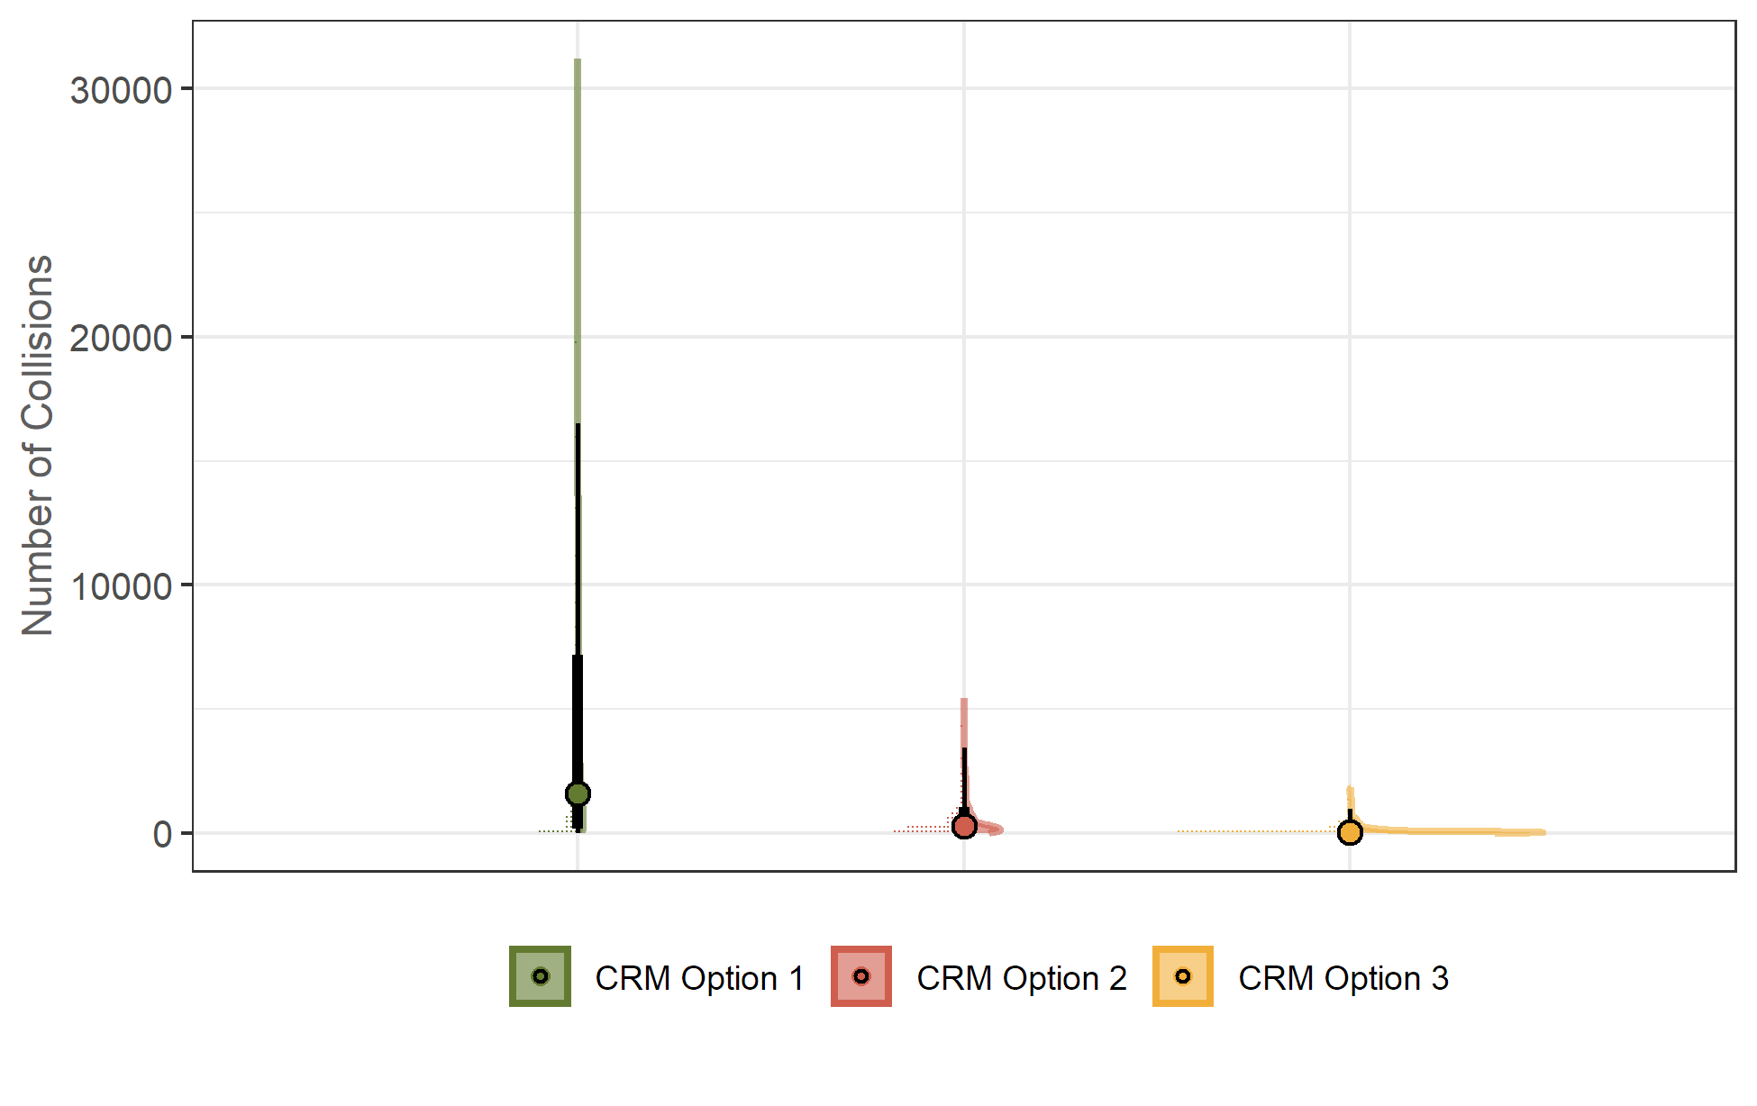

**Table** : Collision estimates of Demo Species 3 at Demoniac Windy, per Annum

| **CRM Option** | **Mean** | **Median** | **SD** | **CV** | **2.5%** | **97.5%** |
| --- | --- | --- | --- | --- | --- | --- |
| Option 1 | 3 495.994 | 1 574.266 | 4 588.102 | 131.239 | 1.805 | 16 499.752 |
| Option 2 | 614.668 | 268.931 | 855.782 | 139.227 | 3.733 | 3 442.320 |
| Option 3 | 144.118 | 44.372 | 253.727 | 176.055 | 0.362 | 989.093 |

# References

Band, B. (2012) Using a collision risk model to assess bird collision risks for offshore windfarms. SOSS report, The Crown Estate.

Masden, E (2015a) Developing an avian collision risk model to incorporate variability and uncertainty. Scottish Marine and Freshwater Science Report Vol 6 No 14. Marine Scotland Science. ISSN: 2043-7722 DOI: 10.7489/1659-1

Masden, E. (2015b) Developing an avian collision risk model to incorporate variability and uncertainty. [R computer code]