sablefish_obs_coverage_draft

Matt Callahan

2023-06-06

This report describes sablefish catch and observer data.

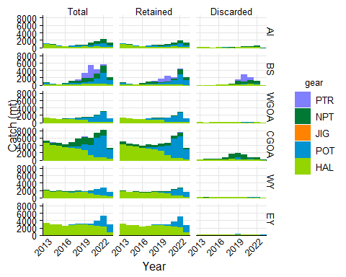

Figure 1. sablefish catch by gear type that was either retained, discarded, or the sum of retained and discarded by management area. Gear types include pelagic trawl (PTR), non-pelagic trawl (NPT), Pot (POT), or Hook and Line (HAL). Areas include the Aleutian Islands (AI), Bering Sea (BS), Western Gulf of Alaska (WGOA), Central Gulf of Alaska (CGOA), West Yakutat (WY), and East Yakutat (EY).

**Table.** Total sablefish catch (mt) by year, area, and gear. Gear types include pelagic trawl (PTR), non-pelagic trawl (NPT), Pot (POT), or Hook and Line (HAL). Areas include the Aleutian Islands (AI), Bering Sea (BS), Western Gulf of Alaska (WGOA), Central Gulf of Alaska (CGOA), West Yakutat (WY), and East Yakutat (EY).

| year | mgmt_area | NPT | POT | HAL | PTR | JIG |
| --- | --- | --- | --- | --- | --- | --- |
| 2013 | AI | 57.88 | 87.20 | 937.06 |  |  |
| 2013 | BS | 133.28 | 351.80 | 149.69 | 0.11 |  |
| 2013 | WGOA | 12.72 | 0.25 | 1,345.41 | 0.00 |  |
| 2013 | CGOA | 659.48 |  | 4,527.22 | 0.31 |  |
| 2013 | WY | 172.56 |  | 1,928.59 | 0.87 |  |
| 2013 | EY |  |  | 3,246.49 |  |  |
| 2014 | AI | 26.09 | 159.97 | 626.89 |  |  |
| 2014 | BS | 34.46 | 164.27 | 115.46 | 0.01 |  |
| 2014 | WGOA | 60.63 | 0.00 | 1,133.77 | 0.09 |  |
| 2014 | CGOA | 735.97 | 1.82 | 3,981.90 | 16.33 |  |
| 2014 | WY | 151.81 |  | 1,519.27 | 0.10 |  |
| 2014 | EY |  |  | 2,817.35 |  |  |
| 2015 | AI | 15.38 | 12.05 | 394.43 |  |  |
| 2015 | BS | 17.02 | 108.06 | 85.16 | 0.05 |  |
| 2015 | WGOA | 35.08 | 0.39 | 954.37 | 8.28 |  |
| 2015 | CGOA | 779.79 | 1.65 | 3,821.66 | 22.44 |  |
| 2015 | WY | 212.17 |  | 1,653.69 |  |  |
| 2015 | EY |  |  | 2,811.28 |  |  |
| 2016 | AI | 29.96 | 20.84 | 289.34 |  |  |
| 2016 | BS | 239.08 | 157.96 | 116.39 | 17.87 |  |
| 2016 | WGOA | 37.93 | 0.94 | 1,004.45 | 8.59 |  |
| 2016 | CGOA | 802.71 | 7.57 | 3,361.06 | 22.96 | 0.31 |
| 2016 | WY | 177.27 |  | 1,473.51 |  |  |
| 2016 | EY |  |  | 2,455.50 |  |  |
| 2017 | AI | 128.53 | 268.50 | 191.43 |  |  |
| 2017 | BS | 588.00 | 365.16 | 106.28 | 90.95 |  |
| 2017 | WGOA | 56.57 | 225.88 | 888.55 | 9.88 |  |
| 2017 | CGOA | 1,191.55 | 442.64 | 3,203.04 | 0.79 |  |
| 2017 | WY | 206.00 | 92.17 | 1,396.15 |  |  |
| 2017 | EY |  | 137.07 | 2,678.47 |  |  |
| 2018 | AI | 178.87 | 285.91 | 199.47 |  |  |
| 2018 | BS | 622.76 | 370.41 | 148.22 | 394.79 |  |
| 2018 | WGOA | 217.52 | 364.61 | 800.76 | 6.24 |  |
| 2018 | CGOA | 2,113.93 | 549.34 | 3,104.89 | 10.06 |  |
| 2018 | WY | 235.76 | 44.60 | 1,581.03 | 0.03 |  |
| 2018 | EY |  | 163.48 | 2,855.94 |  |  |
| 2019 | AI | 240.92 | 203.54 | 218.48 |  |  |
| 2019 | BS | 1,283.04 | 419.46 | 236.55 | 1,222.93 |  |
| 2019 | WGOA | 276.51 | 458.92 | 753.86 | 43.90 |  |
| 2019 | CGOA | 1,944.11 | 1,618.66 | 2,701.01 | 15.90 |  |
| 2019 | WY | 126.17 | 167.99 | 1,507.76 | 0.16 |  |
| 2019 | EY |  | 261.84 | 2,850.69 |  |  |
| 2020 | AI | 695.23 | 397.78 | 138.91 | 0.00 |  |
| 2020 | BS | 1,070.56 | 582.07 | 280.44 | 3,396.33 |  |
| 2020 | WGOA | 174.79 | 1,082.15 | 196.34 | 8.26 |  |
| 2020 | CGOA | 2,026.12 | 2,607.72 | 1,369.17 | 38.10 |  |
| 2020 | WY | 83.43 | 561.07 | 1,190.42 | 0.02 |  |
| 2020 | EY |  | 499.00 | 2,637.54 |  |  |
| 2021 | AI | 773.94 | 569.81 | 233.91 | 0.83 |  |
| 2021 | BS | 1,395.81 | 1,360.94 | 332.75 | 1,079.97 |  |
| 2021 | WGOA | 179.99 | 1,664.68 | 148.18 | 1.20 |  |
| 2021 | CGOA | 1,288.41 | 5,309.86 | 710.17 | 16.07 |  |
| 2021 | WY | 116.70 | 1,535.58 | 677.06 | 0.01 |  |
| 2021 | EY |  | 1,329.88 | 2,541.63 |  |  |
| 2022 | AI | 1,114.54 | 910.61 | 204.40 |  |  |
| 2022 | BS | 2,119.98 | 2,925.99 | 217.76 | 250.34 |  |
| 2022 | WGOA | 224.87 | 2,589.94 | 189.13 | 1.14 |  |
| 2022 | CGOA | 1,472.23 | 5,898.51 | 730.77 | 77.44 |  |
| 2022 | WY | 105.34 | 2,153.23 | 484.30 |  |  |
| 2022 | EY |  | 3,000.60 | 2,226.17 |  |  |
| 2023 | AI | 701.85 | 431.63 | 88.71 |  |  |
| 2023 | BS | 848.92 | 1,285.77 | 25.68 | 0.86 |  |
| 2023 | WGOA | 0.10 | 1,018.03 | 44.09 |  |  |
| 2023 | CGOA | 432.02 | 2,577.75 | 264.59 | 25.25 |  |
| 2023 | WY |  | 1,340.74 | 253.81 | 0.00 |  |
| 2023 | EY |  | 1,992.34 | 810.05 |  |  |

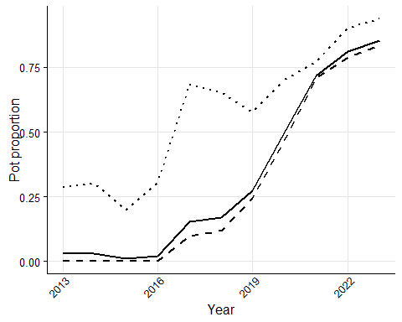

Figure 2. Proportion of fixed gear sablefish catch in pots in the Gulf of Alaska, the Bering Sea and Aleutian Islands, and both combined.

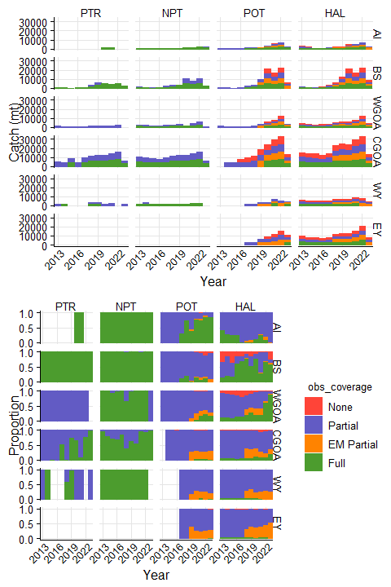

Figure 3. sablefish catch in each observer coverage category in ODDS, including fixed gear electronic monitoring (EM). This catch was not necessarily observed. Gear types include pelagic trawl (PTR), non-pelagic trawl (NPT), Pot (POT), or Hook and Line (HAL). Areas include the Aleutian Islands (AI), Bering Sea (BS), Western Gulf of Alaska (WGOA), Central Gulf of Alaska (CGOA), West Yakutat (WY), and East Yakutat (EY).

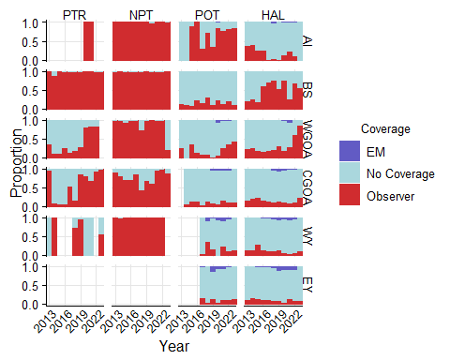

Figure 4. sablefish catch by gear type either observed by electronic monitoring (EM), observers, or no coverage. Biological samples were not taken whenever an observer was present. Gear types include pelagic trawl (PTR), non-pelagic trawl (NPT), Pot (POT), or Hook and Line (HAL). Areas include the Aleutian Islands (AI), Bering Sea (BS), Western Gulf of Alaska (WGOA), Central Gulf of Alaska (CGOA), West Yakutat (WY), and East Yakutat (EY).

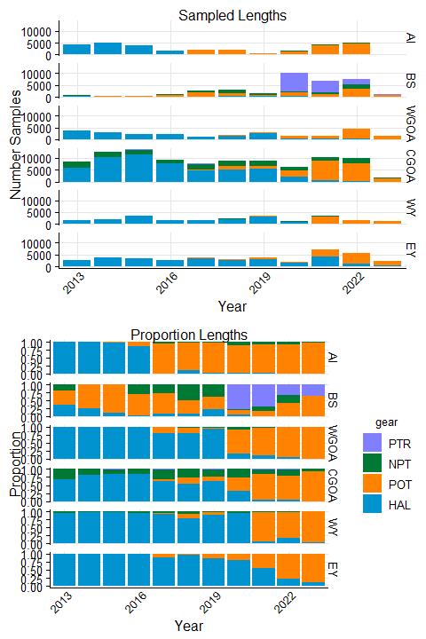

Figure 5. The number of lengths measured by observers and the proportion of sablefish lengths by gear and area. Gear types include pelagic trawl (PTR), non-pelagic trawl (NPT), Pot (POT), or Hook and Line (HAL). Areas include the Aleutian Islands (AI), Bering Sea (BS), Western Gulf of Alaska (WGOA), Central Gulf of Alaska (CGOA), West Yakutat (WY), and East Yakutat (EY).

**Table** : sablefish lengths measured by year, area, and gear

| year | mgmt_area | NPT | HAL | POT | PTR |
| --- | --- | --- | --- | --- | --- |
| 2013 | AI | 5 | 4,152 |  |  |
| 2013 | BS | 142 | 257 | 305 |  |
| 2013 | WGOA | 26 | 3,653 |  |  |
| 2013 | CGOA | 2,696 | 5,787 |  |  |
| 2013 | WY | 82 | 1,513 |  |  |
| 2013 | EY |  | 2,561 |  |  |
| 2014 | AI |  | 4,879 |  |  |
| 2014 | BS |  | 111 | 308 |  |
| 2014 | WGOA |  | 3,066 |  |  |
| 2014 | CGOA | 2,376 | 10,318 |  |  |
| 2014 | WY | 55 | 2,095 |  |  |
| 2014 | EY |  | 3,630 |  |  |
| 2015 | AI |  | 3,728 | 94 |  |
| 2015 | BS |  | 39 | 332 |  |
| 2015 | WGOA | 20 | 2,210 |  |  |
| 2015 | CGOA | 2,079 | 11,281 |  | 163 |
| 2015 | WY | 104 | 3,494 |  |  |
| 2015 | EY |  | 3,507 |  |  |
| 2016 | AI |  | 1,470 | 234 |  |
| 2016 | BS | 339 | 24 | 750 |  |
| 2016 | WGOA |  | 2,251 |  | 4 |
| 2016 | CGOA | 1,338 | 7,786 |  | 9 |
| 2016 | WY | 81 | 1,648 |  |  |
| 2016 | EY |  | 2,546 |  |  |
| 2017 | AI | 85 | 46 | 1,825 |  |
| 2017 | BS | 705 | 235 | 1,562 |  |
| 2017 | WGOA |  | 972 | 247 |  |
| 2017 | CGOA | 2,406 | 4,810 | 289 | 60 |
| 2017 | WY | 71 | 1,636 | 64 |  |
| 2017 | EY |  | 3,485 | 426 |  |
| 2018 | AI | 17 | 214 | 1,647 |  |
| 2018 | BS | 1,526 | 305 | 1,267 |  |
| 2018 | WGOA | 49 | 1,491 | 336 |  |
| 2018 | CGOA | 2,245 | 4,923 | 1,692 | 2 |
| 2018 | WY | 205 | 1,842 | 269 |  |
| 2018 | EY |  | 2,773 | 121 |  |
| 2019 | AI | 10 | 21 | 579 |  |
| 2019 | BS | 523 | 319 | 560 | 6 |
| 2019 | WGOA | 135 | 2,728 | 38 |  |
| 2019 | CGOA | 1,980 | 5,486 | 1,264 | 121 |
| 2019 | WY | 49 | 3,199 | 359 |  |
| 2019 | EY |  | 3,084 | 558 |  |
| 2020 | AI | 172 | 40 | 1,341 |  |
| 2020 | BS | 488 | 593 | 1,280 | 7,626 |
| 2020 | WGOA | 123 | 267 | 1,130 |  |
| 2020 | CGOA | 1,673 | 1,987 | 2,638 |  |
| 2020 | WY | 67 | 988 |  |  |
| 2020 | EY |  | 1,444 | 367 |  |
| 2021 | AI | 321 | 139 | 3,866 |  |
| 2021 | BS | 949 | 90 | 992 | 4,752 |
| 2021 | WGOA | 48 | 146 | 1,239 |  |
| 2021 | CGOA | 1,540 | 437 | 8,344 | 75 |
| 2021 | WY | 78 | 221 | 3,040 |  |
| 2021 | EY |  | 3,978 | 3,136 |  |
| 2022 | AI | 317 | 30 | 4,742 |  |
| 2022 | BS | 1,872 | 73 | 3,188 | 2,463 |
| 2022 | WGOA | 70 | 187 | 4,222 |  |
| 2022 | CGOA | 2,095 | 347 | 7,505 | 23 |
| 2022 | WY | 44 | 287 | 1,332 |  |
| 2022 | EY |  | 1,194 | 4,417 |  |
| 2023 | AI | 1 |  | 63 |  |
| 2023 | BS | 21 |  | 670 | 370 |
| 2023 | WGOA |  |  | 1,449 |  |
| 2023 | CGOA | 110 |  | 1,510 |  |
| 2023 | WY |  | 34 | 1,196 |  |
| 2023 | EY |  | 293 | 2,100 |  |

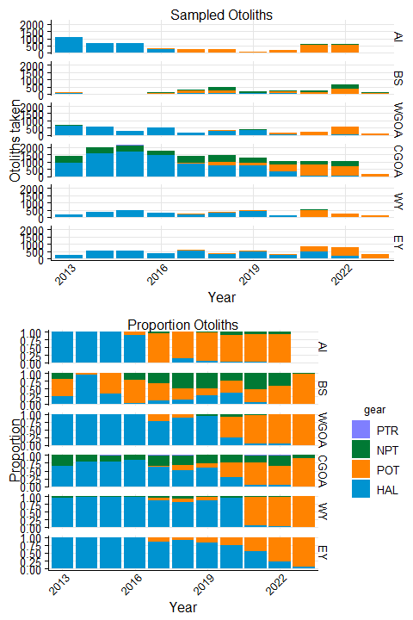

Figure 6. The total and proportion of sablefish ages collected by observers by gear and area. Gear types include pelagic trawl (PTR), non-pelagic trawl (NPT), Pot (POT), or Hook and Line (HAL). Areas include the Aleutian Islands (AI), Bering Sea (BS), Western Gulf of Alaska (WGOA), Central Gulf of Alaska (CGOA), West Yakutat (WY), and East Yakutat (EY).

**Table** : sablefish number of otoliths obtained by year, area, and gear

| year | mgmt_area | NPT | HAL | POT | PTR |
| --- | --- | --- | --- | --- | --- |
| 2013 | AI | 3 | 1,061 |  |  |
| 2013 | BS | 30 | 41 | 85 |  |
| 2013 | WGOA | 8 | 669 |  |  |
| 2013 | CGOA | 485 | 922 |  |  |
| 2013 | WY | 12 | 190 |  |  |
| 2013 | EY |  | 256 |  |  |
| 2014 | AI |  | 651 |  |  |
| 2014 | BS |  | 34 | 2 |  |
| 2014 | WGOA |  | 571 |  |  |
| 2014 | CGOA | 420 | 1,582 |  |  |
| 2014 | WY | 6 | 344 |  |  |
| 2014 | EY |  | 530 |  |  |
| 2015 | AI |  | 665 | 3 |  |
| 2015 | BS |  | 10 | 19 |  |
| 2015 | WGOA | 3 | 306 |  |  |
| 2015 | CGOA | 406 | 1,696 |  | 35 |
| 2015 | WY | 18 | 495 |  |  |
| 2015 | EY |  | 564 |  |  |
| 2016 | AI |  | 289 | 35 |  |
| 2016 | BS | 26 | 5 | 81 |  |
| 2016 | WGOA |  | 537 |  | 3 |
| 2016 | CGOA | 292 | 1,454 |  |  |
| 2016 | WY | 11 | 293 |  |  |
| 2016 | EY |  | 379 |  |  |
| 2017 | AI | 16 | 5 | 252 |  |
| 2017 | BS | 111 | 42 | 179 |  |
| 2017 | WGOA |  | 152 | 44 |  |
| 2017 | CGOA | 465 | 847 | 60 | 9 |
| 2017 | WY | 12 | 206 | 20 |  |
| 2017 | EY |  | 509 | 91 |  |
| 2018 | AI | 1 | 40 | 240 |  |
| 2018 | BS | 232 | 67 | 174 |  |
| 2018 | WGOA | 6 | 297 | 29 |  |
| 2018 | CGOA | 444 | 731 | 267 | 2 |
| 2018 | WY | 35 | 317 | 43 |  |
| 2018 | EY |  | 323 | 32 |  |
| 2019 | AI | 3 | 7 | 80 |  |
| 2019 | BS | 79 | 46 | 34 |  |
| 2019 | WGOA | 23 | 357 | 2 |  |
| 2019 | CGOA | 315 | 744 | 191 | 1 |
| 2019 | WY | 9 | 442 | 56 |  |
| 2019 | EY |  | 452 | 90 |  |
| 2020 | AI | 20 | 6 | 196 |  |
| 2020 | BS | 60 | 91 | 101 | 2 |
| 2020 | WGOA | 14 | 41 | 114 |  |
| 2020 | CGOA | 240 | 306 | 519 |  |
| 2020 | WY | 9 | 148 |  |  |
| 2020 | EY |  | 215 | 70 |  |
| 2021 | AI | 50 | 17 | 542 |  |
| 2021 | BS | 137 | 16 | 114 |  |
| 2021 | WGOA | 9 | 15 | 220 |  |
| 2021 | CGOA | 232 | 39 | 765 | 9 |
| 2021 | WY | 15 | 32 | 476 |  |
| 2021 | EY |  | 458 | 388 |  |
| 2022 | AI | 43 | 6 | 551 |  |
| 2022 | BS | 266 | 6 | 362 |  |
| 2022 | WGOA | 12 | 25 | 550 |  |
| 2022 | CGOA | 341 | 52 | 629 | 6 |
| 2022 | WY | 6 | 9 | 226 |  |
| 2022 | EY |  | 162 | 589 |  |
| 2023 | BS | 3 |  | 97 |  |
| 2023 | WGOA |  |  | 126 |  |
| 2023 | CGOA | 15 |  | 145 |  |
| 2023 | WY |  | 2 | 145 |  |
| 2023 | EY |  | 21 | 285 |  |

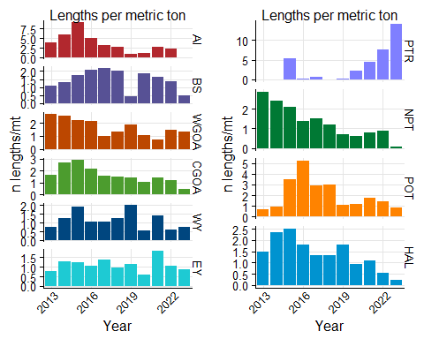

Figure 7. The number of sablefish lengths collected per ton of catch by management area (panel a) or by gear (panel b). Gear types include pelagic trawl (PTR), non-pelagic trawl (NPT), Pot (POT), or Hook and Line (HAL). Areas include the Aleutian Islands (AI), Bering Sea (BS), Western Gulf of Alaska (WGOA), Central Gulf of Alaska (CGOA), West Yakutat (WY), and East Yakutat (EY).

**Table** : Number of sablefish lengths measured per metric ton sablefish catch by year, area, and gear

| year | mgmt_area | NPT | HAL | POT | PTR |
| --- | --- | --- | --- | --- | --- |
| 2013 | AI | 0.086386506 | 4.4308865 |  |  |
| 2013 | BS | 1.065386331 | 1.7168933 | 0.86696466 |  |
| 2013 | WGOA | 2.044524041 | 2.7151554 |  |  |
| 2013 | CGOA | 4.088072823 | 1.2782686 |  |  |
| 2013 | WY | 0.475183953 | 0.7845130 |  |  |
| 2013 | EY |  | 0.7888515 |  |  |
| 2014 | AI |  | 7.7828437 |  |  |
| 2014 | BS |  | 0.9613563 | 1.87493179 |  |
| 2014 | WGOA |  | 2.7042636 |  |  |
| 2014 | CGOA | 3.228394514 | 2.5912232 |  |  |
| 2014 | WY | 0.362295999 | 1.3789474 |  |  |
| 2014 | EY |  | 1.2884462 |  |  |
| 2015 | AI |  | 9.4515049 | 7.80295395 |  |
| 2015 | BS |  | 0.4579554 | 3.07238255 |  |
| 2015 | WGOA | 0.570143803 | 2.3156654 |  |  |
| 2015 | CGOA | 2.666113139 | 2.9518558 |  | 7.262926286 |
| 2015 | WY | 0.490176535 | 2.1128555 |  |  |
| 2015 | EY |  | 1.2474725 |  |  |
| 2016 | AI |  | 5.0805379 | 11.22963728 |  |
| 2016 | BS | 1.417960103 | 0.2062057 | 4.74803338 |  |
| 2016 | WGOA |  | 2.2410342 |  | 0.465744212 |
| 2016 | CGOA | 1.666847353 | 2.3165333 |  | 0.391930049 |
| 2016 | WY | 0.456930639 | 1.1184198 |  |  |
| 2016 | EY |  | 1.0368578 |  |  |
| 2017 | AI | 0.661329472 | 0.2402980 | 6.79690906 |  |
| 2017 | BS | 1.198979765 | 2.2112091 | 4.27755400 |  |
| 2017 | WGOA |  | 1.0939168 | 1.09352110 |  |
| 2017 | CGOA | 2.019215750 | 1.5016991 | 0.65289946 | 75.923120120 |
| 2017 | WY | 0.344663591 | 1.1717919 | 0.69439231 |  |
| 2017 | EY |  | 1.3011180 | 3.10793702 |  |
| 2018 | AI | 0.095039645 | 1.0728477 | 5.76052538 |  |
| 2018 | BS | 2.450380121 | 2.0578143 | 3.42057566 |  |
| 2018 | WGOA | 0.225262360 | 1.8619746 | 0.92152170 |  |
| 2018 | CGOA | 1.062003120 | 1.5855657 | 3.08007910 | 0.198802866 |
| 2018 | WY | 0.869512032 | 1.1650602 | 6.03117193 |  |
| 2018 | EY |  | 0.9709601 | 0.74013252 |  |
| 2019 | AI | 0.041506760 | 0.0961204 | 2.84462024 |  |
| 2019 | BS | 0.407624615 | 1.3485278 | 1.33504625 | 0.004906263 |
| 2019 | WGOA | 0.488234107 | 3.6187214 | 0.08280227 |  |
| 2019 | CGOA | 1.018462712 | 2.0310914 | 0.78089450 | 7.609704523 |
| 2019 | WY | 0.388352356 | 2.1216855 | 2.13699596 |  |
| 2019 | EY |  | 1.0818419 | 2.13104895 |  |
| 2020 | AI | 0.247400028 | 0.2879472 | 3.37120717 |  |
| 2020 | BS | 0.455836267 | 2.1145451 | 2.19903627 | 2.245366866 |
| 2020 | WGOA | 0.703700843 | 1.3598717 | 1.04421276 |  |
| 2020 | CGOA | 0.825716115 | 1.4512429 | 1.01161071 |  |
| 2020 | WY | 0.803045725 | 0.8299615 |  |  |
| 2020 | EY |  | 0.5474800 | 0.73547691 |  |
| 2021 | AI | 0.414761290 | 0.5942571 | 6.78471565 |  |
| 2021 | BS | 0.679890491 | 0.2704707 | 0.72890952 | 4.400133907 |
| 2021 | WGOA | 0.266678955 | 0.9852910 | 0.74428663 |  |
| 2021 | CGOA | 1.195273275 | 0.6153426 | 1.57141654 | 4.667032484 |
| 2021 | WY | 0.668400947 | 0.3264095 | 1.97970422 |  |
| 2021 | EY |  | 1.5651352 | 2.35811412 |  |
| 2022 | AI | 0.284423472 | 0.1467687 | 5.20750097 |  |
| 2022 | BS | 0.883028203 | 0.3352380 | 1.08954473 | 9.838815198 |
| 2022 | WGOA | 0.311296108 | 0.9887229 | 1.63015538 |  |
| 2022 | CGOA | 1.423008601 | 0.4748399 | 1.27235610 | 0.297018485 |
| 2022 | WY | 0.417712530 | 0.5926023 | 0.61860669 |  |
| 2022 | EY |  | 0.5363463 | 1.47203727 |  |
| 2023 | AI | 0.001424803 |  | 0.14595874 |  |
| 2023 | BS | 0.024737442 |  | 0.52108947 | 431.051226819 |
| 2023 | WGOA |  |  | 1.42334126 |  |
| 2023 | CGOA | 0.254618266 |  | 0.58578286 |  |
| 2023 | WY |  | 0.1339599 | 0.89204782 |  |
| 2023 | EY |  | 0.3617055 | 1.05403725 |  |

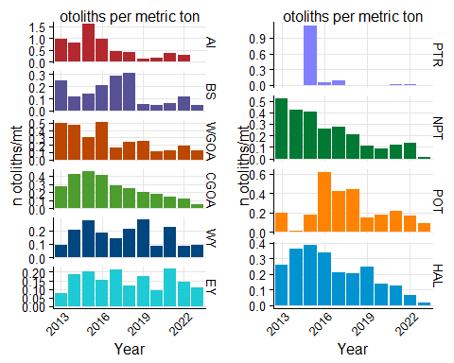

Figure 8. The number of sablefish ages collected per ton of sablefish catch by management area (panel a) or by gear (panel b). Gear types include pelagic trawl (PTR), non-pelagic trawl (NPT), Pot (POT), or Hook and Line (HAL). Areas include the Aleutian Islands (AI), Bering Sea (BS), Western Gulf of Alaska (WGOA), Central Gulf of Alaska (CGOA), West Yakutat (WY), and East Yakutat (EY).

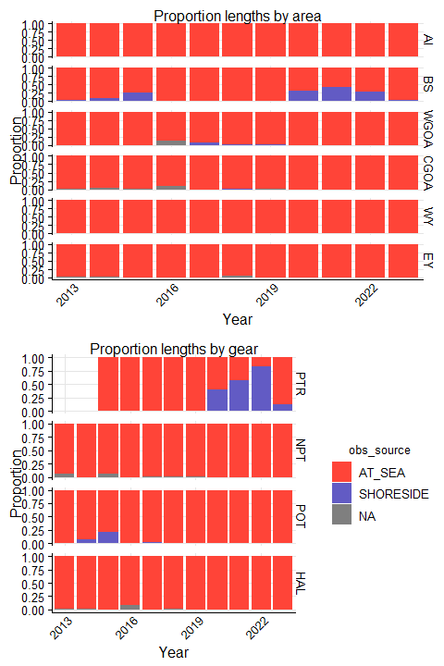

Figure 9. The proportion of sablefish lengths that were measured at-sea versus in ports by observers by management area. Gear types include pelagic trawl (PTR), non-pelagic trawl (NPT), Pot (POT), or Hook and Line (HAL). Areas include the Aleutian Islands (AI), Bering Sea (BS), Western Gulf of Alaska (WGOA), Central Gulf of Alaska (CGOA), West Yakutat (WY), and East Yakutat (EY).

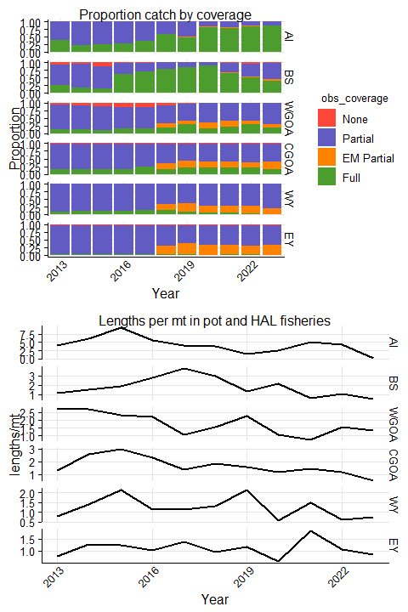

Figure 10. The proportion of sablefish catch by observer coverage (left) and number of lengths collected per metric ton of catch (right). Gear types include pelagic trawl (PTR), non-pelagic trawl (NPT), Pot (POT), or Hook and Line (HAL). Areas include the Aleutian Islands (AI), Bering Sea (BS), Western Gulf of Alaska (WGOA), Central Gulf of Alaska (CGOA), West Yakutat (WY), and East Yakutat (EY).

Fig 10

Cindy - Question: One set for Fixed and one for trawl? Cindy, we will need to specifically check out trawl? E.g., RF in CGOA and WGOA will need to be watched separately from fixed. So one fig. with fixed gear (panels by area) one for trawl. I think people are going to keep saying EM is to blame for things without knowing…so maybe trawl and fixed broken out is good.

THIS IS FAKE DATA.

Cindy and Matt:

Figure type: I know it does not make sense to have one data as line and one as histo, but both as histo could be okay with two axes, but it is harder to compare the two data sets. I tried scatter instead of line, but it was just hard to locate the dots. Not good.

One panel per area and one for total. This just has one of the stacked panels.

Do we separate gears or all combined?

Figure 10. Proportion of sablefish FIXED GEAR catch that was observed using electronic monitoring (EM) and the number of lengths taken per mt of all sablefish catch, by area. Gear types include pot and hook and line. Areas include the Aleutian Islands (AI), Bering Sea (BS), Western Gulf of Alaska (WGOA), Central Gulf of Alaska (CGOA), West Yakutat (WY), and East Yakutat (EY).

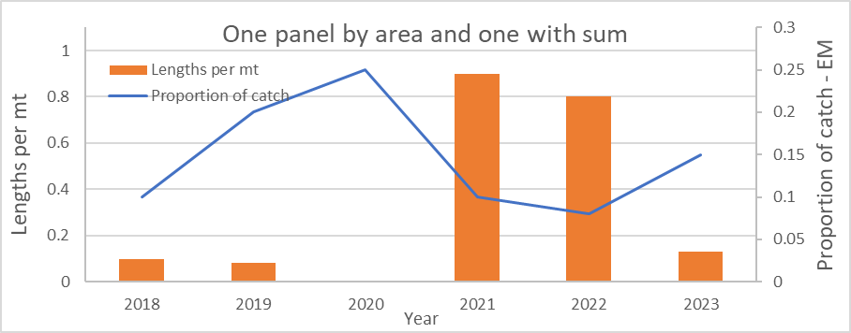

Figure 11?. Proportion of sablefish TRAWL gear catch that was observed using electronic monitoring (EM) and the number of lengths taken per mt of all sablefish catch, by area. Gear types include pelagic and non-pelagic trawls. Areas include the Aleutian Islands (AI), Bering Sea (BS), Western Gulf of Alaska (WGOA), Central Gulf of Alaska (CGOA), West Yakutat (WY), and East Yakutat (EY).

(same as above; 7 panels)