## Appendix 19.A Observer Coverage and Sampling of the Shark Stock

# Introduction

This report provides total catch estimates from the Alaska Regional Office Catch Accounting System (CAS), based on landings, fishery observations, and other data sources. Fishery observations and biological samples are collected by the North Pacific Groundfish Observer Program and the Alaska Fisheries Science Center (AFSC) Fishery Monitoring and Analysis program (FMA). A description of the observer strata is in the “Additional Information” section at the end of this document. More details are available in the North Pacific Groundfish Observer Program Annual Deployment Plans and Annual Reports produced by the FMA. All CAS and observer data were queried through the AKFIN database.

The goals of this report are to present how much of the shark stock catch was observed by the North Pacific Observer Program and how many biological samples were collected by observers by Fishery Management Plan Subareas and gear types since observer restructuring. The total catch of the stock by area and gear is reported in Figure 1 and Table 1. First, the trip is assigned to an observer stratum in the Observer Deployment and Declare System (ODDS). Figure 3 summarizes how much catch was from trips assigned to each observer stratum in ODDS, including partial coverage, electronic monitoring (EM) partial coverage, full coverage, or no coverage. This is a representation of how much catch was attributed to trips in each stratum in ODDS and not how much catch was actually observed.

Table 2 summarizes how much of the catch in recent years was actually covered by observers or EM, as a percent of total catch. Figures 4 and 5 show the actual catch with observer and EM coverage and the proportions of the catch with coverage in more detail, for all years by area and gear. The proportions for each cell are calculated using the catch by coverage type divided by the total catch in each area/grid cell annually. In other words, the proportions are the values in each catch column by area and gear scaled to sum to 1.

Lengths and otoliths are collected at-sea and in ports and the rate of collection depends on the gear and area. A brief summary of measured lengths and collected otoliths for the stock is in Table 3. The total counts of fish sampled for lengths and otoliths are presented in Figures 6-9 and Tables 4 and 5. The count of lengths and otoliths can be used with the catch to evaluate the sampling rate, by dividing the number of lengths or otoliths by the catch (e.g., lengths/mt) (Figures 10 and 11, respectively). This rate can be used to evaluate if the absolute number of biological samples has changed in line with the rate of sampling. For example, the number of lengths collected could be decreasing over time, but if the catch is also decreasing the rate may be stable. In Figure 14 the proportion of catch observed using EM (EM mt/total catch mt) is plotted alongside the sampling rate of lengths (lengths/mt), which cannot be collected with only EM.

# Tables

| Table 19.A.1. Total shark catch (mt) by area, year, and gear. Gear types include non-pelagic trawl (NPT), pot (POT), hook and line (HAL), pelagic trawl (PTR), or jig (JIG). Areas include the Aleutian Islands (AI), Bering Sea (BS), Western Gulf of Alaska (WGOA), Central Gulf of Alaska (CGOA), West Yakutat (WY), and East Yakutat (EY). | | | | | | |
| --- | --- | --- | --- | --- | --- | --- |
| Area | Year | PTR | NPT | POT | HAL | Sum |
| WGOA | 2013 | 1 | <1 | <1 | 30 | 32 |
| WGOA | 2014 | 134 | 1 | <1 | 42 | 177 |
| WGOA | 2015 | 5 |  |  | 51 | 56 |
| WGOA | 2016 | 1 | 1 | <1 | 40 | 42 |
| WGOA | 2017 | 7 | <1 | <1 | 47 | 54 |
| WGOA | 2018 | 1 | 4 |  | 50 | 56 |
| WGOA | 2019 | 7 | 1 |  | 32 | 40 |
| WGOA | 2020 | 12 | <1 | <1 | 33 | 46 |
| WGOA | 2021 | 50 | <1 | 1 | 31 | 81 |
| WGOA | 2022 | 47 | <1 | 1 | 62 | 110 |
| WGOA | 2023 | 23 |  | <1 | 104 | 127 |
| CGOA | 2013 | 20 | 305 | <1 | 1,154 | 1,480 |
| CGOA | 2014 | 31 | 184 | 3 | 650 | 868 |
| CGOA | 2015 | 382 | 187 | <1 | 371 | 941 |
| CGOA | 2016 | 129 | 700 | 1 | 444 | 1,273 |
| CGOA | 2017 | 40 | 371 | <1 | 560 | 971 |
| CGOA | 2018 | 22 | 398 | 1 | 1,066 | 1,487 |
| CGOA | 2019 | 27 | 471 | 2 | 520 | 1,019 |
| CGOA | 2020 | 59 | 154 | 2 | 470 | 685 |
| CGOA | 2021 | 28 | 90 | 1 | 774 | 893 |
| CGOA | 2022 | 34 | 45 | 1 | 894 | 975 |
| CGOA | 2023 | 27 | 85 | 1 | 480 | 592 |
| WY | 2013 | 1 |  |  | 179 | 180 |
| WY | 2014 | 1 |  |  | 228 | 229 |
| WY | 2015 | 1 | 1 |  | 184 | 186 |
| WY | 2016 |  | 1 |  | 114 | 114 |
| WY | 2017 |  | 3 | <1 | 271 | 273 |
| WY | 2018 | <1 |  |  | 1,196 | 1,196 |
| WY | 2019 | <1 | 1 | <1 | 244 | 245 |
| WY | 2020 | <1 | <1 | 1 | 219 | 220 |
| WY | 2021 | <1 | <1 | <1 | 310 | 311 |
| WY | 2022 | <1 |  | <1 | 229 | 229 |
| WY | 2023 | <1 |  | <1 | 513 | 513 |
| EY | 2013 |  |  |  | 465 | 465 |
| EY | 2014 |  |  |  | 309 | 309 |
| EY | 2015 |  |  |  | 206 | 206 |
| EY | 2016 |  |  |  | 522 | 522 |
| EY | 2017 |  |  | <1 | 473 | 473 |
| EY | 2018 |  |  | <1 | 672 | 672 |
| EY | 2019 |  |  | <1 | 683 | 683 |
| EY | 2020 |  |  | 1 | 407 | 408 |
| EY | 2021 |  |  | 9 | 623 | 632 |
| EY | 2022 |  |  | 1 | 934 | 935 |
| EY | 2023 |  |  | 17 | 744 | 760 |

| Table 19.A.2. The proportion of shark catch observed by observers (Obs) or electronic monitoring (EM) by area and gear for the most recent five years and the average proportions from 2013 through the current year. The remainder of the catch had no observer coverage. Gear types include pelagic trawl (PTR), non-pelagic trawl (NPT), pot (POT), or hook and line (HAL). Areas include the Aleutian Islands (AI), Bering Sea (BS), Western Gulf of Alaska (WGOA), Central Gulf of Alaska (CGOA), West Yakutat (WY), and East Yakutat (EY). | | | | | | | |
| --- | --- | --- | --- | --- | --- | --- | --- |
|  |  | PTR | NPT | POT | POT | HAL | HAL |
| Area | Year | % Obs | % Obs | % EM | % Obs | % EM | % Obs |
| WGOA | 2019 | 46 | 35 |  |  | 6 | 9 |
| WGOA | 2020 | 97 | 100 | 13 |  | 1 | 1 |
| WGOA | 2021 | 99 |  |  | 8 | 2 | 22 |
| WGOA | 2022 | 99 |  | 0 | 17 | 3 | 10 |
| WGOA | 2023 | 96 |  |  |  | 2 | 13 |
| WGOA | Avg | 54 | 54 | 2 | 10 | 1 | 20 |
| CGOA | 2019 | 18 | 82 | 12 |  | 10 | 7 |
| CGOA | 2020 | 71 | 72 | 6 |  | 8 | 6 |
| CGOA | 2021 | 74 | 96 | 6 | 8 | 4 | 14 |
| CGOA | 2022 | 91 | 96 | 4 | 10 | 9 | 6 |
| CGOA | 2023 | 91 | 95 |  | 12 | 7 | 9 |
| CGOA | Avg | 32 | 59 | 4 | 6 | 4 | 7 |
| WY | 2019 | 9 | 100 |  |  | 9 | 11 |
| WY | 2020 | 35 | 100 | 15 | 1 | 4 | 8 |
| WY | 2021 | 38 | 100 |  | 19 | 9 | 8 |
| WY | 2022 | 89 |  |  | 11 | 9 | 11 |
| WY | 2023 | 50 |  | 3 | 6 | 1 | 6 |
| WY | Avg | 28 | 100 | 7 | 4 | 3 | 8 |
| EY | 2019 |  |  | 53 |  | 21 | 11 |
| EY | 2020 |  |  | 3 |  | 4 | 6 |
| EY | 2021 |  |  | 1 | 10 | 14 | 5 |
| EY | 2022 |  |  | 6 | 14 | 6 | 8 |
| EY | 2023 |  |  | 1 | 22 | 16 | 8 |
| EY | Avg |  |  | 1 | 17 | 9 | 8 |

| Table 19.A.3. The total catch in mt for each area and year, the number of individual fish lengths (len) and otoliths (oto) collected, and the rate of length and otolith samples, as sampling per mt of catch, for the five most recent years and the average from 2013-present. Areas include the Aleutian Islands (AI), Bering Sea (BS), Western Gulf of Alaska (WGOA), Central Gulf of Alaska (CGOA), West Yakutat (WY), and East Yakutat (EY). | | | | | | |
| --- | --- | --- | --- | --- | --- | --- |
| Area | Year | Catch | Len | Len/mt | Oto | Oto/mt |
| WGOA | 2023 | 127 | 1 | 0.01 |  |  |
| WGOA | Avg | 75 | 0 | 0.00 |  |  |
| CGOA | 2023 | 592 | 46 | 0.08 |  |  |
| CGOA | Avg | 1,017 | 4 | 0.00 |  |  |
| WY | 2023 | 513 | 1 | 0.00 |  |  |
| WY | Avg | 336 | 0 | 0.00 |  |  |
| EY | 2023 | 760 | 1 | 0.00 |  |  |
| EY | Avg | 551 | 0 | 0.00 |  |  |

| Table 19.A.4. Count of shark lengths measured at-sea and in port by observers by area, year, and gear. Gear types include non-pelagic trawl (NPT), hook and line (HAL), pot (POT), and pelagic trawl (PTR). Areas include the Aleutian Islands (AI), Bering Sea (BS), Western Gulf of Alaska (WGOA), Central Gulf of Alaska (CGOA), West Yakutat (WY), and East Yakutat (EY). | | | | | |
| --- | --- | --- | --- | --- | --- |
| Area | Year | PTR | NPT | HAL | Sum |
| WGOA | 2023 | 1 |  |  | 1 |
| CGOA | 2023 | 2 | 44 |  | 46 |
| WY | 2023 |  |  | 1 | 1 |
| EY | 2023 |  |  | 1 | 1 |

| Table 19.A.5. Count of shark otoliths collected at-sea in port by observers by area, year, and gear. Gear types include non-pelagic trawl (NPT), hook and line (HAL), pot (POT), or pelagic trawl (PTR). Areas include the Aleutian Islands (AI), Bering Sea (BS), Western Gulf of Alaska (WGOA), Central Gulf of Alaska (CGOA), West Yakutat (WY), and East Yakutat (EY). | | |
| --- | --- | --- |
| Area | Year | Sum |

# Figures

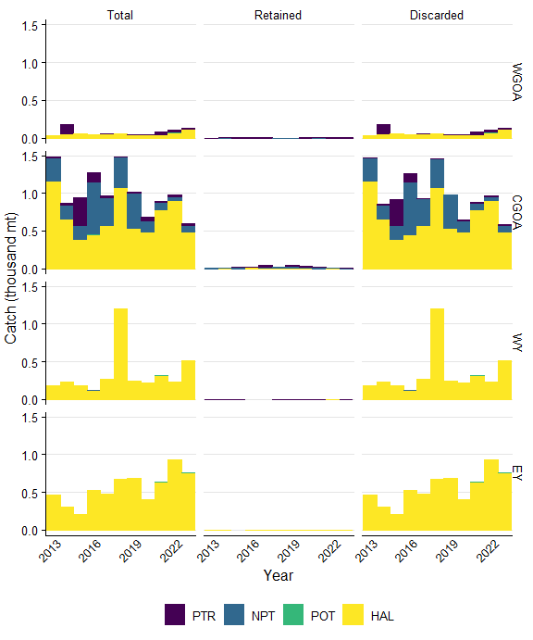

Figure 19.A.1. Shark catch by gear type that was either the total of retained and discarded, retained, or discarded by management area. Gear types include pelagic trawl (PTR), non-pelagic trawl (NPT), pot (POT), or hook and line (HAL). Areas include the Aleutian Islands (AI), Bering Sea (BS), Western Gulf of Alaska (WGOA), Central Gulf of Alaska (CGOA), West Yakutat (WY), and East Yakutat (EY).

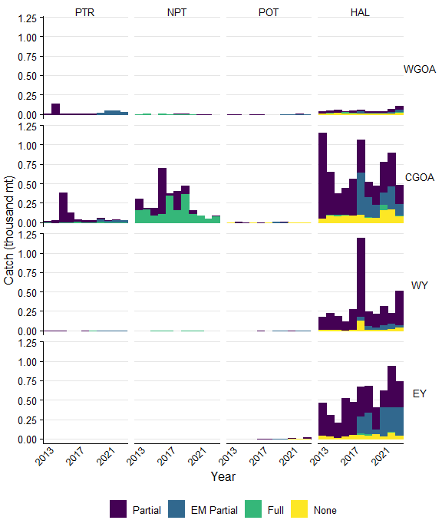

Figure 19.A.2. Shark catch in each observer coverage category in the Observer Deploy and Declare System (ODDS), including fixed gear electronic monitoring (EM). This catch was not necessarily observed. Gear types include pelagic trawl (PTR), non-pelagic trawl (NPT), pot (POT), or hook and line (HAL). Areas include the Aleutian Islands (AI), Bering Sea (BS), Western Gulf of Alaska (WGOA), Central Gulf of Alaska (CGOA), West Yakutat (WY), and East Yakutat (EY).

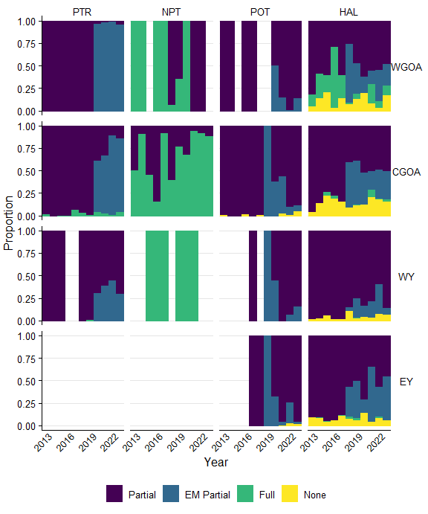

Figure 19.A.3. Utilizing shark catch data, the proportions of catch in each observer coverage category in the Observer Deploy and Declare System (ODDS) for each area, gear, and year, including fixed gear electronic monitoring (EM). I.e., the catch for each area, gear, and year is scaled to 1. This catch was not necessarily observed. Gear types include pelagic trawl (PTR), non-pelagic trawl (NPT), pot (POT), or hook and line (HAL). Areas include the Aleutian Islands (AI), Bering Sea (BS), Western Gulf of Alaska (WGOA), Central Gulf of Alaska (CGOA), West Yakutat (WY), and East Yakutat (EY).

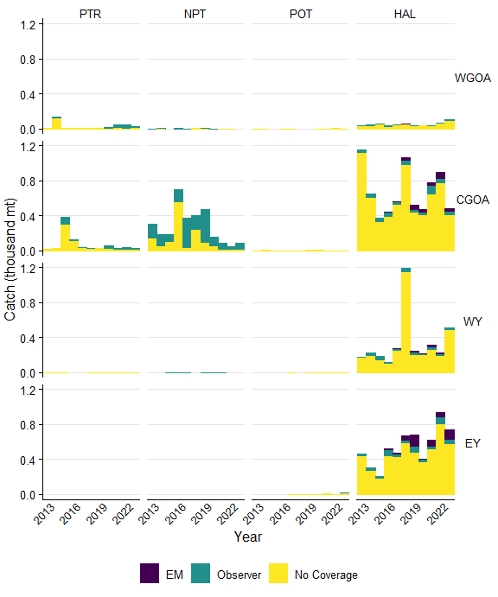

Figure 19.A.4. Shark catch by gear type either observed by electronic monitoring (EM), observers, or no coverage. Biological samples were not taken whenever an observer was present. Gear types include pelagic trawl (PTR), non-pelagic trawl (NPT), pot (POT), or hook and line (HAL). Areas include the Aleutian Islands (AI), Bering Sea (BS), Western Gulf of Alaska (WGOA), Central Gulf of Alaska (CGOA), West Yakutat (WY), and East Yakutat (EY).

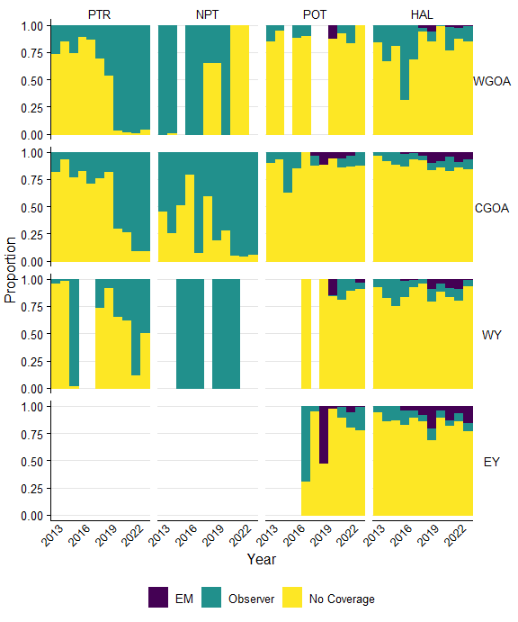

Figure 19.A.5. Utilizing shark catch data, the proportions of catch in each observer coverage category in the Observer Deploy and Declare System (ODDS) for each area, gear, and year, including fixed gear electronic monitoring (EM). I.e., the catch for each area, gear, and year is scaled to 1. This catch was not necessarily observed. Gear types include pelagic trawl (PTR), non-pelagic trawl (NPT), pot (POT), or hook and line (HAL). Areas include the Aleutian Islands (AI), Bering Sea (BS), Western Gulf of Alaska (WGOA), Central Gulf of Alaska (CGOA), West Yakutat (WY), and East Yakutat (EY).

# Additional Information

**Biological Collections**

• Lengths (mm), weight (tenth of a kg), and sagittal otoliths are collected by observers at-sea and at processing plants when North Pacific Groundfish Observer Program protocols call for collections. Otoliths are not collected from all fish that have lengths and weights recorded. Weights are collected when otoliths are collected.

**Observer strata in the North Pacific Groundfish Observer Program**

• Full Coverage - Catcher/processors (with limited exceptions), motherships, catcher vessels that are participating in programs that have transferable prohibited species catch, catcher vessels using trawl gear that have requested full coverage for all fishing activity within the Bering Sea/Aleutian Islands FMP, and inshore processors receiving or processing Bering Sea pollock. Full coverage trips are all assumed to be 100% covered.

• Partial Coverage - Catcher vessels fishing in federally managed groundfish or parallel fisheries, excepting when in full coverage, catcher vessels participating in the Pacific halibut or sablefish IFQ fisheries, catcher vessels participating in the CDQ fisheries or those < 46ft LOA using hook-and-line gear for groundfish, catcher/processor that qualify for partial coverage, and shoreside or stationary floating processors that are not in the full coverage category are in the partial coverage category.

• EM - trawl gear: Trips in this strata have EM recordings and all are reviewed. The review is for compliance monitoring only and catch is not enumerated. Vessels operating in the trawl EM program are required to retain all catch (with limited exceptions) for shoreside sampling by observers at the plant. Shoreside observer sampling targets a 100% coverage rate of all EM - trawl deliveries in the BSAI and 30% in the GOA . This strata went into effect in 2020 as an Exempted Fishing Permit program, only on non-pelagic trawl vessels targeting Pollock, and is becoming regulated for the 2024 fishery.

• EM - fixed-gear: Includes both pot and hook-and-line vessels. Trips logged into ODDS have a partial coverage selection rate and, if selected, the vessel must record all hauls during that trip duration. After the videos are submitted, 30% of recorded hauls are reviewed and catch is fully censused along with discard status of each fish. There are no biological samples collected from fixed-gear EM trips.

• EM note - EM fixed gear is a completely different program from EM non-pelagic trawl, with different origins, directives and methodologies.

• No Coverage or Zero Selection - Vessels < 40ft LOA, jig and exempted vessels.

**Caveats**

• Data prior to the 2013 North Pacific Observer Program restructure are not included in the analyses presented here due to structural changes.

• Not all observer strata were covered each year. For example, hook and line (HAL) tender was only covered in 2017, in which a total of four trips were made and thus deemed not a useful strata to include.

• 2020 - Observer sampling was significantly impacted March-June due to the pandemic, resulting in minimal coverage during those months and reducing the annual realized coverage rates.

# References

North Pacific Observe Program: <https://www.fisheries.noaa.gov/alaska/fisheries-observers/north-pacific-observer-program>