52.141
Exemption Project 2009

Alastair Fraser Dewar
200830284

Bsc Computer Science

Except where explicitly marked to the contrary by quotation or reference, what follows is all my own work. I have not knowingly allowed others to copy my work.

_________________

28th April 2009

The Foxes and Rabbits System

The foxes and rabbits system is a simulator for the population growth of two species related by a predator/prey relationship. The system provides a simulation for the population growth and demise of both the foxes and rabbits in a virtual environment. It allows for analysis of many aspects which can affect an ecosystem.

Animal – This class is a class that is a generic representation of any animals present in the simulation. All animals are a subclass of Animal.
Counter – This class counts how many animal objects there are for each class in the game.
Field – This class represents the field in which the simulation takes place. It is structures like a board, made out of a square grid full of locations.
FieldStats – This class is used to manage any statistics associated with the field such as the animal objects present in the field.
Fox – This class is used to create fox objects and is a sub class of animal. It is a representation of a fox in the simulation. It contains all features unique to foxes exclusively (Features unique to animals are inherited).
Location – This class is used to represent a location in the field. It stores any data specific to that location such as any object present on it.
Rabbit – This class is almost identical to the fox class except it is a representation of animals in the simulation and contains all features unique to rabbits.
Randomizer – This class is used to control all random features unique to the simulation. It also allows for using the same seed to see how various aspects can affect the same situation over and over.
Simulator – This class is the main class for the simulator and controls all the other classes in order to construct a simulator.
SimualtorView – This class provides a visual aid for the simulator program. It allows a visual view of the field and the interactions taking place. It also allows for a graphical user interface to interact with the ongoing simulation.

My Unique Extensions

In order to make this simulation unique I decided to try and introduce aspects with potential to be built upon, providing extensibility. The first idea I had was to introduce a new feature into the environment which would provide a better representation of the real life situation, so I developed the Objects class. This class allows for an object to be placed in the field. Trying to think outside of the box, I added some nifty features for these objects to have. The first was to allow these objects to be invisible to animals. This allowed for me to create a new object subclass, traps. Because of this new ability to be invisible to animals the animals can unsuspectingly stumble into a trap, snaring and killing them. The next feature lacks an example implementation but is a great update, it allows for objects to acquire multiple locations. Some examples of how you could use this is to create obstacles exist in real life such as creating a pond or bush which can now span several locations on the field. Before this update it would have meant creating several objects all in adjacent locations. Some other additions were added in order to increase the functionality as a simulator. The most useful is the logging system. This logs the population levels of the various animals and objects and how they change. On top of this I've built an analyser, which analyses the logs. This area is slightly primitive but provides a good proof of concept and could easily be expanded upon. The most obvious aspect visible to the user is the addition of the GUI. This features drop down menus to allow interaction with the simulation. It allows the user to control almost all aspects of the simulation and ever supports the ability to pause a simulation at any stage to alter it.
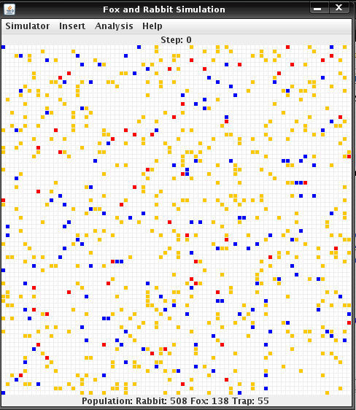

Screenshot showing the initial
GUI including traps,
represented by red dots.

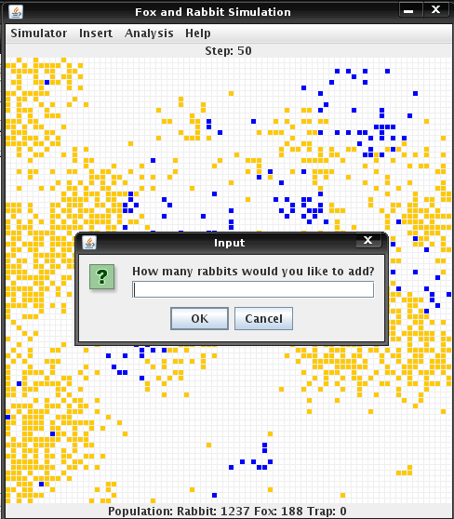

Screenshot showing the
ability to insert various animals/objects at any stage
of the simulation

An extract from the log file
[start]
fox:144+rabbit:561+trap:47
fox:200+rabbit:597+trap:43
fox:243+rabbit:637+trap:34
fox:284+rabbit:647+trap:30
[finish]

There are a total of 4 new classes:
Logger – This class handles the logging of the simulation. Its worth noting, It won't log until the simulation has finished to prevent half written logs.
Analyser – This class handles the analysis of the logs.
Objects – This class is a parent class for all objects that can be introduced into the field. It has support for objects over multiple locations.
Trap – This class holds all features unique to trap objects. It snares any unsuspecting animal to stumble on top of it. It is invisible to animals.

All methods in each of these classes have been developed by me and more information can be found in the javadocs attached.

Some modifications were made to the original code, with the main aim to allow integration of the described changes. I altered the Randomizer class to allow for a completely random simulation every time. In order to add pausing/resuming to a simulation I had to modify the Simulator, adding the pause and resume methods as well as the paused variable. I also modified Simulator in order to add support for objects. Modifications were made to the animal class, and all subclasses to add support for disease. All three classes were modified again to introduce genders and only females being able to give birth. To add a GUI almost all modifications to make this necessary were made to the SimulatorView class. Small amendments were made to the Simulator class in order to add the logging feature.

