Author : Aaditya A

Problem Statement:

Automate the process of searching for a book in the Amazon.com application and validate the process steps, wherever required.

Solution Proposed:

Type of Framework: In this project, I’m using Automation Framework by using Page Object Model design pattern with Page Factory.

Language: In this Selenium Project, I’m using Java language. Even though Selenium supports multiple languages, we are using Java language is just because most of the automation developers have knowledge on Selenium with Java.

POM: As per the Page Object Model, we have maintained a class for every web page. Each web page has a separate class and that class holds the functionality and members of that web page. Separate classes for every individual test.

Packages: We have separate packages for Pages and Tests. All the web page related classes come under Pages package and all the tests related classes come under Tests package.

For example: Home Page, Search Results Page and Product Page have a separate classes to store element locators. For the Home Page Test there would be a separate class which calls the methods from the Home Page class / Search Results Page class / Product Page class.

I will explain based on the below mentioned test automation structure

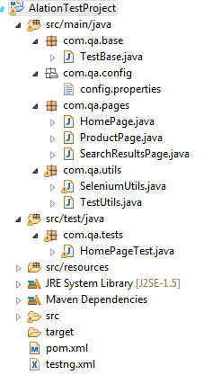
.

Above screenshot illustrates standardized maven project. As per the above maven project, all the tests are kept in the ‘src/test/java‘ and remaining files (such as config.properties, element locators (POM classes), utility files, test data, etc.,) kept under ‘src/main/java‘.

Class Level Explanation :

Test Base Class: Test Base class (TestBase.java) deals with all the common functions used by all the pages. This class is responsible for loading the configurations from properties files, Initializing the WebDriver, Implicit Waits, Extent Reports and also to create the object of FileInputStream which is responsible for pointing towards the file from which the data should be read.

SeleniumUtils Class: Selenium Utility class stores and handles the wrapper for the base commands of Selenium like click, select from dropdown, Assert element text, get text etc., so that these utilities can be re-used across the methods in the pages

Properties file: This file (config.properties) stores the information that remains static throughout the framework such as browser specific information, application URL etc.

All the details which change as per the environment and authorization such as URL, browser to execute are kept in the config.properties file. Keeping these details in a separate file makes easy to maintain.

Screenshots folder: Screenshots folder will be captured and stored in a separate folder and also the screenshots of a failed test cases will be added in the extent reports.

HTML Reports / ExtentAutomationSummary.html : This html file will give the Test Execution Results at the end of the test run, with number of Pass / Fail counts. And the failed steps gives the elaborate exception of which step got failed and with related screenshots. This helps the user to identify the failures in a test run easily.

TestNG: Using TestNG for Assertions, Order of Executions etc.

Maven: Using Maven for build, execution and dependency purpose.

Further value adds can be added:

Test Data: All the test data used in the project can be kept in excel sheet / CSV file. By using ‘TestData.xlsx’ or ‘TestData.csv’, we pass test data and handle data driven testing. We use Apache POI to handle excel sheets / Buffered Reader to handle CSV files.

CI using Jenkins : By using Jenkins CI (Continuous Integration) Tool, we execute test cases on daily basis and also for nightly execution based on the schedule.

***

