This is a solution to the NFT preview card component

## Overview

was a good challenge

## The challenge

Getting the opacity of the background

## Screenshot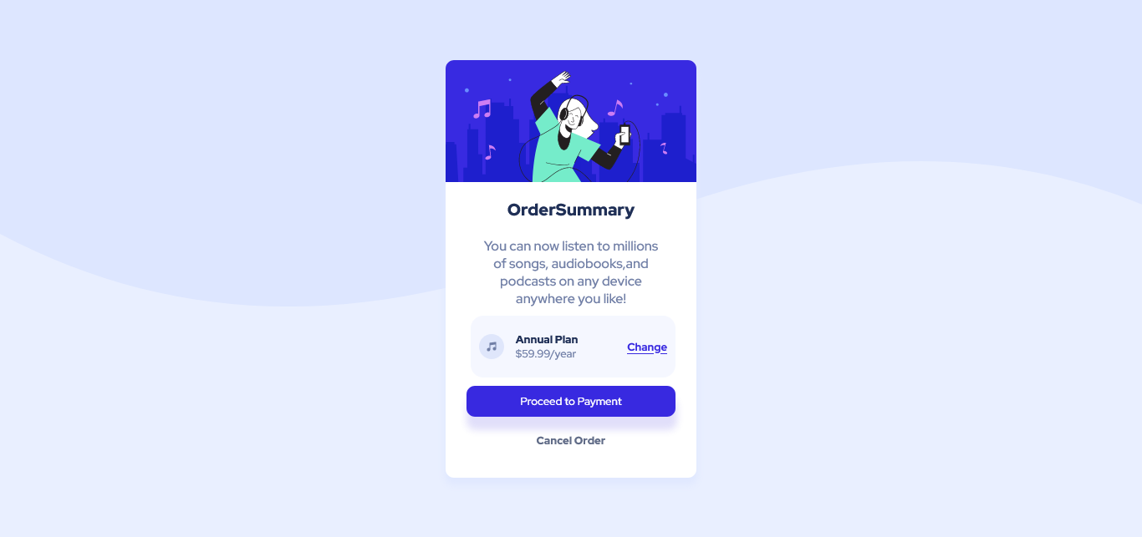

##Live Site URL

Website https://alazarg19.github.io/Order-Summary-component/

##My process

i started from the html and went on up from there everything was going smooth

## Built with

html and css

flexbox

##What i learned

I learned to use flexbox more easily

### Continued development

i would like to be able to pick colors easier

## Author

Website https://alazarg19.github.io/Order-Summary-component/Frontend Mentor @AlazarG19

## Acknowledgments