This is a solution to the NFT preview card component

## Overview

was a good challenge

## The challenge

hover for the nft preview card done

## Screenshot

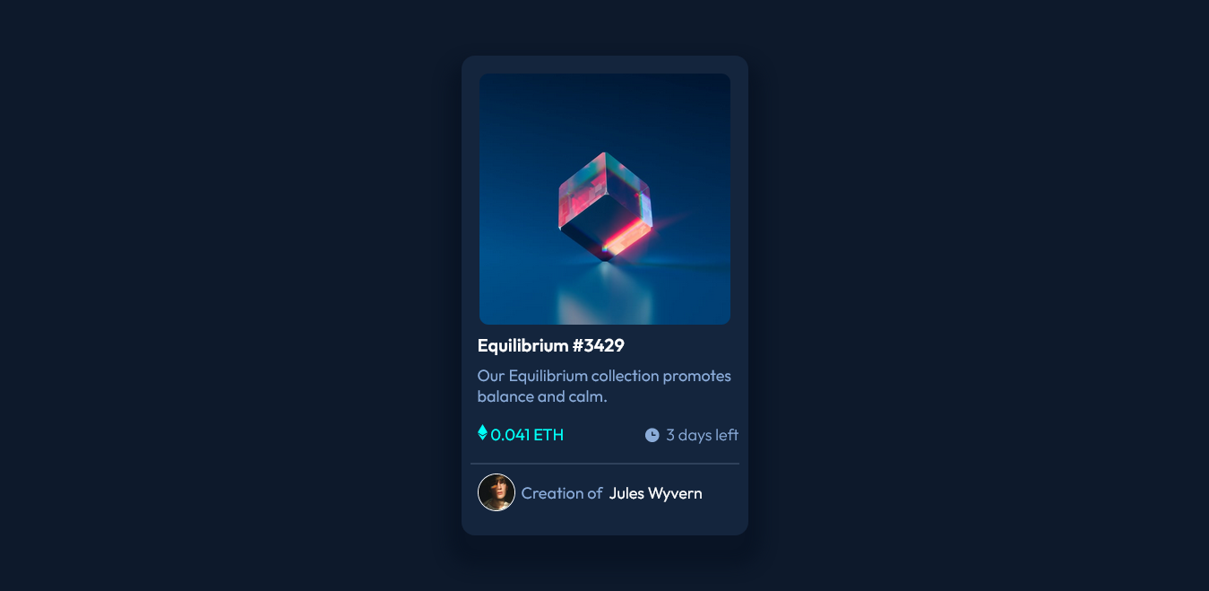

##Live Site URL

Website https://alazarg19.github.io/nft-preveiw-card-component/

##My process

i started from the html and went on up from there everything was going smooth

but the I hadn’t figured out that the container contained a box shadow that

took me a while to figure it out .

## Built with

html and css

flexbox

##What i learned

the main part that took me a while was

<div class="container">

<div class="nft">

<img class="eq-image" src="./images/image-equilibrium.jpg">

<div class="hovernft">

<img class="hovernftimg" src="./images/icon-view.svg" alt="">

</div>

</div>

<div class="title1">

Equilibrium #3429

</div>

<div class="detail1">

Our Equilibrium collection promotes balance and calm.

</div>

<div class="detail2">

<div class="price">

<img src="./images/icon-ethereum.svg" alt="" srcset="">

0.041 ETH

</div>

<div class="dayleft">

<img class="clock" src="./images/icon-clock.svg" alt="" srcset="">

<span>3 days left</span>

</div>

</div>

<div class="creator">

<img class="photo" src="./images/image-avatar.png" alt="">

<span>Creation of</span>

<span>Jules Wyvern</span>

</div>

</div>

i used this to create the box shadow

css

box-shadow: 0px 20px 15px 15px hsl(216deg 61% 9%);

### Continued development

i would like to be able to pick colors easier

## Author

Website https://alazarg19.github.io/nft-preveiw-card-component/

Frontend Mentor @AlazarG19

## Acknowledgments

had more help from a person that did this challenge earlier and found the box shadow

property there