Manual Version 0

1. Project set-up

1.1 Creating/Loading a project

The project will be set-up upon creating an instance of one of the Manager classes (see section 2), e.g.:

swam = MASW2DManager(<prjdir>,path2raw=<optinal path2raw>path2geom=<optinal path2geom>, settings=settings)

The project set-up consists of the following steps:
- Creating the project directory structue (if it does not exist)
- Copying (and by default renaming) raw data into the project directly (if it does not exist there and a path to the raw data was provided)
- Copying or attempting to create the geometry file (if it does not exist in project directory and 1. a path to the geom file was provided and/or 2. source/receiver is contained in seismic data)
- Loading the data
- Creating the database

If a project already exists, upon creating an instance of the Manager and setting the correct project path, the project (database) will be loaded:

swam = MASW2DManager(<prjdir>)

1.1.1 Project directory

|-prjdir
|- 01_data/
- raw/
|- 02_geom/
|- 03_proc/
|- 04_figs/

1.1.2 Geometry file

The geometry file is a csv file introduced and used in the open-source python library formikoj for seismic refraction tomography data processing and modelling (Steiner & Flores Orozco, 2023) that stores an abstract representation of the survey layout. In our toolbox it is passed the methods to provide the information about the survey layout. We slightly adapt the format to store the information for repeated shots at the same location. The file can be created manually using any (spreadsheet) editor or from the seismic data directly if the source and receiver coordinates are contained within the seismic raw data files. The file contains (without a header) in sorted order column-wise: (1) the local station coordinates (x-, y-, and z-coordinates), (2) a flag to indicate wether this location is a geophone or source, (3) the shot file number, (4) the first geophone and (5) the number of active geophones (see Table 1). Height and 3D information is not taken into consideration during the analysis or visualisations in the current version of the surface wave processing toolbox. An example is given in Table 2. For further information check out Steiner & Flores Orozco (2023).

Table 1: Description of the columns of the geometry file
Column | Content | Data type | Description
1 | x-coordinate | float | Station x coordinate, e.g., given in (m)
2 | y-coordinate | float | Station y coordinate, e.g., given in (m)
3 | z-coordinate | float | Station z coordinate, e.g., given in (m)
4 | Geophone flag | int | 1 if a geophone was deployed at station, 0 otherwise
5 | Shot file number (s) separated by ; | str | The numerical part of the file name, e.g., 1001, if a shot was repeated and should be analysed, −1 otherwise
6 | First geophone | str | First active geophone
7 | Number of geophones | str | Number of active geophones (−1 if no shot was conducted at the station)

Table 2: Example of the geometry file structure
x (m) | y (m) | z (m) | Geo | Shot | 1st Geo | # Geo
0.0 | 0.0 | 0.0 | 1 | 1001;1002;1003;1004 | 1;1;1;1 | 48;48;48;48
2.0 | 0.0 | 0.0 | 1 | 1005; 1006 | 1;1 | 48;48
... | .. | .. | .. | .. | .. | ..
20.0 | 0.0 | 0.0 | 1 | -1 | 1 | -1
.. | .. | .. | .. | .. | .. | ..
24 | 0.0 | 0.0 | 0 | 1023; 1024; 1025; 1026 | 10;10;10;10 | 48;48;48;48

References:
Steiner, M., & Orozco, A. F. (2023). formikoj: A flexible library for data management and processing in geophysics—Application for seismic refraction data. Computers & Geosciences, 176, 105339.

2. Manager modules

BaseManager

Base manager class to:
- create project directory
- load seismic raw data
- store/access data in database
- apply functions from SeismicStream, DispersionCurve and CombineCurves classes to a single data set
  - preprocessing (e.g., frequency filtering, trimming)
  - wavefield transformation
  - dispersion curve picking
  - processing of the dispersion curves
  - plotting
- export to file: dispersion curves

MASW2DManager

Class to process seismic data to run MASW workflows
- run base functions on a all data sets or a selection
- windowing
- export to file: dispersion curves

CDCManager

Class to perform the dispersion curve combination
- curve combination
- export to file: dispersion curves

Tomo2DManager

Class to process seismic data to run Tomographic-like approach workflows
- preprocess stream
- computation of phase differences
- run the inversion

3. GUI

Static data viewer

swam.gui_view(attr='FK')

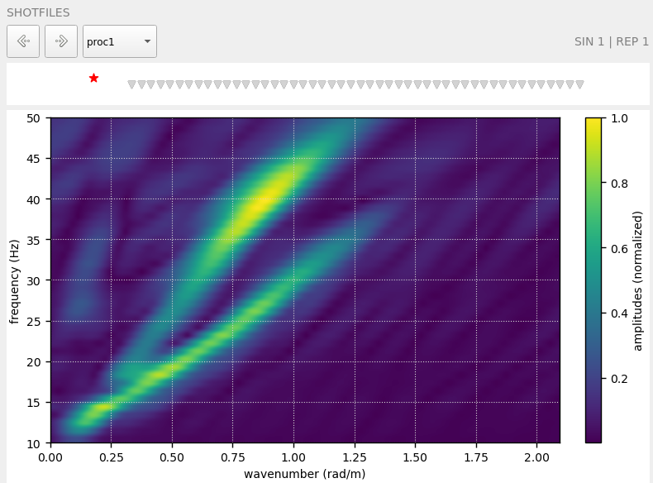

swam.gui_view(attr='FK use_windows = True)

Interactive data viewer

swam.gui_interact(attr='FK')

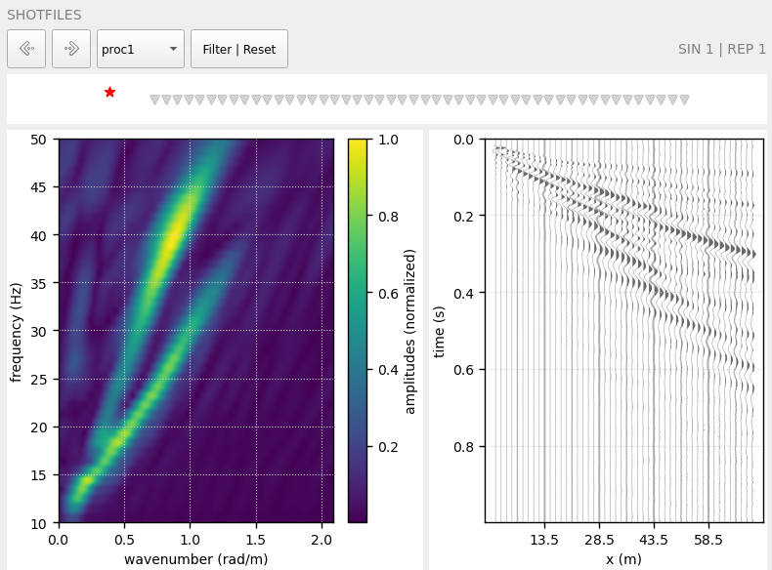

swam.gui_interact(attr='FK', use_windows = True)

4. Database

A database is created when using the manager module, in which data from different processing steps is stored, that can be accessed at later points.
Tables currently stored in the data base are:

- geom
- shots
- recs
- settings
- amps
- par
- pid
- FV
- freq
- pd
- curve

1. Tables defining the survey geometry

Table 3: Table geom
Column | Name | Content | Data type | Description
1 | station_id | Station id | int | Station id
2 | x | x-coordinate | float | Station x coordinate, e.g., given in (m)
3 | y | y-coordinate | float | Station y coordinate, e.g., given in (m)
4 | z | z-coordinate | float | Station z coordinate, e.g., given in (m)
5 | geophone | Geophone flag | int | 1 if a geophone was deployed at station, 0 otherwise
6 | shots | Shot file number(s) | str | The numerical part of the file name, e.g., 1001, if a shot was conducted at this station, −1 otherwise
7 | first_geo | First geophone | int | First active geophone (currently not used, but in later versions relevant for roll-along data)
8 | num_geo | Number of geophones | int | Number of active geophones (−1 if no shot was conducted at the station)

Table 4: Table shots
Column | Name | Content | Data type | Description
1 | station_id | Station id | int
2 | sin | Source location id | int
3 | rep | Shot repetition id | int

Table 5: Table recs
Column | Name | Content | Data type | Description
1 | station_id | Station id | int
2 | rin | Receiver id | int

2. Tables containing seismic data
Table 6: Table amps
Column | Name | Content | Data type | Description
1 | procset | Processing set label | str
2 | sin | Source location id | int
3 | rep | Shot repetition id | int
4 | wid | Window id | int
5 | rin 1 | Processed trace data | float
... | ... | ... | ...
n | rin n | Processed trace data | float

Table 7: Table par
Column | Name | Content | Data type | Description
1 | procset | Processing set label | str
2 | sin | Source location id | int
3 | rep | Shot repetition id | int
4 | wid | Window id | int
5 | npts | Number of samples | int
6 | dt | sampling interval in s | float
7 | delay | pre trigger in s | float
8 | sampling_rate | sampling rate | float

Table 8: Table pid
Column | Name | Content | Data type | Description
1 | procset | Processing set label | str
2 | sin | Source location id | int
3 | rep | Shot repetition id | int
4 | wid | Window id | int
5 | rin | Receiver id | int

Table 9: Table FV
Column | Name | Content | Data type | Description
1 | procset | Processing set label | str
2 | sin | Source location id | int
3 | rep | Shot repetition id | int
4 | wid | Window id | int
5 | method | method | str | Method to calculate the dispersion image
6 | velocity | Testing phase velocity | float
7 | wavenumber | wavenumber | float
8 | f1 | Dispersive energy at frequency 1 | complex
... | ...
n | fn | Dispersive energy at frequency n | complex

Table 10: Table freq
Column | Name | Content | Data type | Description
1 | procset | Processing set label | str
2 | sin | Source location id | int
3 | rep | Shot repetition id | int
4 | wid | Window id | int
5 | method | method | str | Method to calculate the dispersion image
6 | frequency | Frequency | float | Frequency range used to compute the dispersive energy

Table 11: Table pd
Column | Name | Content | Data type | Description
1 | procset | Processing set label | str
2 | sin | Source location id | int
3 | rep | Shot repetition id | int
4 | wid | Window id | int
5 | calc | Aggregate operator | str | Method to create aggregate
6 | fids | Frequency ids | int
7 | frequency | Frequency | float | Frequency range used to compute the dispersive energy
8 | pd1 | Phase difference | float | Phase difference computed between rin1 and rin2
...
n | pdn | Phase difference | float | Phase difference computed between rin n-1 and rinn

Table 12: Table curve
Column | Name | Content | Data type | Description
1 | procset | Processing set label | str
2 | sin | Source location id | int
3 | rep | Shot repetition id | int
4 | wid | Window id | int
5 | xmid | Receiver midpoint | float | Assumed location of the dispersion curve
6 | method | method | str | Method to obtain the dispersion curve
7 | dc_mode | Mode of the dispersion curve | int
8 | frequency | Frequency | float
9 | velocity | Phase velocity | float
10 | error | Dispersion curve absolute error | float

