TITLE of the setup

Short introduction of what to expect from the setup goes here.

Lorem ipsum dolor sit amet, consetetur sadipscing elitr, sed diam nonumy eirmod tempor invidunt ut labore et dolore magna aliquyam erat, sed diam voluptua. At vero eos et accusam et justo duo dolores et ea rebum. Stet clita kasd gubergren, no sea takimata sanctus est Lorem ipsum dolor sit amet. Lorem ipsum dolor sit amet, consetetur sadipscing elitr, sed diam nonumy eirmod tempor invidunt ut labore et dolore magna aliquyam erat, sed diam voluptua. At vero eos et accusam et justo duo dolores et ea rebum. Stet clita kasd gubergren, no sea takimata sanctus est Lorem ipsum dolor sit amet.

Author 1

Author 2

V0; Date

## Table of Content

Table of Content 2

Motivation 3

Goals 3

Outline 3

Prepare the *XXX Setup (Practical Part) 4

Full Setup 4

Bill of Materials 5

Assembly 7

Software Used in this Tutorial 7

Prepare Software to make Software work (Optional) 7

Theoretical Part for the *XXX 8

Introduction 8

Formulas 8

Etc. 8

Experiments 9

Experiment 1 9

Experiment 2 9

Conlcusion 9

Usefull links and Ressources 9

Ressources 9

Links 9

## Motivation

* Why we want to do it?
* What’s the major goal?
* Where can you find this?

Fancy Image can go here! (SRC)

Goals  
At the end you should have learned the following:

* What is light?
* What is diffraction?
* 3D printing with UC2
* Etc.

Outline

Coarse Overview of necessary steps

1. Get the Parts ready
   1. Download
   2. 3D print
   3. Assembly
2. Build a *XXX
3. Do Experiment 1
4. Do Experiment 2
5. Conclusion

# Prepare the *XXX Setup (Practical Part)

Here we want to show the basic system description and how the different parts interact with each other.

## Full Setup

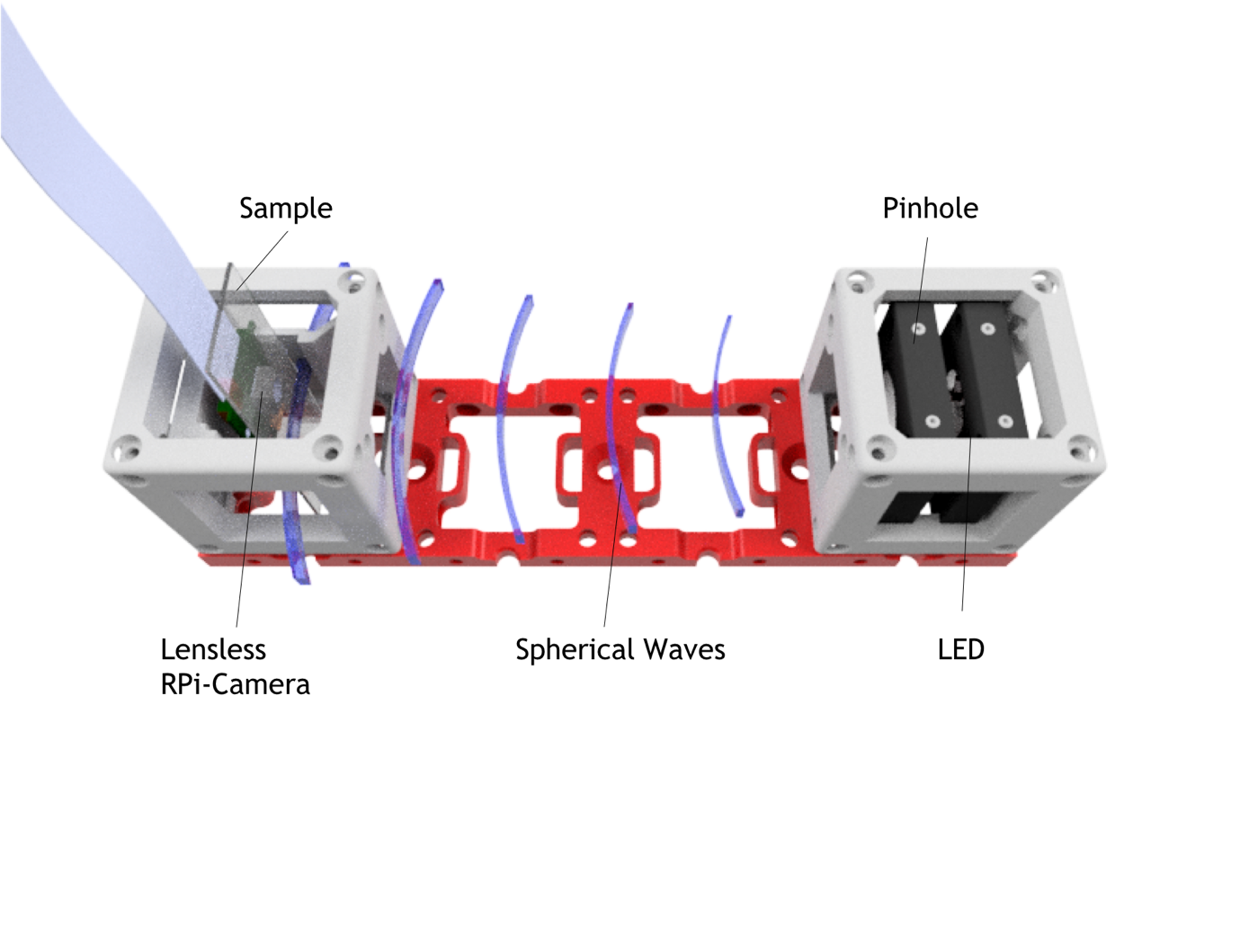

Figure 1 – This is how it should look like once it’s ready.

## Bill of Materials

|  |  |  |  |
| --- | --- | --- | --- |
| Quantity | Description/Name | Image | Price |
| 1 | Grundplatte (1x4)   * <https://github.com/bionanoimaging/UC2-GIT/blob/master/CAD/INLINE_HOLOGRAM/STL/INLINE_HOLOGRAM_00_Base_4x1_v0.stl> |  | 1€ |
| 2 | Cube (2x), 2 Teile   * <https://github.com/bionanoimaging/UC2-GIT/blob/master/CAD/INLINE_HOLOGRAM/STL/INLINE_HOLOGRAM_10_Cube_v0.stl> * <https://github.com/bionanoimaging/UC2-GIT/blob/master/CAD/INLINE_HOLOGRAM/STL/INLINE_HOLOGRAM_10_Lid_el_v0.stl> |  | 1€ |
| 1 | LED (Royal blue, i.e. 1W-3W, Star PCB attached)   * <https://www.amazon.com/Led-World-Extreme-Royal-445-450nm/dp/B00MNB4LJU> |  | 2€ |
| 1 | RPi Camera v2   * <https://shop.pimoroni.de/products/raspberry-pi-camera-module-v2-1-with-mount>   Alternative für Pi Zero:   * <https://shop.pimoroni.de/products/raspberry-pi-zero-camera-module> |  | 15€-33€ |
| 1 | Raspberry Pi V3 + 1SD Micro Card (prebuilt binaries)   * <https://shop.pimoroni.de/products/raspberry-pi-3-b-plus>   Alternativ:  1x Raspberry Pi Zero + 1SD Micro Card (8GB)   * <https://shop.pimoroni.de/products/raspberry-pi-zero-w> | /var/folders/4w/k4yhf14j7xsbp2jd85yk555r0000gn/T/com.microsoft.Word/Content.MSO/45DC5D6D.tmp | 45€  /  15 € |
| 2 | Thorlabs CP02   * <https://www.thorlabs.com/thorproduct.cfm?partnumber=CP02>   Alternative:  Selber drucken |  | 20€ |
| 1 | Netzteil, 5V USB, Raspberry   * <https://www.reichelt.de/usb-ladegeraet-5-v-2500-ma-micro-usb-nt-musb-25-sw-p167078.html?PROVID=2788&gclid=Cj0KCQjw3ebdBRC1ARIsAD8U0V5RBH3hKsPJiLh7Pk8SBP6UYqJqPXgTA_QfsG1lmuD5Y75ie5qSEMIaAiNCEALw_wcB&&r=1> |  | 5€ |
|  | Zusätzliches Material, was ggf. bereits verfügbar ist.   * Alufolie * Alumnium Sheet ca. 30x30 mm, rund? (dickere Aluminium Folie) * Dünne Nadel * Klebestreifen * USB-Stick * Tastatur/Maus |  | 10€ |
| 16 | Kugelmagneten NeoDym, D=6mm   * <https://www.ebay.de/itm/50x-POWER-NEODYM-KUGEL-MAGNET-6-mm-N35-EXPERIMENT-BASTEL-TAFEL/201693302926?hash=item2ef5db908e:g:QgUAAOSwpLNYBJt7> |  | 10€ |
| 16 | Schrauben (DIN 912, M3, 18mm, kein Edelstahl! Müssen magnetisch sein-> Eisen!)   * <https://www.conrad.de/de/toolcraft-839670-zylinderschrauben-m3-12-mm-innensechskant-din-912-iso-4762-stahl-88-geschwaerzt-100-st-839670.html> |  | 1€ |
| 4 | Alu-Stangen (50mmxD6mm)   * <https://www.ebay.de/itm/7960-Alu-Aluminium-Rundstab-6-12mm/321920077077?hash=item4af3ee8d15:m:m6S16XrMjjoQHAna_7z12Ug> |  | 4 € |
| 1 | 100R Widerstand, 1W, oder 4x 400R 0.25W parallel |  | 1 € |
| 1 | (USB) Kabel (defektes Gerät, Schrott), ca. 40cm |  | 1 € |
|  |  |  |  |
|  |  |  |  |
| 1 | Proben: Duschgel mit Glitzereffekt, Mikrokugeln, Epithelzellen |  |  |
| 1 | Probenpräparationskit,  Pipette, Deckgläschen, Objektträger (120x70mm)  <https://www.msg-praxisbedarf.de/MENZEL-Objekttraeger-MIT-Mattrand-50-Stueck.htm?websale8=msg&pi=58150&ref=froogle&subref=MEG101126M&gclid=Cj0KCQjw3ebdBRC1ARIsAD8U0V5Luk5NOQ_5EgCx-r_ZP_9B5Slwe-cPsXAOKK-Mx73bsF8DHiD24gEaArfkEALw_wcB> |  | 5€ |

Assembly

Quick explained Photo-Story to show how the parts belong together.

Lorem ipsum dolor sit amet, consetetur sadipscing elitr, sed diam nonumy eirmod tempor invidunt ut labore et dolore magna aliquyam erat, sed diam voluptua. At vero eos et accusam et justo duo dolores et ea rebum. Stet clita kasd gubergren, no sea takimata sanctus est Lorem ipsum dolor sit amet. Lorem ipsum dolor sit amet, consetetur sadipscing elitr, sed diam nonumy eirmod tempor invidunt ut labore et dolore magna aliquyam erat, sed diam voluptua. At vero eos et accusam et justo duo dolores et ea rebum. Stet clita kasd gubergren, no sea takimata sanctus est Lorem ipsum dolor sit amet.

Software Used in this Tutorial **(Optional)**

* Fiji (<https://imagej.net/Fiji/Downloads>)
* Anaconda Python (3.6) ( <https://www.anaconda.com/download>)
* Cura (<https://ultimaker.com/en/products/ultimaker-cura-software>)
* Tinkercad.com

## Prepare Software to make Software work (Optional)

* Download Pi-Image
* Flash Pi-Image
* Connect Pi to Wifi

# Theoretical Part for the *XXX

Introduction

Lorem ipsum dolor sit amet, consetetur sadipscing elitr, sed diam nonumy eirmod tempor invidunt ut labore et dolore magna aliquyam erat, sed diam voluptua. At vero eos et accusam et justo duo dolores et ea rebum. Stet clita kasd gubergren, no sea takimata sanctus est Lorem ipsum dolor sit amet. Lorem ipsum dolor sit amet, consetetur sadipscing elitr, sed diam nonumy eirmod tempor invidunt ut labore et dolore magna aliquyam erat, sed diam voluptua. At vero eos et accusam et justo duo dolores et ea rebum. Stet clita kasd gubergren, no sea takimata sanctus est Lorem ipsum dolor sit amet.

Formulas

Lorem ipsum dolor sit amet, consetetur sadipscing elitr, sed diam nonumy eirmod tempor invidunt ut labore et dolore magna aliquyam erat, sed diam voluptua. At vero eos et accusam et justo duo dolores et ea rebum. Stet clita kasd gubergren, no sea takimata sanctus est Lorem ipsum dolor sit amet. Lorem ipsum dolor sit amet, consetetur sadipscing elitr, sed diam nonumy eirmod tempor invidunt ut labore et dolore magna aliquyam erat, sed diam voluptua. At vero eos et accusam et justo duo dolores et ea rebum. Stet clita kasd gubergren, no sea takimata sanctus est Lorem ipsum dolor sit amet.

Lorem ipsum dolor sit amet, consetetur sadipscing elitr, sed diam nonumy eirmod tempor invidunt ut labore et dolore magna aliquyam erat, sed diam voluptua. At vero eos et accusam et justo duo dolores et ea rebum. Stet clita kasd gubergren, no sea takimata sanctus est Lorem ipsum dolor sit amet. Lorem ipsum dolor sit amet, consetetur sadipscing elitr, sed diam nonumy eirmod tempor invidunt ut labore et dolore magna aliquyam erat, sed diam voluptua. At vero eos et accusam et justo duo dolores et ea rebum. Stet clita kasd gubergren, no sea takimata sanctus est Lorem ipsum dolor sit amet.

Etc.

Lorem ipsum dolor sit amet, consetetur sadipscing elitr, sed diam nonumy eirmod tempor invidunt ut labore et dolore magna aliquyam erat, sed diam voluptua. At vero eos et accusam et justo duo dolores et ea rebum. Stet clita kasd gubergren, no sea takimata sanctus est Lorem ipsum dolor sit amet. Lorem ipsum dolor sit amet, consetetur sadipscing elitr, sed diam nonumy eirmod tempor invidunt ut labore et dolore magna aliquyam erat, sed diam voluptua. At vero eos et accusam et justo duo dolores et ea rebum. Stet clita kasd gubergren, no sea takimata sanctus est Lorem ipsum dolor sit amet.

# Experiments

Experiment 1

What to do?

What do you observe?

What do you expect?

Why?

Experiment 2

# Conlcusion

Lorem ipsum dolor sit amet, consetetur sadipscing elitr, sed diam nonumy eirmod tempor invidunt ut labore et dolore magna aliquyam erat, sed diam voluptua. At vero eos et accusam et justo duo dolores et ea rebum. Stet clita kasd gubergren, no sea takimata sanctus est Lorem ipsum dolor sit amet. Lorem ipsum dolor sit amet, consetetur sadipscing elitr, sed diam nonumy eirmod tempor invidunt ut labore et dolore magna aliquyam erat, sed diam voluptua. At vero eos et accusam et justo duo dolores et ea rebum. Stet clita kasd gubergren, no sea takimata sanctus est Lorem ipsum dolor sit amet.

# Usefull links and Ressources

## Ressources

## Links

* <https://www.jpl.nasa.gov/edu/learn/project/how-to-make-a-pinhole-camera/>
* <http://pinholemoustache.com/wp-content/uploads/2015/09/2c-cu-acul-cu-grija-stenopa.jpg>