Raspberry Pi

Components / Resources

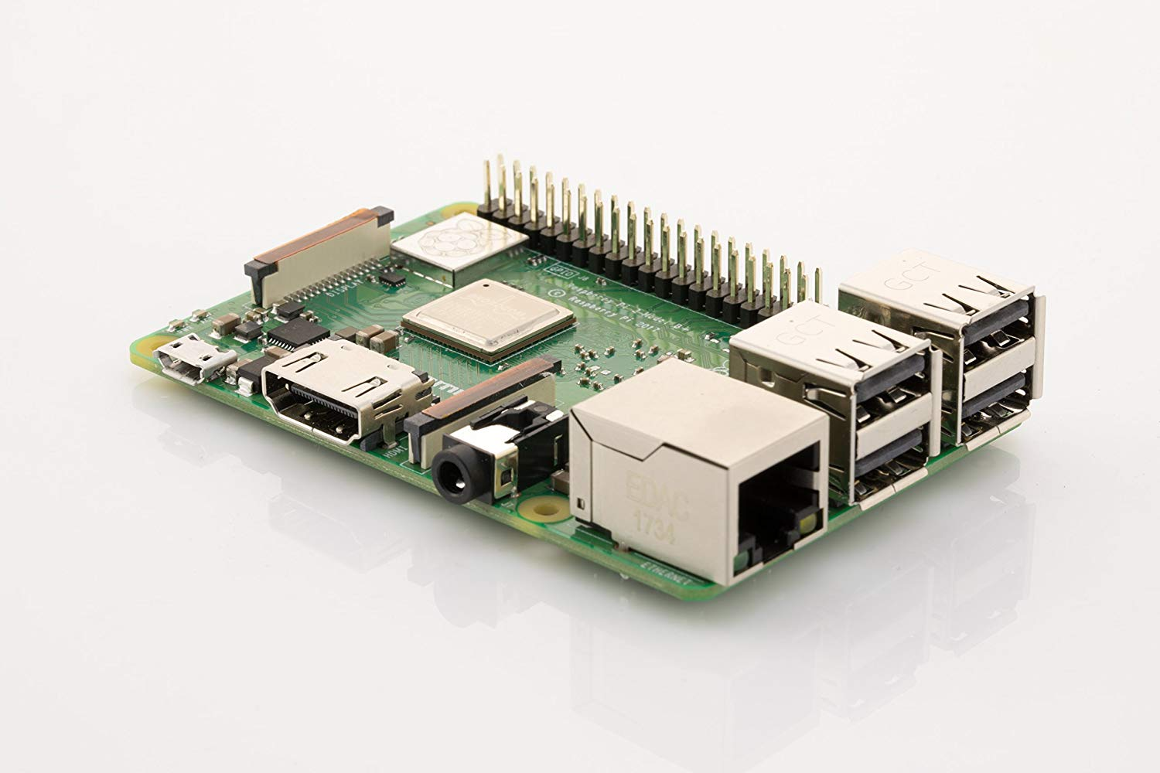

<https://www.amazon.de/Raspberry-1373331-Pi-Modell-Mainboard/dp/B07BDR5PDW/ref=sr_1_1?ie=UTF8&qid=1534931804&sr=8-1&keywords=Raspberry+Pi>

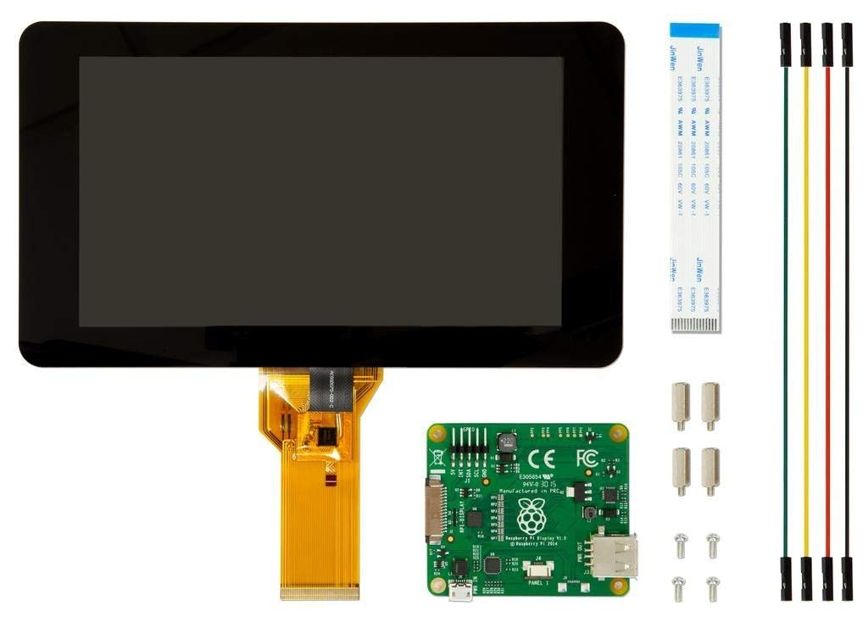

<https://www.amazon.de/Raspberry-Pi-7-inch-Screen-Display/dp/B014WKCFR4/ref=sr_1_3?ie=UTF8&qid=1534934546&sr=8-3&keywords=Raspberry+Pi+7+inch>

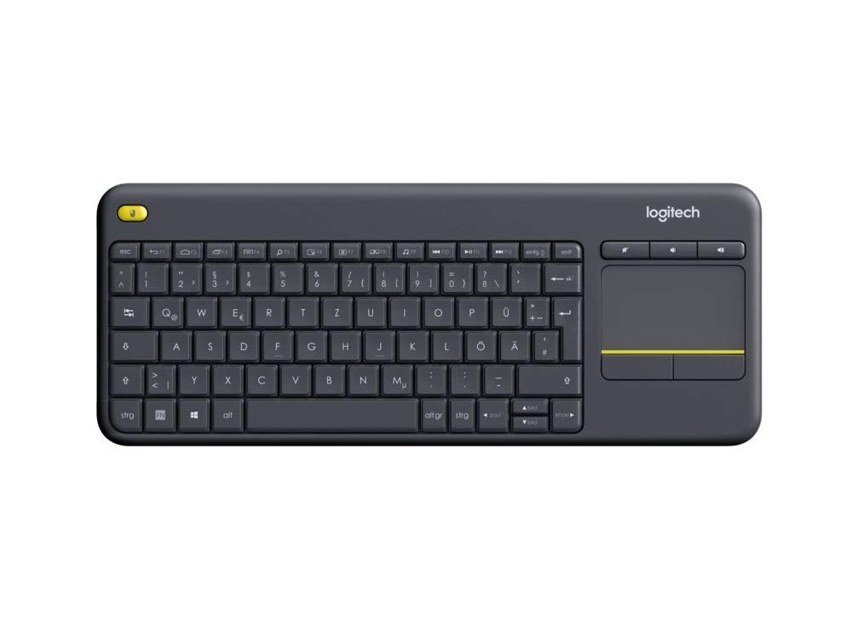

<https://www.amazon.de/Logitech-Wireless-Tastatur-Deutsches-Tastaturlayout/dp/B00VHHWNMI/ref=sr_1_3?ie=UTF8&qid=1534934623&sr=8-3&keywords=logitech+tastatur+touch>

Assembly

Soldering

How-to setup the Raspberry Pi

Software download