Víctor G. Mengual y Alba Correal

04/04/2022

MEMORIA DE LA PRÁCTICA

ELECTRÓNICA DIGITAL. 2º GIERM

PRÁCTICA 2A

DISEÑO DE UN CONTADOR DE VOTOS

Contenido

1. Cuenta Votos 2

1.1 Sumar entradas bit a bit 2

1.2 Obtener SVF(2:0) y SVC(2:0) 2

2. Visualiza Cuenta 4

2.1 Letras F y C 4

2.2 Números SVF(2:0) y SVC(2:0) 4

3 Resultado de Votación 6

4 Vinculación de bloques. 7

DISEÑO DE UN CONTADOR DE VOTOS

Desglosamos la implementación de cada función y su bloque.

# Cuenta Votos

Debemos diseñar un bloque que sume bit a bit las entradas de los interruptores de la FPGA.

## Sumar entradas bit a bit

|  |  |  |  |  |  |  |
| --- | --- | --- | --- | --- | --- | --- |
| Cnt(4:0) | | | | | SST_BY(1,3,5,7) | SST_BY(0,2,3,4) |
| 0 | 0 | 0 | 0 | 0 | 0 | 1 |
| 0 | 0 | 0 | 0 | 1 | 1 | 0 |
| 0 | 0 | 0 | 1 | 0 | 0 | 1 |
| 0 | 0 | 0 | 1 | 1 | 1 | 0 |
| 0 | 0 | 1 | 0 | 0 | 0 | 1 |
| 0 | 0 | 1 | 0 | 1 | 1 | 0 |
| 0 | 0 | 1 | 1 | 0 | 0 | 1 |
| 0 | 0 | 1 | 1 | 1 | 1 | 0 |
| 0 | 1 | 0 | 0 | 0 | 0 | 1 |
| 0 | 1 | 0 | 0 | 1 | 1 | 0 |
| 0 | 1 | 0 | 1 | 0 | 0 | 1 |
| 0 | 1 | 0 | 1 | 1 | 1 | 0 |
| 0 | 1 | 1 | 0 | 0 | 0 | 1 |
| 0 | 1 | 1 | 0 | 1 | 1 | 0 |
| 0 | 1 | 1 | 1 | 0 | 0 | 1 |
| 0 | 1 | 1 | 1 | 1 | 1 | 0 |
| 1 | 0 | 0 | 0 | 0 | 0 | 1 |
| 1 | 0 | 0 | 0 | 1 | 1 | 0 |
| 1 | 0 | 0 | 1 | 0 | 0 | 1 |
| 1 | 0 | 0 | 1 | 1 | 1 | 0 |
| 1 | 0 | 1 | 0 | 0 | 0 | 1 |
| 1 | 0 | 1 | 0 | 1 | 1 | 0 |
| 1 | 0 | 1 | 1 | 0 | 0 | 1 |
| 1 | 0 | 1 | 1 | 1 | 1 | 0 |
| 1 | 1 | 0 | 0 | 0 | 0 | 1 |
| 1 | 1 | 0 | 0 | 1 | 1 | 0 |
| 1 | 1 | 0 | 1 | 0 | 0 | 1 |
| 1 | 1 | 0 | 1 | 1 | 1 | 0 |
| 1 | 1 | 1 | 0 | 0 | 0 | 1 |
| 1 | 1 | 1 | 0 | 1 | 1 | 0 |
| 1 | 1 | 1 | 1 | 0 | 0 | 1 |
| 1 | 1 | 1 | 1 | 1 | 1 | 0 |

|  |  |  |  |  |  |
| --- | --- | --- | --- | --- | --- |
| Cnt(4:0) | | | | | S0S_MC0D |
| 0 | 0 | 0 | 0 | 0 | 1 |
| 0 | 0 | 0 | 0 | 1 | 0 |
| 0 | 0 | 0 | 1 | 0 | 1 |
| 0 | 0 | 0 | 1 | 1 | 0 |
| 0 | 0 | 1 | 0 | 0 | 1 |
| 0 | 0 | 1 | 0 | 1 | 0 |
| 0 | 0 | 1 | 1 | 0 | 1 |
| 0 | 0 | 1 | 1 | 1 | 1 |
| 0 | 1 | 0 | 0 | 0 | 1 |
| 0 | 1 | 0 | 0 | 1 | 0 |
| 0 | 1 | 0 | 1 | 0 | 1 |
| 0 | 1 | 0 | 1 | 1 | 1 |
| 0 | 1 | 1 | 0 | 0 | 1 |
| 0 | 1 | 1 | 0 | 1 | 0 |
| 0 | 1 | 1 | 1 | 0 | 1 |
| 0 | 1 | 1 | 1 | 1 | 1 |
| 1 | 0 | 0 | 0 | 0 | 1 |
| 1 | 0 | 0 | 0 | 1 | 0 |
| 1 | 0 | 0 | 1 | 0 | 1 |
| 1 | 0 | 0 | 1 | 1 | 0 |
| 1 | 0 | 1 | 0 | 0 | 1 |
| 1 | 0 | 1 | 0 | 1 | 0 |
| 1 | 0 | 1 | 1 | 0 | 1 |
| 1 | 0 | 1 | 1 | 1 | 0 |
| 1 | 1 | 0 | 0 | 0 | 0 |
| 1 | 1 | 0 | 0 | 1 | 0 |
| 1 | 1 | 0 | 1 | 0 | 0 |
| 1 | 1 | 0 | 1 | 1 | 0 |
| 1 | 1 | 1 | 0 | 0 | 0 |
| 1 | 1 | 1 | 0 | 1 | 0 |
| 1 | 1 | 1 | 1 | 0 | 0 |
| 1 | 1 | 1 | 1 | 1 | 0 |

|  |  |  |  |  |  |  |  |  |
| --- | --- | --- | --- | --- | --- | --- | --- | --- |
| ab\cde | 000 | 001 | 011 | 010 | 110 | 111 | 101 | 100 |
| 00 | 1 | 0 | 0 | 1 | 1 | 1 | 0 | 1 |
| 01 | 1 | 0 | 1 | 1 | 1 | 1 | 0 | 1 |
| 11 | 0 | 0 | 0 | 0 | 0 | 0 | 0 | 0 |
| 10 | 1 | 0 | 0 | 1 | 1 | 0 | 0 | 1 |

|  |  |  |  |  |  |  |  |  |  |  |  |  |
| --- | --- | --- | --- | --- | --- | --- | --- | --- | --- | --- | --- | --- |
| Cnt(4:0) | | | | | Sh_r(7:0) | | | | | | | |
| 0 | 0 | 0 | 0 | 0 | 0 | 0 | 0 | 0 | 1 | 0 | 0 | 0 |
| 0 | 0 | 0 | 0 | 1 | 0 | 0 | 0 | 0 | 0 | 1 | 0 | 0 |
| 0 | 0 | 0 | 1 | 0 | 0 | 0 | 0 | 0 | 0 | 0 | 1 | 0 |
| 0 | 0 | 0 | 1 | 1 | 0 | 0 | 0 | 0 | 0 | 0 | 0 | 1 |
| 0 | 0 | 1 | 0 | 0 | 0 | 0 | 0 | 0 | 1 | 1 | 1 | 1 |
| 0 | 0 | 1 | 0 | 1 | 0 | 0 | 0 | 0 | 0 | 0 | 0 | 0 |
| 0 | 0 | 1 | 1 | 0 | 0 | 0 | 0 | 0 | 1 | 1 | 1 | 1 |
| 0 | 0 | 1 | 1 | 1 | 0 | 0 | 0 | 0 | 0 | 0 | 0 | 0 |
| 0 | 1 | 0 | 0 | 0 | 0 | 0 | 0 | 0 | 1 | 0 | 0 | 0 |
| 0 | 1 | 0 | 0 | 1 | 0 | 0 | 0 | 0 | 0 | 1 | 0 | 0 |
| 0 | 1 | 0 | 1 | 0 | 0 | 0 | 0 | 0 | 0 | 0 | 1 | 0 |
| 0 | 1 | 0 | 1 | 1 | 0 | 0 | 0 | 0 | 0 | 0 | 0 | 1 |
| 0 | 1 | 1 | 0 | 0 | 0 | 0 | 0 | 0 | 1 | 1 | 1 | 1 |
| 0 | 1 | 1 | 0 | 1 | 0 | 0 | 0 | 0 | 0 | 0 | 0 | 0 |
| 0 | 1 | 1 | 1 | 0 | 0 | 0 | 0 | 0 | 1 | 1 | 1 | 1 |
| 0 | 1 | 1 | 1 | 1 | 0 | 0 | 0 | 0 | 0 | 0 | 0 | 0 |
| 1 | 0 | 0 | 0 | 0 | 0 | 0 | 0 | 0 | 1 | 0 | 0 | 0 |
| 1 | 0 | 0 | 0 | 1 | 0 | 0 | 0 | 0 | 0 | 1 | 0 | 0 |
| 1 | 0 | 0 | 1 | 0 | 0 | 0 | 0 | 0 | 0 | 0 | 1 | 0 |
| 1 | 0 | 0 | 1 | 1 | 0 | 0 | 0 | 0 | 0 | 0 | 0 | 1 |
| 1 | 0 | 1 | 0 | 0 | 0 | 0 | 0 | 0 | 1 | 1 | 1 | 1 |
| 1 | 0 | 1 | 0 | 1 | 0 | 0 | 0 | 0 | 0 | 0 | 0 | 0 |
| 1 | 0 | 1 | 1 | 0 | 0 | 0 | 0 | 0 | 1 | 1 | 1 | 1 |
| 1 | 0 | 1 | 1 | 1 | 0 | 0 | 0 | 0 | 0 | 0 | 0 | 0 |
| 1 | 1 | 0 | 0 | 0 | 0 | 0 | 0 | 0 | 1 | 0 | 0 | 0 |
| 1 | 1 | 0 | 0 | 1 | 0 | 0 | 0 | 0 | 0 | 1 | 0 | 0 |
| 1 | 1 | 0 | 1 | 0 | 0 | 0 | 0 | 0 | 0 | 0 | 1 | 0 |
| 1 | 1 | 0 | 1 | 1 | 0 | 0 | 0 | 0 | 0 | 0 | 0 | 1 |
| 1 | 1 | 1 | 0 | 0 | 0 | 0 | 0 | 0 | 1 | 1 | 1 | 1 |
| 1 | 1 | 1 | 0 | 1 | 0 | 0 | 0 | 0 | 0 | 0 | 0 | 0 |
| 1 | 1 | 1 | 1 | 0 | 0 | 0 | 0 | 0 | 1 | 1 | 1 | 1 |
| 1 | 1 | 1 | 1 | 1 | 0 | 0 | 0 | 0 | 0 | 0 | 0 | 0 |

Como es un bucle, bastará con usar las 3 entradas menos significativas.

|  |  |  |  |  |  |  |  |  |  |  |  |  |
| --- | --- | --- | --- | --- | --- | --- | --- | --- | --- | --- | --- | --- |
| Cnt(4:0) | | | | | Sh_r(7:0) | | | | | | | |
| X | X | 0 | 0 | 0 | 0 | 0 | 0 | 0 | 1 | 0 | 0 | 0 |
| X | X | 0 | 0 | 1 | 0 | 0 | 0 | 0 | 0 | 1 | 0 | 0 |
| X | X | 0 | 1 | 0 | 0 | 0 | 0 | 0 | 0 | 0 | 1 | 0 |
| X | X | 0 | 1 | 1 | 0 | 0 | 0 | 0 | 0 | 0 | 0 | 1 |
| X | X | 1 | 0 | 0 | 0 | 0 | 0 | 0 | 1 | 1 | 1 | 1 |
| X | X | 1 | 0 | 1 | 0 | 0 | 0 | 0 | 0 | 0 | 0 | 0 |
| X | X | 1 | 1 | 0 | 0 | 0 | 0 | 0 | 1 | 1 | 1 | 1 |
| X | X | 1 | 1 | 1 | 0 | 0 | 0 | 0 | 0 | 0 | 0 | 0 |

|  |  |  |  |  |
| --- | --- | --- | --- | --- |
| a\bc | 00 | 01 | 11 | 10 |
| 0 | 0 | 0 | 1 | 0 |
| 1 | 1 | 0 | 0 | 1 |

|  |  |  |  |  |
| --- | --- | --- | --- | --- |
| a\bc | 00 | 01 | 11 | 10 |
| 0 | 0 | 0 | 0 | 1 |
| 1 | 1 | 0 | 0 | 1 |

|  |  |  |  |  |
| --- | --- | --- | --- | --- |
| a\bc | 00 | 01 | 11 | 10 |
| 0 | 0 | 1 | 0 | 0 |
| 1 | 1 | 0 | 0 | 1 |

|  |  |  |  |  |
| --- | --- | --- | --- | --- |
| a\bc | 00 | 01 | 11 | 10 |
| 0 | 1 | 0 | 0 | 0 |
| 1 | 1 | 0 | 0 | 1 |

|  |  |  |  |  |  |  |  |  |  |  |  |  |
| --- | --- | --- | --- | --- | --- | --- | --- | --- | --- | --- | --- | --- |
| Cnt(4:0) | | | | | Sh_l(7:0) | | | | | | | |
| 0 | 0 | 0 | 0 | 0 | 0 | 0 | 0 | 1 | 0 | 0 | 0 | 0 |
| 0 | 0 | 0 | 0 | 1 | 0 | 0 | 1 | 0 | 0 | 0 | 0 | 0 |
| 0 | 0 | 0 | 1 | 0 | 0 | 1 | 0 | 0 | 0 | 0 | 0 | 0 |
| 0 | 0 | 0 | 1 | 1 | 1 | 0 | 0 | 0 | 0 | 0 | 0 | 0 |
| 0 | 0 | 1 | 0 | 0 | 1 | 1 | 1 | 1 | 0 | 0 | 0 | 0 |
| 0 | 0 | 1 | 0 | 1 | 0 | 0 | 0 | 0 | 0 | 0 | 0 | 0 |
| 0 | 0 | 1 | 1 | 0 | 1 | 1 | 1 | 1 | 0 | 0 | 0 | 0 |
| 0 | 0 | 1 | 1 | 1 | 0 | 0 | 0 | 0 | 0 | 0 | 0 | 0 |
| 0 | 1 | 0 | 0 | 0 | 0 | 0 | 0 | 1 | 0 | 0 | 0 | 0 |
| 0 | 1 | 0 | 0 | 1 | 0 | 0 | 1 | 0 | 0 | 0 | 0 | 0 |
| 0 | 1 | 0 | 1 | 0 | 0 | 1 | 0 | 0 | 0 | 0 | 0 | 0 |
| 0 | 1 | 0 | 1 | 1 | 1 | 0 | 0 | 0 | 0 | 0 | 0 | 0 |
| 0 | 1 | 1 | 0 | 0 | 1 | 1 | 1 | 1 | 0 | 0 | 0 | 0 |
| 0 | 1 | 1 | 0 | 1 | 0 | 0 | 0 | 0 | 0 | 0 | 0 | 0 |
| 0 | 1 | 1 | 1 | 0 | 1 | 1 | 1 | 1 | 0 | 0 | 0 | 0 |
| 0 | 1 | 1 | 1 | 1 | 0 | 0 | 0 | 0 | 0 | 0 | 0 | 0 |
| 1 | 0 | 0 | 0 | 0 | 0 | 0 | 0 | 1 | 0 | 0 | 0 | 0 |
| 1 | 0 | 0 | 0 | 1 | 0 | 0 | 1 | 0 | 0 | 0 | 0 | 0 |
| 1 | 0 | 0 | 1 | 0 | 0 | 1 | 0 | 0 | 0 | 0 | 0 | 0 |
| 1 | 0 | 0 | 1 | 1 | 1 | 0 | 0 | 0 | 0 | 0 | 0 | 0 |
| 1 | 0 | 1 | 0 | 0 | 1 | 1 | 1 | 1 | 0 | 0 | 0 | 0 |
| 1 | 0 | 1 | 0 | 1 | 0 | 0 | 0 | 0 | 0 | 0 | 0 | 0 |
| 1 | 0 | 1 | 1 | 0 | 1 | 1 | 1 | 1 | 0 | 0 | 0 | 0 |
| 1 | 0 | 1 | 1 | 1 | 0 | 0 | 0 | 0 | 0 | 0 | 0 | 0 |
| 1 | 1 | 0 | 0 | 0 | 0 | 0 | 0 | 1 | 0 | 0 | 0 | 0 |
| 1 | 1 | 0 | 0 | 1 | 0 | 0 | 1 | 0 | 0 | 0 | 0 | 0 |
| 1 | 1 | 0 | 1 | 0 | 0 | 1 | 0 | 0 | 0 | 0 | 0 | 0 |
| 1 | 1 | 0 | 1 | 1 | 1 | 0 | 0 | 0 | 0 | 0 | 0 | 0 |
| 1 | 1 | 1 | 0 | 0 | 1 | 1 | 1 | 1 | 0 | 0 | 0 | 0 |
| 1 | 1 | 1 | 0 | 1 | 0 | 0 | 0 | 0 | 0 | 0 | 0 | 0 |
| 1 | 1 | 1 | 1 | 0 | 1 | 1 | 1 | 1 | 0 | 0 | 0 | 0 |
| 1 | 1 | 1 | 1 | 1 | 0 | 0 | 0 | 0 | 0 | 0 | 0 | 0 |

|  |  |  |  |  |  |  |  |  |  |  |  |  |
| --- | --- | --- | --- | --- | --- | --- | --- | --- | --- | --- | --- | --- |
| Cnt(4:0) | | | | | Sh_l(7:0) | | | | | | | |
| X | X | 0 | 0 | 0 | 0 | 0 | 0 | 1 | 0 | 0 | 0 | 0 |
| X | X | 0 | 0 | 1 | 0 | 0 | 1 | 0 | 0 | 0 | 0 | 0 |
| X | X | 0 | 1 | 0 | 0 | 1 | 0 | 0 | 0 | 0 | 0 | 0 |
| X | X | 0 | 1 | 1 | 1 | 0 | 0 | 0 | 0 | 0 | 0 | 0 |
| X | X | 1 | 0 | 0 | 1 | 1 | 1 | 1 | 0 | 0 | 0 | 0 |
| X | X | 1 | 0 | 1 | 0 | 0 | 0 | 0 | 0 | 0 | 0 | 0 |
| X | X | 1 | 1 | 0 | 1 | 1 | 1 | 1 | 0 | 0 | 0 | 0 |
| X | X | 1 | 1 | 1 | 0 | 0 | 0 | 0 | 0 | 0 | 0 | 0 |

|  |  |  |  |  |
| --- | --- | --- | --- | --- |
| a\bc | 00 | 01 | 11 | 10 |
| 0 | 1 | 0 | 0 | 0 |
| 1 | 1 | 0 | 0 | 1 |

|  |  |  |  |  |
| --- | --- | --- | --- | --- |
| a\bc | 00 | 01 | 11 | 10 |
| 0 | 0 | 1 | 0 | 0 |
| 1 | 1 | 0 | 0 | 1 |

|  |  |  |  |  |
| --- | --- | --- | --- | --- |
| a\bc | 00 | 01 | 11 | 10 |
| 0 | 0 | 0 | 0 | 1 |
| 1 | 1 | 0 | 0 | 1 |

|  |  |  |  |  |
| --- | --- | --- | --- | --- |
| a\bc | 00 | 01 | 11 | 10 |
| 0 | 0 | 0 | 1 | 0 |
| 1 | 1 | 0 | 0 | 1 |

## 1.2 Obtener SVF(2:0) y SVC(2:0)

En la siguiente etapa, podemos configurar un sumador de números de 2 bits, para que se deduzca un único número binario de las dos sumas previas. Hemos implementado la arquitectura Ripple-Carry. Solo falta añadir el séptimo bit, para lo que bastará con conectarlo al de la primera puerta. Tras esto, habremos hallado SVF(2:0)

Por último, para obtener el número de votos en contra, habría que restar dicho número a 7. Sin embargo, como este número es el complemento a 7 del anterior, solo requiere que invirtamos las salidas de nuestro sumador, y las conectemos al otro bus, SVC(2:0).

El Testbench del circuito muestra la salida:

# Visualiza Cuenta

En este bloque, debemos mostrar en los displays el número de votos a favor y en contra que hemos obtenido en 1. Tenemos dos tipos de configuración de los 7-segmentos, una donde mostramos una letra fija y otra donde mostramos números que cambian en cada votación. Analicemos por separado cada una de estas situaciones.

## Letras F y C

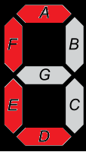Para las letras simplemente veremos qué valores necesitamos en el display.

|  |  |  |  |  |  |  |  |
| --- | --- | --- | --- | --- | --- | --- | --- |
| F | A | B | C | D | E | F | G |
|  | 1 | 0 | 0 | 0 | 1 | 1 | 1 |

|  |  |  |  |  |  |  |  |
| --- | --- | --- | --- | --- | --- | --- | --- |
| C | A | B | C | D | E | F | G |
|  | 1 | 0 | 0 | 1 | 1 | 1 | 0 |

Simplemente bastará con ramificar un bus conectado a la alimentación entre los distintos segmentos del display.

(Nota: los cables, de izda. a dcha. son VVal, VCC(7:0) y GND(7:0)).

## Números SVF(2:0) y SVC(2:0)

En este caso, reutilizaremos el conversor BCD-7 Segmentos de la práctica 0. Las tablas de verdad de cada uno de los displays son:

|  |  |  |  |  |  |  |  |
| --- | --- | --- | --- | --- | --- | --- | --- |
| SVF(2:0) | A | B | C | D | E | F | G |
| 000 | 1 | 1 | 1 | 1 | 1 | 1 | 0 |
| 001 | 0 | 1 | 1 | 0 | 0 | 0 | 0 |
| 010 | 1 | 1 | 0 | 1 | 1 | 0 | 1 |
| 011 | 1 | 1 | 1 | 1 | 0 | 0 | 1 |
| 100 | 0 | 1 | 1 | 0 | 0 | 1 | 1 |
| 101 | 1 | 0 | 1 | 1 | 0 | 1 | 1 |
| 110 | 1 | 0 | 1 | 1 | 1 | 1 | 1 |
| 111 | 1 | 1 | 1 | 0 | 0 | 0 | 0 |

|  |  |  |  |  |  |  |  |
| --- | --- | --- | --- | --- | --- | --- | --- |
| SVC(2:0) | A | B | C | D | E | F | G |
| 000 | 1 | 1 | 1 | 1 | 1 | 1 | 0 |
| 001 | 0 | 1 | 1 | 0 | 0 | 0 | 0 |
| 010 | 1 | 1 | 0 | 1 | 1 | 0 | 1 |
| 011 | 1 | 1 | 1 | 1 | 0 | 0 | 1 |
| 100 | 0 | 1 | 1 | 0 | 0 | 1 | 1 |
| 101 | 1 | 0 | 1 | 1 | 0 | 1 | 1 |
| 110 | 1 | 0 | 1 | 1 | 1 | 1 | 1 |
| 111 | 1 | 1 | 1 | 0 | 0 | 0 | 0 |

En total, el bloque quedaría:

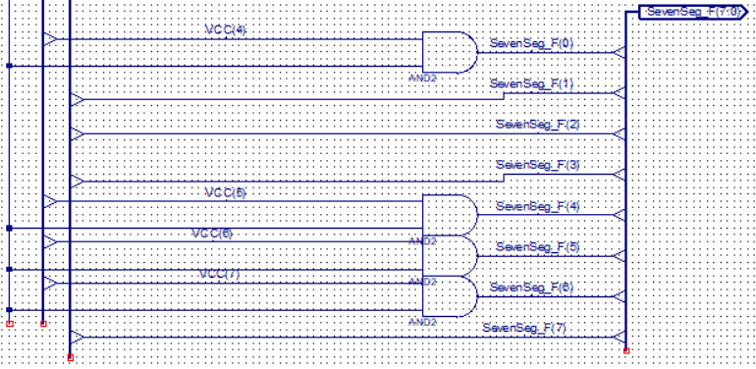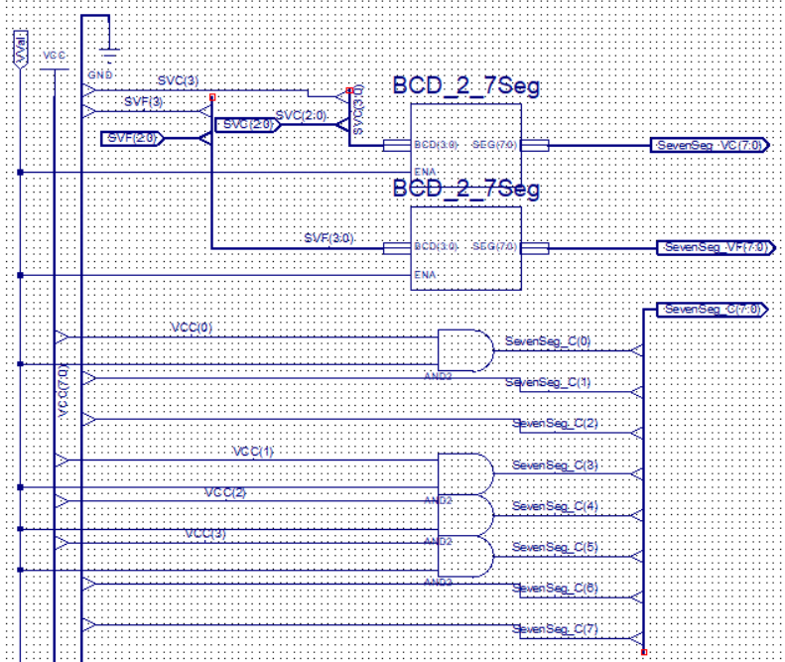

# Resultado de Votación

|  |  |  |  |  |  |  |
| --- | --- | --- | --- | --- | --- | --- |
| E | A | B | C | VF | NA | VC |
| 0 | X | X | X | 0 | 0 | 0 |
| 1 | 0 | 0 | 0 | 0 | 0 | 1 |
| 1 | 0 | 0 | 1 | 0 | 0 | 1 |
| 1 | 0 | 1 | 0 | 0 | 0 | 1 |
| 1 | 0 | 1 | 1 | 0 | 1 | 0 |
| 1 | 1 | 0 | 0 | 0 | 1 | 0 |
| 1 | 1 | 0 | 1 | 1 | 0 | 0 |
| 1 | 1 | 1 | 0 | 1 | 0 | 0 |
| 1 | 1 | 1 | 1 | 1 | 0 | 0 |

Este bloque consiste en definir si la votación es concluyente o no en función del número de votos obtenido en 1 (SVF(2:0)). En nuestro caso, la votación será a favor (VF) a partir de 5/7, en contra (VC) por debajo de 2/7 y no apta (NA) en el resto de casos. Comenzamos construyendo la tabla de verdad de este sistema

Resolvemos el mapa de Karnaugh, para el que obtenemos una salida de:

* para VF
* para NA
* para VC

De este modo, el circuito asociado quedará de la forma:

Cada uno de estos hilos se enviará a los leds de la FPGA. VF se conectará a los 3 últimos, NA a los 2 centrales y VC a los 3 iniciales. Se adjunta la imagen del Testbench:

# Vinculación de bloques.

Unimos todos los bloques en uno único que introduciremos en la FPGA. Visualmente: