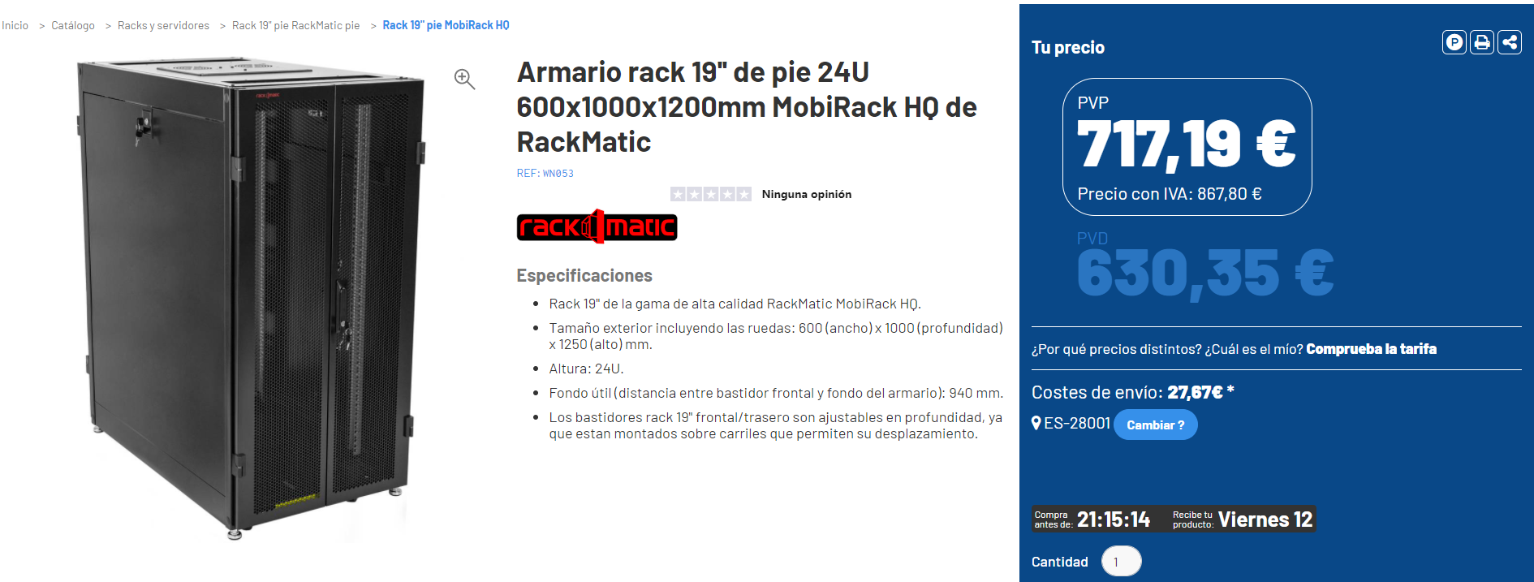

<https://cablematic.com/es/productos/armario-rack-19-de-pie-24u-600x1000x1200mm-mobirack-hq-de-rackmatic-WN053/>

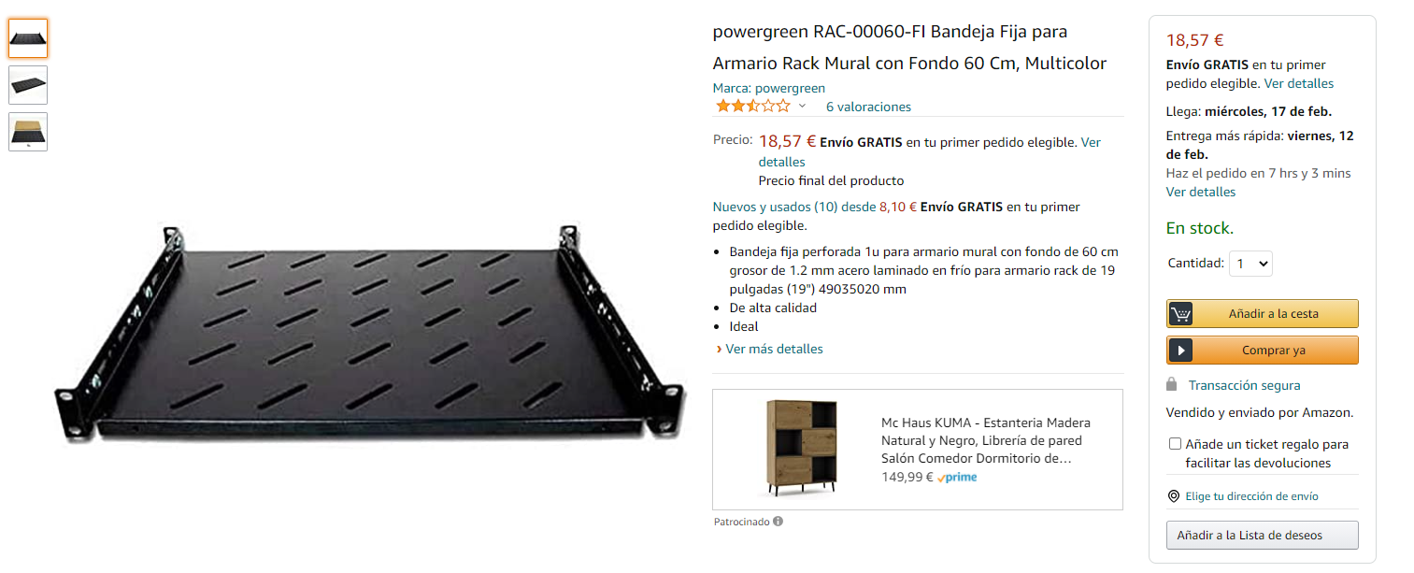

<https://www.amazon.es/BANDEJA-FIJA-PARA-ARMARIO-FONDO/dp/B01AIQXIRM/ref=pd_sbs_5?pd_rd_w=Bx9Zz&pf_rd_p=997f34d9-3657-4c72-af1b-a507fc273b3b&pf_rd_r=3CG4TA1MFSZZ1SGSS4N3&pd_rd_r=9c323ef1-304e-4330-a823-7446140d383c&pd_rd_wg=xNPAC&pd_rd_i=B01AIQXIRM&psc=1>

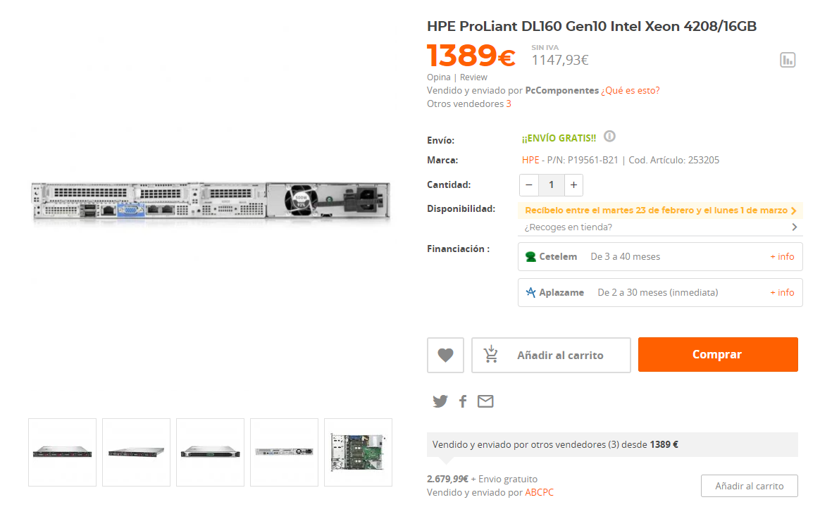

<https://www.pccomponentes.com/hpe-proliant-dl160-gen10-intel-xeon-4208-16gb>

Precio:

Armario Rack Cablematic--------------- (IVA desgravado)------------- 658,02€

Bandeja fija powergreen------------- 18,57€ x 24 módulos----------- 445,68€

HPE ProLiantDL160----------- 8 modulos (ampliables a futuro)------ 11.112€

Total 12.215,70€

\*Las bandejas extra sin usar están con la finaliad de ampliar el cpd a futuro