**Basic Network Configuration with Cisco Packet Tracer**

**Topology:**

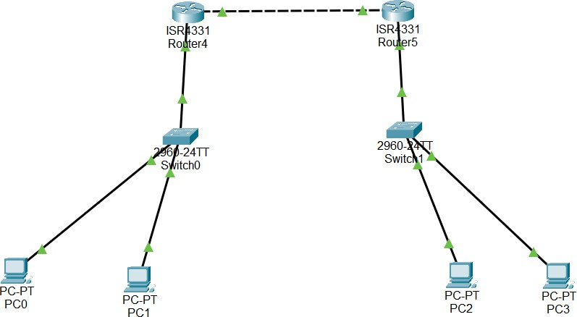

Fig 1. Topology of network

**Initial Setup:**

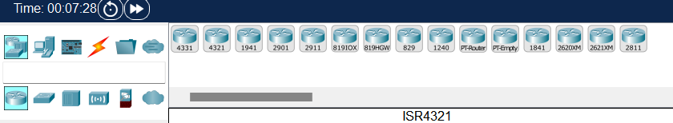

Fig 2. Routers selection

Router 4331 was selected for its performance, scalability, security, and compatibility with Cisco Packet Tracer.

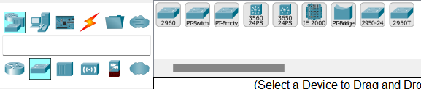

Fig 3. Switches Selection

Cisco 2960 PT Switch was chosen for its compatibility with Packet Tracer, simplicity, reliability, affordability, and scalability. It's ideal for basic network setups.

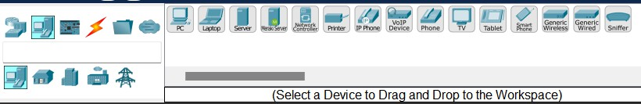

Fig 4. End Devices

We chose a simple PC in Cisco Packet Tracer for its ease of use, practicality, and relevance to basic network configurations. It's a fundamental element for learning networking concepts without unnecessary complexity.

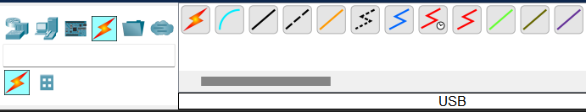

Fig 5. Connections

**Straight Through cables** are ideal for connecting switches to switches, as switches typically have similar interfaces that don't require signal crossover. This choice ensures efficient and direct communication within the local network.

On the other hand, **Crossover cables** are reserved for connecting routers to routers, facilitating the exchange of data between different networks and adhering to industry standards. These cable selections are pivotal in establishing efficient and standardized communication within the network infrastructure.

**IP Address Configuration and Routing Configuration**

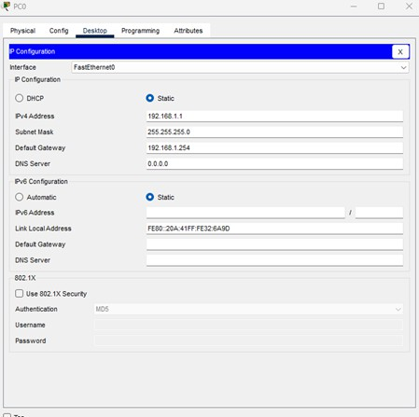

Fig 5. PC0 Configuration

|  |  |  |
| --- | --- | --- |
| **IP Address** | **Subnet Mask** | **Default Gateway** |
| 192.168.1.1 | 255.255.255.0 | 192.168.1.254 |

**IP Address (192.168.1.1)**: This is like telling PC0 its room number within your local network. It's used for communication within your home or office network.This is a Type C private IP address.

**Subnet Mask (255.255.255.0)**: Think of this as a rule that says, "Devices with the same room number (192.168.1.x) are in the same local network.”

**Default Gateway (192.168.1.254)**: This is like showing PC 0 the way to the building's entrance. When PC 0 wants to talk to devices outside your home (like websites), it sends its message through this gateway (usually a router), which then directs it to the right place.

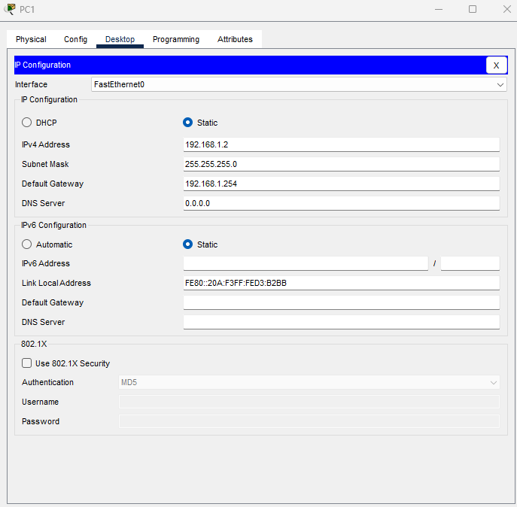

Fig 7. PC1 Configuration

|  |  |  |
| --- | --- | --- |
| **IP Address** | **Subnet Mask** | **Default Gateway** |
| 192.168.1.2 | 255.255.255.0 | 192.168.1.254 |

**IP Address (192.168.1.2)**: Similar to PC 0, PC 1 is assigned a private IP address from the same local network (192.168.1.x). This IP address, 192.168.1.2, serves as PC 1's unique identifier within your local network.

**Subnet Mask (255.255.255.0)**: PC 1 uses the same subnet mask (255.255.255.0). This mask specifies that PC 1 considers any device with an IP address starting with 192.168.1 as part of its local network.

**Default Gateway (192.168.1.254)**: PC 1, like PC 0, is configured with the same default gateway IP address (192.168.1.254). This is the door to the outside world (the internet) for PC 1. When PC 1 wants to communicate with devices outside its local network, it sends data through this gateway (usually a router), which then manages the traffic between the local network and the internet.

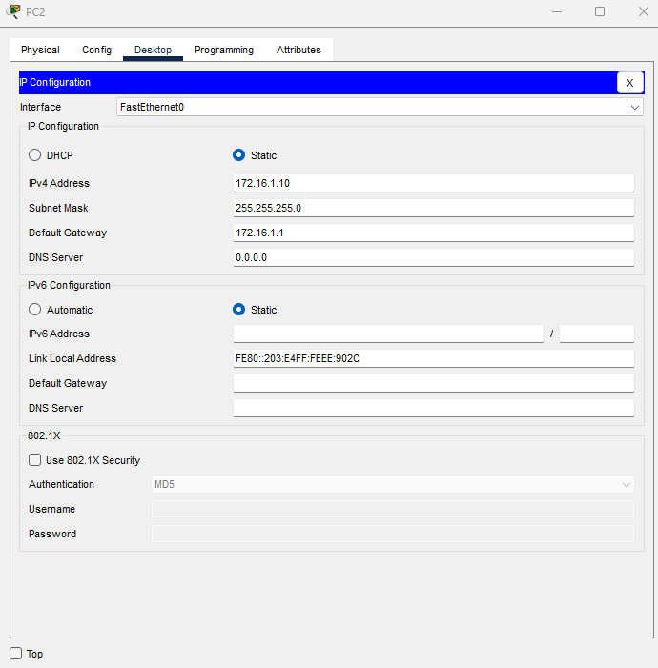

Fig 8. PC2 Configuration

|  |  |  |
| --- | --- | --- |
| **IP Address** | **Subnet Mask** | **Default Gateway** |
| 172.16.1.10 | 255.255.255.0 | 172.16.1.1 |

**IP Address (172.16.1.10)**: PC 2 is assigned a different type of IP address compared to PC 0 and PC 1. This IP address, 172.16.1.10, belongs to the Class B private IP address range (172.16.0.0 to 172.31.255.255). Unlike the Class C private IP addresses used for PC 0 and PC 1, Class B private addresses provide a larger address space for bigger networks.

**Subnet Mask (255.255.255.0)**: PC 2 uses the same subnet mask (255.255.255.0) as PC 0 and PC 1. This mask signifies that PC 2 considers devices with IP addresses starting with 172.16.1 as part of its local network.

**Default Gateway (172.16.1.1)**: PC 2 is configured with a different default gateway compared to PC 0 and PC 1. The default gateway for PC 2 is 172.16.1.1. This gateway serves as the exit point to external networks, similar to the concept of a default gateway for PC 0 and PC 1.

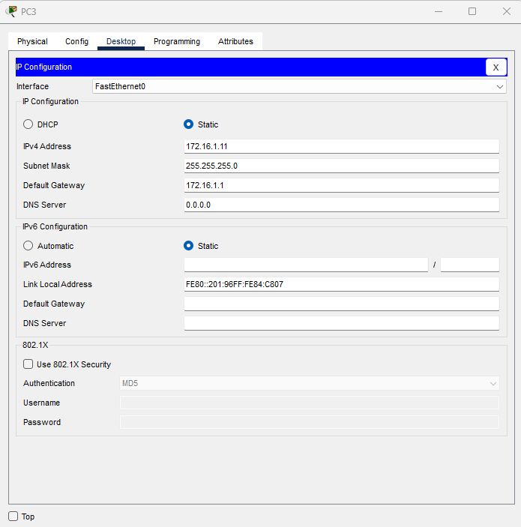

Fig 9. PC3 Configuration

|  |  |  |
| --- | --- | --- |
| **IP Address** | **Subnet Mask** | **Default Gateway** |
| 172.16.1.11 | 255.255.255.0 | 172.16.1.1 |

**IP Address (172.16.1.11)**: Similar to PC 2, PC 3 is assigned an IP address from the Class B private IP address range. Specifically, it's given the IP address 172.16.1.11. This IP address allows PC 3 to be part of the same local network as PC 2, with addresses starting with 172.16.1.

**Subnet Mask (255.255.255.0)**: PC 3 uses the same subnet mask (255.255.255.0) as PC 2. This mask signifies that PC 3 considers devices with IP addresses starting with 172.16.1 as part of its local network.

**Default Gateway (172.16.1.1)**: Just like PC 2, PC 3 is configured with the same default gateway IP address (172.16.1.1). This gateway is responsible for routing data between the local network (172.16.1.x) and external networks, such as the internet.

**Router 4 Configuration**

**Gigabit Fast Ethernet 0/0/0 Interface**: This refers to a specific network interface on a router. In this case, it's labeled as "Gigabit Fast Ethernet 0/0/0." Routers typically have multiple network interfaces to connect to different networks or devices. This interface is assigned the IP address 192.168.1.254.

**IP Address (192.168.1.254)**: This is the unique address assigned to the router's network interface. It's within the IP address range 192.168.1.x, which is commonly used for private local networks. The ".254" at the end indicates that it's the router's address within the local network.

**Subnet Mask (255.255.255.0)**: The subnet mask defines the boundaries of the local network. In this case, the subnet mask 255.255.255.0 signifies that all devices with IP addresses that share the first three

sets of numbers (192.168.1) are part of the same local network. The last set of numbers (the ".0") is used for individual devices within the network.

**Router 5 Configuration**

**Gigabit Fast Ethernet 0/0/0 Interface**: This refers to a specific network interface on a router. In this case, it's labeled as "Gigabit Fast Ethernet 0/0/0." Routers typically have multiple network interfaces to connect to different networks or devices. This interface is assigned the IP address 172.16.1.1.

**IP Address (172.16.1.1)**: This is the unique address assigned to the router's network interface. It's within the IP address range 172.16.1.x, which is commonly used for private local networks. The ".1" at the end indicates that it's the router's address within the local network.

**Subnet Mask (255.255.255.0)**: The subnet mask defines the boundaries of the local network. In this case, the subnet mask 255.255.255.0 signifies that all devices with IP addresses that share the first three sets of numbers (172.16.1) are part of the same local network. The last set of numbers (the ".0") is used for individual devices within the network.

In conclusion, the configuration of PCs, switches, and routers is essential for establishing a functional network infrastructure. Each element serves a specific purpose:

* **PC Configuration**: PCs are assigned unique IP addresses, subnet masks, and default gateways within their respective local networks. These configurations enable them to communicate within the local network and access external networks. The choice of IP address class (Class C or Class B) depends on network size and requirements.
* **Switch Configuration**: Switches connect multiple devices within a local network efficiently. In this setup, Straight Through cables are used for switch-to-switch connections, ensuring seamless communication within the same network. This configuration simplifies and optimizes local data exchange.
* **Router Configuration**: Routers act as gateways between local networks and external networks, including the internet. Each router is configured with specific network interfaces and IP addresses within their local networks. Crossover cables connect routers to routers, enabling the exchange of data between different networks. This configuration ensures proper routing of data between local and external networks.

**Testing Connectivity and VLAN Configuration**

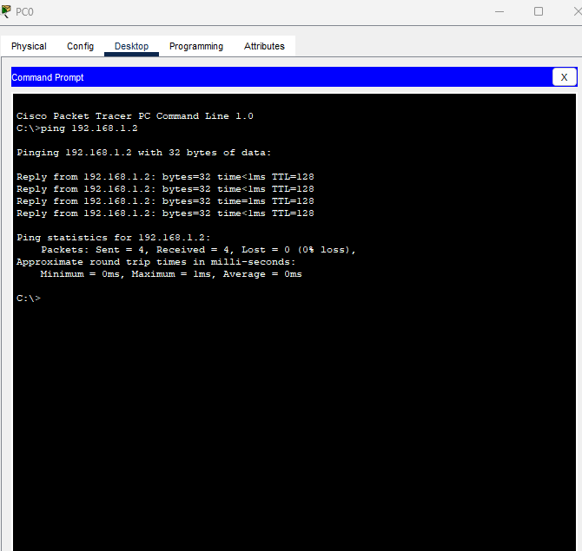

Fig 10. Pinging PC1 from PC0

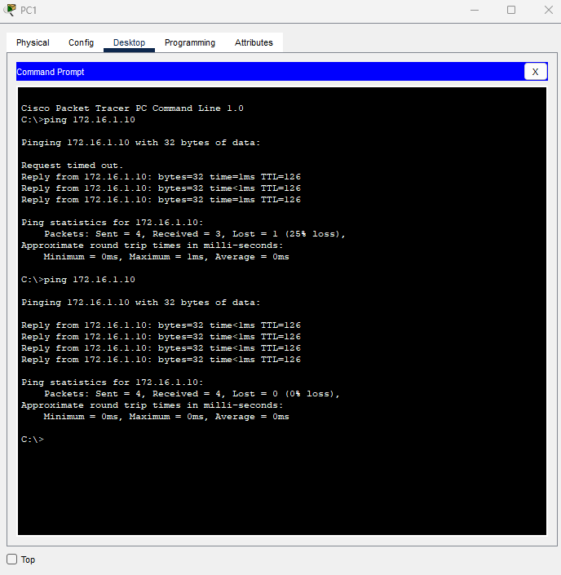

Fig 11. Pinging PC1 to PC2

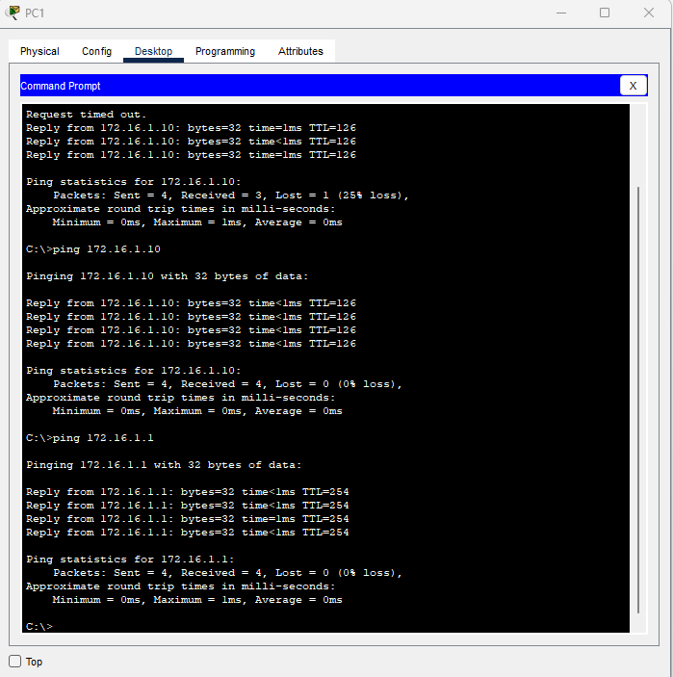

Fig 12. PC1 to Router5

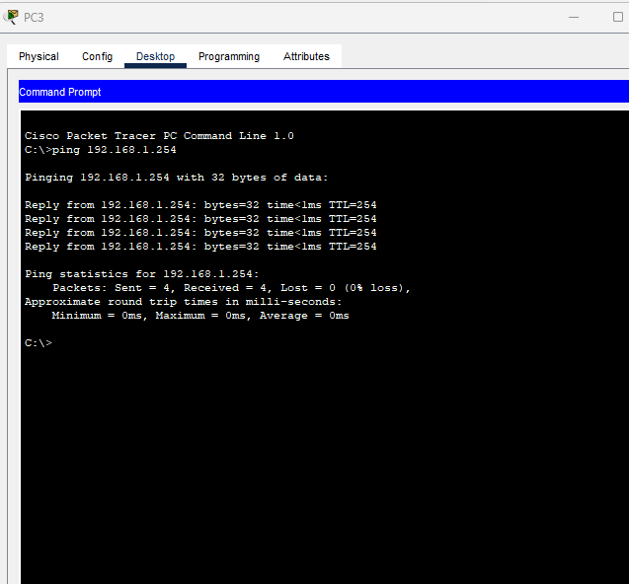

Fig 13. PC3 to Router4

**Routing Verification**

**Inter-VLAN Communication**: The successful exchange of data between different subnetworks, such as PC1 communicating with PC3 and PC2 communicating with PC3, confirms that inter-VLAN routing is operating without issues.

**Default Gateway Configuration**: It's essential to double-check that each PC is configured with the correct router interface as its default gateway. PCs within the 192.168.1.0/24 subnet should be set to use Router 4 (192.168.1.254) as their default gateway, while PCs in the 172.16.1.0/24 subnet should utilize Router 5 (172.16.1.1).

**Router Settings**: Ensure that Router 4 and Router 5 have the necessary routing entries in place to direct traffic between VLANs accurately. Additionally, confirm that the sub-interfaces are correctly associated with their respective VLANs. Router Interface Status: Verify that all router interfaces are in an operational state and functioning correctly. By conducting these ping tests and validating routing functionality, you can assess the correctness of your network configuration and confirm that devices can effectively communicate across VLANs as intended. In the event of any connectivity problems, troubleshoot by reviewing configurations, examining routing tables, and assessing firewall rules as required.

Bonus Question:

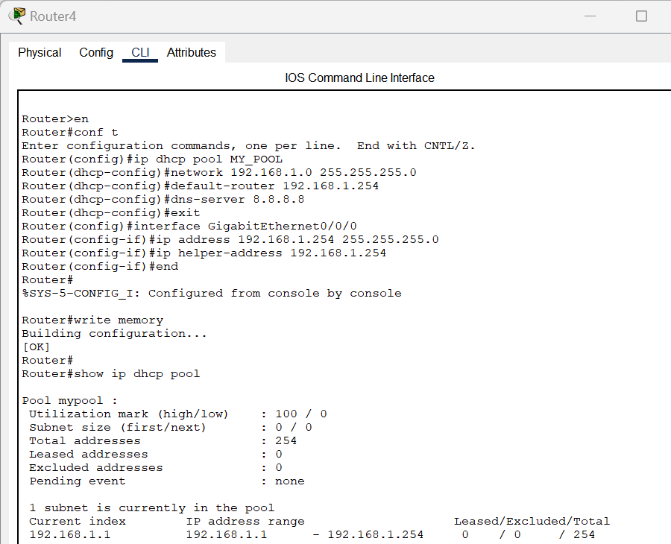

Fig. 15 DHCP Setup

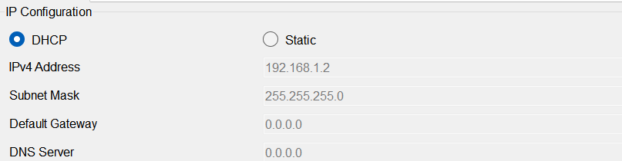

Fig. 16. PC0 IP Configuration set to DHCP

**Entered Privileged EXEC Mode**: I began by accessing privileged EXEC mode by typing en at the router's command prompt.

**Entered Global Configuration Mode**: Next, I entered global configuration mode using the command conf t. This mode allows me to make configuration changes to the router.

**Created a DHCP Pool**: I created a DHCP pool for the subnet by using the command ip dhcp pool MY_POOL. This pool, named "MY_POOL," would define the DHCP settings for our specific subnet.

**Defined the Network and Subnet Mask**: To specify the IP address range for the DHCP pool, I used the command network 192.168.1.0 255.255.255.0. This command set the network address to 192.168.1.0 with a subnet mask of 255.255.255.0.

**Set the Default Gateway**: I configured the default gateway for devices in the subnet with the command default-router 192.168.1.254. This means that any device receiving an IP address from this DHCP pool would use 192.168.1.254 as its default gateway.

**Configured the DNS Server**: I specified the DNS server that DHCP clients should use by typing dns-server 8.8.8.8. In this case, I set it to Google's public DNS server (8.8.8.8).

**Exited DHCP Pool Configuration**: To exit the DHCP pool configuration, I used the exit command, which took me back to global configuration mode.

**Configured the Router Interface**: I then moved on to configuring the router's interface by entering the interface configuration mode for GigabitEthernet0/0/0 with the command interface GigabitEthernet0/0/0.

**Assigned IP Address and Subnet Mask**: For this interface, I assigned the IP address 192.168.1.254 and subnet mask 255.255.255.0 using the command ip address 192.168.1.254 255.255.255.0. This matched the subnet configuration of the DHCP pool.

**Configured DHCP Relay**: To enable DHCP relay on this interface, I used the command ip

helper-address 192.168.1.254. This allowed the router to forward DHCP requests from clients to the DHCP server.

**Exited Interface Configuration**: After configuring the interface, I exited the interface configuration mode.

**Saved the Configuration**: To ensure that all these configuration changes are saved, I used the write memory command to write the configuration to memory.

**Checked DHCP Pool Configuration**: Finally, I verified the DHCP pool configuration by running the command show ip dhcp pool. This displayed information about the DHCP pool, including the IP address range, leased addresses, and excluded addresses.

By completing these steps, I successfully configured the router to act as a DHCP server for the specified subnet, ensuring that devices in that subnet receive IP addresses, default gateways, and DNS server information. The router also relays DHCP requests to itself as the DHCP server for that subnet.